Pure equilibrium tetrahedral finite elements for global error estimation by dual analysis

Martin Kempeneers¹, Jean-Francois Debongnie² and Pierre Beckers’^{ƒ,2}
¹SAMTECH France SA, 12 rue DE Caulet Bat A14, C. Aeroparc ZA St Martin du T., 31300 Toulouse, France
²Department of Aerospace and Mechanical Engineering, University of Liège, Chemin des Chevreuils 1, 4000 Liege, Belgium

KEYWORDS: pure equilibrium model; tetrahedral finite element; error estimation; 3D dual analysis

ABSTRACT
This study presents a general procedure of creating pure equilibrium tetrahedral finite elements for use under the elastostatic hypothesis. These pure equilibrium elements are of the Fraeijs de Veubeke type and the degree of the polynomial approximation functions of their internal stress field is the parameter generating this new elements family. The spurious kinematic modes (SKM), inherent in the equilibrium approach, are eliminated at the element level by converting each tetrahedron into a super-element defined as an assembly of four tetrahedral primitive elements. A mathematical discussion on the number of SKM of the primitive elements as well as their elimination by the super-element technique has been carried out. The development of first and second degree elements is presented here in detail and their efficiency in the frame of global error estimation by dual analysis is emphasized by two numerical applications. The main attribute of the error estimation by dual analysis is that it provides an upper bound on the global discretization error.

- INTRODUCTION
As a majority of computational methods in engineering, the finite elements analysis provides only an approximated solution of a given problem. The errors may have several origins, for example: error due to the hypothesis of the mathematical model, error on the knowledge of the physical quantities, numerical errors, error on the geometry, etc. For the elastostatic analysis, the main component of the total error is generally the discretization error, i.e. the one due to the spatial and functional discretizations of the unknown field. Fortunately, this type of error is also the easiest to control. In fact, the discretization error tends asymptotically towards zero when the size of the elements decreases (h-refinement) or the degree of the polynomial approximation functions increases (p-refinement) or when both parameters are adjusted simultaneously (hp-refinement). An accurate estimation of the discretization error is therefore a very important part of the error control procedure. In what follows we will consider only this kind of error and generally omit the term discretization for the sake of briefness.
Initially developed by Fraeijs de Veubeke and his co-workers [1], the dual analysis was presented as a method to enclose the strain energy of the exact solution of a finite element problem. This method consists in comparing two solutions of a given problem, one obtained using a kinematically admissible model (displacement model), the second obtained using a statically admissible model (equilibrium model). Unfortunately this method presents two major drawbacks: it requires two finite elements analyses and was initially restricted to the particular cases of homogeneous prescribed displacements or zero applied loads, so that the method was progressively abandoned. However, the extension of the method to general boundary conditions cases, its generalization to the error measure and the improvement [2, 3] of the computing powers, initiated a new interest for the method. Indeed, as will be shown here, the dual analysis is a very reliable and accurate method to perform the error estimation. Moreover, it always provides an upper bound on the global error.
Mainly due to their greater complexity, the statically admissible models were not the subject of significant developments like kinematically admissible models on which most actual finite elements computation softwares are based. Only recent works, initiated by Almeida and Freitas, revisited the equilibrium models and extended the method to the 3D problems [4, 5]. They developed new families of hybrid equilibrium finite elements and used them in the context of measure and control of the error by dual analysis. These elements were called hybrid because of the discretization of the displacement field on their sides. However, they lead to completely statically admissible solutions unlike other formulations also called hybrid, e.g. the hybrid-Pian [6] or hybrid-Trefftz elements [7].
The new family of tetrahedral elements presented here is of the pure equilibrium type. It means that it is based on the model developed by Fraeijs de Veubeke [8], which is rigourously the dual of the classical displacement-type model. In this model, the only fields that are discretized are those that appear in equilibrium equations.
In the present paper, Sections 2 and 3 present respectively the notations and the main formulas of dual analysis. Section 4 reviews the general theory of the pure equilibrium method. Section 5 is a general discussion on the number of SKM in tetrahedral elements and on their elimination by the super-element technique. Sections 6 is a detailed presentation of the pure equilibrium approach in the particular case of linear and quadratic tetrahedral elements. Two numerical applications of error estimation by dual analysis are produced in Section 7. They have been performed using the new equilibrium elements and classical displacement-type solutions.

- NOTATION
Let us consider (Figure 1) an elastic volume Ω subjected to body loads f. Its boundary Г can be
split into two parts: Г_{u} with the prescribed displacements .ū and Г_{t} subjected to the surface loads $\overline{t}$.

Figure 1. Model of a mechanical structure.
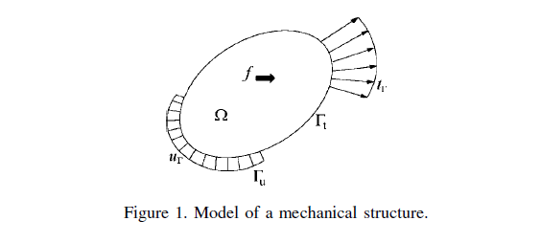
The stress and strain fields (σ and ε) are solutions of the classical equations of elastostatics, which may be divided into three categories:
- The compatibility equations
- The equilibrium equations
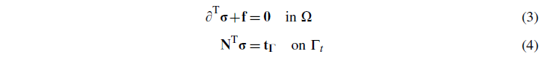
- The constitutive relations
Here
H being the matrix of elastic stiffness, ∂ and N the gradient operator and the stress-tractions transformation matrix, respectively.
In what follows three energy measures will be used:
- The strain energy
- The total potential energy of a kinematically admissible (or compatible) solution u_{h}

- The total complementary energy of a statically admissible (or equilibrium) solution σh

The energy norm is defined by:
- DUAL ANALYSIS AND GLOBAL ERROR ESTIMATION
The dual analysis method is based on the comparison of statically and kinematically admissible solutions. It has been applied for the first time by Fraeijs de Veubeke and his co-workers in the 60s. They developed many 2D equilibrium and displacement-type finite elements to obtain, respectively, the statically and kinematically admissible solutions. Their method can be seen as a pure dual analysis because it is based on two finite elements solutions. However, they presented it initially only as a method to compute bounds on the exact strain energy without any direct reference to error estimation. Moreover, the method was restricted to the particular cases of homogeneous boundary conditions. This section presents the main results of the dual analysis theory with general boundary conditions as they were stated by Debongnie et al. [3].
Let || Δu|| be the norm of the error of a compatible solution U_{h} and |Δσ| the error of an equilibrium solution σ_{h}. Then,
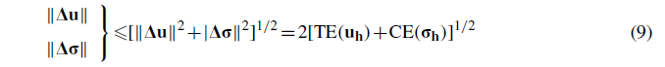
we define a relative error measure:
Remark 1
It can be shown that the measure of the absolute error (9) is strictly equivalent to the global error on constitutive relations e_{RdC} defined by Ladeveze in [9]:
When the exact solution of the problem is available (or at least a reference solution very close to the exact one), the accuracy of an error estimator may be measured by its effectivity index:
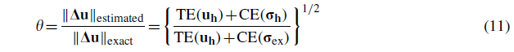
Error estimators are usually considered as reliable when this index is in the range
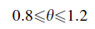
In the case of error estimation by dual analysis, this index is obviously always greater than 1.

- THE PURE EQUILIBRIUM METHOD
  - The complementary energy principle
The principle of the complementary energy consists in finding among a set of statically admissible stress fields (i.e. verifying a priori the equilibrium equations (3) and (4)), the one that minimizes the total complementary energy. In practice, this principle can be divided into two steps:
- Defining by a set of self-equilibrated stress fields, i.e. verifying a priori the strong form of the volume equilibrium equations (3) in Ω.
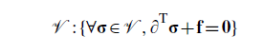
- Finding among this set of solutions the particular one that minimizes the total complementary energy under the constraint of the surface equilibrium (4).
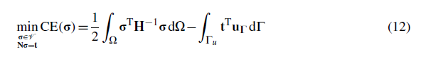

This amounts to looking for a solution (σ, ε) verifying the constitutive relations and satisfying the strong form of the equilibrium equations as well as a weak form (or integral) of the compatibility equations.
In a similar way as in the classical displacement-type finite element method, let us consider a finite element Ω_{e} and apply this principle to this element. In order to extract maximum information from the complementary energy principle, we consider that displacements are prescribed on the whole boundary (Г_{e} = Г_{e,u}).

  - Discretization of the stress field
A set can be defined by a linear combination of a set of independent functions:
where the columns of S are independent approximation functions, all of them verifying the homogeneous form of Equations (3). The parameters s of the linear combination are called generalized stresses. σ₀ is a particular solution of the equilibrium equation (3). In order to simplify the following developments, we will consider zero body forces (σ₀ =0). This hypothesis does not have any effect on most of the discussions of Section 5 [10].
As shown in [11], in the frame of finite elements computations, a general method allowing to create self-equilibrated polynomial approximation functions of degree p consists in using stress potentials.
In 2D, The stress potential to be used is the classical Airy function [12]. The practical method to define self-equilibrated approximation functions with this potential can be found in [13].
In 3D, The columns of S can be obtained either from Morera [14] or Maxwell [15] stress potentials which lead to analogous methods [13, 16].

  - Discretization of the surface tractions
As a consequence of the discretization of the stress field and the respect of the strong form of the surface equilibrium equations (4), the surface tractions must be polynomial fields of degree p as well. One may write
where g is a vector of generalized surface tractions and W a matrix containing the polynomial shape functions of degree p .
The connections between elements are ensured by the reciprocity of the surface tractions on the boundaries. This will be guaranteed by equilibrating the generalized surface tractions on these boundaries, it is the reason we give the name of connectors to these discretization parameters.
Considering all the faces of the element and the discretizations (13) and (14), it is possible to rewrite the surface equilibrium in terms of the generalized quantities:
where C is the so-called static connection matrix. More details on the derivation of this matrix are given in the Section 6.2 of the present paper for tetrahedral elements without volume loads. See [17] for more details on the derivation of this matrix in case of triangular elements and in the presence of volume loads.
  - Definition of the generalized displacements
The disretization (14) allows to rewrite the work of the surface traction on the boundary Г as

Where
is the vector of the generalized displacements conjugate to the generalized surface tractions g.

  - Minimization of the total complementary energy
From the discretization of the stress field (13), the definition of the generalized displacements (17) and the equilibrium equations (15), the total complementary energy (8) may be written in terms of the generalized quantities.
where the element flexibility matrix appears
So, the problem (12) reduces to looking for the parameters s for which the first derivative of the functional CE vanishes. This leads to the stationarity condition:
This allows to rewrite the equilibrium equations (15) in terms of the generalized displacements and the generalized surface tractions as in a classical displacement formulation
Kq=g (19)
with a positive semi-definite stiffness matrix
K = CF⁻¹C^{T}
Remark 2
The global finite elements system can be built easily using the classical assembly method of the displacement-type models.
Remark 3
The stiffness matrix generally exhibits some null eigenvalues in addition to those due to the natural rigid body modes. They correspond to zero energy displacement modes called SKM. Several methods do exist to eliminate these modes. For the sake of robustness, we used the super-element method to eliminate them at the element level. It consists in the creation of super-elements by converting each element into an assembly of several primitive elements. As shown in [18] for 2D elements, a judicious assembly leads to a complete locking of the modes inside triangular or quadrangular super-element. And as announced by Fraeijs de Veubeke in the same reference, such a judicious assembly should also exist for tetrahedral elements. Even if no formal proof of the stability of such elements has been provided so far, tetrahedral super-elements have already been used by the authors to compute 3D equilibrium solutions [16]. Now a proof of Fraeijs de Veubeke’s thesis is presented in the next section, it requires a general counting of the SKM of the primitive tetrahedral finite elements, i.e. an inspection of the rank of their stiffness matrix.

- THE SKM AND THEIR ELIMINATION
  - General formula
Let us denote by n_{s} and n_{g}, respectively, the number of independent stress parameters and the total number of connectors of the element. The dimensions of the matrices C, F and K are:
K : (n_{g} x n_{g}) C : (n_{g} x n_{s}) F : (n_{s} x n_{s})
Considering (18), the flexibility matrix F is regular, so that the rank of the stiffness matrix is given by
rank(K) = rank(C) =n_{s} - n_{sstr}
where n_{sstr} is the number of independent solutions of the system

Cs=0
These modes are called self-stressing modes because they correspond to combinations of the stress parameters that do not generate surface tractions.
The number of SKM n _{skm} being the number of singularities of the stiffness matrix appearing in addition to those due to the natural rigid body modes n_{r}, it is given by:
n_{skm} = dim (K) -rank(K) -n_{r} =n_{g}-n_{s}+n_{sstr} -n_{r} (20)
Let us now write these terms as functions of the degree p of the polynomial approximation functions of the stress field in the particular case of tetrahedral elements.

  - Counting of the generalized quantities in the tetrahedron
    - The generalized surface tractions. In order to ensure the complete transmission of the stress flow through the faces of the element, the number of connectors on one face, in each of the three directions, is given by the minimum number of points necessary to define uniquely a complete polynomial function of degree p in 2D. Which is equivalent to
where 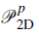is the complete set of polynomials of degree less than or equal to p in two dimensions.
Since
the total number of connectors by element is given by:
    - The generalized stresses. A general polynomial stress field of degree p has a number of parameters equal to six times the dimension of the complete set of polynomials of degree less than or equal to p in 3D. With,
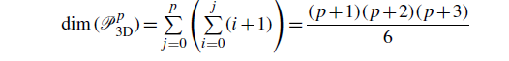
Because the internal equilibrium relations (3) deal with polynomials of degree (p - 1), enforcing the stress field to satisfy the homogeneous form of these equations leads to a number of relations between the parameters equal to
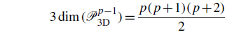
so that finally the number of independent generalized stresses in the element is given by
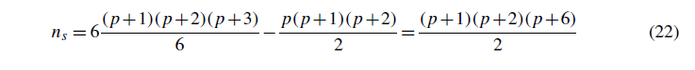

  - Counting of the self-stressing modes in the tetrahedron
The following developments have to do with more than linear tetrahedral elements.
Counting the self-stressing modes in the 2D case can be achieved relatively easily by looking for the zeros of the Airy function and its first normal derivative on the boundary of the element. In the 3D case, despite the existence of analogous stress potentials, such an analysis is from far more complicated. A different approach proposed by Debongnie and presented here is the following two steps method:
    - Looking for the number n_{i} of internal stresses, i.e. the number of independent solutions of Nσ=0 on the boundary, without prescribing the internal equilibrium (3).
    - Establishing the number n_{E} of conditions to apply to these solutions in order to turn them into self-stressing modes.
The number of self-stressing modes is then given by:
(23)
n_{sst}r = n_{i} -n_{E}
    - The internal modes. In what follows we will prove that it is possible to find at most 6 independent internal stress modes of degree 2. Moreover, we will construct 6 such internal modes and prove that they are linearly independent, so that the number of independent quadratic internal stress modes on a tetrahedron is exactly 6. For higher degrees, every multiple of these modes by a polynomial of degree (p - 2) is also an internal mode. So that the number of internal modes of degree p is given by

There is no quadratic self-stressing mode in a tetrahedron.
Proof
This theorem is an obvious consequence of the following stronger result: any vector σ of quadratic functions verifying ∂^{T}σ = 0 inside a tetrahedral domain and N ^{T}σ = 0 on its boundary necessarily vanishes.
The condition ∂^{T}σ = 0 implies that a third degree potential vector a does exist such that
σ=rot a
The general form of this potential is:

a = grad Ø+b
The condition N^{T} rot a=0 implies that b=0 on the boundary.
The gradient having no effect on the vector σ, one may write without any loss of generality:

a=b
So b should be a vector of bubble functions of the third degree, which is impossible on a tetrahedron. Therefore, b=0, which implies σ=0.
□

There are no more than 6 independent quadratic internal stress modes on a tetrahedron.
Proof
Let us first proove that, for a tetrahedron Ω_{e}, a quadratic internal stress mode σ verifying
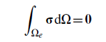
is identically null.

Indeed, this condition implies that
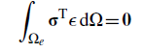
for all constant strain field ε.
Or
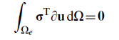

for all linear displacement fields u.
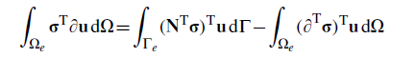
An integration by parts leads to
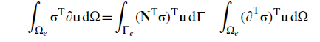
σ being an internal stress field, the first integral vanishes and the previous condition can be rewritten:
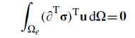
for all linear displacement fields u.
As ∂^{T}σ, this condition imposes σ to be a self-stressing mode. Therefore, considering Theorem 1, we find σ=0.
The previous result leads directly to the thesis. Indeed, 6 conditions suffice to eliminate all the internal stress fields, which implies that the dimension of the space of quadratic internal stress fields on a tetrahedron is 6 at most.

    - Construction of 6 internal modes. Let us denote as 1,2,3,4 the four vertices of the tetrahedron and c_{i} (x) =0 the equation of the face opposed to the vertex i, normalized so that c_{i} (x_{i}) = 1.
The edge vector w_{ij} joining the vertices i and j is orthogonal to the normal vectors n of the two adjacent faces. In tensorial notations, it implies that the symmetrical tensor
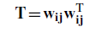
leads to surface tractions
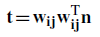
null on the two adjacent faces to the edge ij.
Therefore, a quadratic tensorial field
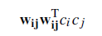
is an internal mode.
So it is possible to define 6 internal modes. Let us proove now that they are linearly independent.
    - Linear independence of the 6 tensors T. The 6 tensors are
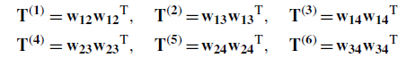
Theorem 3
If these tensors are linearly independent for the trirectangular tetrahedron with unit edge lengths, this property remains true on any other tetrahedron.
Proof
Let us note by v_{ij} the edges of the trirectangular tetrahedron with unit edge lengths. For any tetrahedron, it is possible to find a constant regular matrix A defining the affine transformation between w_{ij} and v_{ij}:
Hence,
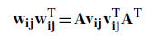

from which,
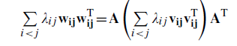
So that the tensors 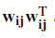 and 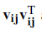 are simultaneously linearly dependent or independent. □
As a consequence we just have to proove that the are linearly independent.
Proof
If we number the vertices of the trirectangular tetrahedron with unit edge lengths such that:
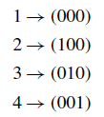
the 6 edge vectors are:
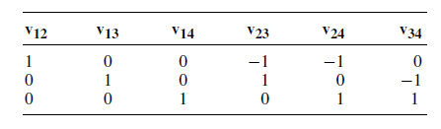

The tensors are linearly independent if and only if
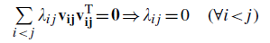

If we note
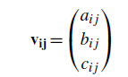

The previous condition can be rewritten
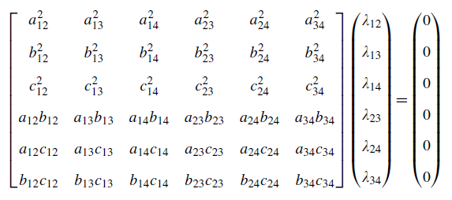

That is the tensors are linearly independent if and only if the determinant of this matrix is different from 0.
In the case of the trirectangular tetrahedron with unit edge lengths, this matrix is
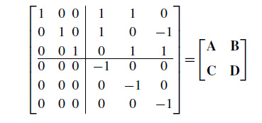

Using the Frobenius-Schur rule, its déterminant is equal to
dtm(A) x dtm(D — CA⁻¹B) = dtm(A) x dtm(D) = —1
Which finally proves the thesis. □
Finally, since the 6 tensors is a base for all 3x3 symmetrical tensor, the 6 quadratic internal stress modes
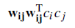
are linearly independent.

    - Conditions to be a self-stressing mode.

For an internal stress mode σ of degree p , the necessary and sufficient condition to be a self- stressing mode is
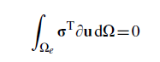
for any displacement field u of degree (p — 1).
Proof
As it has been shown for the Theorem 2, any internal stress mode verifies
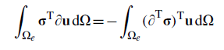
- These conditions are necessary because ∂^{T}σ = 0 leads directly to
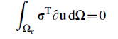
for all displacement fields of degree (p — 1).
- They are also sufficient because if
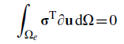
for all displacement fields u of degree (p — 1), taking the particular one:
leads to
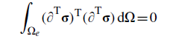
which implies
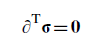

□
The independence of the previous conditions is a direct consequence of the following theorem:

There is no displacement field u of degree (p — 1) such that
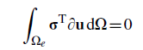
for all internal stress modes σ.
Proof
Let us suppose that such a displacement field v does exist.
Let be the vector base biorthogonal to the vector base of the internal stress modes defined by T in tensorial notation in Section 5.3.1. This base is defined by
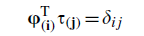
It is possible to write in this base the strain field due to v:
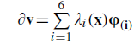
where the λ_{i} (x) are polynomials of degree (p — 2).
The internal stress mode
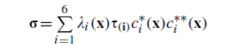
Where are the equations of the faces to consider so that is an internal stress mode), verifies

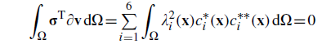

As c_{i} (x)>0 in Ω, the λ_{i} (x) must be all zero and consequently ∂v also □

Therefore, the number of equilibrium conditions for an internal stress mode of degree p is given by the dimension of the set of polynomials of degree less than or equal to (p - 1). We have to subtract from this number the combinations of the displacement parameters leading to null strain fields, i.e. the 6 rigid body modes

    - Number of self-stressing modes. Finally, considering the relations (23), (24) and (25), the number of self-stressing modes in a tetrahedron of degree is

  - The number of SKM in the tetrahedron
    - The particular case of p= 1. In this case, there are no self-stressing mode in the tetrahedron, so that, considering (21) and (22), the general formula (20) leads to
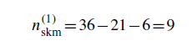
    - The general case for . Taking into account the number of self-stressing modes (26), the general formula (20) leads in this case to a number a SKM
This result had already been announced by Pereira in [19, 20], but to our knowledge it had never been proved.
  - Elimination of the SKM for the tetrahedron
The method used to eliminate the SKM at the element level is based on the super-element concept. This method consists in considering the tetrahedral element as an assembly of four primitive tetrahedra by linking an inner point to the four vertices of the element (Figure 2). The stiffness matrix of the super-element is obtained by condensing the internal degrees of freedom of the assembly.

Figure 2. The tetrahedral super-element.

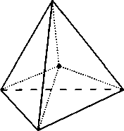

Giving the subscript i to the internal connectors and e to those located on the external faces of the assembly, the equilibrium equations (19) can be rewritten:
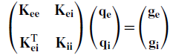

The equations corresponding to the internal degrees of freedom lead to:
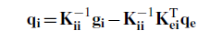
Introducing this result in the external equilibrium equations of the assembly allows to obtain the stiffness matrix of the super-element K and the equivalent loads g such that:
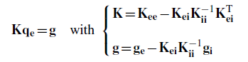
In the case of zero body forces g_{i}=0 and g=g_{e}.
As it will be proved, the super-element does not comprise any SKM. With this aim in view, it is to be noted that the SKM appear in an element when the number of stress parameters that can be connected (i.e. the number of independent non-self-stressing stress modes) is less than the number of connectors plus the number of rigid body modes. That is what expresses the general formula (20) for the number of SKM.

    - The particular case of p= 1. The number of parameters of the assembly is given by:
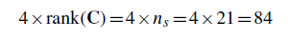
And considering the 6 internal faces and the 4 external faces, the total number of connectors is given by:
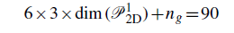
Hence, as
84-90+6=0
there are no SKM in this assembly.

    - The general case for . By the same way, the number of stress parameters that can be connected is:
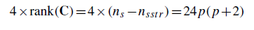
And the number of connectors is:
6x3xdim(P₂^{p}_{D})+ng =15(p+1)(p+2)
So that,
is always greater than zero, which means that the connection is regular or in other terms that the general assembly does not comprise any SKM. However, at high degrees, there is a possibility of supplementary self-stresses of the assembled element. Their number has to be subtracted from the previous result. Unfortunately, up to now, no way has been found for the evaluation of this number.

- THE LINEAR AND THE QUADRATIC EQUILIBRIUM TETRAHEDRAL ELEMENTS
This section describes in details the application of the equilibrium approach presented in Section 4 to the particular cases of tetrahedral elements with p = 1 and p =2.

  - Discretization of the stress field
Using Morera’s potential, it is possible to find 21 and 48 linearly independent vectors defining the columns of S for p= 1 (Table I) and p =2 (Table II) respectively.

  - Discretization of the surface tractions
In contrast to the previous discretization we impose the generalized surface tractions (the connectors) to have a strong physical meaning. A natural choice for these connectors is to define them from local values of the field of surface tractions. Multiplying these local values by the area of the triangular face to which they own gives them the dimension of forces. This choice simplifies the handling of the boundary conditions on Г_{t}.

Table I. The columns of S. p = 1.
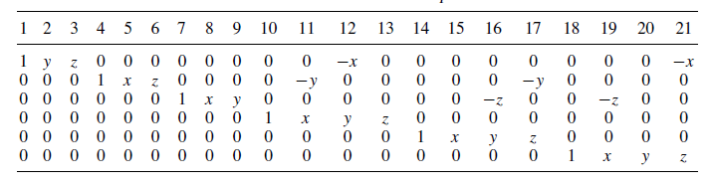

Table II. The columns of S. p = 2.
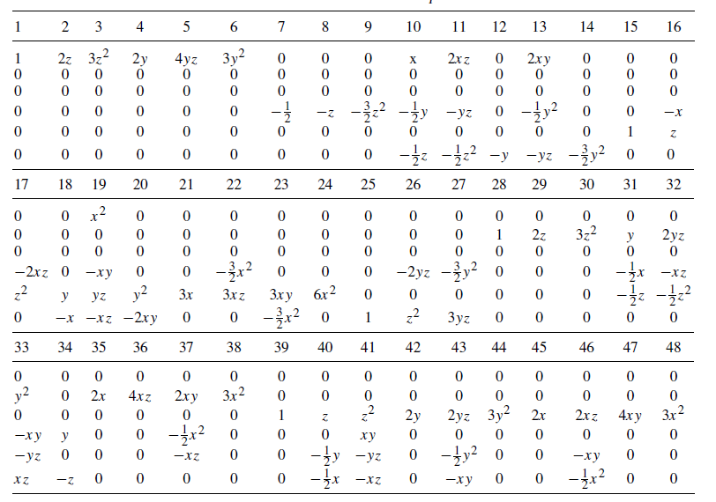

A second choice is the position of the points of application of these forces, i.e. the local values of the field of surface tractions to take under consideration. For the present tetrahedral elements, we chose to take the integration points of the symmetrical quadrature rules over a triangle presented by Lyness and Jespersen in [21]. As it will be shown in Section 6.3, this choice makes the handling of the boundary conditions on Г_{u} easier.
Three and six connectors are necessary by face and by direction, respectively, for linear and quadratic elements. Therefore, the integration rules to consider are the three and six points rules allowing to integrate exactly polynomials, respectively, of the second and of the fourth degree. The positions of the integration points for these rules are given in Table III in area coordinates (s₁, s₂). However, these particular positions of the connectors will really be interesting only if we multiply each connector by the corresponding integration weight (Table III). Hence, on a face I and in the direction i, the connectors have finally the following definition:
where A¹ is the area of the face, 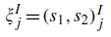and w_{j}, respectively, the position and the weight of the integration point j .

Table III. Positions and weights of the integration points on the triangle.
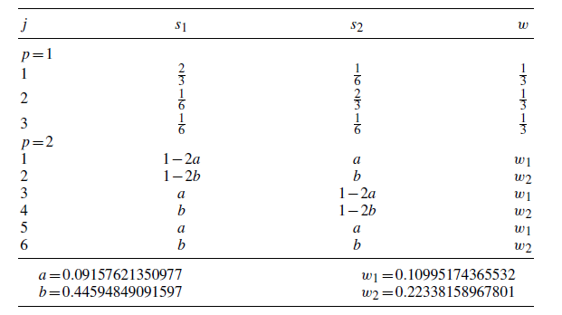
The surface traction shape function corresponding to the connector 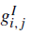 is a polynomial of the same degree as the stress field such that
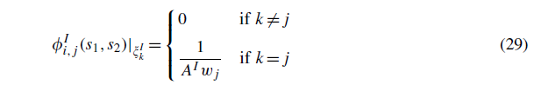

Inserting the discretization of the stress field (13) (with zero body forces) and the surface equilibrium (4) into the definition of the connectors (28) we obtain:
With
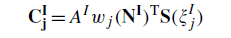
Assembling these matrixes for all connectors and the 4 faces leads to the equilibrium equations of the element in terms of the generalized quantities (15) with
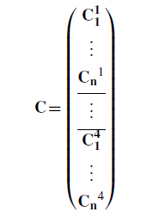
where n = 3andn = 6, respectively, for the linear and the quadratic elements.

  - The generalized displacements
Considering the définition of the generalized displacements (17) and the shape functions 0, the use of the 3 points and 6 points integration rules to compute q leads to:
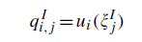
if u_{i} is a polynomial of degree less than or equal to the degree of the stress field.

  - The stiffness matrix
Considering (18), the flexibility matrix F will be computed using appropriate numerical integration rules like the 4 point rule presented by Hammer in [22] for the linear element and the 11 points rule presented by Keast in [23] for the quadratic element. Indeed, these formulas allow to compute exactly the integral of polynomial functions respectively of degree 2 and 4 on a tetrahedral domain. The positions in tetrahedral coordinates (s₁, s₂, s₃) of the corresponding integration points and their weights are given in Table IV.

Table IV. Positions and weights of the integration points in the tetrahedron.
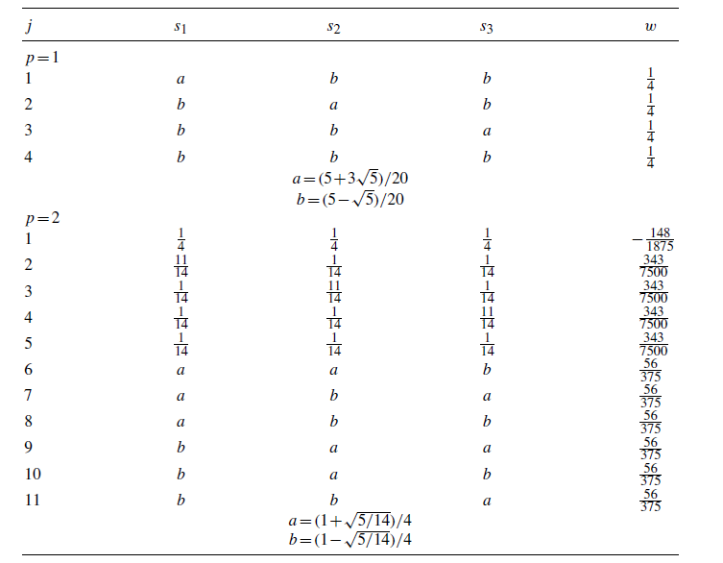

- NUMERICAL APPLICATIONS
  - Hollow plate
In order to study the efficiency of the error estimation by dual analysis, let us consider the simple problem of the square hollow plate subjected to uni-axial traction shown in Figure 3. With the physical properties
P = 1. 0, E = 1. 0, v = 0.3
Seeing the double symmetry of the structure, only one quarter of the plate has to be studied.
In this example, four meshes have been tested (Figure 4). For each of them linear and quadratic approximation functions were considered for the classical displacement-type approach as well as for the equilibrium approach.
As the displacement-type boundary conditions are homogeneous, the total energies defined by (7) and (8) reduce to:
Table V shows the values of the strain energy obtained from linear and quadratic displacement and equilibrium models.
Considering the dual analysis as a method to estimate the error on classical displacement-type solutions, formula (10) leads to the upper bounds of this error listed in Table VI. The upper part of the table shows for each mesh the error estimation obtained by using the dual linear equilibrium solution and the lower part, the error obtained by using the dual quadratic equilibrium solution.
Figure 3. The hollow plate subjected to uni-axial traction.
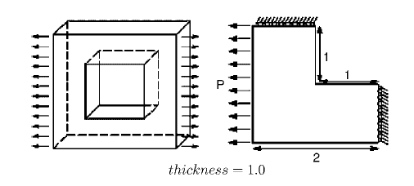

Figure 4. Meshes of a quarter of the hollow plate.
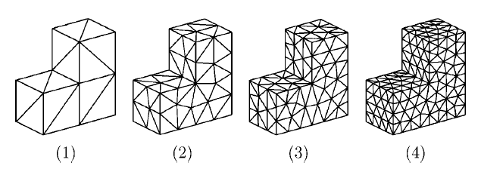

Table V. Strain energies of the computed solutions.
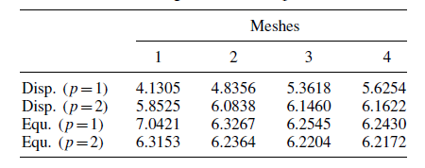

Table VI. Estimated relative errors (%).
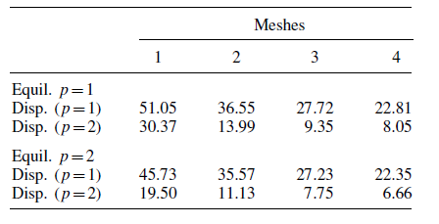

Table VII. Reference relative errors of the compatible solutions (%).
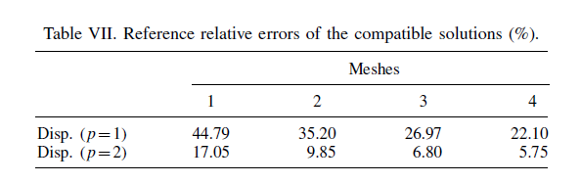
This problem does not have an analytical solution but a reference solution very close to the exact one and obtained by a Richardson extrapolation can be found in [24]:
U_{ref} = 6.2031
This value allows to compute the reference errors on the displacement-type solutions, which are listed in Table VII.
It is then also possible to compute the effectivity indexes (11) of the previous error estimations that are listed in Table VIII.
From these results, it appears that:
- In this particular case of homogeneous displacement-type boundary conditions, equilibrium and displacement models lead always, respectively, to upper and lower bounds of the strain energy of the exact solution.
Table VIII. Effectivity indexes.
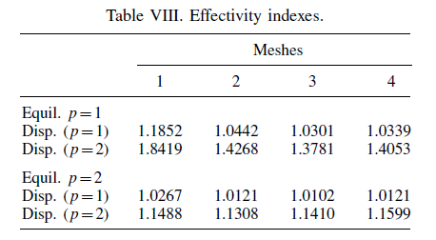

Figure 5. The connecting rod.

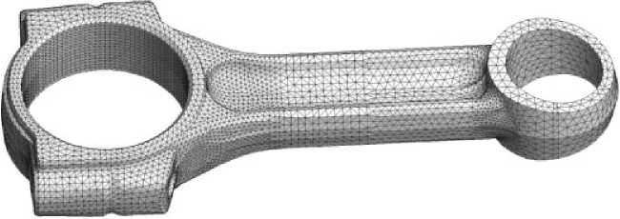

- The use of linear equilibrium solutions to estimate the error on linear displacement-type solutions is generally sufficient to reach the required accuracy. However, in order to maintain this satisfactory precision level, quadratic equilibrium solutions should be used for error measures on quadratic compatible solutions.
- The size of the elements has no substantial effect on the accuracy of the error estimation by dual analysis.

  - Connecting rod
Let us consider now the connecting rod of Figure 5, which is discretized with 52 464 tetrahedral elements. From a size point of view, this problem is a good example of a realistic model as encountered in industrial applications of the finite element method.
A constant pressure is applied on half the cylindrical surface of the small end bore delimited by the plane of symmetry of the connecting rod. The surface of the big end bore is kept fixed so that the connecting rod is subjected to bending and compression stresses.
Table IX shows the global characteristics of two displacement-type solutions and the linear equilibrium solution. These computations have been performed with the finite elements analysis software SAMCEF® in which the linear equilibrium tetrahedral element was especially implemented.
The strain energies coming from the quadratic displacement solution and the equilibrium solution are very close together which means that both solutions are very accurate. Although the number of degrees of freedom is by far greater in the equilibrium model, the CPU times, which indicate the number of arithmetical operations, are not very different. This indicates that even for industrial problems, dual analyses are not prohibitive processes.
These results lead to the error estimations presented in Table X.

Table IX. Solution characteristics.
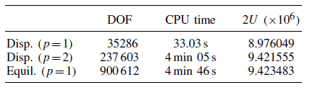
Table X. Reference relative errors of the compatible solutions (%).

- CONCLUDING REMARKS
The error estimation on a displacement-type solution by dual analysis will be all the more accurate as the statically admissible solution is closer to the exact one. The equilibrium models lead to the best statically admissible solution for a given discretization level. Therefore they are the most accurate and natural methods to obtain an equilibrium solution for use in the frame of dual analysis.
The degree of an equilibrium-type solution may be considered as a parameter controlling the accuracy of the error estimation.
As the equilibrium solution does not depend on the displacement-type solution, it may be conceived to perform both analyses in parallel computations on multi-processors computers.
The independence of the dual solutions ensures a slight dependence between the accuracy of the solutions and the efficiency of the error estimator. The efficiency of the estimator is indeed more related to the relative quality of the solutions than to their own accuracy.
Equilibrium models provide equilibrated stress fields while displacement models lead to compatible displacement field. Therefore, in addition to the error estimation, the dual analysis produces an accurate knowledge of all the quantities of interest.

Bibliography
- Fraeijs de Veubeke B. Upper and lower bounds in matrix structural analysis. AGARDograf 1964; 72:165-201.
- Debongnie J-F. A general theory of dual error bounds by finite elements. Technical Report LMF/D5, Université de Liege, 1983.
- Debongnie J-F, Zhong H-G, Beckers P. Dual analysis with general boundary conditions. Computer Methods in Applied Mechanics and Engineering 1995; 122:183-192.
- Moitinho de Almeida JP, Freitas JAT. Alternative approach to the formulation of hybrid equilibrium finite elements. Computers and Structures 1991; 40:1043-1047.
- Pereira OJBA. Um modelo de elementos finitos de equilbrio para elasticidade tridimensional. MSc Dissertation, Universidade Tecnica de Lisboa, 1993.
- Pian THH. Derivation of element stiffness matrices by assumed stress distributions. AIAA Journal 1964; 2: 1333-1335.
- Freitas JAT, Ji Z-Y. Hybrid-trefftz boundary integral formulation for simulation of singular stress fields. International Journal for Numerical Methods in Engineering 1996; 39:281-308.
- Fraeijs de Veubeke B. Displacements and equilibrium models in the finite elements method. In Stress Analysis, Zienkiewicz OC, Holister GS (eds), Chapter 9. Wiley: London, 1965.
- Ladeveze P. Comparaison de modèles de milieux continus. Ph.D. Thesis, Université Pierre and Marie Curie, 1975.
- Kempeneers M. Les forces volumiques dans la formulation équilibre. Technical Report, Université de Liège, 2004.
- Beckers P. Les fonctions de tension dans la méthode des éléments finis. Ph.D. Thesis, Université de Liège, 1972.
- Airy GB. On the strains in the interior of beams. Philosophical Transactions of the Royal Society of London 1863; 153:49.
- Moitinho de Almeida JP, Pereira OJBA. A set of hybrid equilibrium finite element models for the analysis of three-dimensional solids. International Journal for Numerical Methods in Engineering 1996; 39:2789-2802.
- Morera G. Soluzione generale delle equazione indefinite dell’equilibrio di un corpo continuo. Rendiconti Accademia Nazionale Lincei 1892; I(V):137-141.
- Maxwell JC. On reciprocal diagrams, in space and their relation to airy’s function of stress. Proceedings of the London Mathematical Society 1868; 1:58-60.
- Kempeneers M, Beckers P, Debongnie J-F. Eléments finis tétraedriques pour l’analyse duale. Revue Européenne des Eléments Finis 2004; 13(5-6-7):547-558.
- Kempeneers M. Eléments finis statiquement admissibles et estimation d’erreur par analyse duale. Ph.D. Thesis, Université de Liège, 2005.
- Fraeijs de Veubeke B. Diffusive equilibrium models. Lecture notes. International Research Seminar, University of Calgary, Canada, 1973.
- Pereira OJBA. Utilizacao de elementos finitos de equilbrio em refinamento adaptativo. Ph.D. Thesis, Universidade Tecnica de Lisboa, 1996.
- Pereira OJBA. Hybrid equilibrium hexahedral elements and super-elements. Communications in Numerical Methods in Engineering 2008; 24:157-165.
- Lyness JN, Jespersen D. Moderate degree symmetric quadrature rules for the triangle. Journal of the Institute of Mathematics and its Applications 1975; 15:19-32.
- Hammer PC, Marlowe DJ, Stroud AH. Numerical integration over simplexes and cones. Mathematical Tables and other Aids to Computation 1956; 10:130-137.
- Keast P. Moderate-degree tetrahedral quadrature formulas. Computer Methods in Applied Mechanics and Engineering 1986; 55:339-348.
- Cugnon F. Automatisation des calculs éléments finis dans le cadre de la méthode-p. Ph.D. Thesis, Université de Liège, 2000.

Correspondence to: Pierre Beckers, Department of Aerospace and Mechanical Engineering, University of Liege, Chemin des Chevreuils 1, 4000 Liege, Belgium. ^{ƒ}E-mail: pierre.beckers@ulg.ac.be

