Appendices of the paper “Experimentation and driving cycle performance of three architectures for waste heat recovery trough Rankine cycle and organic Rankine cycle of a passenger car engine”

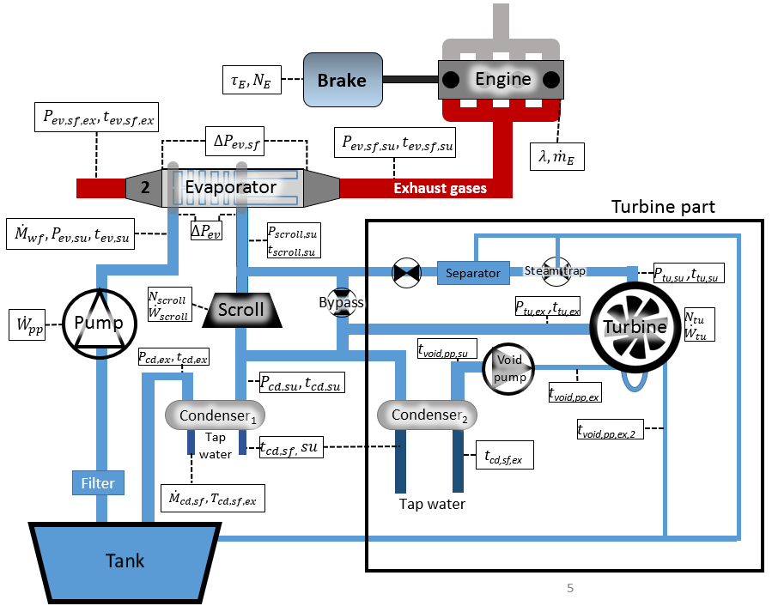
Figure A1: Hydraulic scheme of the Rankine for waste heat recovery on exhaust gases

Table A1: Sensors technical data of the Rankine for the R-EG
Location | Type | Range | Accuracy
Evaporator exhaust gas temperature | K | 0-260 C | 2.5K
Evaporator exhaust water temperature | K | 0-260 C | 2.5K
Evaporator inlet water temperature | T | 0-260 C | 1K
Evaporator inlet gas temperature | K | 200-1200C | 2.5K
Expander inlet water temperature | K | 0-450C | 2.5K
Expander exhaust water temperature | T | 0-260 C | 1K
Condenser exhaust water temperature | T | 0-260 C | 1K
Cooling water condenser exhaust temperature | T | 0-260 C | 1K
Pump supply temperature | T | 0-260 C | 1K
Differential pressure evaporator (water) | DP | 0-1.6bar | 0.1% FS
Evaporator exhaust gas pressure | rel | 0-500mbar | 0.5% FS
Pump exhaust pressure | rel | 0-25bar | 0.5% FS
expander exhaust pressure | rel | 0-5bar | 2.5% FS
Condenser cooling water pressure | rel | 0-4bar | 0.25% FS
Differential pressure evaporator (gas) | DP | 0-1.6bar | 0.1% FS
Condenser exhaust pressure | rel | 0-5bar | 2.5% FS
Differential pressure condenser (water) | DP | 0-1.6bar | 0.1% FS
Water mass flow rate | Coriolis | 0-25g/s | 0.4% FS
expander inlet pressure | Rel | 0-25bar | 0.5% FS
Lambda sensor |  | NS | 0.1
Expander rotational speed | impulse | 0-15000rpm | 30rpm
Fuel mass flow rate |  | 0.3-60kg/h | 1% FS
Void pump water exhaust temperature | T | 0-260 C | 1K
Void pump water supply temperature | T | 0-260 C | 1K
Cooling water condenser (2) supply temperature | T | 0-260 C | 1K
Cooling water condenser (2) exhaust temperature | T | 0-260 C | 1K
Cooling turbine exhaust temperature | T | 0-260 C | 1K
Turbine exhaust temperature | T | 0-260 C | 1K
Turbine supply temperature | T | 0-260 C | 1K
Turbine supply pressure | Rel | 0-20bar | 1% FS
Turbine exhaust pressure | Rel | 0-6bar | 1% FS

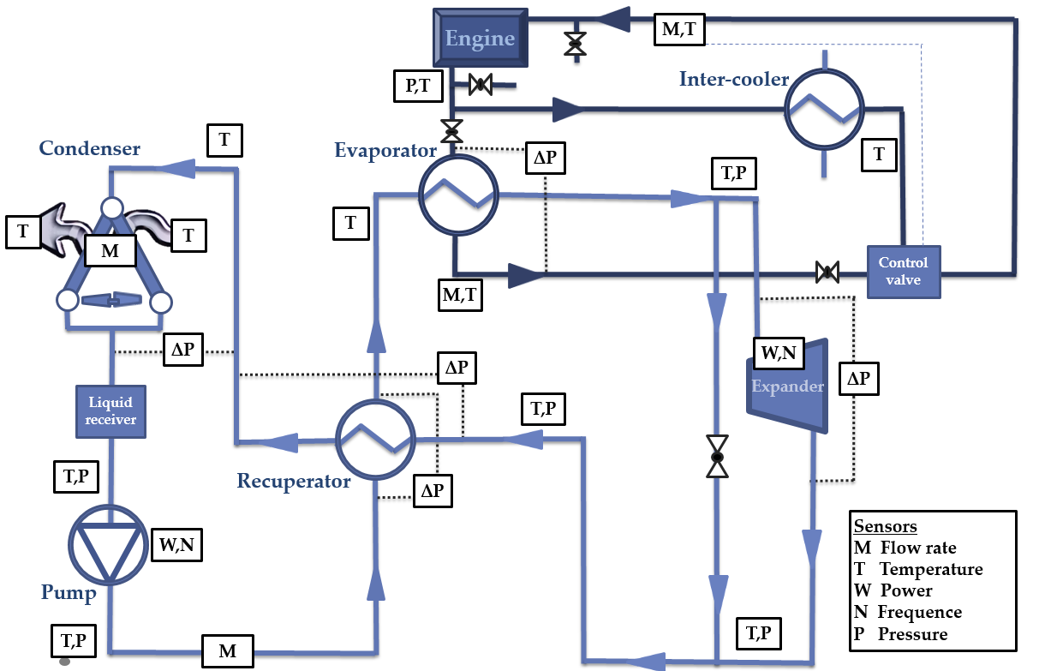
Figure A2: Hydraulic scheme of the test-rig (ORC-CE)

Table A2: Sensors of the test-rig ORC-CE
Sensor | Location | Scale | Accuracy [%FS]
Pressure | Pump in [bar] | [0:7] | 0.5
 | Pump ex [bar] | [1:51] | 0.5
 | Evaporator ex [bar] | [0:50] | 0.5
 | Scroll in [bar] | [0:35] | 0.05
 | Scroll ex [bar] | [1:11] | 0.3
 | Condenser in [bar] | [1:7] | 0.5
 | Differential scroll [bar] | [0:25] | 1
Flow | Refrigerant [kg/s] | [0:0.160] | 0.2
 | Cooling water [kg/s] | [0:3] | 1
Power | Pump [W] | [0:2000] | 0.5
 | Compressor/expander [W] | [0:6000] | 0.5
Speed | Expander [RPM] | [0:8000] | 0.2

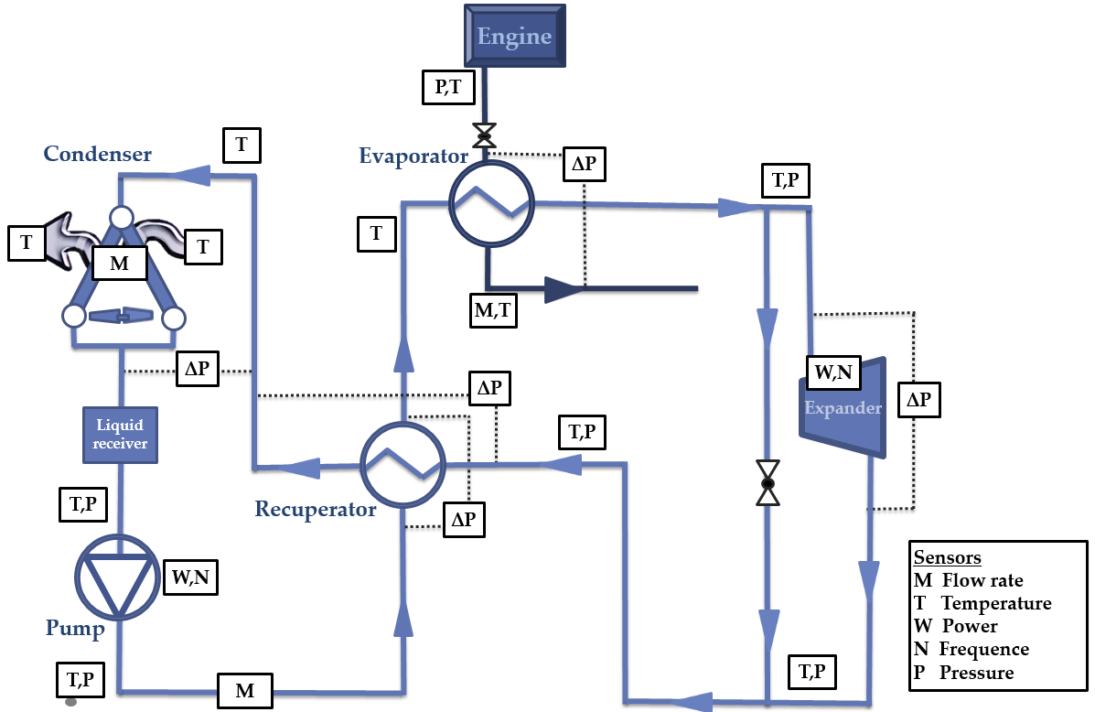
Figure A3: Hydraulic scheme (ORC-EG)
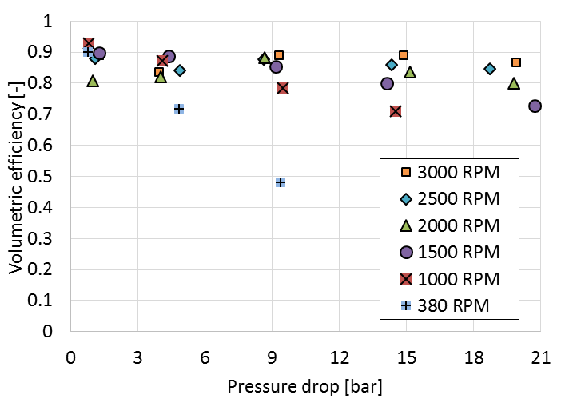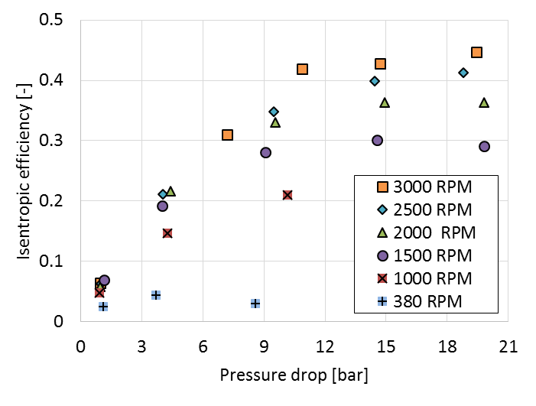
Figure A4: Performance of the gear pump a) volumetric efficiency b) isentropic efficiency

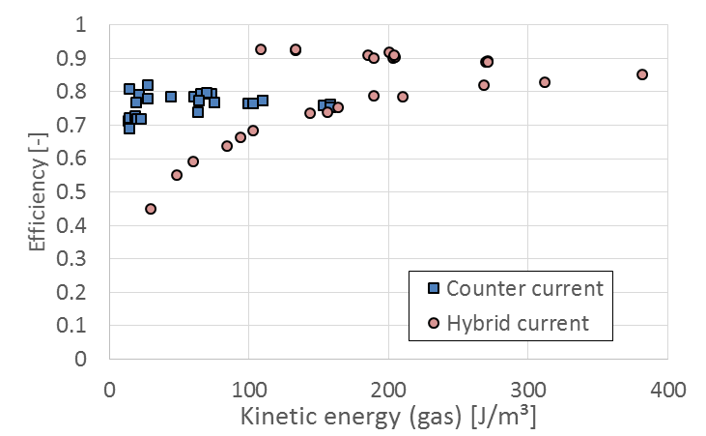
Figure A5: Evaporator efficiency

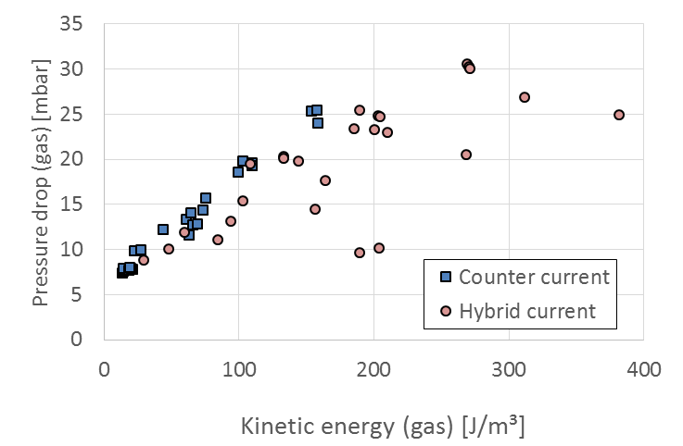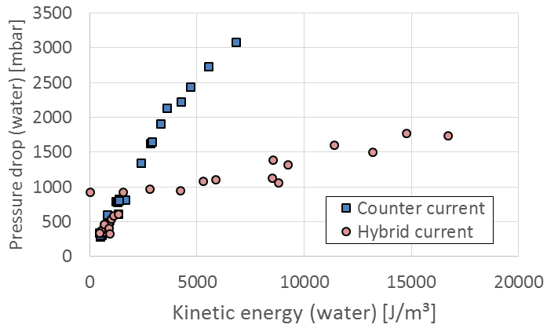
Figure A6: Pressure drop of the evaporator: a) Exhaust gas side b) Water side

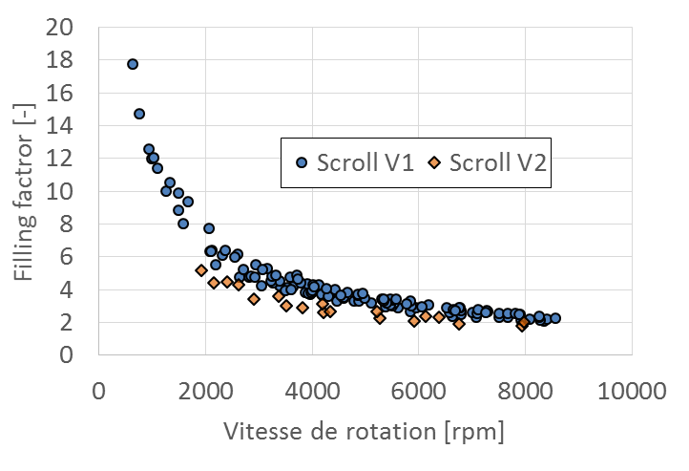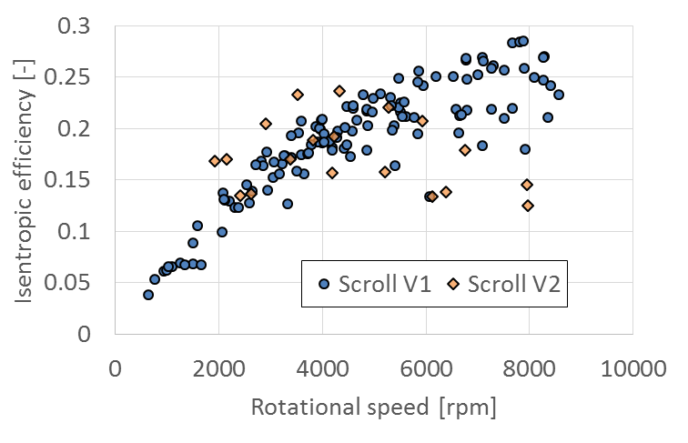
Figure A7: Performance of the scroll expander a) Filling factor and b) isentropic efficiency.
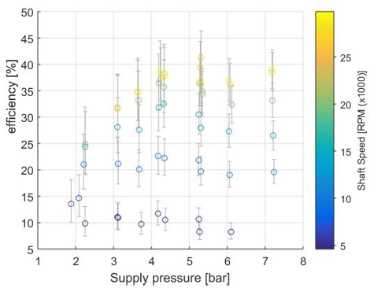
Figure 8A: Evolution of the mechanical isentropic efficiency of the turbine with the supply pressure and shaft speed
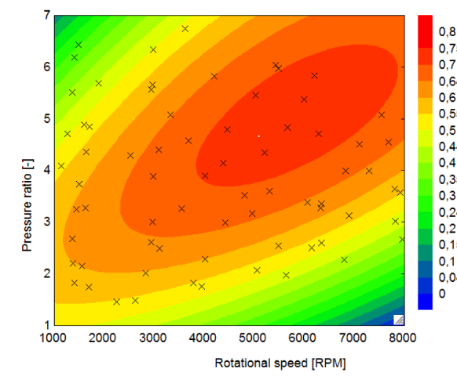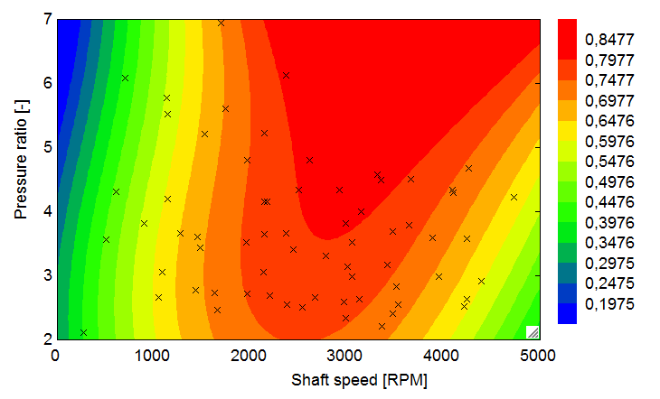
Figure A9 : Isentropic efficiency of the expander (left: scroll 1, right: scroll 2).

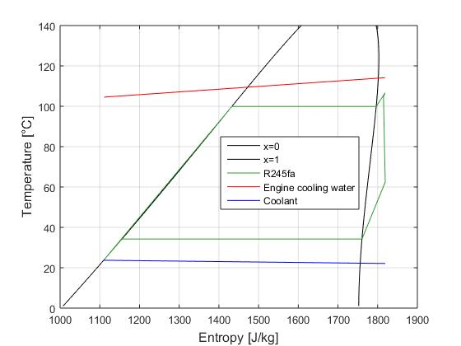
Figure A10: Diagramme T-s

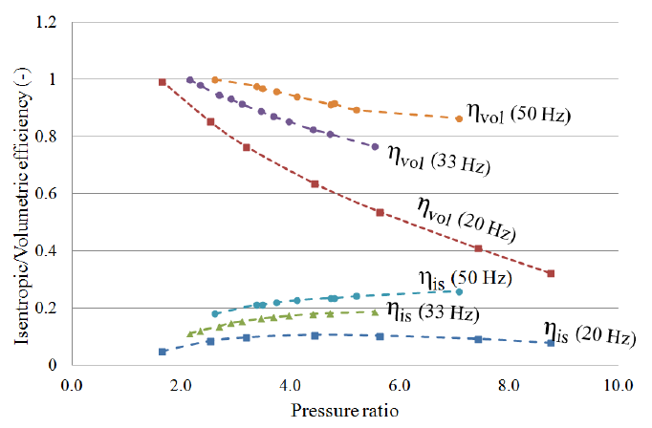
Figure A11: Pump performance (ORC-CE)

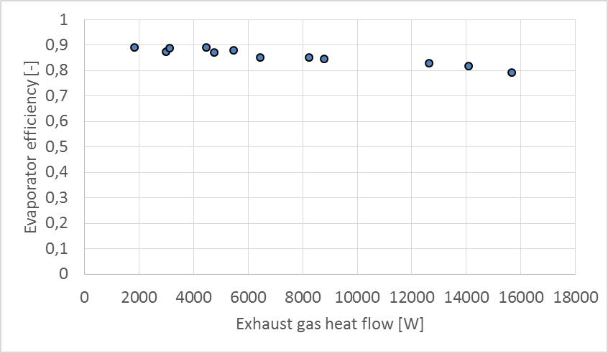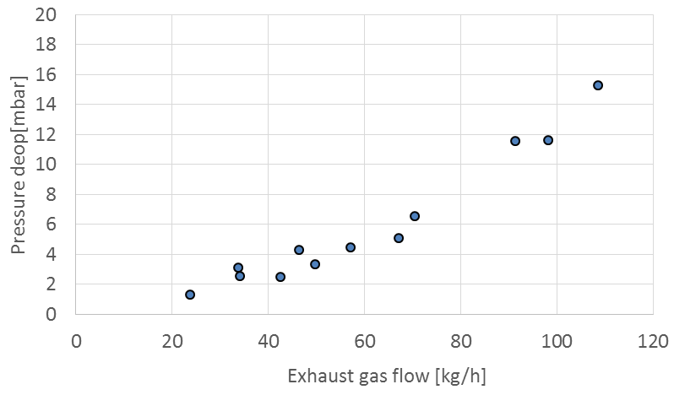
Figure A12: Evaporator performance (ORC-EG).

