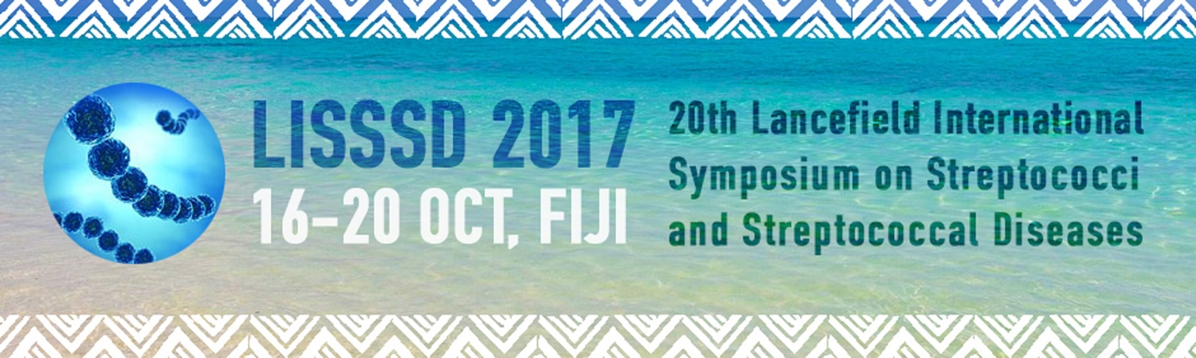

Evaluation of the Xpert®GBS LB test (Cepheid) performed on antenatal screening LIM enrichment broth for detection of Streptococcus agalactiae or group B streptococcus (compared to the reference culture method).
Cecile Meex 1 , Audrey Dupont 1 , Rosalie Sacheli 1 , Julie Descy 1 , pascale huynen 2 , Marie-Pierre Hayette 2 , Pierrette Melin 1
1.National Reference Centre for Streptococcus agalactiae – University Hospital of Liege - CIRM, LIEGE, Belgium
2. Clinical microbiology, University Hospital of Liege, CIRM, LIEGE, Belgium
Background/Aim: Screening-based strategy for prevention of GBS perinatal disease: to evaluate the Xpert®GBS LB test, a rapid real-time PCR, performed on LIM enrichment broth compared with the reference method, that is subculture on selective differential agar performed from the same incubated Lim broth inoculated with a vagino-rectal swab collected at 35-37 weeks’ gestation.
Material/methods: During an 8-months period in 2015-2016, series of consecutive vagino/rectal swabs collected for antenatal GBS screening (at the university hospital of Liege, Belgium) were plated first on Granada agar and then inoculated in selective enrichment LIM broth. The incubated broth was further sub-cultured on Granada and Biorad StrepBselect agars. Moreover, a sterile swab immersed in the same incubated broth was further analyzed by a real-time PCR targeting GBS using the Xpert®GBS LB test on the GeneXpert® system (Cepheid).
Results: Among the 288 antenatal screenings included in the study, 48 (16.7%) were positive for GBS using the culture reference method and 51 Xpert®GBS LB test were positive (17.7%), including the 48 samples positive in culture and 3 additional specimens for witch culture remained negative. Considering the enriched culture as the gold standard, the sensitivity and specificity of the Xpert®GBS LB test were 100% and 98.8% respectively.
Conclusions: The Xpert®GBS LB test performed on incubated LIM broth is at least as efficient as selective enriched culture for antenatal screening of GBS. The turnaround-time and hands-on-time are much shorter for the Xpert® GBS LB but it is more expensive than culture method, which may limit its use.

