|  |  |  |
| --- | --- | --- |
|  |  |  |

**Detection of nitrogen stress on winter wheat by multispectral machine vision**

**Leemans V.**1**, Marlier G.**1**, Gritten F.**1**, Destain M.-F.**1**, Goffart J.-P.**2**, Bodson B.**3**, Mercatoris B.C.N.**1

1 Precision Agriculture Unit, Gembloux Agro-Bio Tech, University of Liege, Belgium

# 2 Walloon Agricultural Research Center, Gembloux, Belgium

3 Crop Science Unit, Gembloux Agro-Bio Tech, University of Liege, Belgium

A paper from the Proceedings of the

13th International Conference on Precision Agriculture

July 31 – August 4, 2016

St. Louis, Missouri, USA

**Abstract.**

*Hand-held sensors (SPAD meter, N-Tester, …) used for detecting the leaves nitrogen concentration (Nc) present several drawbacks. The nitrogen concentration is gained by an indirect way through the chlorophyll concentration and the leaves have to be fixed in a defined position for the measurements. These drawbacks could be overcome by an imaging device that measures the canopy reflectance. Hence, the objective of the paper is to analyse the potential of multispectral imaging for detecting nitrogen concentration.*

*The tests were carried out on parcels submitted to nitrogen inputs varying from 0 to 180 kg N.ha-1. Reference Nc measurements were obtained by the Kjeldahl method and a Hydro N-Tester (Yara). The developed imaging system comprised a CMOS camera and a set of 22 interference filters ranging from 450 to 950 nm mounted on a wheel steered by a stepper motor. The image acquisition and the motor rotation were controlled by a program written in C++. The crop was imaged vertically at one meter height. The raw images presented 1280×1024 pixels covering an area of approximately 0.25 m² and were recorded with a 12-bit luminance resolution. To deal with the natural irradiance variability of the scene, a white reference was used and the integration time was automatically adjusted for each image. The image treatment included the segmentation of Photosynthetically Active Leaves (PAL) by using Bayes theorem and the computation of the mean PAL reflectance after correction of background and illumination fluctuations. Nc was estimated on the basis of the 22 filters by the Partial Least Square (PLS) method and by four filters selected by the Best Subset Selection (BSS) method.*

*In comparison with the Kjeldahl method, the estimation of Nc by means of the Hydro N-Tester, the PLS method and the BSS method (filters 600-80, 950-100, 650-40 and 450-80 nm) gave determination coefficients equal to 0.53, 0.63, and 0.62, respectively. This indicated that the full multi-spectral approach gave significantly better Nc estimation than a portable device and suggested that a camera equipped with four filters would give similar results.*

**Keywords.** Leaves nitrogen content, multispectral imaging, wavelength selection, SPAD meter

|  |
| --- |
| The authors are solely responsible for the content of this paper, which is not a refereed publication.. Citation of this work should state that it is from the Proceedings of the 13th International Conference on Precision Agriculture. EXAMPLE: Lastname, A. B. & Coauthor, C. D. (2016). Title of paper. In Proceedings of the 13th International Conference on Precision Agriculture (unpaginated, online). Monticello, IL: International Society of Precision Agriculture. |

**Introduction**

Application of the right amount of nitrogen (N) is one of the main challenges in agricultural production and related environmental impacts (Dumont et al., 2015). Plant growth is hampered when N lacks, while excess in N fertilizer leads to losses via air, surface water or groundwater pathways.

The determination of optimal fertilizer amount requires the knowledge of the actual N content and of plant biomass. This estimation remains a real challenge. Indeed, analytic laboratory methods for estimating the actual N content are accurate but destructive, time consuming and expensive.

Remote sensing methods are widely described in the literature for detecting nitrogen status in agricultural fields. In particular, hyperspectral imaging appears as a powerful tool for continuous sampling and for selection of narrow wavebands which are sensitive to crop variables, such as nitrogen status (Lebourgeois, 2012). Unfortunately, the transition of research achievements to practical applications remains still limited, namely because of cloud interference (Mulla, 2013).

At a smaller scale, hand-held chlorophyll meters are used. They can be sorted into two groups according to their measurement principle. One group measures the leaf transmittance and the second one evaluates the leaf reflectance (Hlavinka et al., 2013). Devices such as SPAD-502 meter (Konica Minolta Sensing, Osaka, Japan) belong to the first group. The SPAD-502 is an active sensor which measures the difference of absorption of the light emitted by two diodes at 650 and 940 nm through the leave. The first wavelength (red, 650 nm) corresponds to the absorption by chlorophyll ($a_{650}$). The second wavelength (near infrared, 940 nm) is chosen as a reference band where absorption due to other molecules than chlorophyll $(a_{ref})$ occurs while chlorophyll absorbance is insignificant. The output value of the meters $M$ is called the SPAD value and is therefore given by following equation on basis of Lambert-Beer’s law (Udling, 2007):

$M=k\left(a_{650}-a_{ref}\right)= k\log\left(\frac{I_{0(650)}}{I_{(650)}}\right)\left(\frac{I_{(ref)}}{I_{0(ref)}}\right)$ (2)

where $I_{O}$ is the intensity of incident monochromatic light either at 650 nm or at the reference wavelength, $I$ is the intensity of transmitted light either at 650 nm or at the reference wavelength, and $k$ is a proportionality coefficient. *M* is therefore directly related to the amount of chlorophyll present in the sample leaf. Considering that leaf chloroplasts contain 70% of leaf N concentration, $M$ values are often considered as an indicator of leaf N content and are used to detect N stress ([Tremblay et al. 2012](http://onlinelibrary.wiley.com/doi/10.1111/j.1399-3054.2012.01639.x/full#b38)).

In the second group, measurement is based on detection of light in the red and near infrared spectral bands reflected by the measured leaf. An example of chlorophyll meter measuring the leaf reflectance is the GreenSeeker sensor (Trimble Navigation Limited, Sunnyvale, California, USA) which delivers the normalized difference vegetation index (NDVI).

These hand-held devices present several drawbacks. Indeed, they require that the leaves be fixed in a defined position for the measurements. The measurement only concerns a small part of a leaf and therefore a large number of random observations are needed to obtain a representative average value (Jia et al., 2004). Furthermore, the optical readings can be affected by both nitrogen content and water supply of the crop (Gebbers et al., 2013). At high growth stage, NDVI can become saturated in presence of high leaf area index or medium to high biomass conditions ([Cao](http://www.sciencedirect.com/science/article/pii/S037842901300275X) Q., 2013).

Besides these sensors using two spectral bands, the Crop Circle ACS-470 sensor (Holland Scientific Inc., Lincoln, Nebraska, USA) has been developed. It is user configurable with a choice of up to 6 spectral bands, which offers the possibility of computing many spectral vegetation indices. Cao et al. (2013) evaluated the potential of several indices derived from the Crop Circle sensor to estimate rice N status across key growth stages. They found promising indices for evaluating rice above biomass but obtained less satisfactory results in estimating rice plant N concentration ( $R^{2}$ = 0.33).

Besides these specific devices, the use of RGB cameras measuring the intensity of light reflected by the canopy has been reported with the aim to acquire timely and inexpensive information for crop management. Conventional cameras offer the possibility to measure the canopy cover and compute indices and to correlate them with parameters of growth and N nutrition like LAI, shoot dry weight, and shoot N accumulation (Li et al., 2010; Lee and Lee, 2013; Wang et al., 2014). A custom-developed 3-CCD camera with three video channels of green (550 nm), red (650 nm) and near-infrared (800 nm) with a bandwidth of approximately 800 nm for each channel has been developed by Kim and Reid (2006) and was used for in-field plant sensing (Kim et al., 2013).

Overall, optical systems have a great potential in the development of in-field plant sensing systems for real-time nitrogen detection because they are non-destructive and rapid. Nevertheless, several challenges have to be overcome. Besides the nutrition deficiency, the spectral response may be affected by several factors, including the water lack or excess, the growth stage, the senescence, the substrate nature. Last but not least, significant variety x treatment interaction may exist. In this context, multispectral devices have to be preferred to devices operating in two wavelengths since they have the potential to provide multiple signals that can be decorrelated by using appropriate statistical treatments. Furthermore, imaging systems offer the possibility of visualize large scenes of the canopy and evaluate LAI, Photosynthetically Active Leaves, ears, indices, etc.

The aim of this paper is therefore to set up features selection for evaluating N content on the canopy. Multispectral imaging is used for selecting a combination of several significant spectral bands.

**Material and methods**

**Experimental field**

Field experiment were conducted at the University of Liège, Gembloux Agro-Bio Tech (Bordia field, 50.56°N and 4.69°W) (Belgium) during the 2013-2014 growing season. The local climate is temperate with yearly average temperature of 10.5 °C and mean rainfall of 852 mm.

The experiment aimed to study the growth of a wheat cultivar (*Triticum aestivum* L., cv. Edgar) and was arranged in a split-splot design. Two plots were considered on Stagnic Albeluvisol and a Luvisol, respectively. Four subplots were randomly assigned to different N fertilisation strategies, with different rates and timing. These strategies were designed around the Belgian farmers' current practice, which consists of applying 60 kg N ha-1 respectively at tillering, redress and last-leaf stages (Table 1). Ten replications were considered, half were used for final yield determination and the other half for plant dry weight calculation.

Winter wheat was sown on the 24th of October 2013 at a grain density of 350 grains/m² with a row spacing of 14 cm and a planting depth of 2.5 cm. Fababean (*Vicia faba L.*) cover crops were grown before wheat planting. Soil samples showed that there was around 60 kg NO3-N.ha-1 at 0.90m depth at the end of winter (14/03/2014). Following cultural operations were conducted: weeding (Capri duo 265 g.ha-1 + oil 1 L.ha-1) occurred on the 17th of March; plant growth regulator (Chlormequat chloride (CCC), Cyclocel 75 at the rate of 1L.ha-1) was applied on the 10th of April; fungicide was brought on the 5th of May (Osiris 2l.ha-1) and on the 6th of June (Aviator Xpro 1.25 L.ha-1).

The soil moisture was measured continuously during the growing season. There was no hydric stress since pF was comprised between 3.7 and 4.2 in the topsoil (0 – 0.12m) and between 3.1 and 3.4 in the subsoil (0.25-0.30 m).

**Table 1. Field trials**

|  |  |  |  |  |  |
| --- | --- | --- | --- | --- | --- |
| **Growth stage** | **Date** | **Fertilisation level (kg N ha-1)** | | | |
| **Modality 1** | **Modality 2** | **Modality 3** | **Modality 4** |
| Tiller | 12/03/2014 | 0 | 60 | 50 | 30 |
| Stem extension | 07/04/2014 | 0 | 60 | 40 | 30 |
| Flag leaf | 27/05/2014 | 0 | 60 | 65 | 90 |
| **Total fertilization level (kg N ha-1)** | | **0** | **180** | **155** | **150** |

**N leaves concentration**

Wheat plants were destructively sampled on six dates in the growing season: 30 May, 06 June, 13 June, 24 June, 07 July in 2014. Plants within two 0.5 m lengths of row per plot were cut and placed in coolers. From each sample, all green leaves were separated from the stems and oven-dried at 70°C to obtain the dry weight. The dried leaf samples were ground to pass 1-mm screen and stored in plastic bags for chemical analysis. Total N concentration in leaf tissues $N_{c}$ was determined by the Kjeldjahl method in the Laboratory of CRA-W (Gembloux, Belgium) and expressed on the basis of unit dry weight (mg N g−1DW).

**SPAD measurements**

During the 2013-2014 growing season, SPAD transmittance readings were performed with a chlorophyll meter (Hydro N-Tester, Yara International ASA, Norway) comprising two light emitting diodes at 650 nm (chlorophyll absorption) and 960 nm (reference wavelength). As leaf age is an important factor that needs to be considered when collecting SPAD measurements, the 15 last fully developed leaves at the last third of the leaves were collected (Wang G., 2014). A total of 15 plants were measured in each plot and the mean values of the 15 plants were used for analysis. $M$ readings on different leaves were taken on 23 May, 30 May, 06 June, 13 June, 24 June, and 07 July 2014.

**Multispectral measurements**

*Acquisition system*

A multispectral vision system was designed to acquire top-down images of the scene (covered area of approximately 0.25 m²) in the visible and the near infrared spectra (Fig. 1). The acquisition system included a monochrome 12 bits (4096 gray levels) 1.3 megapixels camera (BCI-5, C-Cam Technologies, Belgium) with a filter wheel equipped with 22 band pass interference filters (Table 1). The filters were selected to cover the sensitivity range of the camera sensor and had a central wavelength (LW) ranging from 450 nm (blue) to 950 nm (NIR). They were relatively wide (40-100 nm FWHM). The rotation of the filter wheel was controlled by a stepper motor.

In-field spectral measurements made under natural ambient illumination were significantly influenced by solar radiation changes from cloudy to sunny situations, which affects spectral responses at all stages of plant growth. To solve that problem, a white reference plate was used and the integration time was automatically adjusted in order to acquire images through each filter with the white reference radiance at about 3800 grey levels and a precision of ± 5%.

The image acquisition and the motor rotation were controlled by a program written in C++. As some plant physiological system and physical processes such as nitrogen uptake efficiency are varying on a circadian rhythm (Xuet al., 2012), measurement campaigns were always made at the same time of the day (from 1:30 to 3:30 pm).

**Table 2. Interference filters**

|  |  |  |  |
| --- | --- | --- | --- |
|  | **ID** | **Central lengthwave (nm) $LW$** | **FWHM (nm)** |
| Blue | S | 450 | 50 |
| Blue | U | 450 | 80 |
| Green | V | 500 | 40 |
| Green | O | 500 | 80 |
| Green | T | 550 | 50 |
| Green | K | 550 | 80 |
| Red | R | 600 | 50 |
| Red | C | 600 | 80 |
| Red | F | 650 | 40 |
| Red | J | 650 | 80 |
| Red edge | Q | 700 | 50 |
| Red edge | L | 700 | 80 |
| Red edge | E | 750 | 40 |
| Red edge | L | 750 | 80 |
| NIR | W | 800 | 50 |
| NIR | N | 800 | 100 |
| NIR | H | 850 | 40 |
| NIR | G | 850 | 100 |
| NIR | I | 900 | 40 |
| NIR | M | 900 | 100 |
| NIR | D | 950 | 40 |
| NIR | P | 950 | 100 |

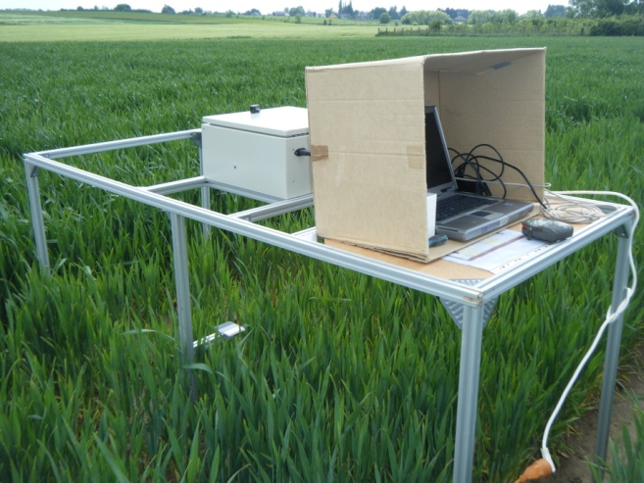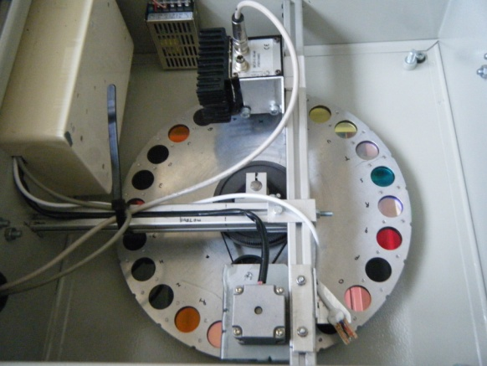

**Fig 1. Multispectral vision system (left), table structure with computer, camera and wheel filter (right).**

*Image treatment*

Image processing was divided into three main algorithms (Fig. 2) which were assemblied to calculate the leaves mean reflectance in an image.

The first algorithm (Fig. 2, right) aims to compute the mean white reference. This includes (i) the application of a mask on the image to select the white reference; (ii) the search of the maximum pixel radiance $R_{max}$; (iii) the application of a threshold value (0.87 of $R_{max}$ was chosen for obtaining acceptable results in both visible and NIR images); (iv) the calculation of the mean white radiance value.

1. The second algorithm (Fig. 2, left) aims to discriminate the Photosynthetically Active Leaves[1] (PAL) from the rest of the image by using the Bayes’ theorem. This theorem aims to calculate for each pixel the probability to be assigned in different classes. The number of classes was set at two (PAL and not PAL) before the 6 June campaign. After, the class number was increasing to six (ground, white reference, grey and black reference, ears, PAL, non PAL) because of the necessity to discriminate ears from PAL.
2. The third algorithm (Fig. 2, center) comprised several steps (i) image background correction; (ii) image normalization by mean white reference radiance; (iii) mask application to only select PAL; (iv) calculation of mean reflectance of Photosynthetically Active Leaves at each filter wavelength $R_{}$

These algorithms were writen in Matlab® R2008b (The Mathworks, USA).

**Data analysis**

In a first stage, leaf concentration $N_{c}$ was assessed with an analysis of variance (ANOVA) considering two fixed factors (soil and fertilizer level). In a second stage, the relationship between $N_{c}$ and $M$ SPAD values was analysed. In a third stage, data analysis aimed at analyzing $N_{c}$ on basis of multispectral vision. Partial least squares regression (PLS regression) was applied to analyze the relationship between leaves mean reflectance $R_{}$ from the 22 filters and $N_{c}$. This method permits to reduce the large number of measured spectral variables to a few non-correlated principal components (PCs) which represent the relevant information to predict the dependent variable N. In the second step, the smallest subset to minimize the Mallows’ Cp was selected by the best subset selection (BSS) method. PLS and BSS algorithms of Minitab 17 (Minitab, Inc., US) were used. Validation of the models was performed by comparing differences in the determination coefficient $R^{2}$ and root mean square error (RMSE). This latter was computed as:

$$RMSE= \frac{\sum_{i=1}^{n}{{\left({\hat{y}}_{i}-y_{i}\right)}^{2}}}{n}$$

where ${\hat{y}}_{i}$ and $y_{i}$ were the predicted and measured crop variables, and $n$ the number of samples.

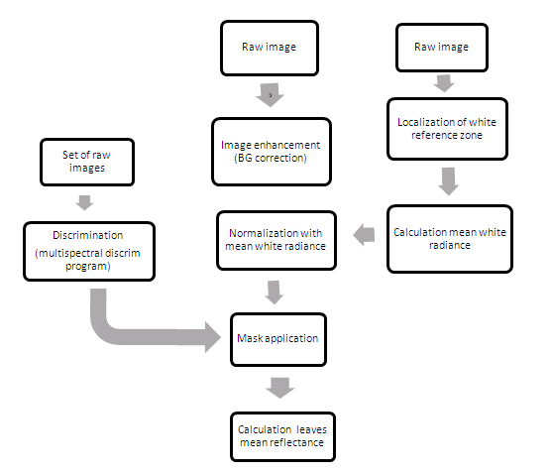

**Fig 2. Flow chart of the embedded image processing: (right) localization and calculation of white mean radiance; (left) discrimination of leaves; (centre) algorithm of leaves mean reflectance calculation.**

An example of the leaves discrimination is given in Fig. 3, the original image is displayed in RGB (Fig. 3, left).

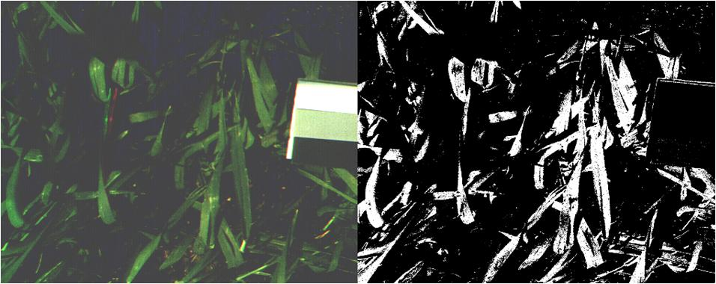

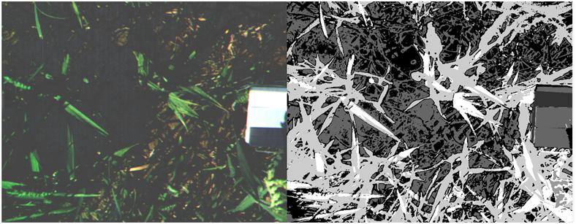

**Fig. 3. Above: Discrimination with two classes (image from 23th of May campaign). Below: Discrimination with 5 classes (image from the 13th of June campaign)**

**Results**

**Nitrogen leaves concentration**

Fig. 4 presents the changes in wheat leaf N concentration through the growing season. The mean $N_{c}$ was 32.80 mg N g−1DW, the standard deviation was 4.24 mg N g−1DW, and the minimum and maximum were equal to 20.10 and 39.17 mg N g−1DW, respectively. The range was thus 19.07 mg N g−1DW.

As the differences between the plots on Stagnic Albeluvisol and Luvisol were considered not significant, the mean values were plotted. The overall patterns were similar for modalities 2 (60-60-60 kg N ha-1), 3 (50-40-65 kg N ha-1), and 4 (30-30-90 kg N ha-1). Leaf reached a maximum (39 % of dry matter) which reflected the rapid exploration of the soil by the roots and high N uptake rates relative to shoot growth. Following the maximum, there was decrease in leaf $N_{c}$ through the rest of the growing season. With no fertilizer (modality 1), $N_{c}$ was significantly lower.

**Relationship between nitrogen leaves concentration and $M$ SPAD value**

The linear relationship between $N_{c}$ and $M$ SPAD values is shown in Fig. 5. There were significant differences in the $Nc$– $M$ relationship during the growing season according to the growth stage (R2 = 0.53). Similar determination coefficients were obtained by others authors (Rorie et al., 2011; Wang et al., 2014). By using the linear model, the RMSE was equal to 2.9 mg N g−1DW. As suggested by Wang et al. (2014), the measurement technique of $M$ could be improved by computing indices such as the normalized difference SPAD.



Fig 4. Leaf concentration during 2013-2014 growing season for four modalities (Table 1).



Fig. 5. M value vs N Concentration.

**Partial least squares regression**

The partial least square (PLS) regression aimed to reduce the 22 filter responses $R_{}$ to a smaller set of uncorrelated components. The scatterplot of the determination coefficient $R^{2}$ and predicted $R^{2}$ as a function of the number of components shows that the optimal model comprised five components (Fig. 6 left). The projected scatterplot of the standardized regression coefficients indicated the importance of each filter in the model (Fig. 6 right). C filter (600 nm, FWHM 80 mm) took the greater importance. With five components, $R^{2}$ = 0.68, predicted $R^{2}$ = 0.63, and RMSE = 2.1 mg N g−1DW.

Three over the five components could be distinguished by a significant increase of $R^{2}$. The following interpretation was then focused on these three first components (Fig. 7). The first component allowed the separation of NIR (inside the red circle) and visible filters, except for the L filter (Fig. 7 left). Both NIR and visible wavelengths were thus important in the prediction of leaf $N_{c}.$ Positive and negative correlations were obtained between $R_{}$ and $N_{c}$ respectively with the NIR filters and the visible filters. Considering the third component (Fig. 7 right), it can be seen that a negative correlation was obtained with only two filters (F and C).

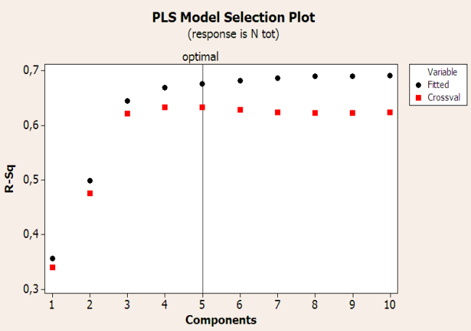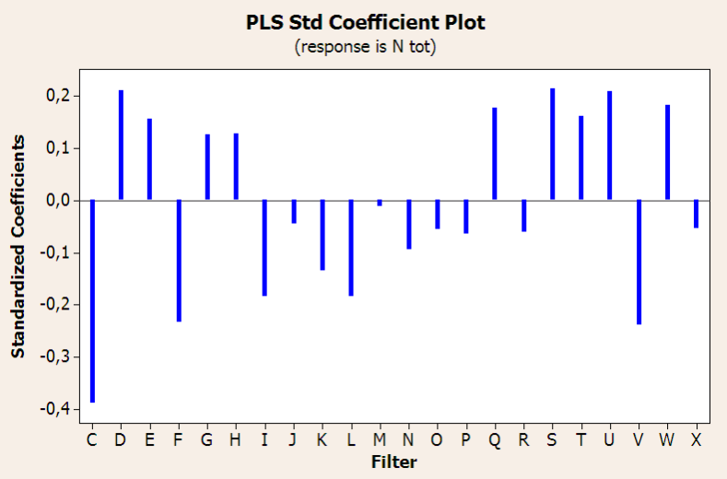

**Fig. 6. Left. Scatterplot of the $r^{2}$ and RMSE as a function of the number of components. The vertical line indicates the number of components in the optimal model. Right: Projected scatterplot of the standardized regression coefficients.**

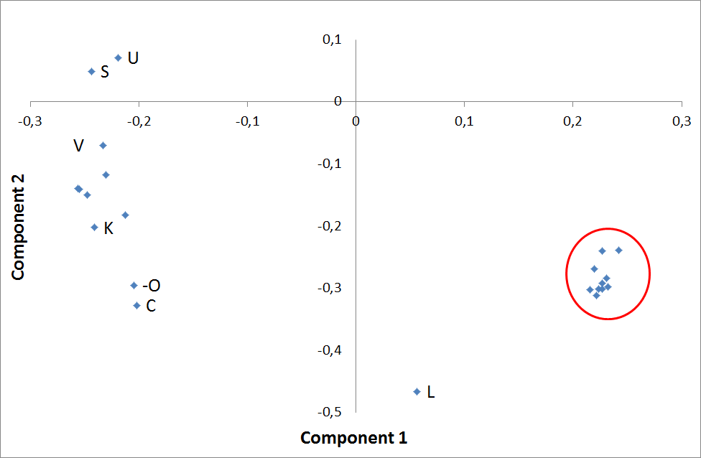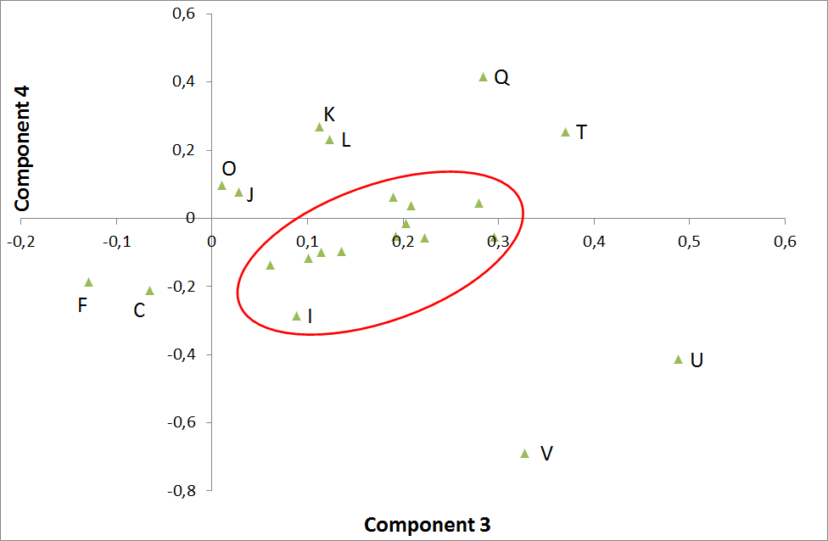

**Fig. 7. PLS loading plot.**

**Best subset regression**

Using best subset regression with acceptable Mallow’s Cp, four filters were selected: C(600, 80 mm), D(950, 100 nm), F(650, 40 nm), U(450, 80 nm), two of them presenting an overlap (C and F). These four filters presented high standardized regression coefficients in the PLS (Fig. 6 right). The model based on this reduced set of variables presented determination coefficient $R^{2}$ and predicted $R^{2}$ respectively equal to 0.64 and 0.62, and the RMSE was 2.5 mg N g−1DW.

**Discussion and conclusion**

In this study two fundamentally different methods are used for evaluating $N_{c}$. The method based on the $M$ SPAD measures individual leaves transmittance of light emitted at 650 and 960 nm, while the multispectral approach evaluates the canopy reflectance under whole solar radiation. The results are summarized in Table 3. The best results are obtained with the full-multispectral approach ( $R^{2}$ = 0.63) but a multispectral approach using four selected filters could be efficient for evaluating $N_{c}$ ( $R^{2}$ = 0.62). These results are encouraging in comparison with those obtained with a Crop Circle ACS-470, for rice plant N concentration ( $R^{2}$ = 0.33) (Cao et al. 2013).

**Table 3. Results synthesis**

|  |  |  |  |  |
| --- | --- | --- | --- | --- |
| **Device** | **Method** | **Number of selected filters** | $$R^{2}$$ | **RMSE**  **mg N g−1DW** |
| Hydro N-Tester | $M$ SPAD | - | 0.53 | 2.9 |
| Filter wheel | PLS | 22 | 0.63 | 2.1 |
| Filter wheel | Best subset | 4 | 0.62 | 2.5 |

Two of the four selected filters had central wavelength $LW$ in the red spectral region (C, F). The wavelength band 600 – 650 nm corresponding to the radiation absorption by plant chlorophyll, the link between this pigment and the N concentration is confirmed. Another filter (D) had $LW$ in the NIR where absorbance of leaves is small or absent. The last filter had $LW$ in the blue (U) which probably corresponds to radiation absorption of both chlorophyll and carotenoids. No filter in the red-edge was selected, contrary to other studies (Shiratsuchi et al., 2011), probably due to the absence of water stress.

A substantial literature exists on the characteristics of SPAD meters and the sources of uncertainties associated to $M$ value. The measurements are affected by the plant characteristics (leaf thickness, dry leaf mass per area, the leaf water content, …) and by environmental conditions (diurnal changes). The sources of uncertainties in the multispectral vision system are also numerous and are mainly related to the image treatment of the canopy which reveals complex. In further studies, the multispectral approach could be extended by considering wider ranges of N leaves concentration, different water content, several cultivars, …

**References**

[Cao](http://www.sciencedirect.com/science/article/pii/S037842901300275X) Q., [Miao](http://www.sciencedirect.com/science/article/pii/S037842901300275X) Y., [Wang](http://www.sciencedirect.com/science/article/pii/S037842901300275X) H., [Huang](http://www.sciencedirect.com/science/article/pii/S037842901300275X) S., [Cheng](http://www.sciencedirect.com/science/article/pii/S037842901300275X) S.,  [Khosla](http://www.sciencedirect.com/science/article/pii/S037842901300275X) R., [Jiang](http://www.sciencedirect.com/science/article/pii/S037842901300275X) R. (2013). Non-destructive estimation of rice plant nitrogen status with Crop Circle multispectral active canopy sensor. Field Crops Research 154, 133-144.

Dumont B., Basso B., Leemans V., Bodson B., Destain J.-P., Destain M.-F. (2015). Systematic analysis of site-specific yield distributions resulting from nitrogen management and climatic variability interactions. Precision Agriculture 16(4), 361-384.

Gebbers R., Tavakoli, H., Herbst, R. (2013).Crop sensor readings in winter wheat as affected by nitrogen and water supply. Precision Agriculture 2013 - Paper Presented at the 9th European Conference on Precision Agriculture, ECPA 2013, 2013, 79-86.

Hlavinka J., Nauš J., Špundová M. (2013). Anthocyanin contribution to chlorophyll meter readings and its correction. [Photosynthesis Research](http://link.springer.com/journal/11120) 118(3), 277-295.

Jia L., Chen X., Zhang F., Buerkert A., Römheld V. (2004). Use of Digital Camera to Assess Nitrogen Status of Winter Wheat in the Northern China Plain. Journal of Plant Nutrition 27 (3), 441–450.

Kim Y., Reid J.-F., Zhang Q. (2008).Fuzzy logic control of a multispectral imaging sensor for in-field plant sensing. Computers and Electronics in Agriculture 60(2), 279-288.

Kim Y., Reid J.F. (2006). Modeling and calibration of a multi-spectral imaging sensor for in-field crop nitrogen assessment. Appl. Eng. Agric., 22 (6) (2006), 935–941.

# Lebourgeois V., Bégué A., Labbé S., Houlès M., Martiné J. (2012). A light-weight multi-spectral aerial imaging system for nitrogen crop monitoring. J. Precision Agriculture, 13(5), 525-541.

### Lee K.-J., Lee B.-W. (2013). [Estimation of rice growth and nitrogen nutrition status using color digital camera image analysis](http://primo.lib.ulg.ac.be/primo_library/libweb/action/display.do?frbrVersion=2&tabs=detailsTab&ct=display&fn=search&doc=TN_scopus2-s2.0-84875602493&indx=18&recIds=TN_scopus2-s2.0-84875602493&recIdxs=17&elementId=17&renderMode=poppedOut&displayMode=full&frbrVersion=2&vid=32ULG_VU1&mode=Basic&frbg=&srt=rank&tab=default_tab&dscnt=0&vl%28freeText0%29=camera%20nitrogen&vl%28362751202UI1%29=all_items&dum=true&dstmp=1461597393613). European Journal of Agronomy 48, 57-65.

### Li Y., Chen D., Walker C.N., Angus J.F.(2010).Estimating the nitrogen status of crops using a digital camera**.** Field Crops Research 118(3), 221-227.

Mulla D.J. (2013). Twenty five years of remote sensing in precision agriculture: Key advances and remaining knowledge gaps. Biosystems Engineering, 114, 358-371.

Ollinger S.V. (2011). Sources of variability in canopy reflectance and the convergent properties of plants. The New phytologist 189(2), 375-94.

Rorie L.R.,Purcell L.C.,Mozaffari M.,Karcher D.E.,King C.A.,Marsh M.C. and Longer D.E. (2011). Association of "Greenness" in corn with yield and leaf nitrogen concentration. Agronomy Journal, 103, 529-535.

Shiratsuchi L., Ferguson R., Shanahan J., Adamchuk V., Rundquist D., Marx, D.,Slater, G. (2011). Water and nitrogen effects on active canopy sensor vegetationindices. Agron. J. 103, 1815–1826.

### Tremblay N., Wang Z., Ma B., Belec C., Vigneault P. (2009). A comparison of crop data measured by two commercial sensors for variable-rate nitrogen application. Precision Agriculture 10(2), 145-161.

### Uddling J., Gelang-Alfredsson J., Piikki K., Pleijel H. 2007. Evaluating the relationship between leaf chlorophyll concentration and SPAD-502 chlorophyll meter readings. Photosynth Res 91, 37-46.

### Wang Y., Wang D., Shi P., Omasa K. (2014). [Estimating rice chlorophyll content and leaf nitrogen concentration with a digital still color camera under natural light](http://primo.lib.ulg.ac.be/primo_library/libweb/action/display.do?frbrVersion=4&tabs=detailsTab&ct=display&fn=search&doc=TN_faoagrisUS201500166432&indx=15&recIds=TN_faoagrisUS201500166432&recIdxs=14&elementId=14&renderMode=poppedOut&displayMode=full&frbrVersion=4&vid=32ULG_VU1&mode=Basic&frbg=&srt=rank&tab=default_tab&dscnt=0&vl%28freeText0%29=camera%20nitrogen&vl%28362751202UI1%29=all_items&dum=true&dstmp=1461597393613). Plant methods, 10(1), p.304.

Wang G., Bronson K., Thorp K., Mon J., Badaruddin M. (2014). Multiple Leaf Measurements Improve Effectiveness of Chlorophyll Meter for Durum Wheat Nitrogen Management. Crop science 54, 818-826.

### Xu G.,Fan X. and Miller A.J., 2012. Plant nitrogen assimilation and use efficiency. Annual Review of Plant Biology, **63,** 153-182.

1. In this experiment PAL included sunlit two last fully developed leaves