Application of NIR hyperspectral imaging combined to chemometrics to assess the impact of tillage on the root system development of a winter wheat crop.

G. Fraipont¹, D. Eylenbosch¹, J.A. Fernández Pierna², V. Baeten², B. Dumont¹, B. Bodson¹

¹Crop Science Unit, Gembloux Agro-Bio Tech, University of Liège, Passage des Déportés, 2, 5030, Gembloux, Belgium, Guillaume.Fraipont@ulg.ac.be
²Valorisation of Agricultural Products Department - Walloon Agricultural Research Centre (CRA-W),Henseval building, Chaussée de Namur,24, 5030, Gembloux, Belgium

Keywords: NIR Hyperspectral Imaging - Chemometrics - Support Vector Machines - Root quantification - Soil

Nowadays, a better comprehension of the root system of crops is seen as a major possible way to sustainably improve yields [1]. So far, only a few techniques allow a precise quantification of the root system of field-cultivated plants. Within this context, this research applies an innovative procedure of root system quantification of a crop throughout the crop season consisting in the combination of near infrared hyperspectral imaging (NIR-HSI) and chemometric tools [2]. Its major advantage lies in its ability to rapidly perform measurements, allowing higher spatial and temporal resolution.

A total of 384 soil samples were collected by soil coring at 4 different dates during the 2011-2012 crop season in the 0-30 cm soil layer. Two tillage systems were studied : conventional tillage (CT) and reduced tillage (RT). The roots were extracted from cores by washing on sieves. The dried samples were scanned by a NIR hyperspectral line scan instrument working in the 1100-2498 nm spectral range and combined with a conveyor belt. Each obtained image was analyzed by a classification tree based on successive Support Vector Machines (SVM) models to separate the spectra into 4 spectral classes: background, soil, crop residues and roots. Finally, a regression line allowed to convert a number of pixels to grams of roots [2].
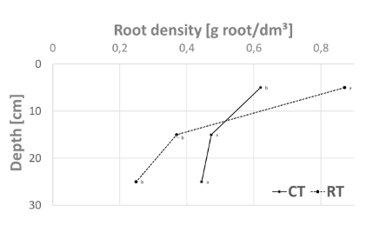
Figure 1. Root system development of winter wheat at the second node stage under CT and RT. Within each layer, letters indicate the statistical difference between treatments.
In the 30 first centimeters of soil, no growth of the root system was observed between stages BBCH 13 (3 leaves) and BBCH 29 (end of tillering). Then, an important growth was measured until stage BBCH 32 (second node) followed later in the season by a decrease up to stage BBCH 89 (crop senescence). Moreover, a significant influence of tillage on the development of the root system was highlighted (figure 1). The conventional tillage allowed a more homogeneous development of the root system in the soil profile compared to reduced tillage for which a concentration of the root system in the 10 first centimeters of soil was noticed. This observation could be explained by differences in soil humidity and density in the two tillage systems.

In conclusion, this study highlights the high potential of the root biomass quantification method based on NIR-HSI technology for agronomical applications related to soils.

Acknowledgement: Fraipont G. (FRIA Research Fellow) is financially supported by the Belgian National Fund for Scientific Research (F.R.S.-FNRS).

References:
[1] Gregory, P. J., Atkinson, C. J., Bengough, A. G., Else, M. A., Fernández - Fernández, F., Harrison, R. J., & Schmidt, S. Contributions of roots and rootstocks to sustainable, intensified crop production. Journal of Experimental Botany, 64(5), 1209–1222 (2013).
[2] Eylenbosch, D., Fernández Pierna J.A., Baeten, V., & Bodson, B. Use of NIR-HSI and dichotomist classification tree based on SVMDA models in order to discriminate roots and crop residues of winter wheat. In: Proceedings of the 9th EARSeL SIG Imaging Spectroscopy workshop, Luxembourg, 237-238 (2015).

