EXPERIMENTAL VALIDATION OF HEAT TRANSPORT MODELLING IN DISTRICT HEATING NETWORKS.
Kevin Sartorª and Pierre Dewallefª
ª Aerospace and Mechanical Engineering Department - Laboratory of Thermodynamic and Energetic, University of Liège, Allée de la découverte 17, 4000 Liège, Belgium. Kevin.sartor@ulg.ac.be
Abstract:
District heating networks (DHN) are generally considered as a convenient, economic and environmental-friendly way to supply heat to a large amount of buildings. Some modelling technics are required to consider the dynamic behaviour of district heating network to design them correctly, spare investment costs and limit the heat losses related to the use of a too high operating temperature. For the same reasons, the DHN control or retrofit of installations also requires the assessment of the DHN dynamic behaviour.
To achieve this, the heat transport in DHN, which is one of the key issues in the behaviour of a whole centralized heating system, has to be correctly modelled. Previous work evidenced current limitations of one dimensional finite volume method to model heat transport in pipes and proposed an alternative method considering the thermal losses and the inertia of the pipes.
The present contribution intends to experimentally validate this model on a test rig facility available in the Thermodynamics laboratory of the University of Liège (ULg, Belgium) and on an existing district heating network. For both experimental facilities, the current model shows good agreement between experimental data and simulation results for a large range of water velocities. Moreover, it is shown that the thermal inertia of the pipe has a significant influence on the outlet pipe temperature profile.
Keywords:
District Heating Network, DHN, pipe, dynamic simulation, heat transport, experimental validation.

Introduction
District heating networks (DHN) appeared in Europe since the 14th century (in France) [1] and they have been developed since 1950 [2]. Nowadays, they are generally considered as a convenient way to supply heat to a large number of buildings with a central heating plant generating high conversion efficiency and fuel flexibility [3]. Moreover the DHN allows a variety of energy sources to feed them especially the renewable ones such as biomass or industrial waste heat. The size of DHN varies widely: from several dozens of meters (for industry or small communities) to several kilometres (such as Moscow city network [4]).The control of large DHN is a key challenge to reduce heat losses and to minimize the heat cost while ensuring the user comfort in buildings. To achieve this, an open-loop control is often implemented [5] because of the simplicity of use and the limited investments related to this method. The control of the studied application detailed herein basically consists of holding a water temperature set point supplying to the network inlet to ensure thermal comfort in buildings. This supply temperature is a function of the hour of the day and the ambient temperature. However they are not adapted for widespread networks or DHN fed by multiple heat plants. Indeed this control often leads to observe large variation of the fluid return temperature to the heat plant. If the heat supplied to the network is more important compared to the heat demand of the buildings, the return temperature increases. This leads to higher heat losses of the pipes while the pipe temperature is more important than the required one. On the other hand, it often involves an oversizing of the installations (pumps, heat plants,…) leading to a higher investment costs because of the unwanted variations of temperature and flow rates. Finally, thermal discomfort can also appear in some buildings, even if the rated power plant is oversized: typically the fluid velocity is about one meter per second and the heat transport delay can reach hours to feed correctly the furthest buildings connected to pipes of several kilometres.
One solution is to instrument the network at numerous key locations to measure the temperatures, and the mass flow rates. Doing so, a closed-loop control and some dedicated control techniques of thermal systems [6,7] can be used. However this method is often expensive because of the numerous expensive sensors which have to be used; especially if a retrofit of the system is performed since these sensors are generally intrusive. Therefore it is proposed to model the dynamic behaviour of the system to avoid the costs of the sensors.
In previous work [8], the heat waves in the network were dynamically modelled to determine at each key location the flow rates and the temperatures of the transport fluid. As others studies related to heat transport in DHN [9,10], the ambient losses are considered but the thermal inertia of the pipes influence is also investigated. In must also be noted that only water was considered as working fluid.
In this paper, the model developed in [8] is validated on a test bench available at the Thermodynamics laboratory of University of Liège (ULg) and on a pipeline of an existing district heating network.
The developed model allows in a further study to be extend to the whole ULg network and coupled to predictive heat demand methods to implement a control at a lower cost. In this paper, large networks for which the time delays are quite long, typically hours, are focused but the conclusions can be extended to small ones as well.

Problem statement
In large networks, the length of pipes can reach several kilometres. When heat is injected at one end of the pipe, the heat propagation to buildings located further in the network depends on the fluid velocity, and it can take a significant amount of time. The order of magnitude of the fluid velocity is generally the meter per second, to limit pressure losses and the related pump consumption. Therefore the delay to transport heat can reach minutes or hours. As for example, the hospital connected to the DHN of the University of Liège is at a distance of about 3 kilometres from the heating plant and the fluid velocity is generally between 0.5 to 1 m/s leading to a heat transport delay from one to two hours.
Previous work performed by the authors [8] shows that an one-dimensional finite-volume modelling method could be used to model the dynamic behaviour of a pipe but requires an important spatial discretization of the pipe, as it involves a high computational time incompatible with the final use of the modelling, namely the control. On the other hand, the decrease in the spatial discretization level involves a significant numerical diffusion linked to the discretization scheme used, and therefore an anticipation of the heat waves at the pipe outlet. To counter these issues, an alternative model called “plug flow” was developed and will be detailed in the following section of this article. The results of this model give us the same accuracy as the exact solution of the one-dimensional problem model. Moreover, these results are obtained with a “rough” spatial discretisation leading to a very quick simulation (simulation time is speeding up by a factor 1000). Two major phenomena occurring in a DHN are also considered: heat losses and pipe thermal inertia. For an insulated pipe, the heat losses have a slight influence on the outlet temperature of the pipe especially for short pipe length. However, they have to be considered while they generally represent 5% - 20% of the annual heat supplied to the network [11–13]. On the other hand, the influence of the thermal inertia of the pipe on the outlet pipe temperature has been exhibited as this induces a significant delay in the heat transport.
Based on previous work [8], this contribution focusses on the experimental validation of the “plug flow” model on an experimental test rig built at the University of Liege and on experimental data of the ULg DHN. The influence of the pipe thermal inertia and the heat losses on the outlet pipe temperature discussed during the modelling step are finally demonstrated based on experimental data.

Modelling
The proposed modelling method is based on the standard TRNSYS Type 31 component. For further information about the original model, the reader can refer to [9,14]. This studied modelling method is based on a Lagrangian approach, i.e. the properties of each fluid particle are considered along their direction in function of time, considering the energy balance in each cell. In order to simplify the resolution, the flow was considered as incompressible which is valid if the fluid is water and for low pressure variations [15]. Moreover, the pressure drop in each cell is currently neglected, so the mass and energy balance are expressed by:
$\frac{∂m}{∂t}=0$, (1)
$V ρ \frac{∂h}{∂t}= \dot{Q}$, (2)
This component models the thermal behaviour of fluid flow in a pipe whose cell volume and density are considered as constant. That is valid for low temperature variation of a fluid cell covering the pipe which occurs in an insulated pipe as the studied case. This assumption involves a constant density. The pipe is divided in cells that follow the heat waves propagation: the entering fluid shifts the position of the existing cell and the energy balance is applied to each cell. However, due to the pipe length of DHN parts, it is proposed to set a pressure loss only at the pipe outlet to consider the pumping work. This pressure loss is defined by the non-linear Darcy-Weisbach equation [16].
The current model used for the experimental validation in this contribution is an improved model developed in [8]. It considers the influence on the outlet pipe temperature of the pipe thermal inertia and the heat losses.
The constituting pipe material itself is divided into cells initialized to a fixed temperature In opposite to fluid cells, pipe cells have a fixed location. Each cell has a thermal inertia (TI) depending on the geometrical characteristic of the pipe:
$TI= V ρ C_{p}$, (3)
where V is the cell volume [m³] is defined as $\frac{∆x \left(D_{out}-D_{in}\right) π}{4}$ and where $∆x$ is the cell length, $ρ$and $C_{p }$are respectively the density [kg/m³] and the specific heat [J/kg/K] of the constituting material of the pipe and D_{out} and D_{in} respectively the outer and inner pipe diameter [m].
The heat exchanges between the fluid cell and the constituting pipe cell or between the constituting pipe cell and the ambient are computed by using a heat transfer coefficient. The heat transfer coefficient corresponding to the heat exchange between the fluid and the pipe can be computed from the flow characteristics by [17,18]. The present contribution is not intended to be a review of the literature on the calculation of heat losses and thermal resistance in district heating and the interested reader is referred to [15, 16] for a more complete information concerning the heat transfer between the pipe and the ambient. Finally, previous experimental studies are used to determine the heat loss coefficient of the pipe [11,19].
If several pipes reach or leave a key location of the DHN, an energy balance is performed on this location. The mass balance results from a hardy-cross algorithm to consider the partition of the fluid in the different pipes knowing the pressure losses in each branch of the DHN.

Experimental apparatus
To support the discussion, an experimental test rig (Figure 1) is built in the Thermodynamics Laboratory of the University of Liège. It is composed of a 39 m steel pipe of 2 inches which is insulated by 13 mm of insulation whose thermal conductivity is 0.04 W/(m.K). The pipe density measured is 8000 kg/m³ and its specific heat capacity is considered to be 500 J/kg/K [20]. Natural heat transfer coefficient is calculated by [17] thanks to the dimensional test rig characteristics and is 4W/(m².K). The ambient temperature near the pipe is measured by T-thermocouple protected by a dedicated casing to avoid the radiation influence, inlet and outlet water temperatures are measured by type T-thermocouples directly immerged inside the pipe to avoid the time response due to thermal inertia of immersion sleeves. Incoming water is heating up by 300 kW natural gas boiler and the volume flow rate is measured by a mechanical volume flow meter with impulsions (4 per litre) whose nominal flow rate is 6 m³/h. The data acquisition system is a NI cDAQ 9188 coupled with NI9213 for the thermocouple measurement and NI 9401 for the pulse counting. In the Table 1, the accuracy of the different sensors are listed:

Table 1 – Accuracy and ranges of the sensors used on the test rig.
 | Accuracy | Range
T-thermocouple | 0.3 °C | -40 to 120 °C
Volume flow rate | 3% | 0.48 to 12 m³/h
NI9213 | 0.6 °C | -

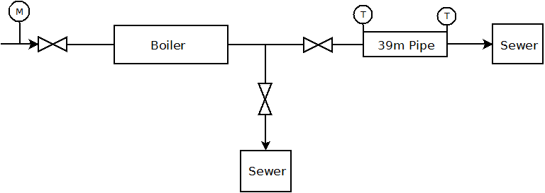
Figure 1. Test rig diagram
Before to perform a test, the water-city network is pushed inside the studied pipe during about 10 minutes to stabilize its temperature, assumed at the water network temperature. Using this test bench, several parameters can be studied: the flow velocity and the temperature step. In district heating network, the flow velocity is generally lower than 2 m/s [21–23] to avoid large pressure drops. Due to test bench constraints, the maximum flow velocity considered is 1 m/s.
To complete this analysis, the behavior of a real DHN is also investigated. Due to the lack of information available in the literature or mismeasurement [10] in some data available, it is proposed to perform a test on the ULg DHN which has a total length of 10 km and distributes pressurized hot water at 125 °C to approximately 70 buildings located in the University campus (Figure 2). Due to instrumentation facilities, the supply pipe analyzed is the first pipe which connects the plant to the DHN (encircled in red in Figure 2). The mass flow rate and the inlet pipe temperature are getting from the heating plant owner. For the information of the reader, the maximal flow velocity in the ULg DHN is 1.5 m/s. The resolution of the mass flow rate is 1 t/h and the one of the temperature is 0.1 °C. Concerning the outlet pipe temperature, three K- thermocouples are directly put on the pipe and averaged. An initial steady state test has been performed to ensure an accurate measurement of the water pipe temperature by this technique. The K-thermocouples are measured by the same data acquisition system as previously.
The analyzed pipe is a 106 m steel pipe with a diameter of 35 cm which is insulated by 15 cm of insulation whose thermal conductivity is 0.03 W/(m.K). Based on experimental data [11], the heat loss coefficient has been previously identified to 0.41 W/(m.K).

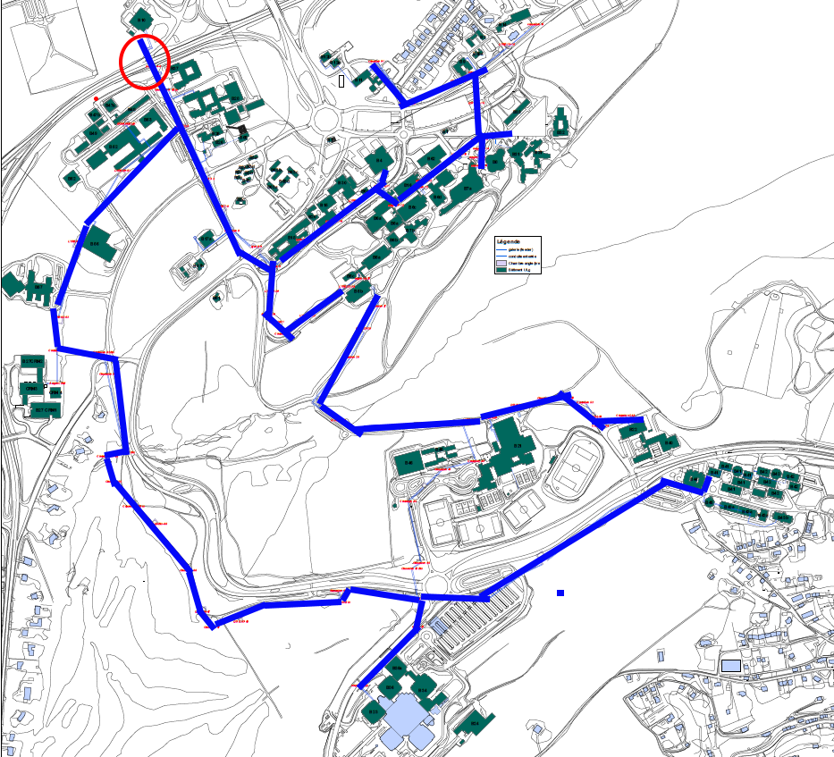
Figure 2 – Diagram of the ULg DHN. Buildings in green, supply pipes in blue, analysed pipe encircle in red.

Results and discussion
To validate the model on the ULg test rig, it is proposed to consider several water velocity which are typical in DHN (0.3 – 1.1 m/s). A good agreement is found between the experimental data and the model results in Figure 3. Especially the time when the outlet pipe temperature begins to increase. Therefore the time delay is correctly modelled with a very quick simulation (inferior to 0.5 s) without any numerical diffusion as the finite volume method [8]. In the different tests, there is a light overestimation of the outlet pipe temperature at the end of the temperature step. It is mainly due to the sensor accuracy but the authors think the fact the model is a one-dimensional model should explain this tiny difference. Indeed the constituting pipe material is considered as a lot of cells of the same temperature. In the experiment, there is a gradient inside the cell which is not modelled here. However, as described later in this section, there is a good agreement of the thermal inertia influence too.

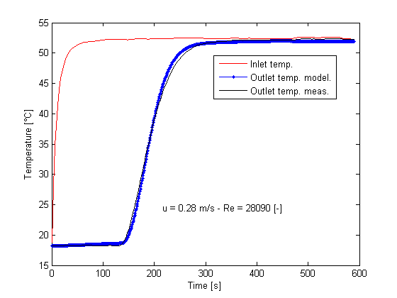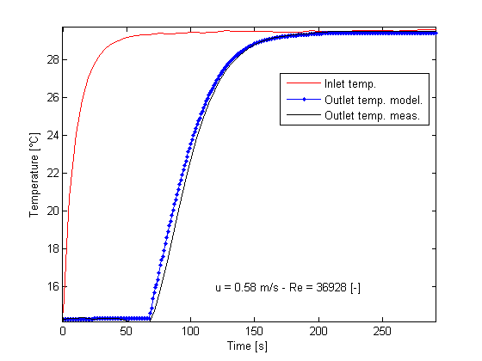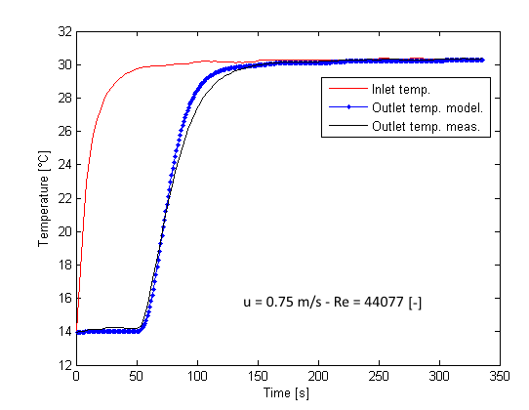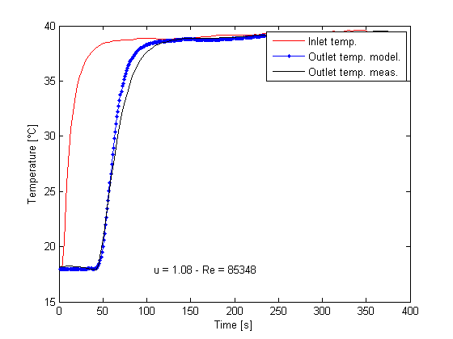
Figure 3 – Test rig results for water velocity of 0.28, 0.58, 0.75 m/s and 1.08 m/s.
A complementary test was carried out to check if an increasing step followed by a decreasing step of temperature is correctly assessed (Figure 4). In this case the pipe is heated during about 10 minutes to stabilize the water and pipe temperature and then the boiler is shut off.

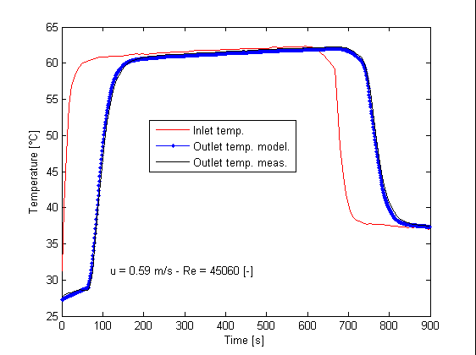
Figure 4 – Test rig results for water velocity of 0.59 m/s and for an increasing and a decreasing step temperature
As shown in previous work, the significant influence of the pipe thermal inertia on the heat transport in pipes is demonstrated in Figure 5. In this case, it is considered that there is no pipe thickness (green crosses). The pipe thermal inertia induces an extra delay on the outlet temperature (blue dots). Even if this delay is quite reduced in this test (about 50 seconds), it has to be considered in a real network while the pipe length is larger: for example, one kilometre pipe induces an extra-delay of 200 seconds [8].
This influence should be considered during early morning heating boost and could be treated in more efficient energetic way. Indeed to guarantee the thermal comfort of the users, this heating boost is generally performed too soon leading to more important and useless heat losses due to too high supply water temperatures. Coupled to predictive control of energetic needs of buildings, this current model could be used to feed only the required heat demand in the network and save energy.

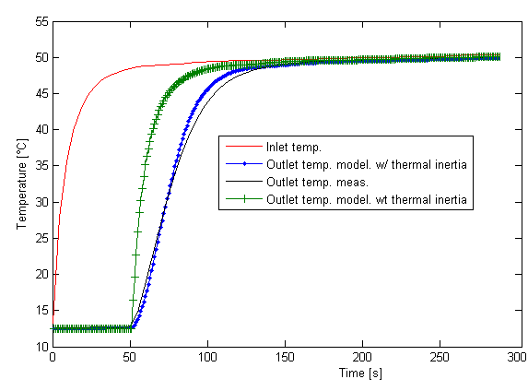
Figure 5 – Influence of the thermal pipe inertia on the results.
To extend the validity range of the model with low velocity and so low Reynolds number (between 5000-10000 [-]), the last experiment (Figure 6) has been performed with a low water velocity (0.11 m/s). This condition could occur in oversized pipelines and in networks that serve low heat density areas [24]. Once again, there is a good agreement with the experimental data: the absolute error on the outlet pipe temperature is lower (0.2°C) than the accuracy of the data acquisition system. In this case, the thermal inertia has no influence on the outlet pipe temperature while the fluid velocity is very low.
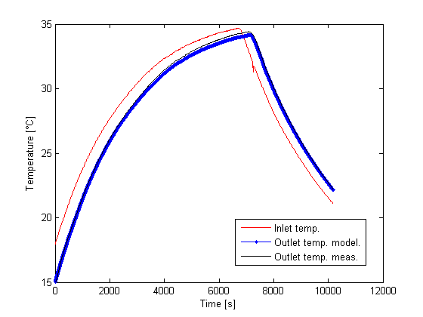
Figure 6 – Results for low water velocity.
Concerning the results of the ULg DHN (Figure 7), the velocity and the temperature at the inlet pipe are imposed by the control of the whole plant. The test has been performed during several winter hours to catch some temperature and mass flow rate variations. Here are the results:
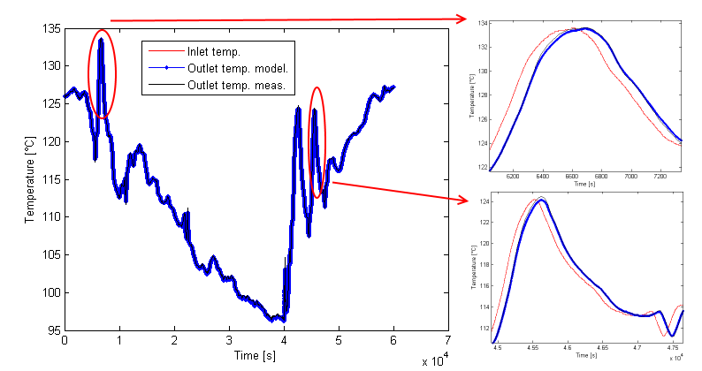
Figure 7 – Results for the ULg DHN.
Once again, there is a good agreement between the model and the measurements such as for the time delay that the thermal inertia.

5.1 Sensitivity analysis
To complete the discussion, a sensitivity analysis is performed. Indeed the accuracy of the results can be influenced by some parameters which can sometimes be difficult to measure and / or change in function of their age. The first one is the inside pipe diameter which is a function of the pipe machining tolerance, the pipe roughness or the incomplete information due to past modifications in pipe manufacturing standards. This can led to a pipe thickness variation of 10% [24] and therefore on a variation on the fluid velocity and the time shift on the outlet pipe temperature. Notice that the pipe roughness could also involve a variation up to 10% of the heat transfer coefficient between the fluid and the pipe. On the other hand, the thermal inertia is affected by the pipe thickness and the manufacturing standard while the density and the specific heat can vary from 5%. Finally, the thermal coefficient of the insulation is considered while it has a direct influence on the heat losses and on the outlet pipe temperature. It depends of the insulation age, the ambient temperature and the moisture content [25–27]. In this case, a factor of 10% is considered.
Concerning the variation on the velocity due to uncertainty on pipe thickness, the variation is quite reduced. The corresponding relative error on fluid velocity and on corresponding time delay is less than 3% for the ULg test rig and less than 1% for the ULg DHN. These last tiny errors are due to the low ratio between pipe thickness and pipe diameter and so the reduced influence of the uncertainty of the pipe thickness on the fluid velocity and so on the time delay.
The uncertainty of specific heat and density of pipe constituting material involving a variation of the thermal inertia of 5 % which has a reduced influence on the outlet pipe temperature (Figure 8). The mean square error of the outlet temperature is initially 0.02 °C and is 0.002 °C when the initial thermal inertia is increased of 5 %.
The influence of the different parameters on the heat losses are also quite reduced. Indeed for the ULg test rig, the higher heat losses due to high heat transfer coefficient involve a temperature reduction at the outlet pipe; but the thermocouple precision (0.3 °C) is higher than this calculated temperature difference (<< 0.1°C). This can be seen on Figure 9. It is due to the heat losses represent less than 0.5% of the heat injected in the considered cases. It is the same for the case of a large DHN such as those ULg DHN. Despite of the length of pipe is larger, the temperature difference is generally difficult to measure while the ratio between the heat losses and the heat injected is low too if the pipe is insulated. Readers are reminded that even this temperature difference is quite reduced the total heat losses of a complete network (not only one pipe) can reach 20% of the annual heat injected and therefore it has to be considered to assess the overall performance of the system.
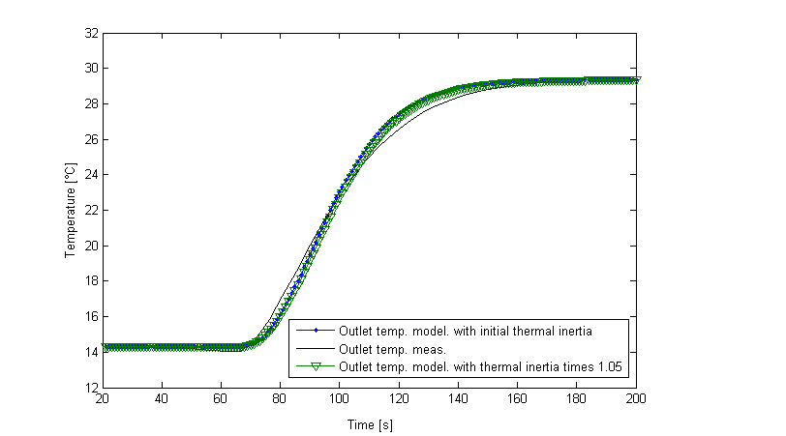
Figure 8 – Reduced influence of thermal inertia on outlet pipe temperature due to uncertainty on specific heat and density of pipe constituting materials.
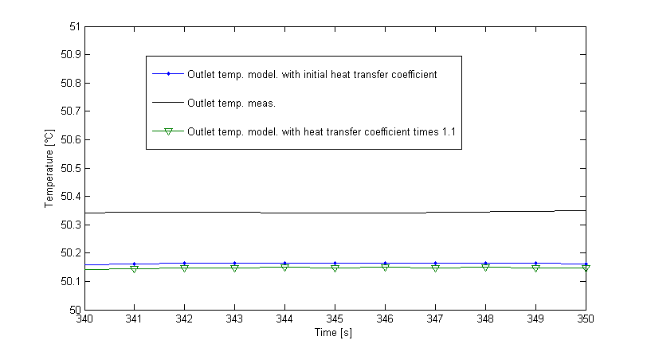
Figure 9 – Non-measurable influence on heat losses and outlet temperature due to uncertainties on pipe thickness and heat transfer coefficients.

Conclusions and perspectives
District heating networks are composed of numerous long pipes to supply buildings involving delays in heat transport due to low fluid velocities. These delays could be the source of overconsumption or discomfort in buildings. A practical solution to mitigate these issues consists in instrumenting the whole network and using some dedicated algorithm to control the heat supplied to the DHN. But this solution is generally expensive. Another option resides in detailed heat transport modelling in district heating network. It is a key challenge to assess where and when is the heat injected without sensors to improve the efficiency of energy use.
In this paper, the developed modelling approach is validated on an experimental test rig and on a real district heating network. This approach assumes that the working fluid is in liquid state. The results show a good agreement between experimental data and simulation results for a large range of water velocities. Moreover, it is shown that the thermal inertia of the pipe has a significant influence on the outlet pipe temperature response, especially when quick temperature variations occur such as a morning boost of the network. It is therefore important to take it into account for the control of the whole system.
On the other hand, a sensitivity analysis is performed and shows that the constituting material parameters of the district heating have a reduced influence on the results. That allows the same model to be used for a wide number of system configurations.
To reduce energy consumption and assess correctly the behaviour of the whole system, accurate building consumption models are also required. If the building consumption is not properly modelled, the outlet building temperature could be over or underestimated, leading to a miscalculation of the inlet return pipe temperature and a miscalculation of the whole system. If the building envelope and the energy systems are known, the accuracy of the building consumption depends mainly on the occupant’s behaviour in residential buildings. This influence is reduced in sufficiently large DHN for which the average occupancy is known.
The next steps of the work will consist in the modelling of an existing DHN with all branches, implement different control strategies and include renewable energy sources, and so on, to reduce the environmental footprint of the network.

Nomenclature
- A area, m²
- C_{p} specific heat, J/(kg K)
- D diameter, m
- h enthalpy, J/kg
- mass flow rate, kg/s
- p pressure, Pa
- $\dot{Q}$ heat flux, J/s
- $Re$ Reynolds number [-]
- t time, s
- T temperature, K
- u velocity, m/s
- V volume, m³
Greek symbols
- ρ density, kg/m³
Abbreviations and subscripts
- DHN, District heating network
- ULG, University of Liège
- in inlet
- out outlet

References
1. Rezaie B, Rosen MA. District heating and cooling: Review of technology and potential enhancements. Appl Energy. 2012;93:2–10.
2. Dobos L, Abonyi J. Controller tuning of district heating networks using experiment design techniques. Energy. 2011;36:4633–9.
3. Wissner M. Regulation of district-heating systems. Util Policy [Internet]. 2014 Dec;31(0):63–73.
4. MOEK. Infrastructure monopoly of the Moscow government in heat energy distribution.
5. Madsen H, Sejling K, Søgaard HT, Palsson OP. On flow and supply temperature control in district heating systems. Heat Recover Syst CHP [Internet]. 1994 Nov;14(6):613–20.
6. Laajalehto T, Kuosa M, Mäkilä T, Lampinen M, Lahdelma R. Energy efficiency improvements utilising mass flow control and a ring topology in a district heating network. Appl Therm Eng [Internet]. 2014 Aug;69(1–2):86–95.
7. Jie P, Zhu N, Li D. Operation optimization of existing district heating systems. Appl Therm Eng [Internet]. 2015 Mar 5;78(0):278–88.
8. Sartor K, Thomas D, Dewallef P. A comparative study for simulating heat transport in large district heating networks. In: PROCEEDINGS OF ECOS 2015 - THE 28TH INTERNATIONAL CONFERENCE ON EFFICIENCY, COST, OPTIMIZATION, SIMULATION AND ENVIRONMENTAL IMPACT OF ENERGY SYSTEMS. 2015.
9. Dahm J. District Heating Pipelines in the Ground - Simulation Model. 2001.
10. Gabrielaitienė I, Kačianauskas B, Sunden B. Application of the Finite Element Method for Modelling of District Heating Network. J Civ Eng Manag. 2003;9(3):153–62.
11. Sartor K, Quoilin S, Dewallef P. Simulation and optimization of a CHP biomass plant and district heating network. Appl Energy. Elsevier Ltd; 2014;130:474–83.
12. Frederiksen S, Werner S. Fjärrvärme : Teori, teknik och funktion. Press L, editor. 1993.
13. Thorsen JE, Christiansen CH, Brand M, Olesen PK, Larsen CT. Experiences On Low-Temperature District Heating In Lystrup - Denmark. In: Proceedings of International Conference on District Energy. 2011.
14. TRNSYS 17 Manual – Volume 4 – Mathematical Reference.
15. Hoffman J, Johnson C. Computational Turbulent Incompressible Flow. October [Internet]. 2007;4:415. Available from: http://www.springerlink.com/index/10.1007/978-3-540-46533-1
16. Krope A, Krope J, Ticar I. The reduction of Pipelines, friction losses in district-heating. J Mech Eng. 2000;46(8):525–31.
17. Nellis GF, Klein SA. Heat transfer. Press CU, editor. 2009.
18. Li P, Seem JE, Li Y. A new explicit equation for accurate friction factor calculation of smooth pipes. Int J Refrig [Internet]. 2011;34(6):1535–41. Available from: http://dx.doi.org/10.1016/j.ijrefrig.2011.03.018
19. Gary EP, Marlin JK, David LCLFm. Field Measurements of Heat Losses from Three Types of Heat Distribution Systems. 1991.
20. Cvema F. ASM_Ready_Reference. ASM International, editor. 2002. 560 p.
21. Skagestad B, Mildenstein P. District Heating and Cooling Connection Handbook. 1999.
22. EUDP. Guidelines for Low-Temperature District Heating. 2014.
23. Woods P. Heat networks: Code of pratice for the UK. 2014.
24. Gabrielaitiene I, Bøhm B, Sunden B. Evaluation of Approaches for Modeling Temperature Wave Propagation in District Heating Pipelines. Heat Transf Eng. 2008;29(October 2014):45–56.
25. de Boer S, Korsman J, Smits IM. LONG TERM HEAT LOSS OF PLASTIC POLYBUTYLENE PIPING SYSTEMS. In: The 11th International Symposium on District Heating and Cooling, August 31 to September 2, 2008, Reykjavik, ICELAND. 2008. p. 1–8.
26. Ochs HM-SF. Temperature and Moisture Dependence of the Thermal Conductivity of Insulation Materials. NATO Advanced Study Institute on Thermal Energy Storage for Sustainable Energy Consumption (TESSEC) %L 2005temperatureins. 2005.
27. KELLNER J, DIRCKX V. Change of thermal conductivity of polyurethane pre-insulated pipes as a function of time. 1999.

