Supporting Information S3

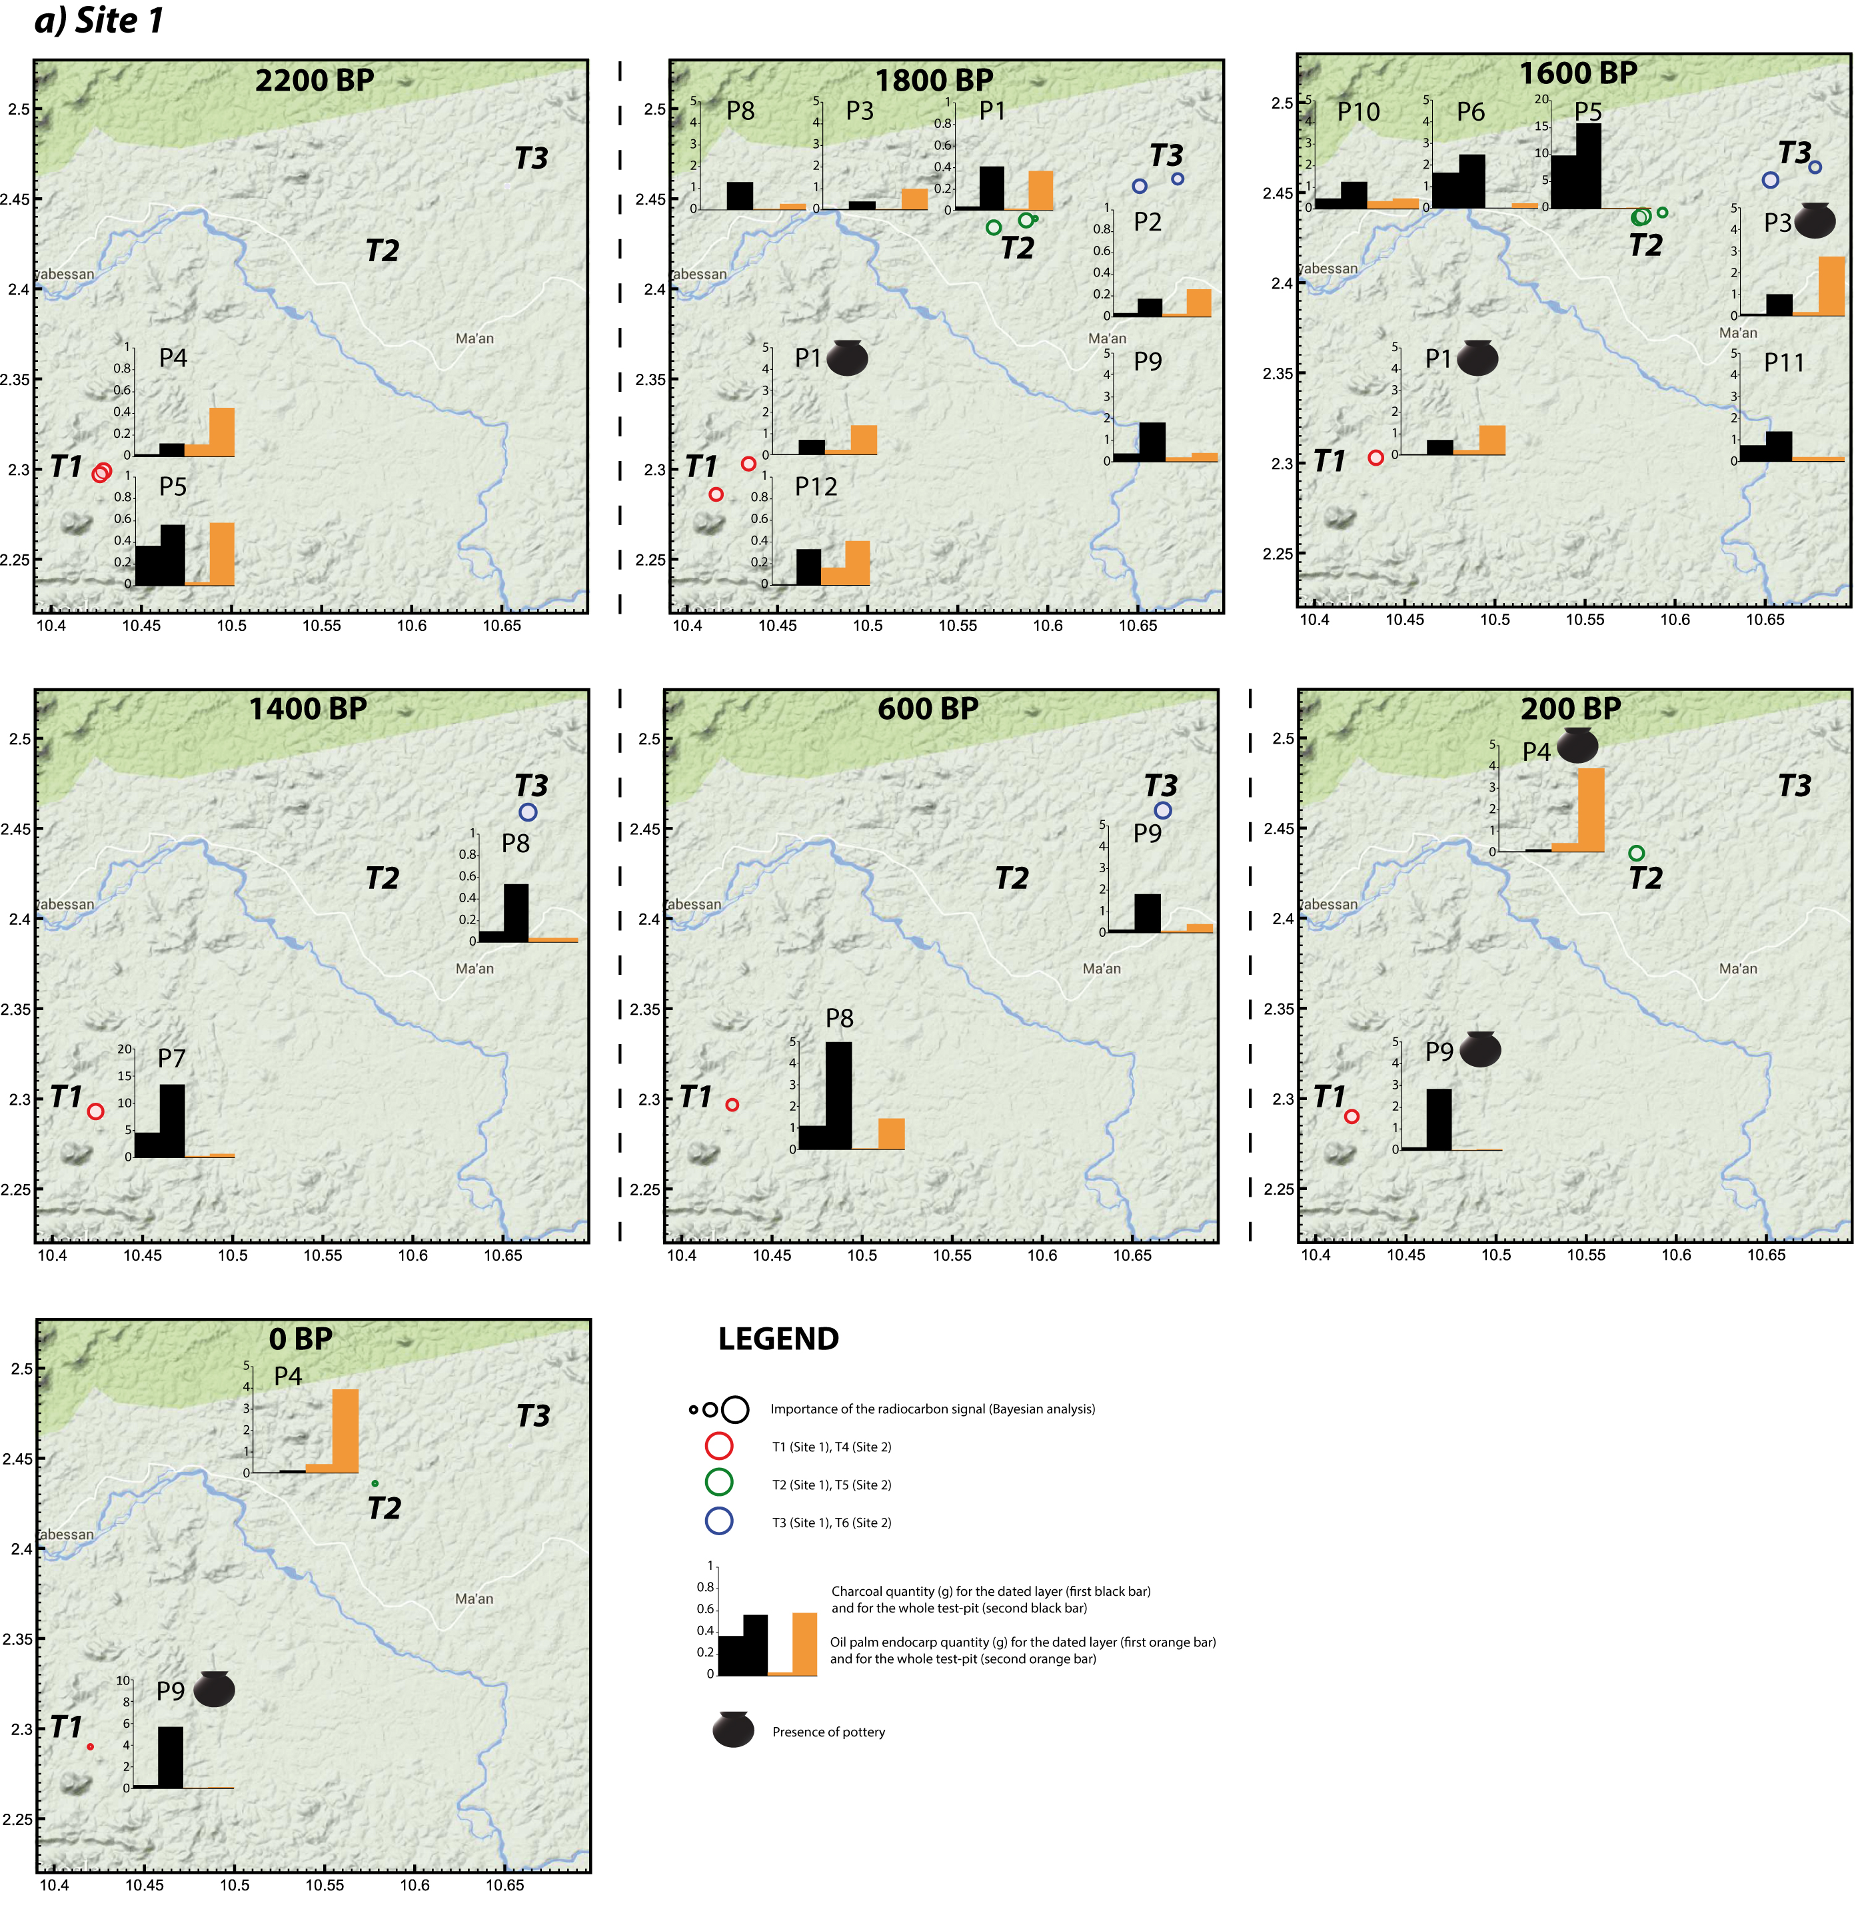

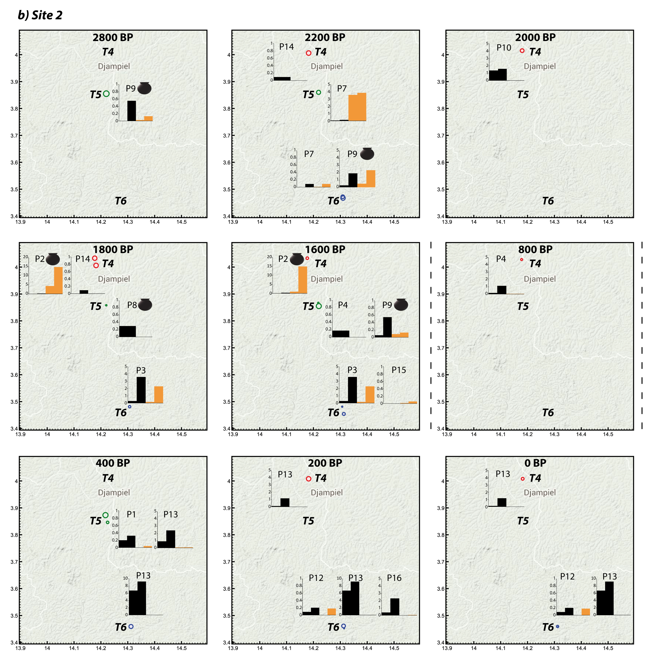

Figure S3. Modeled distributions of the radiocarbon dates in BP at 200-years intervals across the six transects, with mention of the macroremains quantities: a) Site 1 and b) Site 2. Circle sizes increase with increasing probability distribution of the radiocarbon signal, according to a Bayesian model. Maps show the discontinuity of spatial occupation over time and the spacing between synchronous human activities in a same transect. Age-intervals with no radiocarbon signal are not represented. Macroremains quantities (in g) by dated test-pit (P1 to P16) are represented by type: charcoal (black) and oil palm endocarps (orange), and by dated level (first bar) and for the whole test-pit (second bar).

