Modifying physical environment to be appropriate for children
Jidovtseff, B.¹, Delvaux A. ¹, Mornard M. ¹
¹University of Liège; email: b.jidovtseff@ulg.ac.be

Introduction

The CEREKI Center has been based in Liege (Belgium) for more than 25 years. It is dedicated to providing physical activities for 3 to 8 years old children. These experiences have been the basis for research and reflection on how to engage with children of this age.

Method

The context of sports practice used by adults is seldom suited to children. In order to generate motivation and children’s positive behavior toward sport, it is important to offer adapted conditions with an appropriate pedagogical approach. Modifying the physical environment to adapt to children’s needs is essential for successful participation.

Results and Discussion

From our experience it is important : 1) to maximise active time, 2) to favour fundamental motor skills and perceptual development, 3) to take into account inter-individual differences, 4) to favor amusement, imagination and self-confidence, 5) to emphasize motor progress and not performance, 6) to guarantee optimal security. It appears that adapting the environment to the children’s needs is often critical in order to meet the above requirements.

Using circuit organization in an adapted physical environment appears to be a very successful pedagogy in different categories of game with 3 to 8 years old children. The circuit themes are influenced by gymnastic (rotation, balance, adventure, trampoline), track and field (jumping, throwing, running) and ball games (football, basket ball, volley ball, hockey). Circuit organisation permits guided discovery, increases motor involvement time, develops active movement, promotes learning and allows management of groups of children to move safely with autonomy. A very good knowledge of the equipment and of children’s motor development is important in creating the most suitable circuit.

Circuits have to be organised in such a way that children can do most exercises on their own with only a little assistance. Furthermore, the arrangement of equipment offers multiple possibilities of movement in order to favour active motor discovery for all children. Individual instructions permit a good adaptation of the task difficulty to promote success and development. The autonomy of children allows the teacher to move throughout the circuit and assist children in their learning.

One of the most original physical adaptations is the water habituation circuit that has been modified in a pool that is not adapted to the children (figure 1). As a result, the children are able to progress along the circuit according to their ability and confidence. This educational approach is progressive and adapted to the children’s level of ability.

Figure 1 - CEReKi aquatic circuit

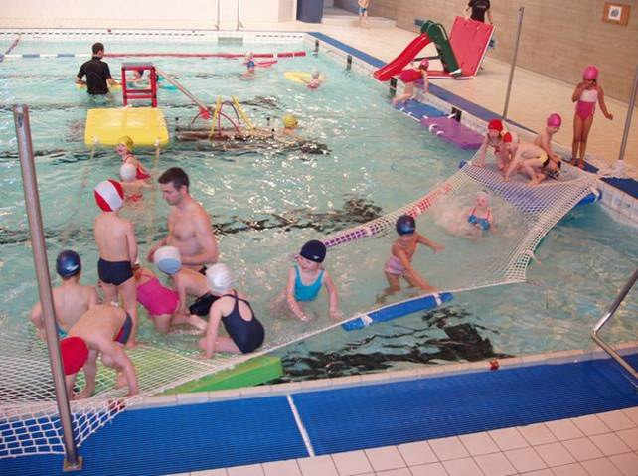

Conclusions

Our experience confirms that adapting physical environments is critical for providing appropriate physical activity for 3 to 8 years old children.. Moreover, the pedagogy has to favour success, discovery and a fun environment. This work illustrates what can be achieved and provides clear guidance for developing centres to support the promotion of physical activity in early childhood.

