EMODnet regional gridded abundance products: a tool to facilitate ecosystem assessments

Simon Claus¹, Lennert Tyberghein¹, Peter Herman², Olivier Beauchard², Jean Marie Beckers³ and Francisco Hernandez¹
¹ Flanders Marine Institute (VLIZ)
InnovOcean site, Wandelaarkaai 7, B-8400 Oostende, Belgium
E-mail: simon.claus@vliz.be
² Royal Netherlands Institute for Sea Research
Korringaweg 7, 4401 NT Yerseke, Netherlands
³ GeoHydrodynamics and Environment Research
University of Liège, Sart Tilman B5a, 4000, Liège, Belgium

The European Marine Observation and Data Network (EMODnet) is a network of organisations supported by the EU’s integrated maritime policy. These organisations work together to observe the sea, process the data according to international standards and make that information freely available as interoperable data layers and data products. Within the EMODnet Biology project a set of gridded map layers is being produced showing the average abundance of different species of different trophic levels per species group for different time windows (seasonal, annual or multi-annual as appropriate) using geospatial modelling. The spatial modelling tool used to calculate the gridded abundance maps is based on DIVA. DIVA (Data-Interpolating Variational Analysis) is a tool to create gridded data sets from discrete point measurements of the ocean. The interpolation is based on a given correlation length scale and signal-to-noise ratio of the observations.

It was decided to select a number of well-known and published cases from diverse data sources to test the methodology. The selection was based on data availability within the EurOBIS database, reference to existing literature and relevance to the project. Currently data products are available for more than 40 species from the North Sea, Baltic Sea and North East Atlantic. The products are currently made for different species groups, such as benthos, zoo- and phytoplankton, birds, fish and mammals. The availability of zeroes (i.e. explicit knowledge of the sites where a species was looked for but was absent) is essential for the gridding procedure using DIVA. Since most databases only record presences, the reconstruction of zeroes is a requirement for the mapping. A list of datasets for which zeroes can be reconstructed in a consistent way must be made before gridding can be automated with EMODnet biological data. It will be used to determine further goals for the (semi-)automatic data gridding to be applied to many biological data.

These gridded map layers showing the abundance for copepod species most frequently recorded from the North Atlantic CPR dataset will be delivered as operational oceanographic products and services (OOPS), to support the integrated ecosystem assessments (IEAs), recently undertaken by ICES.

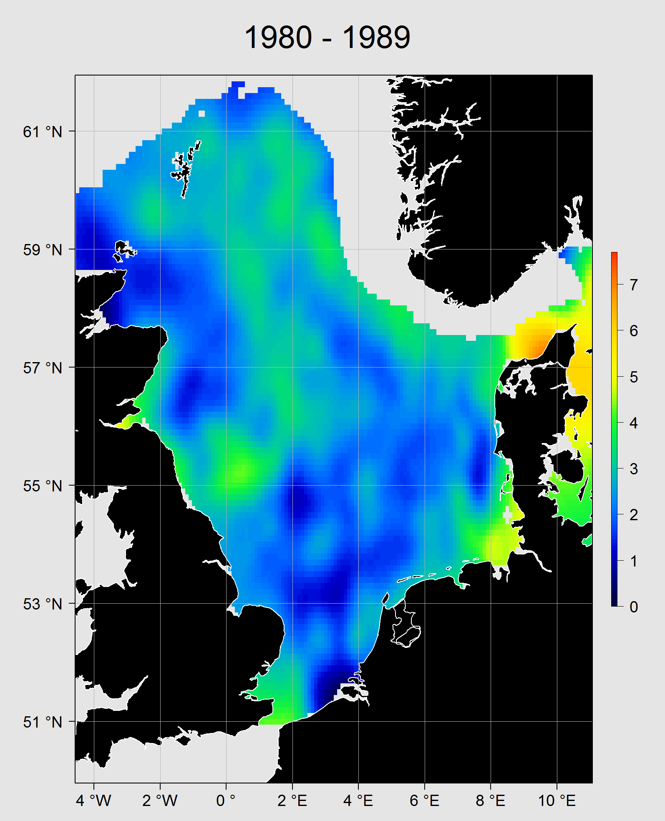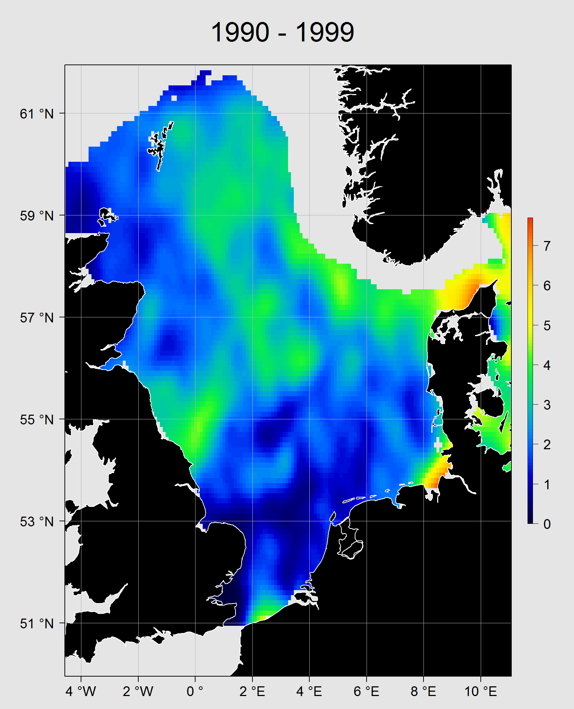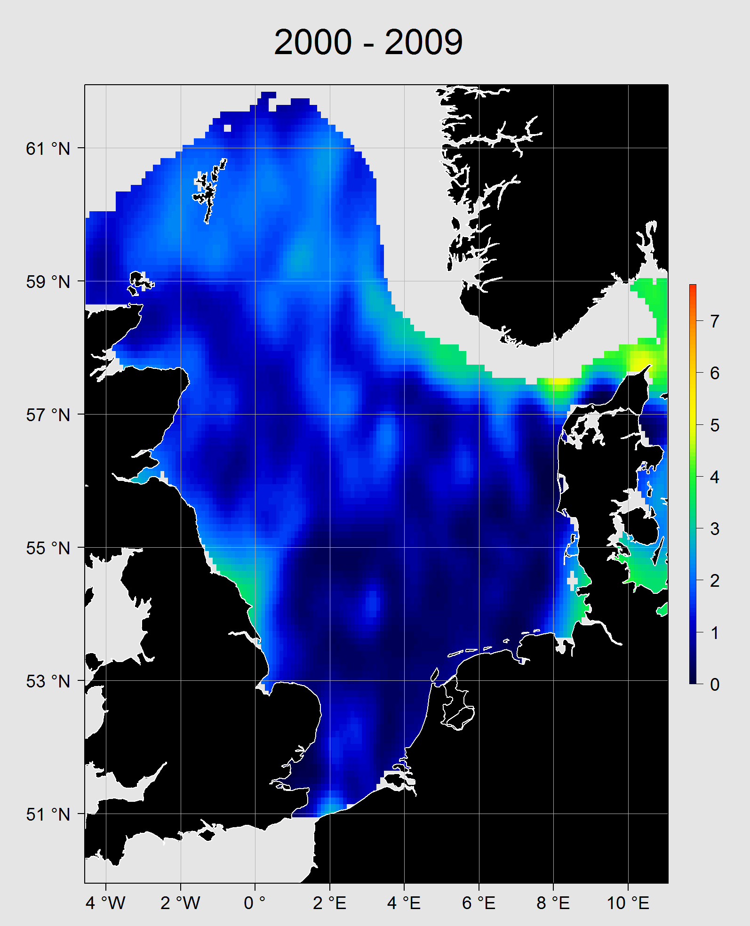

Cod (Gadus morhua) stocks in the North Sea. We gridded the data from the ICES IBTS (International Bottom Trawl Survey – ln(x+1)-transformed number of fish counted per haul) fish surveys for a running average of ten years. Together these maps were combined in an animation showing the temporal evolution of the stock. Here we show three snapshots (per decade) illustrating the dramatic decrease of the cod stock in the North Sea.

