Markets Flash Graphs*

Jean-Marie Choffray**
September 19, 2015. Revised Sept. 30.

Summary

A graph is worth a hundred words... A good graph may suggest some new heuristics. And…, a series of excellent graphs may provide the backbone of a theory! The goal of this paper is to share a set of graphs from multiple sources that offer as many flashes on current and past market conditions. Inevitably, these graphs reflect my own biases and questionings. They are not meant to induce any action aside, maybe, from their integration in a personal Information System. The Great Recession of 2008, whose consequences are still unfolding, has been for each of us a powerful invitation to modesty. We live in a world where improbable, unthinkable and impossible events happen every day... More than ever, it’s time to sit down, shut up, watch out, build graphs, and think… hard!

* Beware of potentially spurious “causal” relations!
“He who believes he knows, doesn't know that he believes…”

** Jean-Marie Choffray is Chair Professor Emeritus of Management Science at the University of Liège (Belgium), where he taught Internet-Based Global Investing and Entrepreneurship. He holds a PhD in Management Science from the Massachusetts Institute of Technology.
Recent work: http://orbi.ulg.ac.be/simple-search?query=jean+marie+choffray
Markets Flash Graphs

- 01/09/2015 The “Center” of the world… 4
- 02/09/2015 China’s Wake-up call… 5
- 03/09/2015 A case of divergence… 6
- 04/09/2015 Nasdaq “Stage” of development… 7
- 05/09/2015 Oil is butter too… 8
- 06/09/2015 Is the FED disarmed... 9
- 07/09/2015 A rope around the neck… 10
- 07/09/2015 BABA boom… 11
- 07/09/2015 Game over... 12
- 08/09/2015 Is gold doomed... 13
- 09/09/2015 The short of a lifetime… 14
- 09/09/2015 3-D Printing stocks’ nightmare… 15
- 09/09/2015 Bullish Uptrend... 16
- 09/09/2015 Structural vs financial leverage... 17
- 10/09/2015 A house of cards… 18
- 10/09/2015 Market’s current valuation… 19
- 10/09/2015 A “Stealth” recovery… 20
- 12/09/2015 This makes perfect sense… 21
- 13/09/2015 Markets jaws… 22
- 13/09/2015 Recurrent wows and oops… 23
- 18/09/2015 The painful Long March… 24
- 30/09/2015 Blowin’ in the wind… 25

Markets Flash Graphs

“Markets Flash Graphs” should ideally be used in parallel with “Internet-based investing at the edge of chaos”, “Protecting assets under non-parametric market conditions”, “L’art d’investir avec internet”, and “Ceci n’est pas un conseil”. All four papers are available on Orbi (links underneath). And it doesn’t require to be a computer nerd to translate them if needed!

Today’s “Investing environment” relies on a hybrid network of market places and market participants. It is characterized by high frequency trading systems, over leveraged shadow entities and hedge funds, flash crashes, incompetent management, reverse merger frauds, dot bubble 2.0 IPOs and stealth PPT, FED, ECB, BoE, and… PBoC actions! Market participants are mostly software applications (“Bots”) that run automated investment tasks, increasingly frequently through the Internet…

In a few words, these four papers explore how markets actually behave. They attempt to derive a concise and coherent set of “Heuristics” aimed at conceptualizing response to the “Unknown”, at connecting proven “Facts” and at converting observed “Discrepancies” into profitable investment opportunities. This approach – at best, a tentative and incomplete theory on investing under edgy circumstances –, should be tested, validated and improved gradually, as you collect additional facts and information.

That’s where “Graphs” enter the picture… We all learn that a graph is worth a hundred words... A good graph may suggest some new heuristics. And…, a series of excellent graphs may provide the backbone of a Theory! The goal of this paper is to share a set of graphs from multiple sources that offer as many flashes on current and past market conditions. Inevitably, these graphs reflect my own biases and questionings. They are not meant to induce any action aside, maybe, from their integration in a personal Information System. The Great Recession of 2008, whose consequences are still unfolding, has been for each of us a powerful invitation to modesty. We live in a world where improbable, impossible and unthinkable events happen every day... More than ever, it’s time to sit down, shut up, watch out, build graphs, and think… hard!

Useful links to Orbi:

- http://orbi.ulg.ac.be/handle/2268/106795
- http://orbi.ulg.ac.be/handle/2268/168479
- http://orbi.ulg.ac.be/handle/2268/92033
- http://orbi.ulg.ac.be/handle/2268/164249
The “Center” of the world…* September 1, 2015.
Standard & Poor’s 500 Index (SP500)

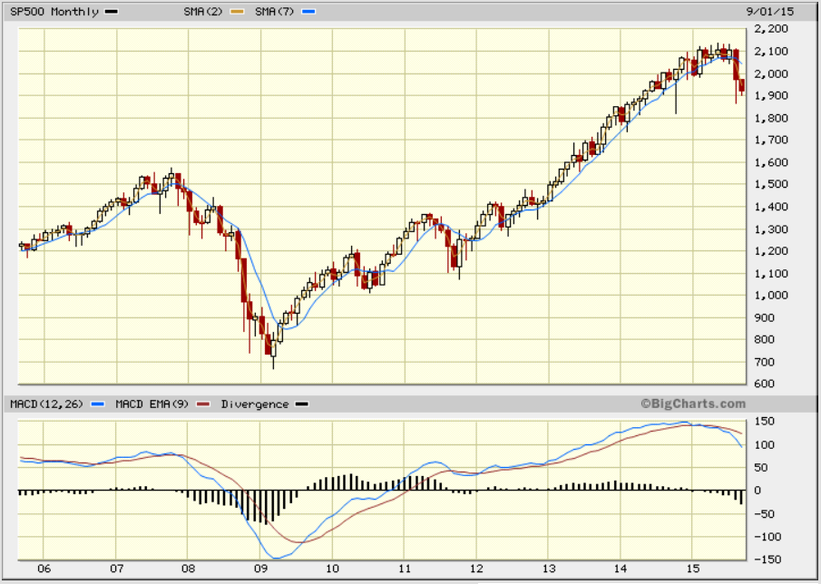

Dow Jones Industrial Average (DJIA)

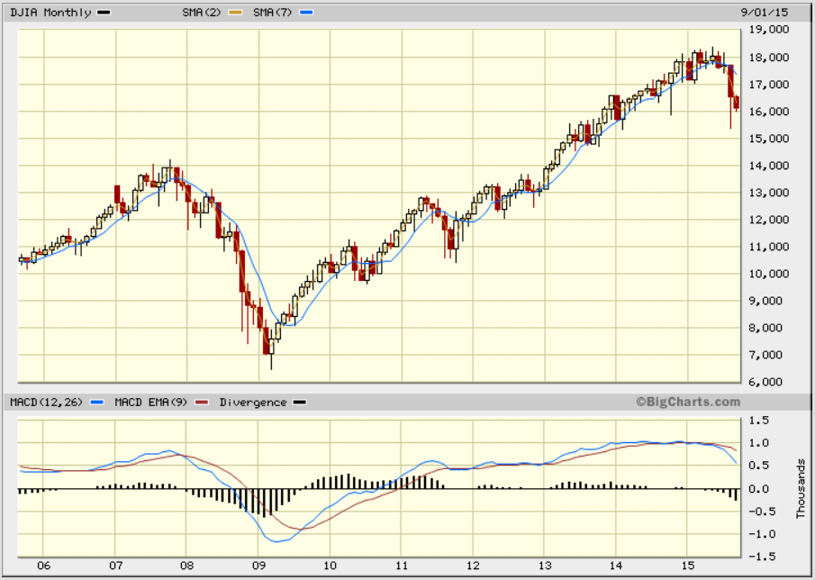

Source: www.bigcharts.com, ten years, monthly data, two Simple Moving Averages (2, 7 ~ SMA50, SMA200), MACD analysis.

Lesson: When it rains in the US, it pours on the rest of the world…

* Beware of potentially spurious “causal” relations!
“He who believes he knows, doesn't know that he believes…”

China’s wake-up call…* September 2, 2015.
Shanghai Composite Index (CN: SHCOMP)

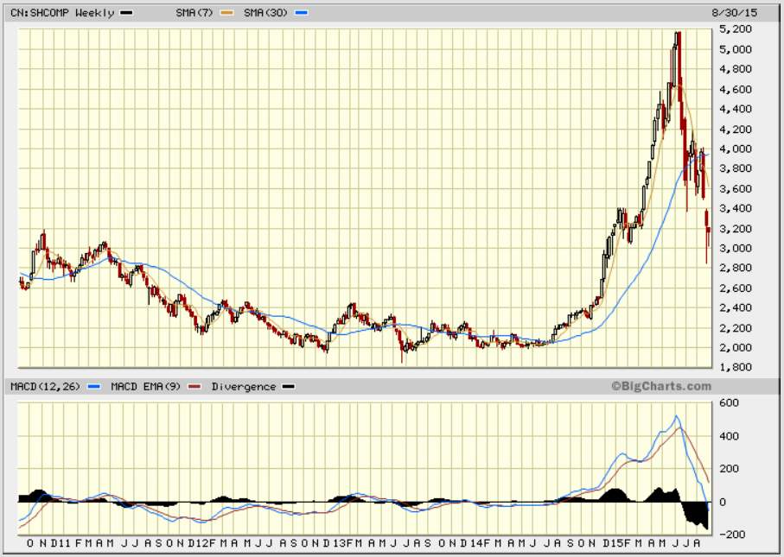

Shenzhen New Index (XX: 399100)

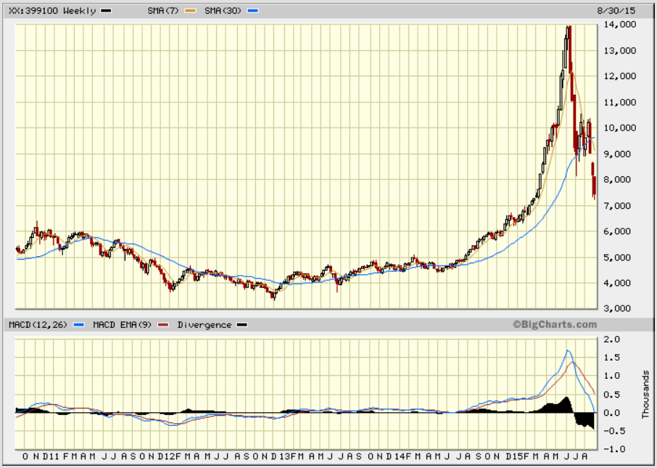

Source: www.bigcharts.com, five years, weekly data, two Simple Moving Averages (7, 30 ~ SMA50, SMA200), MACD analysis.

Lesson: China is no exception…

* Beware of potentially spurious “causal” relations!
“He who believes he knows, doesn't know that he believes…”
A case of divergence…* September 3, 2015.
Standard & Poor’s 500 (SP500) vs Philadelphia Gold/Silver Index (XAU)

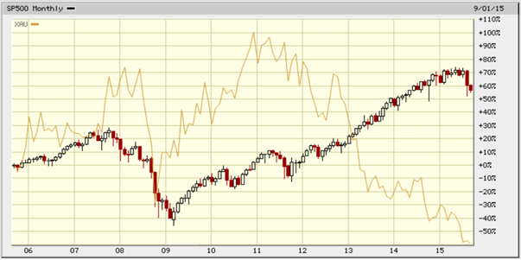

Philadelphia Gold/Silver Index (XAU) vs Newmont Mining (NEM)

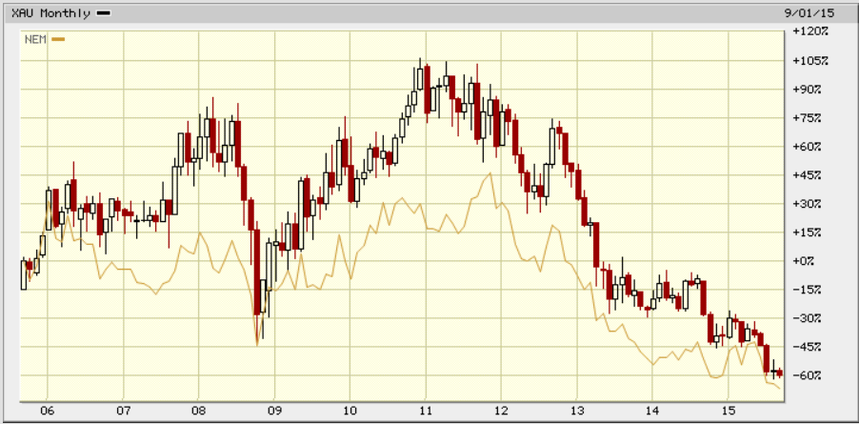

Source: www.bigcharts.com, ten years, monthly data.

Lesson: The gold market is decoupling…

* Beware of potentially spurious “causal” relations!
“He who believes he knows, doesn't know that he believes…”

Nasdaq “Stage” of development…* September 4, 2015.

Nasdaq PowerShares ETF (QQQ), five years, weekly data

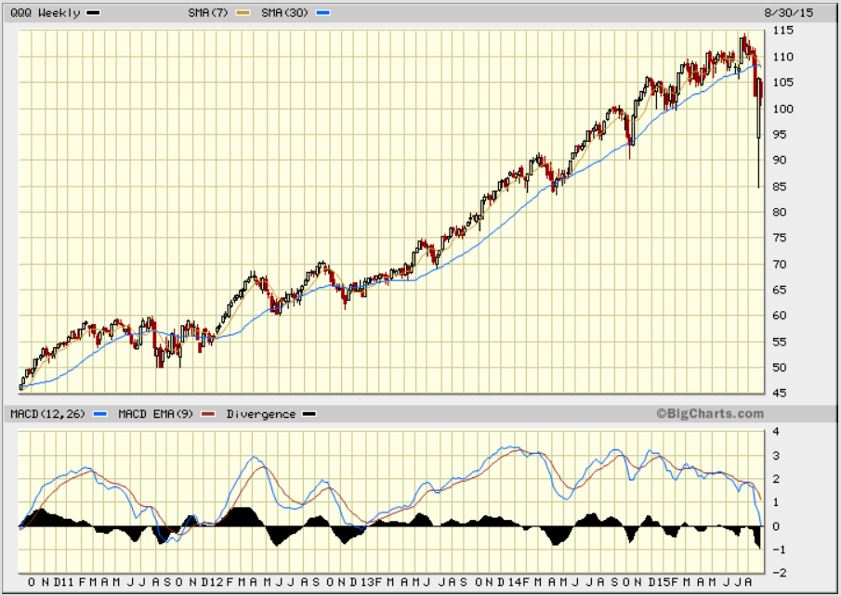

CBOE NASDAQ Volatility Index (VXN), last twelve months, daily data

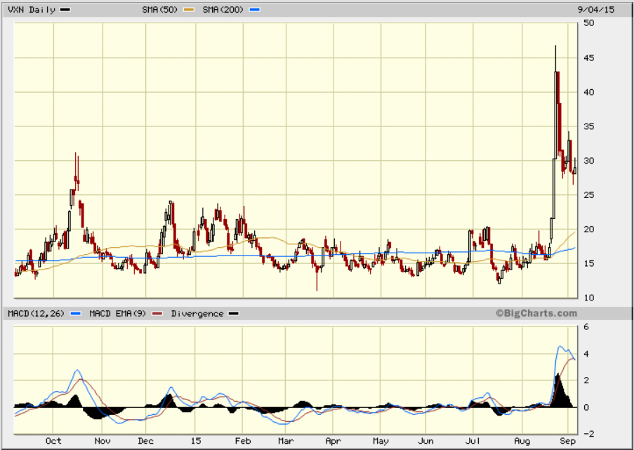

Source: www.bigcharts.com, two Simple Moving Averages (~ SMA50, SMA200), MACD analysis.

Lesson: The Nasdaq market is in “Bear” mode…

* Beware of potentially spurious “causal” relations!
“He who believes he knows, doesn't know that he believes…”
Oil is butter too…* September 5, 2015.

USO: United States Oil Fund LP

DNO: United States Short Oil Fund
SCO: ProShares UltraShort Bloomberg Crude Oil (ETF)
DWTI: VelocityShares 3x Inverse Crude ETN linked to the S&P GSCI Crude Oil Index

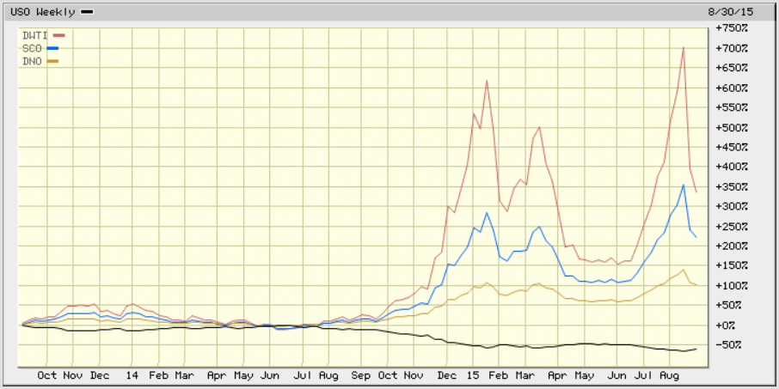

Source: www.bigcharts.com, last two years, weekly data.

Lesson: The oil price decline is not lost for all…

* Beware of potentially spurious “causal” relations!
“He who believes he knows, doesn't know that he believes…”

Is the FED disarmed…* September 6, 2015.

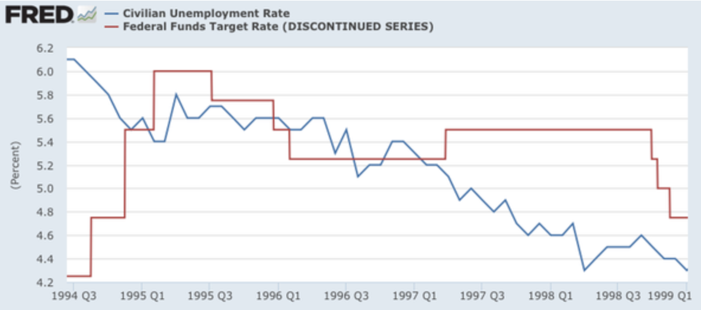

“Hiking rates now is still a really bad idea — and the arguments for that bad idea just keep getting worse…”

Source: Paul Krugman, http://krugman.blogs.nytimes.com/2015/09/04/the-fed-should-remember-the-90s/, September 4, 2015.

Lesson: The Federal Reserve has few degrees of freedom left…

* Beware of potentially spurious “causal” relations!
“He who believes he knows, doesn't know that he believes…”

A rope around the neck…* September 7, 2015.
Apple Inc.
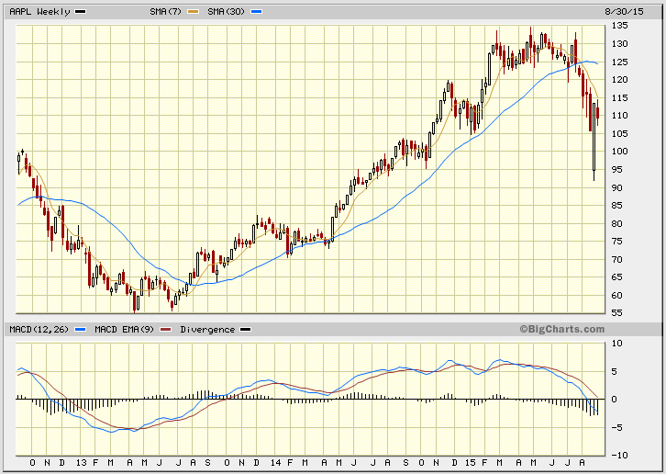

Tesla Motors Inc.
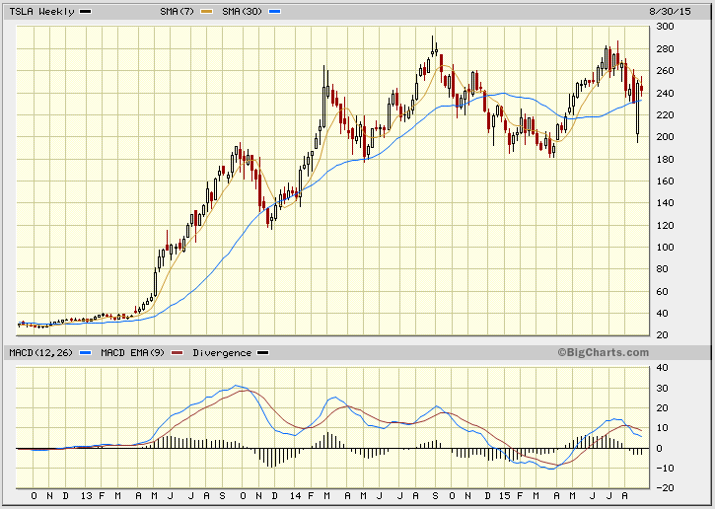

Netflix Inc.
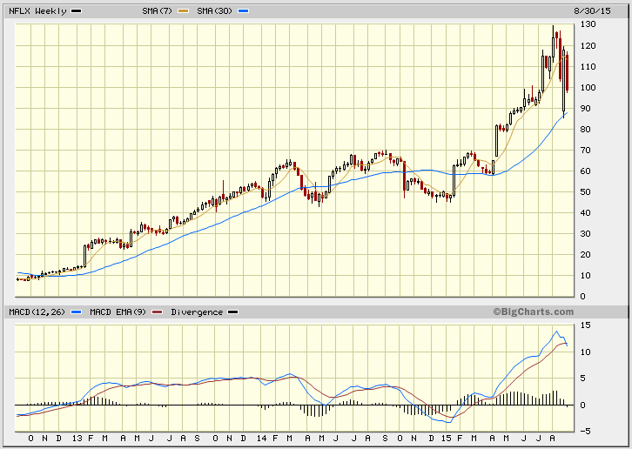

Source: www.bigcharts.com, three years, weekly data, two Simple Moving Averages
(~ SMA50, SMA200), MACD analysis.

Lesson: “Bearish Cross” in uptrend…

* Beware of potentially spurious “causal” relations!
“He who believes he knows, doesn't know that he believes…”
BABA boom…* September 7, 2015.

Alibaba Group Holding Ltd

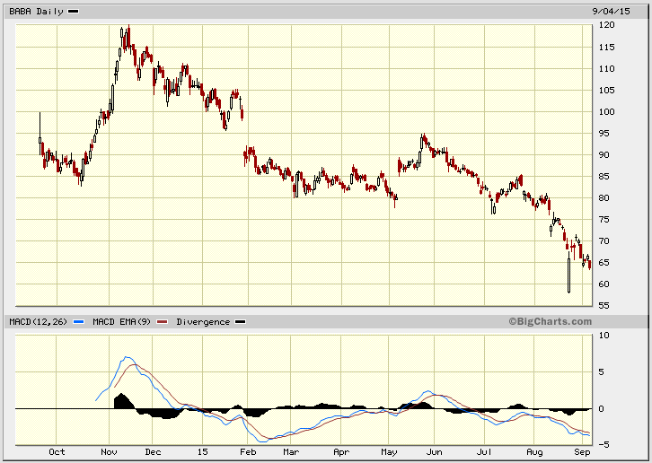

Source: www.bigcharts.com, one year, daily data, MACD analysis.

Report suggests Ma and co-founder Joseph Tsai are looking to diversify their investments without scaring Alibaba investors. Source: http://fortune.com/2015/09/04/is-alibabas-jack-ma-looking-to-borrow-2-billion-against-his-stock/

Lesson: Ma and Tsai are right to try to diversify…

* Beware of potentially spurious “causal” relations!
“He who believes he knows, doesn't know that he believes…”
Game over…* September 7, 2015.

S&P 500© [SP500], and all Federal Reserve Banks Total Assets

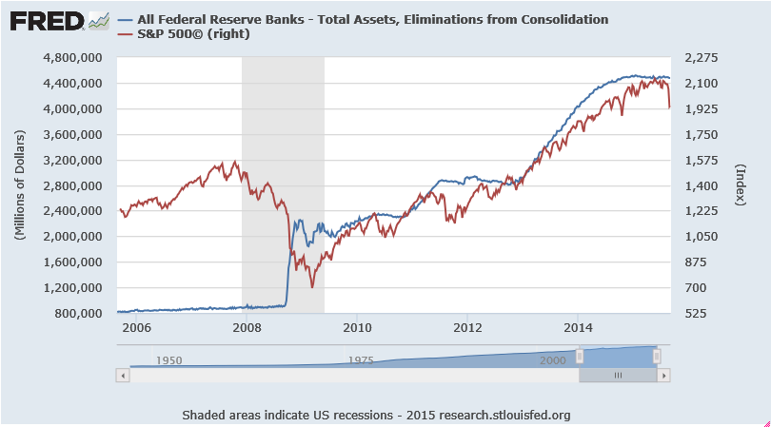

Source: S&P 500© [SP500], All Federal Reserve Banks Total Assets, retrieved from FRED, Federal Reserve Bank of St. Louis https://research.stlouisfed.org/fred2/, September 7, 2015.

Lesson: Markets may need more monetary dry powder…

* Beware of potentially spurious “causal” relations!
“He who believes he knows, doesn't know that he believes…”

Is gold doomed…* September 8, 2015.

Gold to Monetary Base Ratio

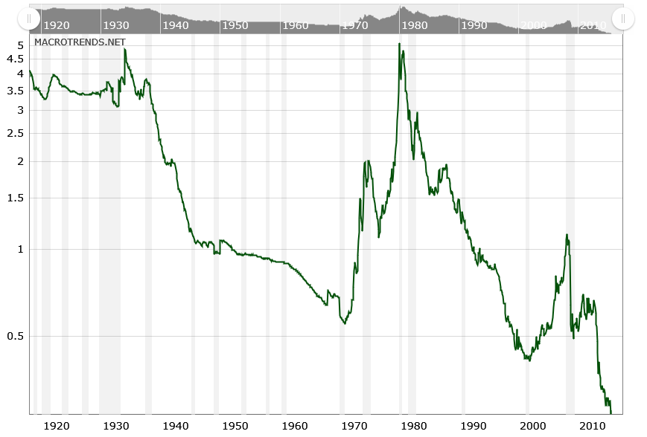

DOW to Gold Ratio (Ounces)

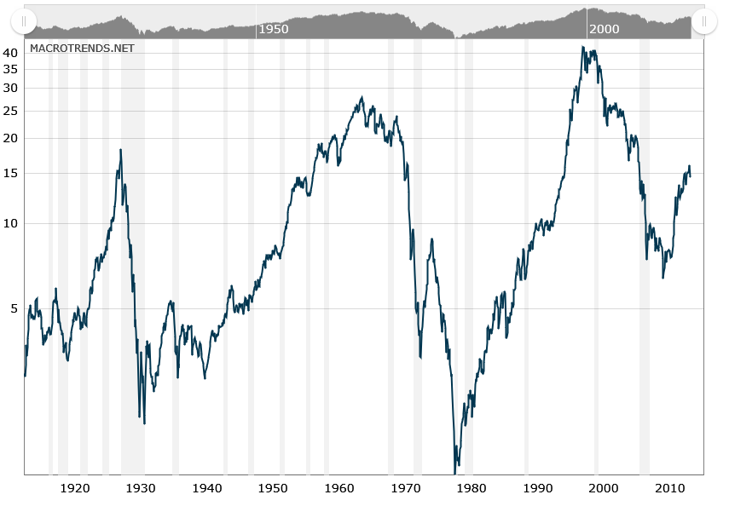

Source: http://www.macrotrends.net/1444/gold-to-monetary-base-ratio
http://www.macrotrends.net/1378/dow-to-gold-ratio-100-year-historical-chart

Lesson: Didn’t Greenspan say “Gold is currency”…

* Beware of potentially spurious “causal” relations!
“He who believes he knows, doesn't know that he believes…”
The short of a lifetime…* September 9, 2015.

“German bunds are 'the short of a lifetime'.” (Bill Gross)
http://www.cnbc.com/2015/04/21/bill-gross-german-bunds-are-the-short-of-a-lifetime.html

“Monetary policy will in fact be effective if the central bank can credibly promise to be irresponsible… and creates expectations of inflation…” (Paul Krugman)
http://www.brookings.edu/~/media/projects/bpea/1998%202/1998b_bpea_krugman_dominquez_rogoff.pdf

XX:AXTWEN, NYSE 20+ Yr Treasury Bond Total Return Index (INDEX)

TBF, ProShares Short 20+ Year Treasury (ETF)
TBT, ProShares UltraShort Lehman 20+ Year Treasury (ETF)
TTT, ProShares UltraPro Short 20+ Year Treasury (ETF)

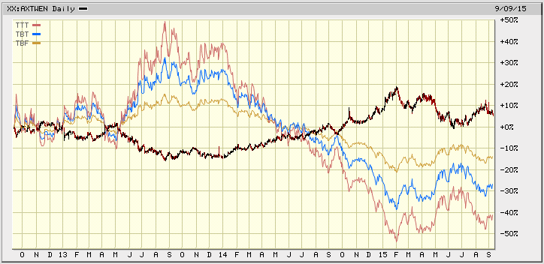

Source: www.bigcharts.com, three years, daily data.

Keep an eye on TBZ, PST… too!

Lesson: “Skyfall” coming soon to a market theater near you…

* Beware of potentially spurious “causal” relations!
“He who believes he knows, doesn't know that he believes…”

3-D Printing stocks’ nightmare…* September 9, 2015.

SSYS, Stratasys Ltd
ONVO, Organovo Holdings Inc
PRLB, Proto Labs Inc
VJET, Voxeljet AG
XONE, ExOne Co
DDD, 3D Systems Corp

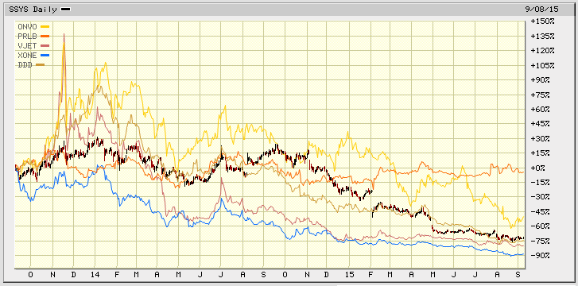

Source: www.bigcharts.com, two years, daily data.

Lesson: But…, 3-D Printing is not going to disappear anytime soon…

* Beware of potentially spurious “causal” relations!
“He who believes he knows, doesn't know that he believes…”

Bullish Uptrend...* September 9, 2015.

Statistically, yes… apparently! Realistically…, the future will tell!

CPST, Capstone Turbines Corp

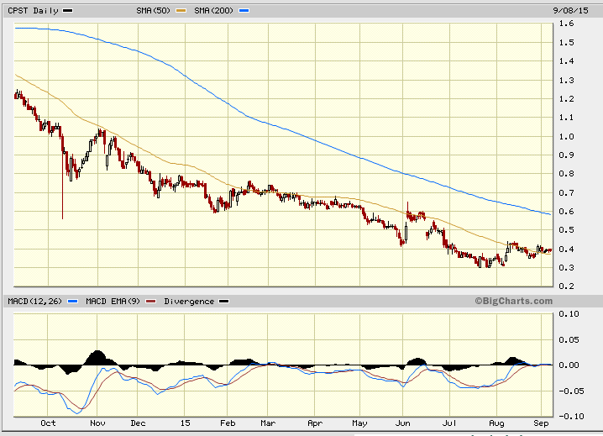

FCEL, FuelCell Energy Inc

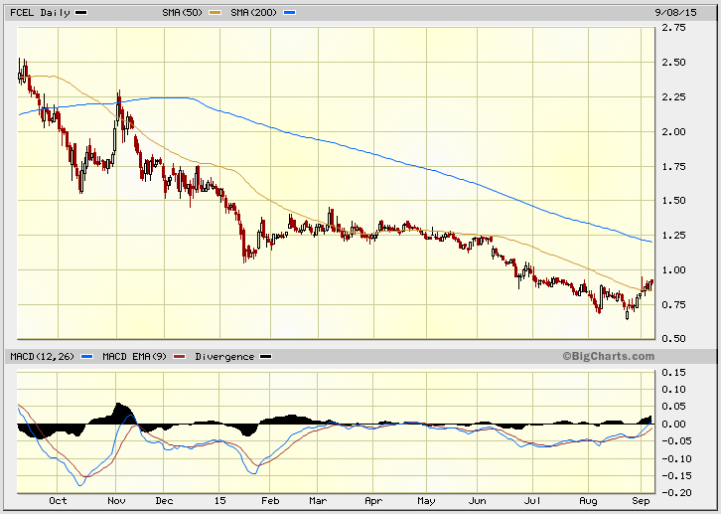

Source: www.bigcharts.com, last twelve months, daily data, MACD.

Lesson: “Green tech” may finally turn blue…

* Beware of potentially spurious “causal” relations!
“He who believes he knows, doesn't know that he believes…”
Structural vs financial leverage…* September 9, 2015.

USO, United States Oil Fund LP [Structural lever: 1 (none)]

UCO, ProShares Ultra Crude Oil (ETF) [Structural lever: 2]

XOM, Exxon Mobil Corp, [Financial lever: (+/-) 2,01]
EOG, EOG Resources, Inc, [Financial lever: (+/-) 1,95]
PXD, Pioneer Natural Resources Co, [Financial lever: (+/-) 1,75]
CVX, Chevron Corp, [Financial lever: (+/-) 1,73]

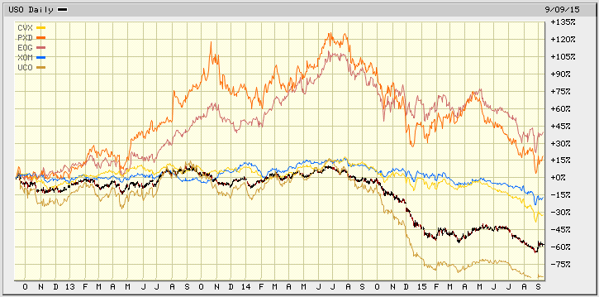

Source: www.bigcharts.com, three years, daily data.

Lesson: And, the winner is “Structural Leverage”…

* Beware of potentially spurious “causal” relations!
“He who believes he knows, doesn't know that he believes…”

A house of cards…* September 10, 2015.

BKF, iShares MSCI BRIC (ETF)

EWZ, iShares MSCI Brazil (ETF)
ERUS, iShares MSCI Russia (ETF)
INDA, iShares MSCI India ETF (ETF)
MCHI, iShares MSCI China ETF (ETF)

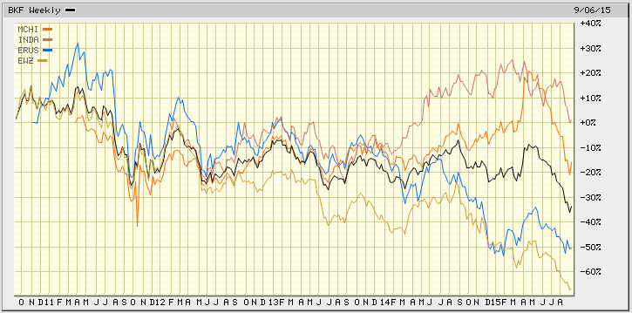

Source: www.bigcharts.com, five years, weekly data.

But…, inverse and/or leveraged ETFs do exist in the BRIC space!
(Search: http://etfdb.com/)

Lesson: The BRICS are broke…

* Beware of potentially spurious “causal” relations!
“He who believes he knows, doesn't know that he believes…”

Market’s current valuation…* September 10, 2015.

S&P 500 Price to Earnings Ratio

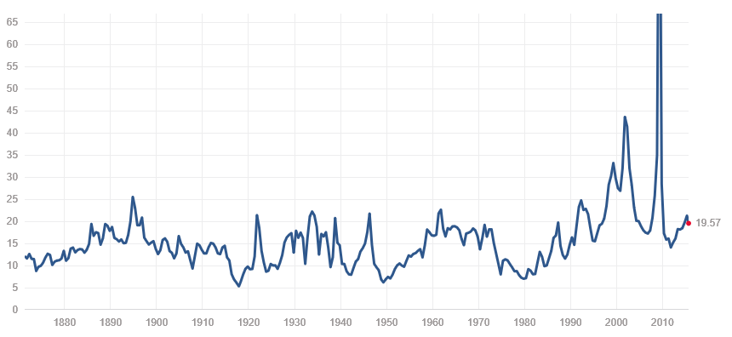

S&P 500 Price to Sales Ratio

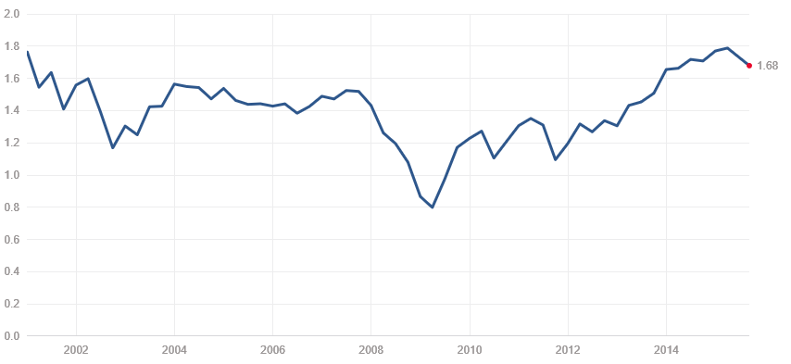

Source: http://www.multpl.com/.

Lesson: Bubbly and expensive, must be Champagne…

* Beware of potentially spurious “causal” relations!
“He who believes he knows, doesn't know that he believes…”

A “Stealth” recovery…* September 10, 2015.

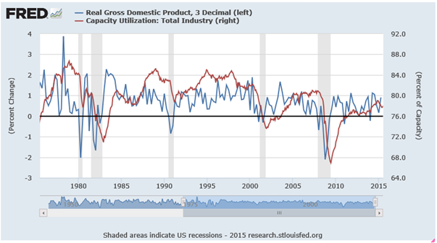

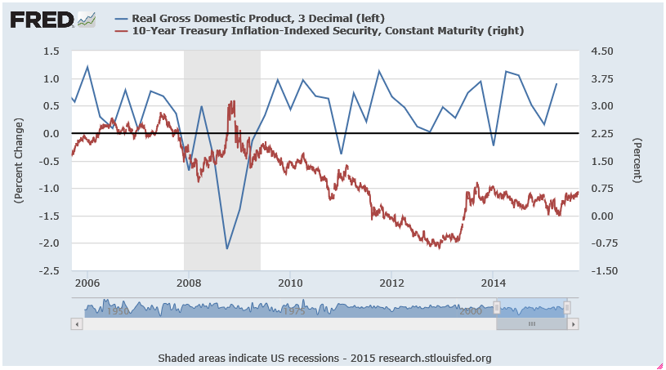

Source: https://research.stlouisfed.org/

Lesson: Weak recovery despite historically accommodative monetary policy…

* Beware of potentially spurious “causal” relations!
“He who believes he knows, doesn't know that he believes…”
This makes perfect sense…* September 12, 2015.
OIL, iPath Goldman Sachs Crude Oil Total Return Index ETN

VLO, Valero Energy Corp.
XOM, Exxon Mobil Corp.
PXD, Pioneer Natural Resources Co.
DO, Diamond Offshore Drilling Inc.

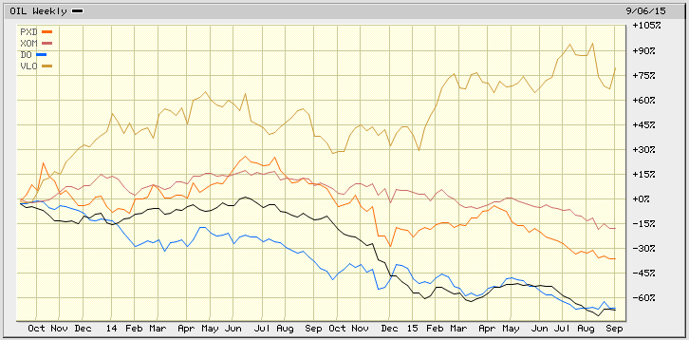

Source: www.bigcharts.com, two years, weekly data.

But…, here is how Morgan Stanley sees oil prices playing out through 2018.

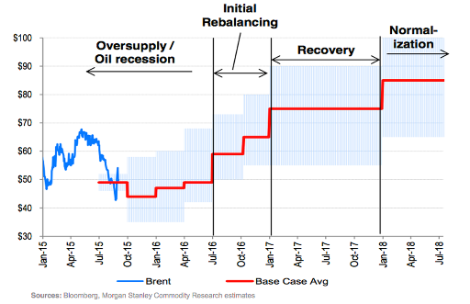

Source: http://uk.businessinsider.com/morgan-stanley-evolution-of-the-oil-cycle-through-2018-2015-9?r=US&IR=T

Lesson: Refining margins are greater than exploration and production margins…

* Beware of potentially spurious “causal” relations!
“He who believes he knows, doesn't know that he believes…”
Markets jaws…* September 13, 2015.

Money is never lost! It changes pocket…

SPY, SPDR S&P 500 ETF Trust (ETF)
SH, ProShares Short S&P500 (ETF)

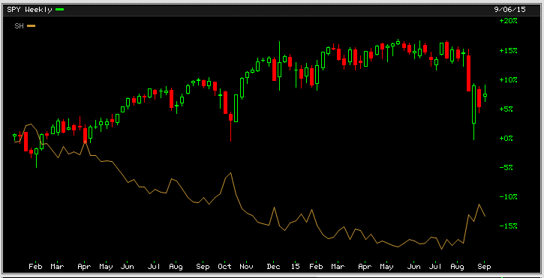

QQQ, PowerShares QQQ Trust (ETF)
PSQ, ProShares Short QQQ (ETF)

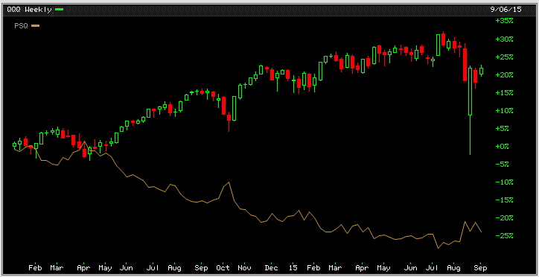

Source: www.bigcharts.com, two years, weekly data.

Lesson: Bulls make money. Bears make money. Pigs get slaughtered…

* Beware of potentially spurious “causal” relations!
“He who believes he knows, doesn't know that he believes…”
Recurrent wows and oops…* September 13, 2015.

ACI, Arch Coal Inc

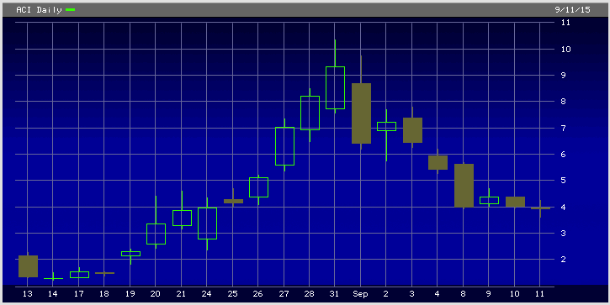

AAPL, Apple Inc.

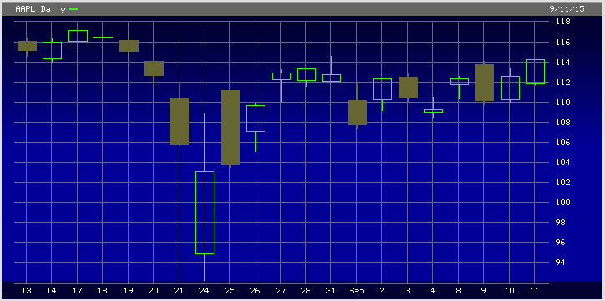

Source: www.bigcharts.com, last month, daily data.

Lesson: Number of believers makes God’s existence more likely than efficient markets…

* Beware of potentially spurious “causal” relations!
“He who believes he knows, doesn't know that he believes…”

The painful Long March…* September 18, 2015.

CN: SHCOMP, Shanghai Composite Index
XAU: PHLX Gold/Silver Index

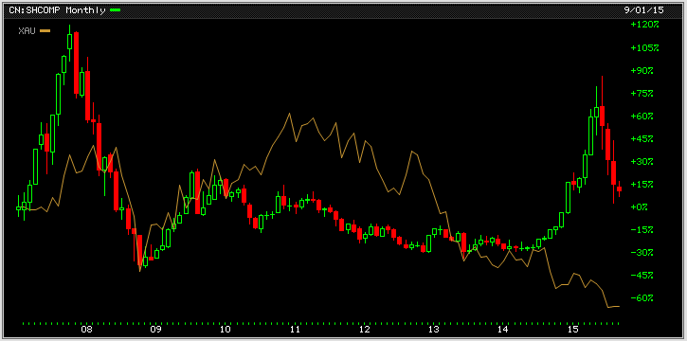

Source: www.bigcharts.com, monthly data, 01/01/2007- 17/09/2015

Question: Is China’s future growth worth that much gold ?…

* Beware of potentially spurious “causal” relations!
“He who believes he knows, doesn't know that he believes…”

Blowin’ in the wind…* September 30, 2015.

VIX, CBOE Volatility Index

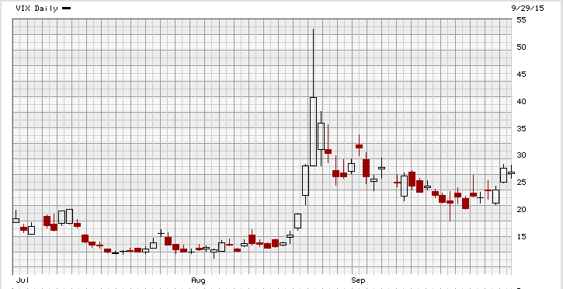

Source: www.bigcharts.com, three months, daily

VXX, Barclays Bank PLC iPath S&P 500 VIX Short-Term Futures ETN

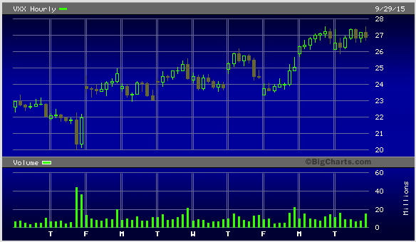

Source: www.bigcharts.com, last ten days, hourly

Lesson: The power of the unexpected… (FOMC decision, VW scandal, EM-FX collapse, Hajj stampede, UN General Assembly). “La réponse est dans le vent…” (H. Aufray)

* Beware of potentially spurious “causal” relations!
“He who believes he knows, doesn't know that he believes…”

