MAVEN’s Imaging Ultraviolet Spectrograph and the Legacy of Charles Barth.
N.M. Schneider¹, W.E. McClintock¹, A.I. Stewart¹, J. Deighan¹, S.K. Jain¹, A. Stiepen¹
¹Laboratory for Atmospheric and Space Physics, University of Colorado at Boulder, 3665 Discovery Drive, Boulder, CO 80303

The Ultraviolet spectrometer onboard Mariner 6 and 7, provided first ultraviolet spectrum of Mars upper atmosphere. These groundbreaking observations were helpful in determining the composition and structure of Martian upper atmosphere [1]. More than 40 years later, the Imaging Ultraviolet Spectrograph (IUVS) onboard MAVEN spacecraft has been observing Martian atmosphere, building on those initial Mariner observations. IUVS instrument carries two detectors: FUV detector (115-190 nm) with a spectral resolution of ~0.6 nm and MUV detector (180-340 nm) with a spectral resolution of ~1.2 nm [2]. In its limb-observing mode, IUVS measures the Martian UV airglow layer in the altitude region of 80 to 220 km with vertical resolutions of ~5 km. Martian dayglow spectra as seen by the IUVS show similar features as observed by Mariner 6 and 7 [1] more than four decade ago, and recently by SPICAM onboard Mars Express [3]. Several atomic and molecular features are seen the detector images, e.g., H Lyman alpha, oxygen emissions at 130.4 and 135.6 nm, carbon emissions at 156.1 and 165.7 nm, and CO Fourth Positive bands in the FUV, and CO Cameron, CO₂⁺ UV doublet bands in MUV, and the OI 297.2 nm line in the MUV. On night-side, IUVS observed widely distributed nitric oxide (NO) ϒ and δ UV bands, which can be used as a tracer to understand the day to night global circulation. These NO emissions are common features in terrestrial airglow [4,5]. Figure 1 shows the comparison of ultraviolet dayglow spectra observed by IUVS and Mariner 6 and 7. The observations made by IUVS along with the other instruments onboard MAVEN spacecraft have started unraveling the mysteries of Martian atmosphere and its evolution.

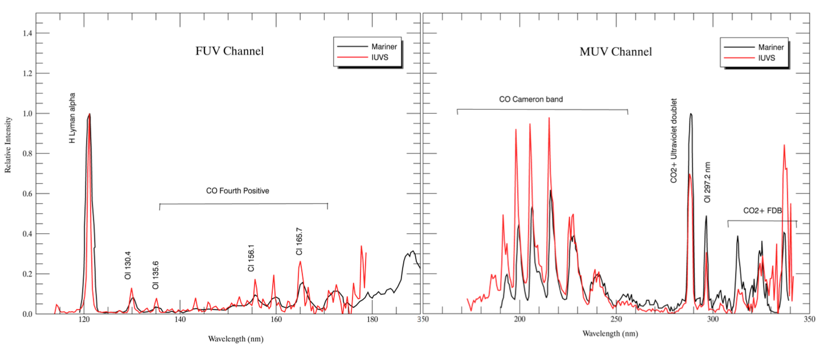
Figure 1: Comparison of Mariner FUV and MUV spectra (average of 120 individual spectra) with IUVS observed FUV and MUV spectrum.

References: [1] Barth C.A., et al. (1971), J. Geophys. Res. 76, 2213-2227. [2] McClintock, W. E. et al. (2014), Space Sci. Rev., doi: 10.1007/s11214-014-0098-7. [3] Leblanc, F. et al. (2006), JGR, 111, E09S11, doi:10.1029/2005JE002664Lett., 40, 2529-2533, doi:10.1002/grl50435. [4] Barth C. A., et al. (2003), J. Geophys. Res., 108(A1), 1027. [5] Barth, C. A. (2010) J. Geophys. Res., 115, A10305.

