TABLE OF CONTENTS

Abbreviations 3

List of figures 7

Introduction 11

1. Vertebrate skeletal tissues 11
a. Cartilage 11
b. Bone 13
2. Zebrafish 15
3. Skeletogenesis in zebrafish 16
I. Zebrafish chondrocranial structures 16
II. Chondrogenesis in the zebrafish head skeleton 19
i. Homeobox transcription factors 22
ii. Transcription factor AP (Activating enhancer binding Protein)-2 alpha 23
iii. Distal-less related homeobox transcription factor 24
iv. SRY (Sex determining Region Y) Box 9 transcription factors 24
v. Runt-related transcription factor 2 27
III. Pharyngeal endoderm patterns cNCC and is required for zebrafish head development. 28
i. casanova and van gogh mutants 28
ii. SRY (Sex determining Region Y) Box 9 transcription factor b 29
iii. Runt-related transcription factor 3 30
IV. Ectoderm 30
V. Cell signaling in cartilage and bone. 31
i. Bone morphogenic protein 31
ii. Hedgehogs 34
4. Zinc finger transcription factors 37
a. EGR family 38
b. EGR1 40
I. General 40
II. Promoter 40
III. Transcriptional regulation 42
IV. Expression pattern 43
V. Functions 43

Objectives of this study 47

Results 49

1. Egr1 is essential for zebrafish pharyngeal cartilage development. 49
2. Egr1 regulates late chondrogenesis in pharyngeal skeleton. 51
3. Egr1 regulates myogenic gene myoD. 55
4. Egr1 is expressed in pharyngeal endoderm and oral epithelium. 56
5. Egr1 is required for pharyngeal endoderm expression of sox9b 59
6. Runx3 controls cartilage development by regulating egr1 and sox9b expression in pharyngeal endoderm. 62
7. Down-regulation of egr1 does not regulate Hh or Bmp ligand expression or Fgf signaling in the pharyngeal region. 66
8. Egr1 down regulates follistatin a expression in pharyngeal endoderm and cartilage. 67
9. BMP signaling is required for pharyngeal cartilage formation and runx2b expression in cartilage. 70
10. Egr1 is required for BMP signaling in the pharyngeal region 74
11. Egr1 is involved in early bone formation. 76
12. Mutation of the egr1 gene causes defects similar to those in egr1 morphants. 77

Discussion & Conclusions 79

1. Endodermal expression of the transcription factor Egr1 is essential for chondrogenesis and ossification. 79
2. Pharyngeal endoderm hosts a regulatory cascade of transcription factors required for formation of the viscerocranium. 80
3. Endodermal signaling controls the BMP pathway in cartilage precursor cells. 82
4. Multiple roles of the pharyngeal endoderm in cranial cartilage formation 85
5. Multiple signaling pathways converge on developing chondrocytes 86
6. Preliminary results of the analysis of egr1 mutant are similar to egr1 morphants 87
7. Egr1 in musculoskeletal development. 88
8. Final conclusions 90

Materials & Methods 93

1. Fish and embryo maintenance 93
2. Loss of function and rescue experiments 93
3. Whole-mount in situ hybridization and immunohistochemisrty. 94
4. Image acquisition 95
5. Alcian Blue staining 95
6. Alizarin Red staining 95
7. Heat shock conditions 96
8. Dorsomorphin treatments 96

Bibliography 97

Abbreviations

A
Alk: anaplastic lymphoma kinase
Aml: acute myeloid leukemia protein
Ap2α: Activating enhancer binding Protein 2 alpha (Tfap2α)
B
Bmp: bone morphogenic protein
BmpR: bone morphogenic protein receptor
C
Cas: casanova
Cbfa: core-binding factor subunit alpha
cNCC: cranial neural crest cells
Col: collagen
CRE: cyclic AMP (adenosine monophasphate) response element
D
Disp: dispatched
Dlx: distal-less homeobox
DMSO: dimethylsulfoxid
dnBMPR: BMPR dominant negative
dpf: days post fertilization
E
Ebs: egr1 binding site
Egf: epidermal growth factor
Egr1: early growth response 1
EMC: extracellular matrix
Erk: extracellular-signal-regulated kinase
F
Fgf: fibroblast growth factor
Fli1: friend leukemia integration
Fsta: follistatin A
G
GAG: glucoaminoglycans
GFP: green fluorescent protein
Gh: growth hormone
I
Ihh: indian hedgehog
H
Hh: hedgehog
hpf: hours post fertilization
Hox: homeobox
Hsp: heat shock protein
J
Jef: jellyfish
K
kb: kilo-base pair
KO: knock-out
Krox: krüppel box
L
Lhβ: luteinizing hormone
Low: lockjaw
M
M-csf: Macrophage colony-stimulating factor
Map: Mitogen activated protein
Mek: Mitogen-activated protein kinase kinase
mM: millimolar
Mmp: matrix metalloproteinase
MO: morpholino
MO spl: splicing morpholino
MO tr: translation morpholino
MOcon: control morpholino
Moz: monocytic leukemia zinc finger
mRNA: messenger ribonucleic acid
MyoD: myogenic différentiation
N
NAB: Ngfi A binding
NCC: neural crest cells
NCD: NAB conserved domain
Nfκb : nuclear factor kappa-light-chain-enhancer of activated B cells
ng: nanogram
Ngf: nerve growth factor
Ngfi A: nerve growth factor induced clone A
Nkx: NK homeobox
O
OA: osteoarthritis
Osx: osterix
Otx: orthodenticle homolog
P
pb: pair base
Pdgf: Plateled-Derived Growth Factor
pg: picogram
Ptc/Ptch: patched
R
RA: rheumatoid arthritis
RT-PCR: reverse transcriptase –polymerase chain reaction
Runx: runt-related
S
Smad: Mothers against decapentaplegic homolog
SRE: serum response element
Srf: serum response factor
SSD: sterol-sensing domain
Shh: sonic hedgehog
Smo: smoothened
Sox: SRY (Sex determining Region Y) Box
Sp1: specific protein 1
T
Tbx: T box
Tcf: ternary complex factor
tgfβ: Transforming growth factor beta
Timp: tissue inhibitors of metalloproteinase
V
Vegf: vascular endothelial growth factor

Z
Zif268: zinc finger clone 268

List of figures

Introduction | Page
Figure 1. Histological sections of hyaline, fibrous and elastic cartilage. | 12
Figure 2. Schematic representation of endochondral bone formation. | 14
Figure 3. Schematic representation of intramembranous bone formation. | 15
Figure 4. Schematic representation of larval (A-C) and juvenile (D-F) zebrafish skull. Lateral (A, D) and ventral (B, C, E, F) views of the viscerocranium (A, C, D, F) and neurocranium (B, E). | 16
Figure 5. Ventral scheme of zebrafish pharyngeal tissue structure at 24 hpf. | 18
Figure 6. Schematic representation of neural crest cell formation and migration from the neural plate. | 20
Figure 7. Schematic representation of cranial neural crest cell differentiation in zebrafish. | 21
Figure 8. Schematic representation of the relation between posterior brain segmentation and migration of neural crests. | 22
Figure 9. Sox9a and Sox9b mutation causes cartilaginous defects in zebrafish development. | 25
Figure 10. Sox9a and Sox9b are essential for bone formation and Sox9b regulates runx2b expression. | 26
Figure 11. A. BMP pathway. | 32-33
Figure 11. B. BMP pathway. | 32-33
Figure 12. Hedgehog (Shh) signaling pathway. | 35-36
Figure 13. Schematic representation of a C₂H₂ type zinc finger. | 38
Figure 14. Schematic representations of EGR proteins. | 40-41
Figure 15. Schematic representation of the regulatory region of the mouse EGR1 gene | 42
Table 1. Zebrafish viscerocranium and neurocranium composition at 6 dpf. | 18-19
Table 2. EGR family members in various vertebrate species. | 40-41
Results
Figure 1. Injection of various concentration of egr1 splicing (spl) morpholino affects head cartilage formation at 4 dpf. | 49-50
Figure 2. Knock-down of egr1 severely affects head cartilage formation at 4 dpf. | 51-52
Figure 3. Only late chondrogenic and osteogenic marker genes display decreased expression in egr1 morphants between 24 and 48 hpf. | 53
Figure 4. Egr1 knock-down does not alter Fli1a expression during chondrogenesis. | 54
Figure 5. Transcription factor Egr1 regulates expression of myoD. | 56
Figure 6. Expression of egr1 in the pharyngeal region between 30 hpf to 5 dpf is restricted to endoderm and epithelium. | 57
Figure 7. casanova mutants, lacking endoderm, do not express egr1 at 48 hpf. | 59
Figure 8. casanova mutants, lacking endoderm, display head cartilage deffects at 4 dpf. | 60
Figure 9. Egr1 is required for expression of sox9b in pharyngeal endoderm. | 61
Figure 10. Endodermal Sox9b is essential for runx2b expression pharyngeal arches. | 62
Figure 11. Runx3 is required for pharyngeal egr1 and sox9b expression at 48 hpf. | 63
Figure 12. Runx3 depleted embryos can be rescued by runx3 and egr1 mRNA. | 65
Figure 13. egr1 expression does not regulate shh expression at 48hpf. | 66
Figure 14. egr1 morphants do not display a variation in expression of Bmp ligands. | 67
Figure 15. casanova mutants, lacking endoderm, do not express sox9b or fsta at 48 hpf. | 68
Figure 16. Expression of fsta is increased in runx3 and egr1 morphants and sox9b mutants. | 69
Figure 17. egr1 and fsta knock-down do not affect ventralisation of cranial neural crest cells. | 70
Figure 18. BMP signaling is required between 27 and 37 hpf for runx2b expression and head cartilage development. | 72-73
Figure 19. Bmp signaling is down-regulated in egr1 morphants. | 75
Figure 20. Egr1 regulates bone formation at 5 dpf. | 76
Figure 21. Homozygous egr1 mutant embryos present cartilaginous defects similar to egr1 morphants. | 77
Figure 22. Homozygous egr1 mutant embryos phenocopy egr1 morphants. | 78

Discussion and Conclusions
Figure 1. Runx3, Egr1 and Sox9b form a regulatory cascade required to modulate Bmp-signaling during cranial cartilage development in zebrafish. | 84

Introduction

Vertebrate skeletal tissues.
The term skeleton derives etymologically from the Greek word skeletos which means « dried ». The skeleton is a rigid animal structure that supports organs, muscles and helps to maintain a certain shape despite Earth’s gravity. The main roles of vertebrates’ endoskeleton are protection, support, locomotion, metabolism of calcium and phosphates, food intake and breathing. Skeletal tissues include different types of specialized connective tissues such as bone, cartilage, ligaments and tendons. Functional differences between these tissues are essentially linked to the nature and proportion of the components of their extracellular matrix (ECM) (Weather 2001).

Cartilage.
Cartilage is an avascular semi-rigid tissue that combines flexibility and firmness. These properties are due to the predominance of an extracellular matrix that is primarily composed of glucosaminoglycans (GAGs), chondroitin sulphates and proteoglycans, but also elastic fibers and collagen fibers. The major type of collagen is type II and in lesser amounts type IX, X and XI.
Cartilage can be subdivided into three different types according to their histology:
- Hyaline: This type of cartilage is the most common cartilage type and is mainly composed of chondrones (group of isogenic chondrocytes) encased into an ECM that is predominantly composed of GAGs and collagen fibers (Fig.1A). Hyaline cartilage also represents the precursor matrix to bone during embryogenesis and endochondral bone formation. This type of cartilage is resistant to deformation. In adult vertebrates, hyaline cartilage can be found in joints, the respiratory system, the epiphyseal growth plate and the most ventral parts of the ribs.
- Fibrous: Also called fibrocartilage, it is a cartilage type where the web of collagen fibers (type I) is much more developed than in hyaline cartilage (Fig.1B). Fibrous cartilage combines the properties of hyaline cartilage, resistance to deformation and the properties of connective tissue, resistance to traction. This type of cartilage is mostly found in intervertebral discs, insertion points of ligament and tendons, meniscus, pubic symphysis and in the temporomandibular joint.
- Elastic: This cartilage is enriched in collagen fibers (type II) and elastin in the ECM and is found in intervertebral discs, joints, outer ear, epiglottis and larynx cartilage. Elastin confers to elastic cartilage the ability to resist to pressure and bending. (Fig.1C)
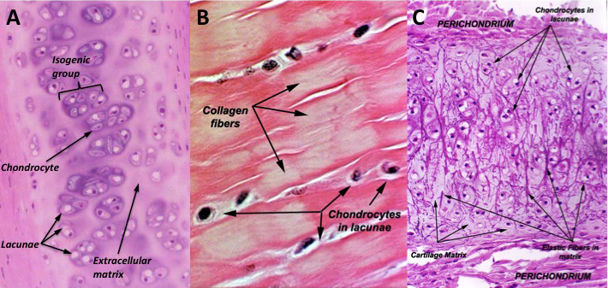
Figure 1. Histological sections of hyaline, fibrous and elastic cartilage.
(A) Hyaline cartilage is characterized by chondrocytes encaged in lacunae and surrounded by a large amount of extracellular matrix. Clusters of chondrocytes in their lacunae form isogenic groups. (B) Fibrous cartilage is formed by a large amount of collagen fibers, chondrocytes are less numerous and more widespread than in other cartilage types. (C) Elastic cartilage is like hyaline cartilage but differs from it due to its high amount of elastic fibers.
http://www.vetmed.vt.edu/education/curriculum/vm8054/labs/Lab7/lab7.htm

Originally, cartilage derives from cranial neural crest cells (cNCCs) and mesoderm. Cartilage arising from cNCCs forms cartilage of the head, while cartilage arising from the mesoderm mainly forms limb and trunk cartilage (Kuo and Erickson 2010). Formation of cartilage begins by the differentiation of primitive mesenchymal cells into chondroblasts. These cells divide and proliferate while synthesizing the fundamental substance and fibrous components of the ECM. Chondroblasts are progressively separated from each other by ECM and are finally isolated in a space called lacuna. They continue their division within this lacuna and form isogenic groups of cells called chondrones. This type of division is called interstitial growth and is only possible if the ECM is not too rigid. When a single, postmitotic chondroblast is encaged in a lacuna, it is called a chondrocyte. Later on, the cartilage only grows by appositional growth on its surface, also called perichondral growth. Perichondrium is a dense irregular connective tissue surrounding the cartilage. The perichondrium is composed of two layers, the inner chondrogenic layer that forms chondroblasts and chondrocytes and the outer, fibrous layer composed of fibroblasts that produce collagenous fibers.

Bone.
Bone is composed of cells and an extracellular collagen matrix called osteoid. Its mineralization is due to a deposit of hydroxyapatite cristals which confers to bone rigidity and considerable solidity. Like in cartilage, the periosteum, which is a fibrous and dense connective tissue, surrounds the external surface of the bone.
In terms of ontogeny, two types of bone are distinguished, endochondral bone and dermal bone.
- Endochondral ossification concerns bones that are preceded by a cartilaginous matrix (Fig.2). The perichondrium acquires an osteogenic potential and plays the role of periosteum. This connective tissue produces osteoblasts secreting unmineralized bone matrix, called osteoid. Osteoblasts that get trapped within the matrix are called osteocytes. A bone collar is being formed.
Meanwhile, chondrocytes within the cartilage matrix become hypertrophic and resorb the surrounding cartilage, only leaving thin perforated trabeculae in the matrix. This matrix progressively calcifies and chondrocytes degenerate. Blood vessels and mesenchymal cells colonize the spaces left by chondrocytes, the latter differentiate into osteoblasts. These osteoblasts produce osteoid that becomes mineralized.
At the beginning, the bone is called woven bone because it is characterized by a random orientation of collagen fibers and is mechanically weak. Later, woven bone will undergo reorganization by osteoclasts and osteoblasts into lamellar bone (haversian bone), which has a regular parallel alignment of collagen into sheets (lamellae) and is mechanically strong. The inner part of the bone is composed of spongy bone, which contains the red marrow and is the center of hematopoiesis. Note that teleost fish (like zebrafish) do no form bone marrow and their hematopoietic center is located in the kidney (Song, Sun et al. 2004).
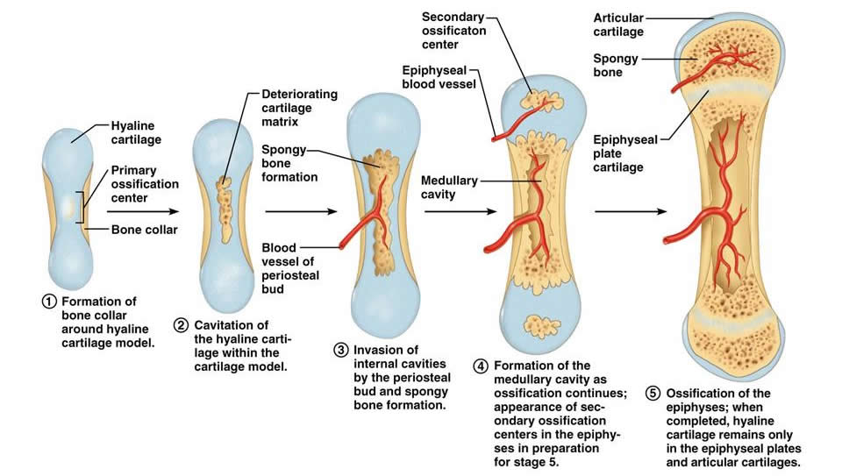
Figure 2. Schematic representation of endochondral bone formation.
1. A bone collar forms around a cartilaginous scaffold. 2.Mature chondrocytes degenerate, leaving a perforated trabeacula cavitation. 3. Blood vessels invade the cavitation, osteoblasts colonize it and secrete osteoid. 4. In long bones, secondary ossification centers form in the epiphyses. 5. The first ossification step is completed.
http://classes.midlandstech.edu/carterp/Courses/bio210/chap06/lecture1.html

- Intramembranous ossification gives rise to dermal bones, which are not built on a cartilaginous matrix (Fig.3). Dermal bones are formed within the derma. The connective tissue forms sheets and is highly irrigated with blood. Some of the mesenchymal cells in this tissue differentiate into osteoblasts and form an ossification center. These osteoblasts secrete bone matrix (osteoid) and will form spongy bone. Osteoblasts getting trapped within the matrix are then called osteocytes. The surrounding connective tissue forms the periosteum and produces more and more osteoblasts. These osteoblasts accumulate at the surface and also produce matrix, which will form compact bone that surrounds the spongy bone. Compact bone is denser and stronger than spongy bone, which contains red marrow. Bones that undergo this type of ossification are flat bones that are usually found on the skull and clavicles.
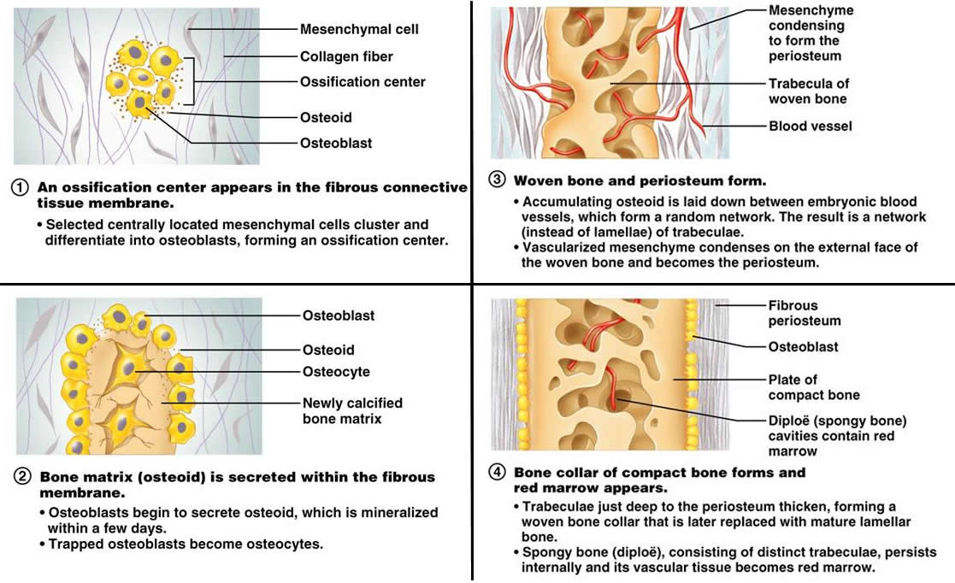
Figure 3. Schematic representation of intramembranous bone formation.
1. Mesenchymal cells within the derma differentiate into osteoblast and form ossification centers. 2. Osteoblasts secrete bone osteoid and osteoblasts captured into this matrix differentiate into osteocytes. 3. Blood vessels colonize the osteoid and periosteum forms. 4. Bone becomes compact on the outer part and red bone marrow develops centrally of the bone.
http://classes.midlandstech.edu/carterp/Courses/bio210/chap06/lecture1.html

Zebrafish.
The zebrafish, or Danio rerio, is a tropical freshwater fish belonging to the Cyprinidae family and to the order of Cypriniformes. The zebrafish is a fabulous vertebrate model organism in scientific research due to its remarkable characteristics such as fully sequenced genome, transparency of the embryos developing outside of the mother, rapid development, availability of mutants and easy manipulation and drug administration.

Skeletogenesis in zebrafish.

Zebrafish chondrocranial structures.
74 bones compose the cephalic skeleton of the adult zebrafish, with 45 endochondral bones of the neurocranium and viscerocranium and 29 dermal bones of the dermatocranium. When the head skeleton is cartilaginous, we talk about the chondrocranium and after ossification, we talk about osteocranium (Nüsslein-Volhard C. 2002).
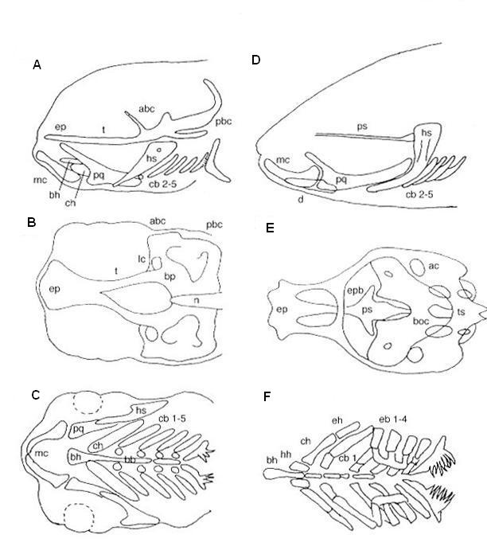
Figure 4. Schematic representation of larval (A-C) and juvenile (D-F) zebrafish skull. Lateral (A, D) and ventral (B, C, E, F) views of the viscerocranium (A, C, D, F) and neurocranium (B, E).
anterior basicranial commisure (abc), auditory capsule (ac), basibranchials (bb), basihyal (bh), basioccipital (boc), basal plate (bp), ceratobranchials (cb), ceratohyal (ch), dentary (d), epibranchial (eb), epihyal (eh), ethmoid plate (ep), epiphysial bar (epb), hypohyal (hh), hyosymplectic (hs), lateral commissure (lc), Meckel’s cartilage (mc), notochord (n), posterior basobranchial commissure (pbc), palatoquadrate (pq), parasphenoid (ps), trabeculae (t), tectum synopticum (ts). (Nüsslein-Volhard and Dahm 2001)

The neurocranium is formed by four capsules; ethmoid, orbital, otic and occipital, which protect the major subdivisions of the brain and the sensory organs (Fig.4B,E).
The viscerocranium (Fig.4A,C,D,F), also called pharyngeal arches, is composed of seven pairs of cartilaginous and bony elements surrounding the pharynx. The two most anterior pairs of arches are called the mandible and the hyoid. The four most posterior pairs carry the gills, while the fifth carries the only teeth of the zebrafish. These five posterior pairs of arches are also known as the branchial arches. Once the embryo has become juvenile (thirty days of development), each branchial arch can contain up to five elements, including basi-, hypo-, cerato-, epi- and pharyngobranchials (table 1) (Vandewalle, Parmentier et al. 1998). At the larval stage, the different elements that compose each branchial arch are not separated and form one single element called the ceratobranchial. It is important to mention that these structures form when the yolk sac is reducing. After hatching, the larvae will be able to feed themselves and the viscerocranium will be vital for predatory life. The viscerocranium of the zebrafish is completely ossified at 21 dpf (days post fertilization).
It is important to mention that the viscerocanium is formed by the interaction of cranial neural crest cells (ectodermal origin), endoderm, mesoderm and ectoderm. Cellular communication via signaling pathways and physical interactions between these tissues are required for correct cartilage formation. Each arch is constituted by a core made of cranial neural crest cells (cNCC) that will differentiate into skeletal cells (Fig.5). Central of each cNCC core, there is a mesodermal core, which will form musculature and endothelial cells. An outer layer of ectoderm surrounds the cNCC; it will form the epidermis and neuronal tissues. The inner endodermal layer will form endodermal pouches, pharyngeal epithelium and gills.
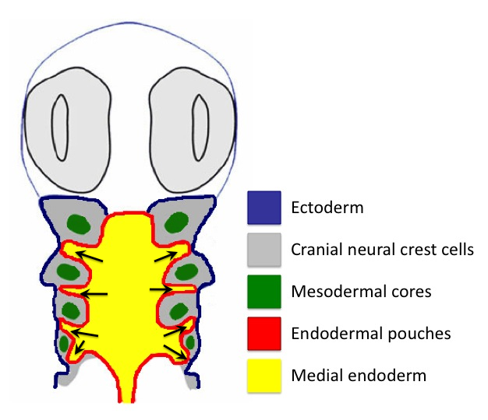 | Figure 5. Ventral scheme of zebrafish pharyngeal tissue structure at 24 hpf.  Each pharyngeal arch is constituted by an inner core of mesoderm (green), surrounded by a core of cranial neural crest cells (grey). The outer layer is formed of ectoderm (blue) and the inner layer is composed of endoderm (yellow) that forms the endodermal pouches (red, arrows).  (Kopinke, Sasine et al. 2006)

The dermatocranium forms the external surface of the skull and surrounds the neurocranium and the two first pairs of pharyngeal arches.

Table 1. Zebrafish viscerocranium and neurocranium composition at 6 dpf (Nüsslein-Volhard and Dahm 2001).
Region | Cartilage elements
Viscerocranium or pharyngeal arches
Pharyngeal arch 1 or  mandible | Meckel’s cartilage
 | Palatoquadrate
Pharyngeal arch 2 or  hyoid | Hyosymplectic
 | Interhyal
 | Ceratohyal
 | Basihyal
Pharyngeal arch 3 or  branchial arch 1 | Ceratobranchial 1
 | Hypobranchial 1
 | Basibranchial 1
Pharyngeal arch 4 or  branchial arch 2 | Ceratobranchial 2
 | Hypobranchial 2
 | Basibranchial2
Pharyngeal arch 5 or  branchial arch 3 | Ceratobranchial 3
 | Hypobranchial 3
 | Basibranchial 3
Pharyngeal arch 6 or  branchial arch 4 | Ceratobranchial 4
 | Hypobranchial 4
 | Basibranchial 4
Pharyngeal arch 7 or  branchial arch 5 | Ceratobranchial 5
 | Basibranchial 5
Neurocranium
Anterior | Ethmoid plate
 | Trabeculae cranii
 | Anterior basicranial commissure
 | Orbital cartilage
Posterior | Posterior basicranial commissure
 | Basal plate
 | Parachordal cartilage
 | Otic capsule
 | Occipital arch

Chondrogenesis in the zebrafish head skeleton.
The chondrocranium derives from two types of tissues, cranial neural crest cells (cNCCs) and mesoderm, while the viscerocranium derives exclusively from the cNCCs (Schilling and Kimmel 1994).
In vertebrates (Fig.6), neural crest cells (NCCs) form bilaterally at the dorsal edge of the neural tube (neuroepithelium) by the end of gastrulation. Later, they loose their adhesive properties, they separate from the neural tube (neural keel in zebrafish) and migrate ventrally to finally give rise to cartilage, neurons, glial cells and pigment cells. NCCs are sometimes referred to as ectomesenchyme, forming the “fourth germ layer” in addition to endoderm, mesoderm and ectoderm.

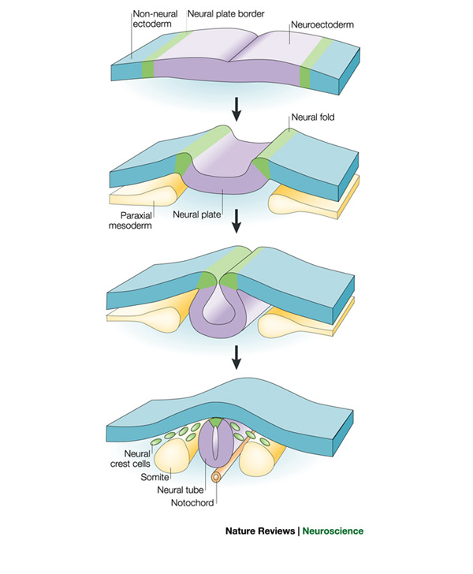
Figure 6. Schematic representation of neural crest cell formation and migration from the neural plate.
The neural plate border (green) is induced by signaling between the neuroectoderm (purple) and the non-neural ectoderm (blue) and from the underlying paraxial mesoderm (yellow). During neurulation, the neural plate borders (neural folds) elevate, causing the neural plate to roll into a neural tube (neural keel in zebrafish). Neural crest cells (green) delaminate from the neural folds or the dorsal neural tube (shown), depending on the species and axial level (Gammill and Bronner-Fraser 2003).

During chondrogenesis, the cNCCs differentiate into chondrocytes and express various genes coding for transcription factors or signaling molecules (Fig.7). Throughout the entire process, they also receive different extracellular signals, which are essential for proper chondrogenesis and morphogenesis of skeletal pieces.
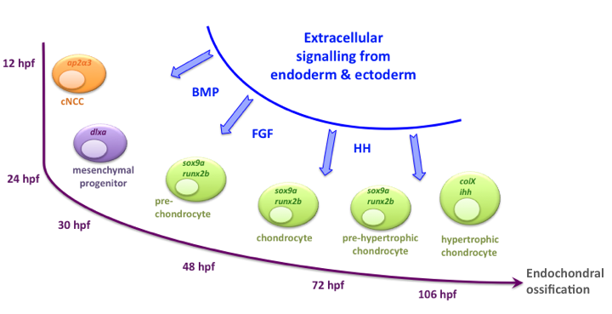
Figure 7. Schematic representation of cranial neural crest cell differentiation in zebrafish.
During chondrogenesis of the viscerocranium, the different cartilaginous elements arise from the cranial neural crest cells (cNCCs). These progenitors differentiate and express various genes such as ap2α3 and hoxa2, which are essential for arch segmentation specification. Later on, cNCCs lose their adhesive properties and express genes such as dlx2a. After their migration, those cells will express other genes crucial for chondrogenesis. Among these, runx2b, sox9a and col2a1. Afterwards, chondrocytes will proliferate and become hypertrophic and finally undergo endochondral ossification.

Based on their original anterior-posterior position along the posterior brain, cNCCs exhibit a segmental organization and specification to form three clusters of cells that migrate and separate into the pharyngeal arches (Fig.8) (Schilling and Kimmel 1994). The first cluster gives rise to the mandible, the second to the hyoïd and the third will separate into five clusters of cells giving rise to the five branchial arches.
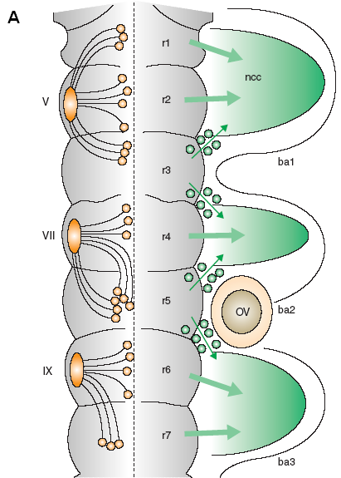 | 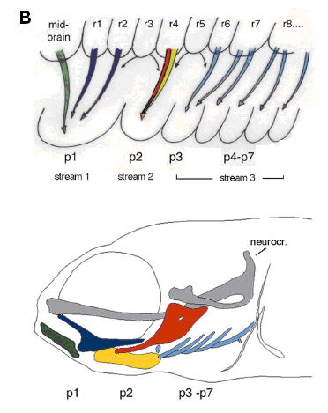
Figure 8. Schematic representation of the relation between posterior brain segmentation and migration of neural crests.
(A) The zebrafish posterior brain is segmented into seven rhombomeres (r1-7). Branchial motor nerves V, VII and IX (orange ellipses) gather the axons of cellular bodies (orange circles) that are located in the different rhombomeres. Cranial neural crest cells (cNCCs) (green circles) migrate laterally (green arrows) from rhombomeres r1, r2, r4, r6 and r7 to pharyngeal arches forming the first three clusters (ba 1-3) (Trainor and Krumlauf 2001). (B) Cranial neural crest cells migrate in three distinct waves. The code of colors on this scheme indicates where the cNCCs originate from the rhombomeres and to which cartilage element they will give rise at 4 dpf (Piotrowski and Nusslein-Volhard 2000). neural crest cells (ncc), otic vesicle (ov), trigeminal nerve (V), facial nerve (VII), glossopharyngeal nerve (IX), rhombomere 1 to 7 (r 1-7), pharyngeal arches 1 to 7 (p 1-7).

Homeobox transcription factors.
Among the genes involved in the anterior-posterior positioning of the diverse skeletal elements, there are the homeobox transcription factors Hox (Homeobox) and Otx (Orthodenticle homolog) (Santagati and Rijli 2003). Like in drosophila and in all vertebrates, the overlapping expression domains of the Hox and Otx genes delimit positional identity (Lumsden and Krumlauf 1996). For example, migrating cNCCs of the second stream (hyoid) are the most anterior cNCCs to express hox genes and derive from the hox2-expressing region of the hindbrain. In contrast, the first stream (mandibular) gives rise to jaws, cells do not express hox genes and derive from hox-negative regions of the anterior hindbrain and midbrain. In chicken, grafts of NCCs from a HOX-negative region of the neural tube to a more posterior HOX-positive region give rise to ectopic mandibular structures in an inappropriate anterior-posterior (A-P) position (Noden 1983). In zebrafish and Xenopus, ectopic expression of hox genes in cNCCs of the first stream leads to ectopic hyoid skeletal elements instead of the mandible (Pasqualetti, Ori et al. 2000; Hunter and Prince 2002).
In most cases, each Hox protein controls the setting of a limited number of skeletal elements and its absence causes dysostosis (alteration of one single or several bones) (Kimmel, Miller et al. 2001). A similar phenotype is also observed in lockjaw (low) zebrafish mutants, where the expression of the transcription factor Tfap2α in cNCC is disrupted. The hox2a gene harbors response elements for the transcription factor Tfap2α and is required in cNNC for hyoid formation. Loss of expression of each of these two, hox2a or tfap2α, genes leads to partial transformation of the mandibular and hyoid elements, especially in the dorsal region of the arch (O'Brien, d'Alencon et al. 2004). In contrast, mutations in the histone acetyltransferase moz (monocytic zinc finger) disrupt the expression of both hox2a and hox2b in the second cNCC stream, but not in the brain. This disruption results in a partial transformation of hyoid elements into mandibular elements (Miller, Maves et al. 2004). These studies in low and moz support the paradigm of independent regulation of hox2 genes in cNCC and in the hindbrain and reveal that the final fate of the cNCC is not dictated only by its positional origin in the hindbrain, but requires signals from adjacent tissues.

Transcription factor AP (Activating enhancer binding Protein)-2 alpha
Long before starting their migration process, cNCCs express among others tfap2α, starting at 12 hpf (8-10 somites) (Knight, Javidan et al. 2005). tfap2α is also expressed in very early ectoderm during late blastula and late gastrula stages. Mutation of this gene (lockjaw) causes defects in all cNCCs derivatives, including craniofacial cartilages and pigment cells. Later on, diverse cartilaginous elements are absent (hyoid) or reduced and pigmentation is decreased. Indeed, in addition to the before-mentioned Hox genes hoxa2 and hoxb2, the transcription factor Tfap2α regulates the expression of dlx2a in cNCCs and kit in pigment cell precursors. Tfap2α is required for melanocyte and iridophore differentiation but also neuronal and glial cell survival. Transplantation of wildtype cNCC into lockjaw embryos rescues hyoid arch outgrowth, but never completely rescues development of all cartilage elements, suggesting that tfap2α may have functions in pharyngeal ectoderm for cartilage development (Knight, Nair et al. 2003; Knight, Javidan et al. 2004).

Distal-less related homeobox transcription factors.
cNCCs lose their adhesive properties and start their migration during neurulation around 12 hpf. Throughout their migration, these cells express members of the Dlx (distal-less-related homeobox) family, which play a major role in proximo-distal polarity within each single pharyngeal arch (Yanagisawa, Clouthier et al. 2003; Sperber, Saxena et al. 2008). The zebrafish has three bi-gene clusters, containing dlx1a and dlx2a, dlx3b and dlx4b, dlx5a and dlx6a (Stock, Ellies et al. 1996). Both genes of each cluster more or less coexpress in the same domains of the pharyngeal cartilage and they have functional redundancies (Ellies, Stock et al. 1997; Qiu, Bulfone et al. 1997). In this family, the most studied and used as marker is dlx2a, which is the first gene of the Dlx family to be expressed in cNCC (14 hpf); its down-regulation leads to an increase of apoptosis and a down-regulation of sox9a expression in cNCCs (Sperber, Saxena et al. 2008).

SRY (Sex determining Region Y) Box 9 transcription factors.
In zebrafish, the Sox9 gene is duplicated into sox9a and sox9b. These two orthologs have been described as presenting redundant as well as distinct expression patterns during embryonic development. Before cNCC migration, sox9a is expressed in the otic vesicle, while transcripts of sox9b are observed in cNCCs, NCCs of the trunk and also in the otic vesicle. After cNCC migration into the arches, sox9a starts to be expressed in cNCCs (Yan, Willoughby et al. 2005). At this stage, cNCCs are considered as pre-chondrocytes. The sox9b gene is expressed first in premigratory cNCC but is downregulated shortly after cNCC migration and starts to be expressed in pharyngeal endoderm (Yan, Willoughby et al. 2005).
Loss of function studies revealed that transcription factor Sox9a is not required for cNCC specification, nor migration. However, Sox9a is absolutely essential for chondrogenesis (Fig.9B,G,L,Q). Indeed, Sox9a directly controls the expression of the col2a1 gene coding for collagen type II, the major collagen type in cartilage (Bell, Leung et al. 1997; Yan, Willoughby et al. 2005). Yan has described the jellyfish mutant, deficient in the sox9a gene (Yan, Miller et al. 2002; Yan, Willoughby et al. 2005) whose phenotype results in a complete absence of pharyngeal cartilages. Concerning osteogenesis (Fig.10G), sox9a disruption results in a complete absence of many endochondral bones (hyomandibular, ceratohyal) and some smaller, dermal bones (dentary, opercular, maxillary), while others remain unaffected (cleithrum) at 5 dpf.
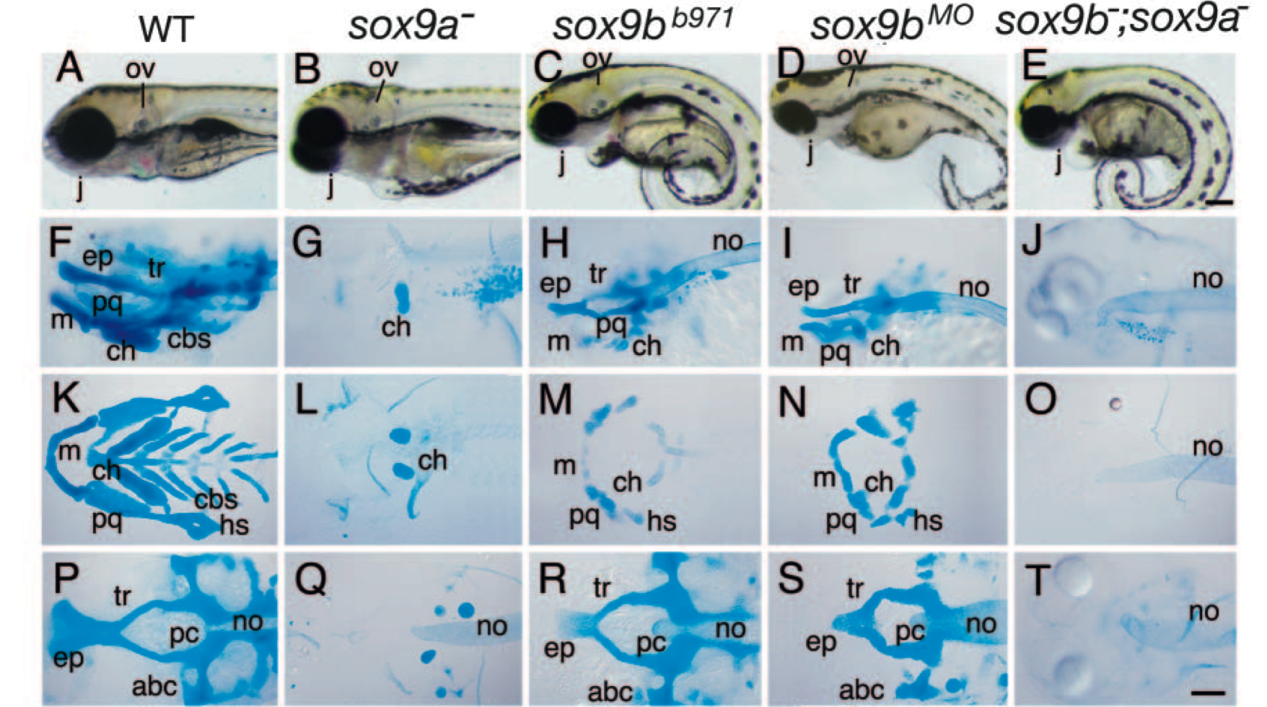
Figure 9. Sox9a and Sox9b mutation causes cartilaginous defects in zebrafish development.
Lateral views of living larvae (A-E), lateral views (F-J) and ventral views of flatmounts (K-O: viscerocranium; P-T: chondrocranium) of Alcian Blue stained larvae. All animals are 4 dpf old. Scale bars 100 μm. anterior basicranial commissure (abc), ethmoid plate (ep), ceratobranchials (cbs), ceratohyal (ch), hyosymplectic (hs), jaw (j), Meckel’s cartilage (m), notochord (no), otic vesicle (ov), parachordal (pc), trabecula.(tr) (Yan, Willoughby et al. 2005).

Yan et al. described a sox9b^{b971} mutant, characterized by cartilaginous and bone defects between 4 and 7 dpf. In contrast to the jellyfish (jef) mutant (sox9a^{-/-}), sox9b^{b971} mutant larvae preserve portions of cranial cartilages. sox9b-disrupted larvae display a reduction in size of the two first arches (mandible and hyoid), the ceratobranchials are absent, whereas the neurocranium is merely reduced (Fig.9C,D,H,I,M,N,R,S). Like the sox9a gene, sox9b does not influence tfap2α expression in premigratory cNCC, however, only sox9b^{b971} mutation leads to smaller pre- and postmigratory dlx2 gene expressing cell population domains. Both mutants, sox9a^{-/-}and sox9b^{-/-}, exhibit a severe reduction of col2a1 expression in postmigrating cNCC. sox9b deficient embryos express runx2b only in the cleithrum (Fig.10C) and in a small portion of the neurocranium, while this expression remains unaffected in jellyfish mutants (Fig.10B). Bone analyzes by Alizarin red staining reveals that Sox9b is absolutely required for development of endochondral bone and dermal bone in cephalic and pectoral fin skeletons (Fig.10H). Indeed, sox9b deficiency leads to a total absence of any bony elements; only drafts of the opercula and the cleithrum are present (Yan, Willoughby et al. 2005).
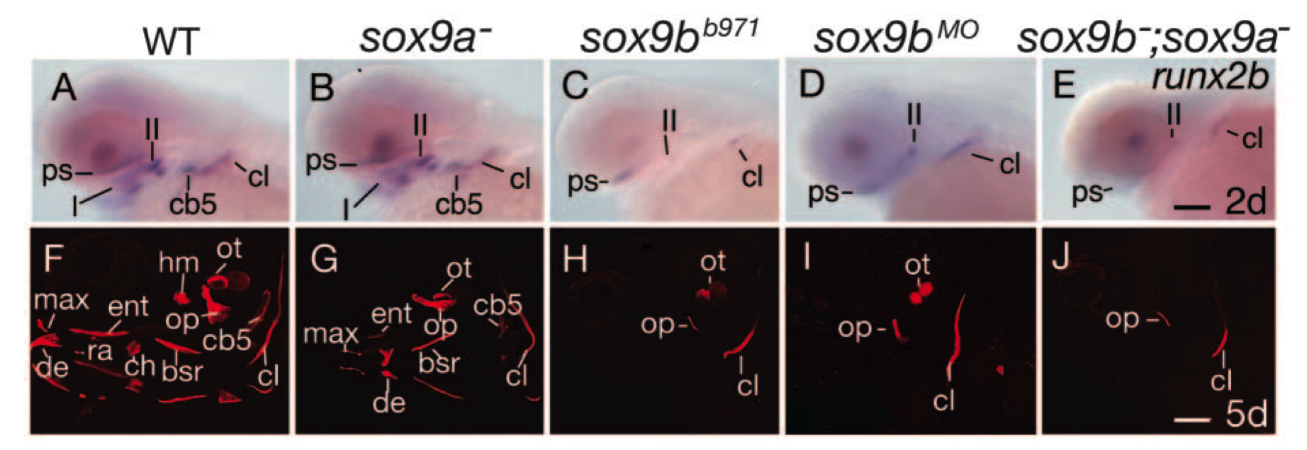
Figure 10. Sox9a and Sox9b are essential for bone formation and Sox9b regulates runx2b expression.
(A-E) In situ hybridizations of runx2b on sox9a mutants, sox9b mutants and morphants and double sox9a and sox9b mutants at 48 hpf. sox9b^{-/-} (C), sox9b morphants (D) and double mutants sox9a^{-/-};sox9b^{-/-} do not express runx2b in pharyngeal arches. (F-J) Alizarin Red staining of the calcified bones on 5 dpf old larvae. Sox9b deficient larvae (H-J) do not develop dermal, nor endochondral bone, while sox9a deficient larvae only fail to develop endochondral bones (Yan, Willoughby et al. 2005). ﬁrst pharyngeal arch (I), second pharyngeal arch (II), brachiostegal rays (bsr), ceratobranchial arch 5 (cb5), ceratohyal (ch), cleithrum (cl), dentary (de), entopterygoid (ent), hyomandibular (hm), maxilla (max), opercle (op), otolith (ot), parasphenoid (ps), retroarticular (ra). Scale bar: in J, 100 µm.

The sox9a;sox9b double-mutant phenotype is additive: chondrocytes do not stack in sox9a mutants and do not expand properly in sox9b mutants, whereas compound mutants fail to do either, resulting in more severe craniofacial defects (Yan, Miller et al. 2002). These double mutants completely fail to form cartilage (Fig.9E,J,O,T) and bones (Fig.10E,J), only partial cleithrum and opercula are observable at 5 dpf. Taken together, these results suggest that Sox9a is more important for endochondral bone formation, while Sox9b plays a role for both endochondral and dermal bone formation in skeletal head and pectoral fin formation.

Runt-related transcription factor 2.
The RUNX family, RUNX1 (AML1), RUNX2 (CBFA1) and RUNX3 (AML2), is composed of DNA-binding transcription factors that regulate the expression of genes involved in cellular differentiation and cell cycle progression. RUNX1 plays a crucial role in hematopoiesis and its loss of function is frequently observed in leukemia (Speck and Gilliland 2002). RUNX3 is best characterized in neurogenesis of the dorsal root ganglia (Inoue, Ozaki et al. 2002; Kramer, Sigrist et al. 2006) and is considered as tumor suppressor in stomach cancer (Bae and Choi 2004; Ito, Chuang et al. 2011). In humans and mouse, RUNX2 haploinsufficiency causes a hereditary congenital bone disorder called cleidocranial dysplasia (Lee, Thirunavukkarasu et al. 1997; Mundlos, Otto et al. 1997; Otto, Thornell et al. 1997). The absence of Runx2 causes a failure of endochondral and intramembranous ossification (Otto, Thornell et al. 1997). Affected mouse embryos do not develop any bones and die at birth after respiratory failure. Detailed investigations have shown that these mice fail to express alkaline phosphatase, an early marker of osteoblast differentiation. These mice lack osteoblasts and vascularization of the bone marrow. Humans who are carrying this disease are viable but have a delay in the ossification of midline structures. People with RUNX2 haploinsufficiency have severe skeletal defects, such as hypoplasia or aplasia of clavicles, permanent teeth leading to supernumerary teeth, prognathic with a protrusive mandible due to hyperplasia of facial bones, frontanelles fail to close, bones and joints are underdeveloped and their stature is short (Mundlos, Otto et al. 1997). The loss of functional RUNX2 affects both intramembranous and endochondral ossification, like in mice mutants.
In zebrafish, the Runx family is represented by four genes, runx1, orthologs runx2a and runx2b and runx3. In pharyngeal skeletal development, runx1 is expressed in the epithelium, runx2a and runx2b in mesenchymal condensations (cNCC) and runx3 in endoderm (Flores, Lam et al. 2006). The function in skeletogenesis of each gene was studied by morpholino microinjection: runx1 and runx2a knock-down only caused a mild delay in chondrogenesis of pharyngeal arches, while runx2b and runx3 expression have proven to be absolutely required for pharyngeal cartilage development. runx2b down-regulation causes absence of all pharyngeal arches and defects in the neurocranium, whereas loss-of-function of runx2a has no influence on zebrafish cranial chondrogenesis. Runx2b plays a key role in chondrocyte maturation but also in osteoblast differentiation (Flores, Lam et al. 2006). Embryos lacking Runx2b fail to develop hypertrophic chondrocytes and osteoblasts do not differentiate. Flores et al. have shown that the expression of runx2b is dependent of Runx3, but they did not show by which signaling pathway (Flores, Lam et al. 2006). runx2a and runx2b are differentially expressed throughout zebrafish head skeletal development. During their maturation, the mesenchymal condensations resulting from migration of cNCCs express runx2a and runx2b. Starting at 44 hpf, runx2a is expressed at low levels in operculum and cleithrum, which are the two first intramembranous bones to form in zebrafish. runx2a transcripts are also observed at higher levels in the mandible from 40 hpf until at least 3 dpf and starting at 44 hpf in basicranial cartilage such as trabecula cranii, ethmoid plate and parachordal. runx2b expression starts much earlier, at 34 hpf, in the basicranial cartilage, more specifically in the trabecula cranii. At 40 hpf, this expression extends to all pharyngeal cartilages, operculum, ethmoid plate and cleithrum and continues at least until 3 dpf.

Pharyngeal endoderm patterns cNCC and is required for zebrafish head development.
During development, pharyngeal endoderm plays a crucial role in patterning of the cNCC-derived skeleton. Indeed, like in all vertebrates, a series of pharyngeal pouches or slits subdivide the pharyngeal arches of the embryo; these pouches are derived from endoderm. The cNCC will differentiate between these endodermal pouches into cartilage (David, Saint-Etienne et al. 2002). It has been proven that the endoderm physically interacts with cNCCs and that its absence, reduction or malformation causes severe cartilage alterations or absence of diverse cartilaginous elements (David, Saint-Etienne et al. 2002). Endodermal pouches guide cNCC migration into arches and missing or malformed endodermal pouches lead to streams of cNCC that often do not separate from each other.

casanova and van gogh mutants.
Screening of mutants during mutagenesis programs have led to the identification of many mutants with craniofacial defects due to absence or alteration of endodermal pouches (Piotrowski, Schilling et al. 1996; Schilling, Piotrowski et al. 1996). Their detailed study has allowed identification of the mutated genes and led to a better understanding of their function in cartilage development. The endoderm-deficient mutant casanova (cas, mutation of the sox32 gene) fails to develop pharyngeal cartilages entirely, while neurocranial cartilage remains unaffected. These specific defects can be restored by transplantation of wild-type endoderm into casanova mutants, suggesting that cNCCs contributing to pharyngeal cartilages depend on the presence of pharyngeal endoderm (Alexander, Rothenberg et al. 1999; David, Saint-Etienne et al. 2002). Disruption of tbx1 (in the van gogh mutant) does not result in the absence of endoderm, but in a failure of endodermal pouch formation and a disorganization of mesodermal cores, which leads to an absence of cNCC segmentation into distinct elements. Pharyngeal cartilage is reduced or lost. Similar to casanova mutants, a transplantation of wild-type endoderm can rescue the van gogh defects (Piotrowski, Ahn et al. 2003). These mutant analyzes clearly reveal the importance of endoderm in ventral head skeletal differentiation and patterning.

SRY (Sex determining Region Y) Box 9 transcription factor b.
Studies of other mutants and genes expressed in endoderm support the fact that pharyngeal endoderm plays a crucial role in cranial cartilage development in zebrafish, similar to other vertebrates. As referred above (section 3.a.II.iv), the sox9b gene is expressed first in premigratory cNCC but is downregulated shortly after cNCC migration and starts to be expressed in pharyngeal endoderm (Yan, Willoughby et al. 2005). The sox9b^{b971} mutant is characterized by an absence of ceratobranchials, reduced mandible and hyoid elements and a slightly reduced neurocranium. As mentioned previously, this mutant does not express runx2b in the viscerocranium, but still in the cleithrum and neurocranium at two days of development. Sox9b is also essential for development of endochondral and dermal bone in cephalic and pectoral fin skeleton (Yan, Willoughby et al. 2005). The signaling pathway that links endodermal Sox9b to Runx2b expression in cartilage has not yet been identified.

Runt-related transcription factor 3.
An additional member of the runt-related factor family, Runx3 is also expressed in pharyngeal endoderm and plays a crucial role in cranial cartilage development (section 3.a.II.v). runx3 is expressed in pharyngeal endoderm starting at 34 hpf until at least 3 dpf, but at 4 dpf it starts also to be expressed in mature chondrocytes. Knock-down experiments using morpholino injection have shown its role on runx2b expression in cartilage precursor cells, down-regulation of runx3 results in a complete absence of the viscerocranium and of the anterior part of the neurocranium. Thus, Runx3 has a crucial function in chondrogenesis, but also in osteogenesis by regulating runx2b expression. On the other hand, runx3 morphants have no morphological abnormality in pharyngeal endoderm, thus it can be concluded that Runx3 has no action on formation and survival of endodermal cells (Flores, Lam et al. 2006).

Ectoderm.
A second set of epithelial-mesenchymal interactions occurs in cranial skeletal development between cNCC and the surface ectoderm, which forms epidermis.
Studies of the previously described tfap2α (section 3.a.II.ii) and its close relative tfap2β support a role for the ectoderm in craniofacial patterning in zebrafish. tfap2α is expressed in cNCC and in the ectoderm, while tfap2β mRNA is found exclusively in ectoderm. Depletion of Tfap2ß has no or little effect on the cranial skeleton, probably due to functional redundancy with ectodermal Tfap2a, while the deficiency in expression of both factors leads to an absence of both pharyngeal and neurocranial cartilages. The defect in this double deficient animals is also much more important than in lockjaw mutants (tfap2α gene mutation), indicating that ectoderm is involved in cartilage development. The facial ectoderm shows a high level of apoptosis in embryos lacking both orthologs and transplantation of wild type ectoderm rescues cartilage development (Schorle, Meier et al. 1996; Knight, Nair et al. 2003; Knight, Javidan et al. 2005).

Cell signaling in cartilage and bone.
As mentioned above, cartilage and bone interact with the different surrounding tissues both physically and molecularly. Different signaling pathways are well known for their crucial role in cartilage and bone development. These signaling pathways are composed of secreted ligands that bind to and activate a membrane receptor. In this manuscript, we will cover two major signaling pathways, the bone morphogenic protein (BMP) and hedgehog (Hh) pathwaysthat are very conserved among vertebrates and which interact together to form and maintain the skeleton.

Bone morphogenic protein.
Bone morphogenic proteins (BMP), as their name suggests, were originally discovered for their function in bone and cartilage formation. BMPs are found in vertebrates as well as in invertebrates and have a broad spectrum of biological activities in various tissues such as kidney, liver, lungs, neuronal and hematopoietic development, tooth and of course bone and cartilage. They are members of the BMP/transforming growth factor β (TGFβ) family and more than a dozen of these factors have been classified in the BMP subfamily. BMP ligands are secreted (autocrine, paracrine, endocrine) and bind to type II serine/threonine kinase receptor dimers (homo- or heterodimers), causing the recruitment of type I (Alk-X) serine/threonine kinase receptor dimers (homo- or heterodimers) to form a hetero-tetrameric complex with the ligand. Type I receptors transduce their signal inside the cell by phosphorylating receptor-regulated Smads (R-Smad) (Wrana, Attisano et al. 1992; Kim and Choe 2011). There are five R-Smads: Smad1, Smad2, Smad3, Smad5 and Smad9 (also referred as Smad8). Once phosphorylated, R-Smad has a high affinity to a co-Smad (Smad4) and forms a complex with it. This complex enters the cell’s nucleus and initiates transcription of its target genes by binding to the promoter and cofactors. Two other Smads complete the Smad family, Smad6 and Smad7, which are inhibitory Smads (I-Smad). I-Smads either compete with R-Smads for type I receptor binding and prevent their phosphorylation, or bind to co-Smads and inhibit their binding to R-Smads. A further complexity is brought to the system by the existence of extracellular inhibitors, such as Noggin, Chordin or Follistatin, which bind to BMP ligands and prevent their binding to their receptors. These inhibitors block activation of Bmp signaling.
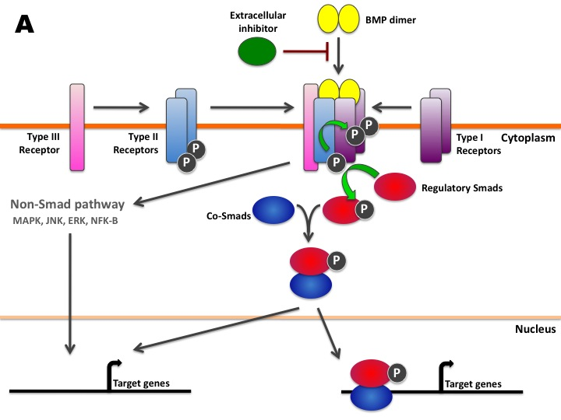

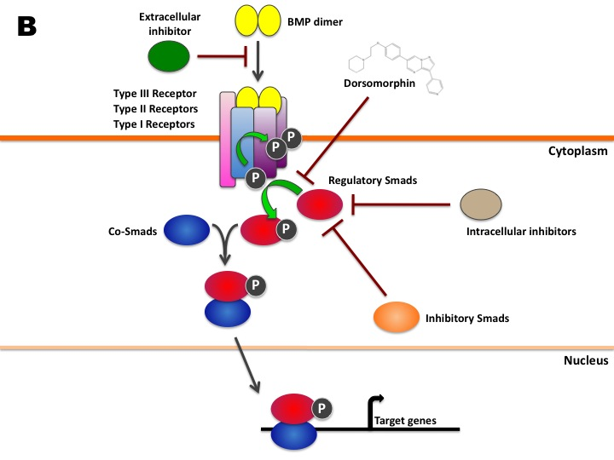
Figure 11. A. BMP pathway.
A secreted BMP dimer binds to its receptor complex. Once the BMP dimer is bound to its receptors, the active kinase domain of receptor II phosphorylates receptors I and III. In turn, receptor I then activates the Smad pathway by phosphorylating regulatory R-Smads. The phosphorylated R-Smad associates with a co-Smad and forms a complex that translocates into the nucleus to initiate transcription of various genes. BMPs can also signal through non-Smad pathways, notably via MAPK, ERK, JNK, NFκ-B etc.
B. BMP signaling inhibitors.
Extracellular inhibitors such as Noggin, Chordin, Follistatin, etc. can block receptor activation by binding to the BMP ligands. Various molecules and proteins such as inhibitory I-Smads (Smad6 and 7), intracellular inhibitors (Smurfs) and drugs such as dorsomorphin can suppress phosphorylation of R-Smads. All these inhbitors are able to block the BMP signaling pathway.

BMP signaling plays an essential role for chondrocyte and osteoblast differentiation and maturation, especially during endochondral ossification. Among the BMP ligands that stimulate chondrocyte and osteoblast differentiation are Bmp2, Bmp4, Bmp6 and Bmp7 (Nishimura, Hata et al. 2008). Various studies in mice have shown that BMPs regulate transcription factors such as Runx2, Osterix, Msx2 and Sox9, crucial for cartilage and bone formation (Nishimura, Hata et al. 2008). Bmp2 and Bmp7 possess an osteoinductive signaling capacity and are required for Runx2 expression in mouse (Lee, Hong et al. 2002; Tou, Quibria et al. 2003). They are expressed in prehypertrophic and hypertrophic chondrocytes during endochondral bone formation and are essential for cell proliferation and maturation (Shu, Zhang et al. 2011). Analyses of Bmp7 have revealed its essential role in cartilage repair after injury (Chubinskaya, Hurtig et al. 2007; Che, Zhang et al. 2010). Bmp receptors (BmpR) are similarly required for skeletal development (Fujii, Takeda et al. 1999; Zhao, Harris et al. 2002). Studies on transgenic mice expressing a truncated, dominant-negative BmpR-IB under the control of the type I collagen promoter have shown that BmpRs are essential for postnatal bone growth in mice (Zhao, Harris et al. 2002). R-Smads (Smad1, Smad5, Smad8) and co-Smad (Smad4) similarly play a critical role as transcriptional regulators in osteoblastogenesis and chondrogenesis (Fujii, Takeda et al. 1999). However, Smad proteins and Bmp receptors are ubiquitously expressed in many tissues and it is therefore difficult to conceive regulatory models for osteoblastogenesis and chondrogenesis that involve BMP-Smad signaling.
Like in mice, Bmps play a crucial role in zebrafish cartilage and bone development. Various Bmp genes are transcribed in endodermal pouches of the pharyngeal arches, such as bmp2a, bmp2b, bmp4, and bmp5 (Holzschuh, Wada et al. 2005). Bmp signaling has been shown to be essential for fin regeneration (Smith, Avaron et al. 2006). Using Chordin as Bmp inhibitor, Smith et al. have demonstrated that there is an alteration in the maturation of bone-secreting cells, reduction of bone-matrix deposition but also a downregulation of runx2a/b, sox9a/b and col10a1, all of which are crucial for chondrocyte and osteoblast maturation. Bmp receptor type I, Alk8, has been clearly identified to be required for cranial neural crest cell (cNCC) formation (Payne-Ferreira and Yelick 2003). Analyses of alk8 mutants, laf (lost-a-fin) and dominant-negative alk8 transgenic lines revealed that an altered alk8 function results in patterning defects of premigratory cNCC and, as a consequence defects in cartilage development. Recent studies have shown that Bmps play an essential role in dorso-ventral patterning of the craniofacial skeleton (Alexander, Zuniga et al. 2011; Zuniga, Rippen et al. 2011). These studies have shown that Bmp signaling is also required for ventral arch development in cNCCs just after their migration. By blocking Bmp signaling using dominant-negative Bmp transgenics, specific ventral markers, such as edn1, hand2 and dlx6a were reduced while, on the other hand dorsal marker expression domains were enlarged, such as that for jag1b. These effects lead to the loss or reduction of ventral and intermediate cartilage elements and the misshaping of dorsal elements. On the other hand, an overexpression of Bmps causes a dorsalization of ventral elements, specific ventral markers expand in a more dorsal position.

Hedgehogs.
The Hedgehog (Hh) protein was first discovered in the fruitfly, Drosophila melanogaster as a determinant for segment antero-posterior polarity in the developing larvae. Its mutation causes fruitfly embryos to be covered with small projections, making them look like a hedgehog. In vertebrates, three different homologs have been discovered; sonic hedgehog (Shh), indian hedgehog (Ihh) and desert hedgehog (Dhh). The hedgehog signaling pathway is involved in numerous functions, such as patterning the nervous system, limbs, teeth, notochord, lungs, etc.
In vertebrates, Hh ligands are cleaved and a cholesterol molecule is added to the carboxyl end of the N-terminal domain (Fig.12). This cleavage is absolutely required for proper Hh signaling, while the cholesterol residue allows the Hh ligand to bind to cell membranes and is essential for secretion of the Hh ligand. Disruption of the cleavage leads to developmental disorders such as holoprosencephaly, which is characterized by a failure of the brain to form two hemispheres and craniofacial defects, including midline facial cleft and cyclopia (Roessler, Belloni et al. 1996; Maity, Fuse et al. 2005; Roessler, Ma et al. 2009). Diffusion of Hh is also restricted through sequestration by its receptor Patched (Ptch or Ptc). Hh can signal either in an autocrine or in a paracrine way. During paracrine signaling, the Hh ligand requires participation of the dispatched protein (Disp). The Disp protein modifies the cholesterol residue to release the Hh ligand coupled to its cholesterol-modified molecule from the membrane (Burke, Nellen et al. 1999; Kawakami, Kawcak et al. 2002). Hh reaches its target cell and binds to its receptor Patched (Ptch1, Ptch2). In absence of Hh ligands, Ptch inhibits Smoothened (Smo). Ptch has a sterol-sensing domain (SSD), which has been shown to be essential for suppression of Smo activity. It is suggested that Ptch regulates Smo by removing oxysterols from Smo like a pump (Strutt, Thomas et al. 2001). Upon binding of a Hh protein or a mutation in the SSD of Ptch, the pump is turned off, thereby allowing oxysterols to accumulate around Smo (Corcoran and Scott 2006). This accumulation of oxysterols leads to the activation of Smo, which in turn activates the zinc finger proteins Gli. Activated Gli accumulates in the nucleus and controls the transcription of hedgehog target genes.
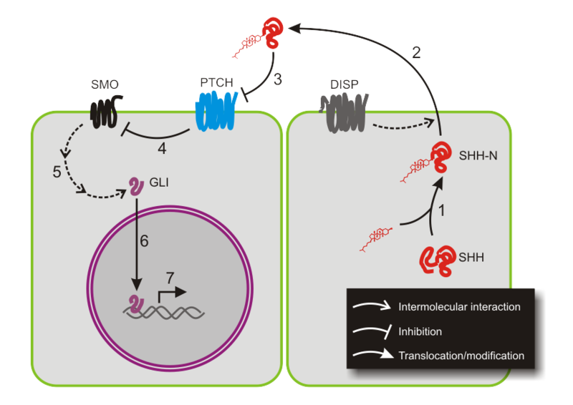

Figure 12. Hedgehog (Shh) signaling pathway.
(1) Sonic hedgehog (Shh), the Hh ligand, is cleaved and linked to a cholesterol molecule at its N-terminus. (2) Dispatched (Disp) enables Shh to be secreted. (3) Shh binds to Patched (Ptch) and (4) Ptch inhibition on Smo is lifted. (5) Smo activates Gli, which translocates into the nucleus (6) and activates transcription of target genes (7).
(Figure from Peter Znamenskiy, donated to public domain)

Hh signaling is known to have a critical role in vertebrate skeletal development. Mice lacking Ihh display abnormal chondrocyte proliferation and maturation and an absence of mature osteoblasts in prenatal enodochondral bone formation (St-Jacques, Hammerschmidt et al. 1999). Ihh controls chondrocyte hypertrophization by forming a negative feedback loop with parathyroid hormone related protein (PTHrP). Pthrp binds to its receptor Pthr1 and inhibits Ihh expression, with the consequence to keep chondrocytes in a proliferative state and not becoming hypertrophic. If Pthrp is absent, chondrocytes become hypertrophic. More recent studies have revealed that Ihh regulates chondrocyte and osteoblast development independently of Pthrp expression as well (Long, Zhang et al. 2001; Kobayashi, Soegiarto et al. 2005; Maeda, Nakamura et al. 2007; Mak, Kronenberg et al. 2008). shh^{-/-} KO mice (Chiang, Litingtung et al. 1996; Yamagishi, Yamagishi et al. 2006) also present a loss of craniofacial elements. Shh is essential for mesenchymal cell survival in pharyngeal arches.
In zebrafish, various mutants have confirmed that Hh signaling is required for proper chondrocranium formation. The chameleon mutant, lacking functional Disp, displays reduced mandible, hyoid arches and a complete lack of ceratobranchials (Schwend and Ahlgren 2009). This mutant succeeds in cNCC specification and migration, however the cNCCs differentiate into fibrous connective tissues rather than into chondrocytes. Chameleon larvae do not express key-genes for cartilage formation such as dlx2 and sox9a, but also bapx1 and gdf5 that are essential for joint formation. smo^{-/-} receptor mutants in zebrafish (Chen, Burgess et al. 2001) also present a loss of craniofacial elements. Treating zebrafish embryos with the Hh signaling inhibitor cyclopamine (binds to Smo) leads to cranial defects (Schwend and Ahlgren 2009). Treatments between 4 and 12 hpf cause defects in cNCC patterning and between 32-48 hpf inhibit differentiation of cNCC into chondrocytes (Schwend and Ahlgren 2009). The Hh ligand Ihh is also involved in endochondral bone formation. Ihh promotes hypertrophy of chondrocytes and is essential for maintenance of the growth plate and trabecular bone (Maeda, Nakamura et al. 2007; Mak, Kronenberg et al. 2008). Skeleton development involves multiple signaling pathways that also interact with one another. Studies have demonstrated that the Gli2 protein, mediating Hh signaling, directly regulates transcription of bmp2 during osteoblast maturation (Zhao, Qiao et al. 2006). Hammond et al. have recently shown that an increased Hh signaling leads to premature mineralization of endochondral bones (Hammond and Schulte-Merker 2009). Detailed analyses of Hh receptor ptc1/2 mutants showed that their early-mineralized bone was characterized by an upregulation of osterix (osx), a master regulator of osteoblast differentiation, when compared to wild-type siblings. On the other hand, disruption of Ihh in cranial skeletogenesis leads to a severe delay of endochondral bone formation. Together with Fgfs, Hhs are also well studied in limb growth. Shh signaling is required for anterior-posterior patterning of the limb bud in vertebrates; Shh expression in the posterior limb bud is regulated by Fgf signaling also controlling proximal-distal limb outgrowth (Towers, Mahood et al. 2008; Zhang, Verheyden et al. 2009).

Zinc finger transcription factors.
The molecular processes that control skeletal development are various, involving hormones, extracellular factors, membrane receptors and transcription factors. Among the transcription factors, binding specifically to DNA through their binding site, the zinc finger family is the largest, but only a few of them are involved in cartilage and bone development.
Zinc fingers are small protein structural motifs that are highly conserved and frequently involved in protein-nucleic acid interaction (Pellegrino and Berg 1991). Each zinc finger is composed of a group of conserved amino acids, four of which bind to one or more zinc ions to help stabilize their folds. There are different types of zinc finger domains, among which the C2H2 type is by far the best-characterized (Fig.13). Actually, the first described zinc finger was a C2H2 type. It was identified in the transcription factor TFIIIA in Xenopus laevis, which is involved in transcription of the 5S RNA gene contributing to the large subunit of the ribosomes. This motif is composed of 25 to 30 amino acids and contains two conserved cysteines and two conserved histidines. Its consensus sequence is (Tyr, Phe)-X-Cys-X₂₋₄-Cys-X₃-Phe-X₅-Leu-X₂-His-X₃-His-X₅, where each X represents a non-conserved amino acid (Pelham and Brown 1980; Ginsberg, King et al. 1984; Miller, McLachlan et al. 1985; Pellegrino and Berg 1991; Wilson, Day et al. 1992). Nuclear magnetic resonance studies have established that the C2H2 motif forms a C-terminal α helix including the two conserved histidine residues and an N-terminal, antiparallel β sheet containing the two conserved cysteine residues (Gibson, Postma et al. 1988; Lee, Gippert et al. 1989; Klevit, Herriott et al. 1990). The C2H2 zinc finger motif is found in numerous transcription factor families, among those the EGR family.
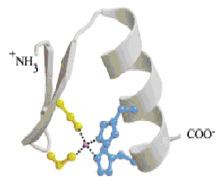
Figure 13. Schematic representation of a C₂H₂ type zinc finger.
The C-terminal α helix contains the two conserved histidine residues (in blue), while the anti-parallel β sheet in N-terminal contains the two conserved cysteine residues. These four residues chelate a zinc ion.

EGR family.
Early growth response (EGR) family members are immediate early genes coding for transcription factors involved in transmission of various stimuli that initiate cellular responses such as mitosis, cellular differentiation and apoptosis (Swirnoff and Milbrandt 1995). Activation of immediate early genes is very fast, transient and independent of de novo protein synthesis (Lemaire, Revelant et al. 1988; Cao, Koski et al. 1990).

Table 2. EGR family members in various vertebrate species.
Genes | Synonyms | Full name | Organisms | References
EGR1 | Nfgi-A | Nerve growth factor-induced clone A | Rat | (Milbrandt 1987)
 | Zif268 | Zinc finger clone 268 | Mouse | (Lemaire, Revelant et al. 1988)
 | Krox-24 | Krüppel box 24 | Mouse | (Sukhatme, Cao et al. 1988)
 | EGR1 | Early growth response 1 | Human | (Suggs, Katzowitz et al. 1990)
 | egr1 | Early growth response 1 | Zebrafish | (Drummond, Rohwer-Nutter et al. 1994)
EGR2 | Krox-20 | Krüppel box 20 | Mouse | (Chavrier, Lemaire et al. 1988)
 | EGR2 | Early growth response 2 | Human | (Joseph, Le Beau et al. 1988)
 | Krox-20 | Krüppel box 20 | Chicken | (Nieto, Bradley et al. 1991)
 | Krox-20 | Krüppel box 20 | Xenopus | (Bradley, Snape et al. 1993)
 | krox-20 | Krüppel box 20 | Zebrafish | (Oxtoby and Jowett 1993)
EGR3 | EGR3 | Early growth response 3 | Human | (Patwardhan, Gashler et al. 1991)
 | Egr3 | Early growth response 3 | Mouse | (Patwardhan, Gashler et al. 1991)
 | Egr3 | Early growth response 3 | Rat | (Yamagata, Kaufmann et al. 1994)
EGR4 | Ngfi-C | Nerve growth factor-induced clone A | Rat | (Crosby, Puetz et al. 1991)
 | Egr4 | Early growth response 4 | Mouse | (Barrow, Simin et al. 1994)
 | pAT133 | Clone pAT133 | Human | (Muller, Skerka et al. 1991)

The EGR family is composed of four genes, EGR1, EGR2, EGR3 and EGR4, which were all described under different names depending on the animal species where they were identified (Table 2). Their translated proteins have several characteristics in common, such as a DNA binding domain in the C-terminus that is composed of three C2H2 type zinc fingers. This binding domain recognizes the nonameric consensus sequence (5‘-GCG T/GGG GCG-3’ which can be found in the promoter of numerous genes (Fig.14A,B) (Christy and Nathans 1989; Wilson, Day et al. 1992; Cao, Mahendran et al. 1993). Each zinc finger binds through hydrogen bonds and Van der Waals interaction to a subunit of the binding site composed of three base pairs (Pavletich and Pabo 1991; Elrod-Erickson and Pabo 1999). EGR transcription factors possess a transactivation domain at the N-terminus, but also a repression domain R1 (Fig.14C) (O'Donovan, Tourtellotte et al. 1999). This repression domain is located between the DNA binding and the transactivation domains, but is absent in EGR4 (Fig.14C) (Crosby, Veile et al. 1992). By binding to this repression domain R1, the NAB (NGFI-A binding) co-repressors NAB1 and NAB2 inhibit the transcriptional activity of EGR1, EGR2 and EGR3 (Russo, Sevetson et al. 1995; Svaren, Sevetson et al. 1996; Swirnoff, Apel et al. 1998). NAB proteins have two conserved domains, the N-terminal NCD1 (NAB conserved domain 1) domain and the C-terminal NCD2 (NAB conserved domain 2) domain (Fig.14D). The first one is responsible for co-repressive binding to EGR family members, while the second one is responsible for EGR protein repression (O'Donovan, Tourtellotte et al. 1999). NAB1 is a constitutive gene and is expressed in almost all cell types, while NAB2 is only induced by the same stimuli that control EGR expression (Svaren, Sevetson et al. 1996; Swirnoff, Apel et al. 1998). This suggests that NAB2 is under dependence of EGR factors and acts as a negative feed-back loop on EGR activity (Ehrengruber, Muhlebach et al. 2000).
A
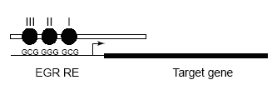
B
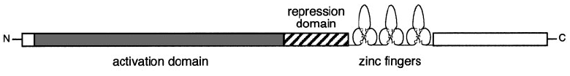
C
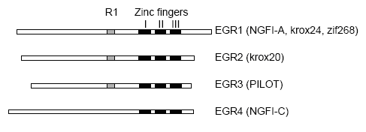
D
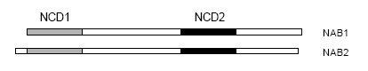
Figure 14. Schematic representations of EGR proteins.
(A) Bond between an EGR member to its specific response element (RE). Each zinc finger (black circles) binds to a sub-unit composed of three base pairs in an anti-parallel conformation. Zinc finger I binds to the triplet in 3’ and zinc finger III to the triplet in 5’. (B) Representation of the molecular structure of the zinc finger transcription factor EGR1. The EGR1 protein is composed of an N-terminal transactivation domain (grey) and a C-terminal DNA binding domain composed of three zinc fingers. Between these two domains, a repression domain (black stripes) that binds NAB proteins. (C) Alignment of the four EGR family members. The three zinc fingers are represented in black. The repression domain R1 that binds NAB proteins is in grey and is absent in EGR4. (D) NCD1 and NCD2 are conserved domains in the repressive proteins NAB1 and NAB2. The N-terminal NCD1 domain (grey) is responsible for binding to the different EGR members and the C-terminal NCD2 domain (black) is responsible for the transcriptional repression of EGR1, EGR2 and EGR3 after binding to R1. (O'Donovan, Tourtellotte et al. 1999)

EGR1.

General.
The transcription factor EGR1 has been identified for the first time in mouse fibroblasts, epithelial cells and lymphocytes (Sukhatme, Kartha et al. 1987). Since then, homologs of this protein have been identified in numerous vertebrates (Milbrandt 1987; Christy, Lau et al. 1988; Lemaire, Revelant et al. 1988; Suggs, Katzowitz et al. 1990; Drummond, Rohwer-Nutter et al. 1994). The amino acid sequence of the EGR1 protein has a very high degree of similarity between the different species, such as human, rat, mouse and zebrafish (Drummond, Rohwer-Nutter et al. 1994; Long and Salbaum 1998; Burmeister and Fernald 2005). The zebrafish protein shares respectively 55%, 56% and 62% identity in amino acid sequence with human, mouse and chicken Egr1 protein. Specifically in the zinc finger binding domain, these proteins share at least 95 % of identity (Hu, Yang et al. 2006).
The EGR1 gene is located on different chromosomes depending on the considered species. In mouse, like in the rat, it is located on chromosome 18; in human on chromosome 5 and in zebrafish on chromosome 14. In mouse and zebrafish, the Egr1 gene spans respectively about 3.8 kb and 3.4 kb and consists of two exons and one 700 pb intron (Tsai-Morris, Cao et al. 1988; Drummond, Rohwer-Nutter et al. 1994).

Promoter.
The regulatory sequences controlling EGR1 gene expression are located in the 5’ flanking region and, in mouse, consist of five SREs (Serum Response Elements), one CRE (Cyclic AMP Response Element), one TATA box, but also binding sites for transcription factors Sp1 (Specific protein 1) and NFκB (Tsai-Morris, Cao et al. 1988; Thiel and Cibelli 2002). Interestingly, Egr1 can bind to its own promoter through the EBS (EGR1 binding site) sequence, 5’-CGC CCC CGC-3’. Egr1 binding to this site leads to repression of its own gene transcription (Cao, Mahendran et al. 1993), thereby completing the negative auto-regulatory loop initiated by inducing expression of the co-repressor NAB2.
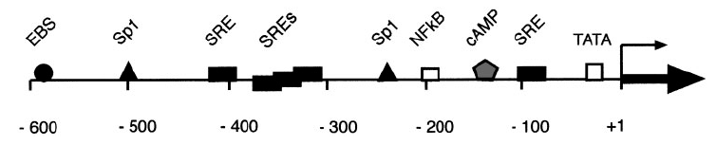
Figure 15. Schematic representation of the regulatory region of the mouse EGR1 gene.
The 5’ region contains the TATA box and several serum response elements (SRE), one cAMP response element (CRE) and binding sites for transcription factors such as Sp1 and NFκB. EGR1 is able to bind to its own promoter through its binding site EBS forming an auto-regulatory loop. The C-terminal arrow represents the transcription initiation site of the EGR1 gene. (Thiel and Cibelli 2002)

Transcriptional regulation.
During transcriptional activation of the EGR1 gene in response to serum, a ternary complex is involved. This complex is composed of transcription factor SRF (Serum Response Factor), TCF (Ternary Complex Factor) and a SRE (Serum Response Element: promoter sequence recognized by SRF-TCF). The TCF family includes the proteins Elk1, Ets, Sap1 and Sap2. SRF and TCF are activated by the Ras-Raf-MEK-ERK signaling pathway, constituted of MAP kinases (Mitogen-Activated Protein) and widespread in fundamental eukaryotic processes such as cell proliferation, survival and apoptosis (Kolch 2000).
Among the extracellular signals that initiate the Ras-Raf-MEK-ERK pathway upon binding to transmembrane tyrosine kinase receptors, there are growth and differentiation factors such as PDGFs (Plateled-Derived Growth Factors), FGFs (Fibroblast Growth Factors), EGF (Epidermal growth factor), VEGFs (Vascular Endothelial Growth Factor) and NGFs (Nerve Growth Factors) (Sukhatme, Kartha et al. 1987; Christy, Lau et al. 1988; Gineitis and Treisman 2001).

Expression pattern.
During embryogenesis in mouse, Egr1 is expressed in cartilage, bones, tooth germs, salivary glands, nasal glands, tendons, vibrissa, skeletal striated muscles, but also in skeletal tissues such as the perichondrium, membranous bones of the head, alveolar bone or the periosteal and endochondral ossification sites in limb bones (McMahon, Champion et al. 1990). In adults, the expression of Egr1 is restricted to thymus, brain, heart and lungs (Christy, Lau et al. 1988; Lemaire, Revelant et al. 1988).
It is in our laboratory that the zebrafish egr1 expression pattern has been described and published (Close, Toro et al. 2002). Before gastrulation, no egr1 transcripts were detected by in situ hybridization. This is in contradiction with what has been observed in Xenopus laevis, where egr1 expression has been detected at the beginning of gastrulation (Panitz, Krain et al. 1998). Close et al. detected egr1 transcripts at the beginning of somitogenesis in posterior adaxial cells of the presomitic mesoderm, but also in hindbrain. At 23 somites, egr1 expression drops and is limited to a small number of adaxial cells. However, new expression domains appear at this stage in the forebrain, more specifically in the telencephalon and hypothalamus. This expression is maintained until 30 hpf and other expression domains are observed, such as the mesencephalon and pharynx. Ten hours later, egr1 transcripts are also observed in the diencephalon, tegmentum, heart, otic vesicle and retina. At 48 hpf, egr1 is strongly expressed in the hindbrain and midbrain, expression is maintained in the pharynx and heart, but disappears in the retina.

Functions.
The EGR1 transcription factor is involved in numerous cellular and physiological functions. This broad spectrum ranges from cell survival to cell death, differentiation to transformation, growth, senescence, cell repair, reproduction, memory and learning.
Originally, EGR1 was identified as an early-response gene following stimulation by mitogens and serum growth factors (Milbrandt 1987; Lemaire, Revelant et al. 1988; Sukhatme, Cao et al. 1988). These first studies were focusing on growth and cell differentiation (Sukhatme, Cao et al. 1988). EGR1 plays a crucial role in differentiation and maturation of hematopoietic cell types such as macrophages (Nguyen, Hoffman-Liebermann et al. 1993; Lee, Wang et al. 1996; Krishnaraju, Hoffman et al. 2001). EGR1 also acts on proliferation of T cells (Perez-Castillo, Pipaon et al. 1993), astrocytes (Hu and Levin 1994; Biesiada, Razandi et al. 1996), keratinocytes (Kaufmann and Thiel 2002) and glomerular mesangial cells (Hofer, Grimmer et al. 1996).
A “pro-apoptotic” role has been attributed to EGR1 and this important function bestows EGR1 a repression activity in numerous cancers (Krones-Herzig, Adamson et al. 2003; Krones-Herzig, Mittal et al. 2005). EGR1 activates the apoptotic cascade according to three different scripts. First, EGR1 induces apoptosis by activating p53 (tumor protein 53) synthesis (Nair, Muthukkumar et al. 1997; Pignatelli, Luna-Medina et al. 2003). As a reminder, the p53 protein is a transcription factor known to be the “guardian of the genome” in reference to its role in ensuring genome stability by preventing mutations. P53 is crucial in multicellular organisms, where it regulates the cell cycle but has also a tumor suppressor function. Second, EGR1 binds to the transcription factor C-JUN and increases its apoptotic activity (Ham, Eilers et al. 2000). Third, EGR1 activates the Pten gene (Phosphatase and Tensin homolog), which codes for a tumor repressive protein (Virolle, Adamson et al. 2001).
However, the expression and function of EGR1 differs depending on the considered cancer type. In most cancers, Egr1 expression is reduced in proliferating tumor cells, while ectopic expression of Egr1 can repress tumor growth (Huang, Liu et al. 1995; Huang, Fan et al. 1997). Among these cancers are breast carcinoma, glioblastoma, osteosarcoma, lung cancer and fibrosarcoma (Huang, Liu et al. 1995). In contrast, in most human prostate cancers, an overexpression of Egr1 is observed (Eid, Kumar et al. 1998). EGR1 controls transcription of many genes involved in prostate tumor growth. This statement is supported by the observation that Egr1 knock-out (KO) mice present a defect in prostate tumor cell progression (Abdulkadir, Carbone et al. 2001).
In mice, it has been shown that Egr1 transcripts are found in higher amounts than normal in tissues that have suffered from mechanical lesion (Santiago, Lowe et al. 1999). Other reports show that extracellular stimuli such as UVB irradiation (Huang, Fan et al. 1998; Huang, Fan et al. 1999), ischemia and hypoxia (Yan, Lu et al. 1999) rapidly and strongly induce Egr1 expression. This expression is supposed to be a protection against damages caused by these stimuli.
First studies of a knock-out mouse line for the Egr1 gene have revealed female sterility due to suppression of the production of the β sub-unit of the luteinizing hormone (LHβ), consistent with the presence of Egr1 response elements in the Lhß promoter (Lee, Sadovsky et al. 1996). Later, a new strain of Egr1 KO mice with a complete deletion of the Egr1 gene was described and revealed that both sexes, male and female, present fertility defects and all individuals are smaller (Topilko, Schneider-Maunoury et al. 1998). A detailed evaluation of this new strain revealed a complete inhibition of LHβ production, atrophy of reproductive organs and a drastic reduction of growth hormone (Gh) production. Egr1 is essential for normal anterior pituitary development and more specifically for Lhβ and Gh synthesis (Topilko, Schneider-Maunoury et al. 1998; Slade and Carter 2000).
Several studies have revealed an involvement of Egr1 in skeletal development and homeostasis. Macroscopically, Egr1^{-/-} KO mice do not exhibit a skeletal phenotype, however they present increased bone resorption and reduction of bone mass, but also an increase of M-CSF secreted by cells of the bone matrix (Srivastava, Weitzmann et al. 1998; Cenci, Weitzmann et al. 2000). The absence of Egr1 blocks the ability of estrogen to repress M-CSF expression, leading to the emergence of a highly osteoclastogenic bone marrow environment. Lower amounts of estrogen lead to a decrease of Egr1 and Sp1 (Specificity protein) association in stromal cell nuclei, with the consequence to have a higher level of phosphorylated Egr1 and higher levels of free Sp1 proteins that bind to the M-CSF promoter. Ovarectomy of wild-type mice leads to the down regulation of estrogens and consequently to bone defects. Experiments using an anti-M-CSF antibody that neutralize in vivo M-CSF have shown that in ovarectomized mice, this antibody prevents the rise of osteoclast number, bone loss and resorption. The same antibody treatment in Egr1^{-/-} KO mice restored a normal level of bone resorption, confirming that increased M-CSF production accounts for the remodeling abnormalities in the Egr1 KO. Ovariectomy on Egr1^{-/-} KO mice fails to further increase M-CSF production, bone loss and bone resorption (Cenci, Weitzmann et al. 2000). These studies conclude that estrogen deficiency induces M-CSF production by an Egr1-dependent mechanism. EGR1 acts as a suppressor of osteoclastogenesis (Kukita, Kukita et al. 1997).
EGR1 has also a role in osteoblast differentiation and maturation (Suva, Ernst et al. 1991) and is induced during microgravity simulation by clinorotation and mechanical deformation (Granet, Boutahar et al. 2001). By imposing rib fractures in Egr1^{-/-} KO mice, studies have concluded that Egr1 is a regulator of endochondral fracture repair (Reumann, Strachna et al. 2011).
Several studies indicate that transcription factor EGR1 has a role in osteoarthritis (OA) and rheumatoid arthritis (RA), which are characterized by degradation of joints. In fact, Egr1 transcripts were found to be down-regulated at least six-fold in OA cartilage compared to healthy cartilage (Wang, Connor et al. 2000). RA is characterized by a chronic inflammation process, a high level of metalloproteinases (MMPs) and proinflammatory cytokines in joints. Egr1 regulates MMPs and their specific inhibitors (TIMPs). Up-regulation of metalloproteinases is known to degrade cartilage matrix in rheumatoid pathologies (Grimbacher, Aicher et al. 1997; Aicher, Alexander et al. 2003). Compared to healthy patients, RA patients present a high level of Egr1 transcripts in synovial fibroblasts (Aicher, Dinkel et al. 1999). This upregulation contributes to fibrosis, which is characterized by an excess of fibrous connective tissue. In fibroblasts, Egr1 regulates transcription of alpha1 and alpha2 chains of type I collagen (Alexander, Judex et al. 2002). Rockel et al. have shown that Egr1 is essential for the regulation of extracellular matrix genes in chondrocytes and that Egr1 might represent a potential drug target in OA and RA therapeutic strategy (Rockel, Bernier et al. 2009).
Functional studies in zebrafish have reported that egr1 knock-down using two different morpholinos causes serious defects in oculogenesis (Hu, Yang et al. 2006; Zhang, Cho et al. 2013). Egr1 morphants have smaller lens and retina and lack of appropriate differentiation of the cells that compose these structures. In Egr1^{-/-} KO mice, the eyes are longer and these mutant mice suffer from myopia but no further experiments where made to see if there are changes in the ocular tissues (Schippert, Burkhardt et al. 2007).

Objectives of this study

Preliminary results in zebrafish in our laboratory have shown that the transcription factor Egr1 is expressed in the pharyngeal region but also in the brain, retina, otic vesicle and heart during the first two days of development (Close, Toro et al. 2002). First knock-down experiments using antisense morpholinos against egr1 mRNA were performed and revealed defects in brain development and the occurrence of a ventral curvature of the tail. Rescue experiments revealed that both defects could be alleviated by expression of exogenous Egr1, indicating that they were specific to Egr1 depletion. Additional knock-down experiments revealed the presence of severe jaw cartilage malformations in 4 dpf morphants. This latter observation, combined with the involvement of Egr1 in skeletal formation described above, prompted us to further investigate the function of Egr1 in cartilage and bone formation.
The objectives of this study are:
- To confirm and characterize the function of Egr1 in cartilage formation using loss and gain of function approaches such as knock-down, rescue and over-expression experiments.
- To examine in detail the expression of the transcription factor Egr1 in the pharyngeal region by performing in situ hybridizations at various stages.
- To study in detail by which mechanisms the transcription factor Egr1 regulates cartilage formation in zebrafish. Factors and processes regulated by Egr1 are investigated as well as factors that modulate Egr1 expression.

Results

Egr1 is essential for zebrafish pharyngeal cartilage development.
To gain insights into an embryonic role of Egr1 in cartilage formation, we depleted Egr1 in developing zebrafish embryos by microinjecting fertilized embryos with morpholinos (MO) directed against egr1 transcripts or a control sequence (MOcon). Two different morpholinos against egr1 were used, one inhibiting egr1 splicing (MOegr1 spl) and the other preventing translation of egr1 mRNA (MO egr1 tr). We first tested several concentrations of the splicing morpholino and showed that injection of MO egr1 spl efficiently inhibited egr1 splicing in embryos, as judged by RT-PCR of 2 days post fertilization (dpf) embryos (Fig.2I), whereas injection of MOcon did not. The embryos were injected at the one cell stage and pharyngeal and cranial cartilages were stained with Alcian Blue at 4 dpf. We observed a dose dependent decrease of the formed cartilage elements (Fig.1).

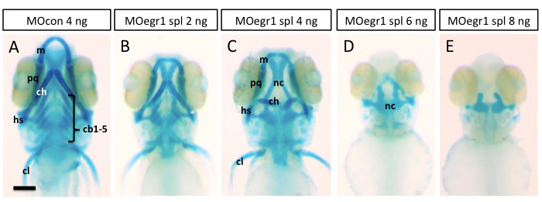

Figure 1. Injection of various concentration of egr1 splicing (spl) morpholino affects head cartilage formation at 4 dpf.
(A-E) Ventral views of 4 dpf old larvae injected with egr1 splicing morpholino. Cartilage elements are stained with Alcian Blue. (A) Control 8 ng MOcon treated larvae displaying all cartilage elements of the head. (B) 2 ng of MOegr1 spl injected larvae display a reduced size of cartilage elements, but all elements are present. (C) Larvae injected with 4 ng of MOegr1 spl display an absence of ceratobranchials, the hyoid elements are severely reduced and malformed and the other cartilaginous structure are reduced in size. (D, E) Embryos who where injected with 6 and 8 ng of MOegr1 spl do not develop any cartilage elements constituting the viscerocranium and present a severe reduction of the anterior neurocranium (nc). ceratobranchial from 1 to 5 (cb 1-5), ceratohyal (ch), cleithrum (cl), hyoid (h), mandible (m), neurocranium (nc), palatoquatrade (pq).

When we compared the effects of MO egr1 tr with those of MO egr1 spl, we observed similar results although the translation morpholino appeared to be less efficient (Fig.2A-C). In embryos injected with 8ng of MOegr1 tr, branchial cartilages were completely absent, while Meckel's cartilage and the palatoquadrate were significantly reduced and the ceratohyal and hyosymplectic misshapen (104/119; 89%) (Fig.2A,B). A similar phenotype was obtained when 4ng MO egr1 spl was injected, with 87% (120/137) of injected individuals failing to develop branchial cartilages and displaying reduction and malformation of the two first pharyngeal arches (Fig.2C). Axis modification of the hyosymplectics and ceratohyals was also observed in a lateral view (Fig.2B,C,D,E). These results indicate that egr1 may be required for craniofacial development in zebrafish.
To test the specificity of the observed phenotype, we co-injected egr1 mRNA together with MO egr1 or MOcon. Co-injection of 75 pg of egr1 mRNA together with 8 ng MOegr1 tr rescued the development of pharyngeal and cranial skeleton in 87% of co-injected embryos (43/49; 87%) (Fig.2G), while branchial arch development in 4 ng MOegr1 spl injected embryos was also rescued by egr1 mRNA expression (Fig.2H). In contrast, injection of 75 pg egr1 mRNA alone had only slight effects on formation of the cartilaginous elements (Fig.2F). Thus, for all subsequent experiments, we used 4ng of MO egr1 spl. We conclude that Egr1 is required for pharyngeal cartilage development in zebrafish.

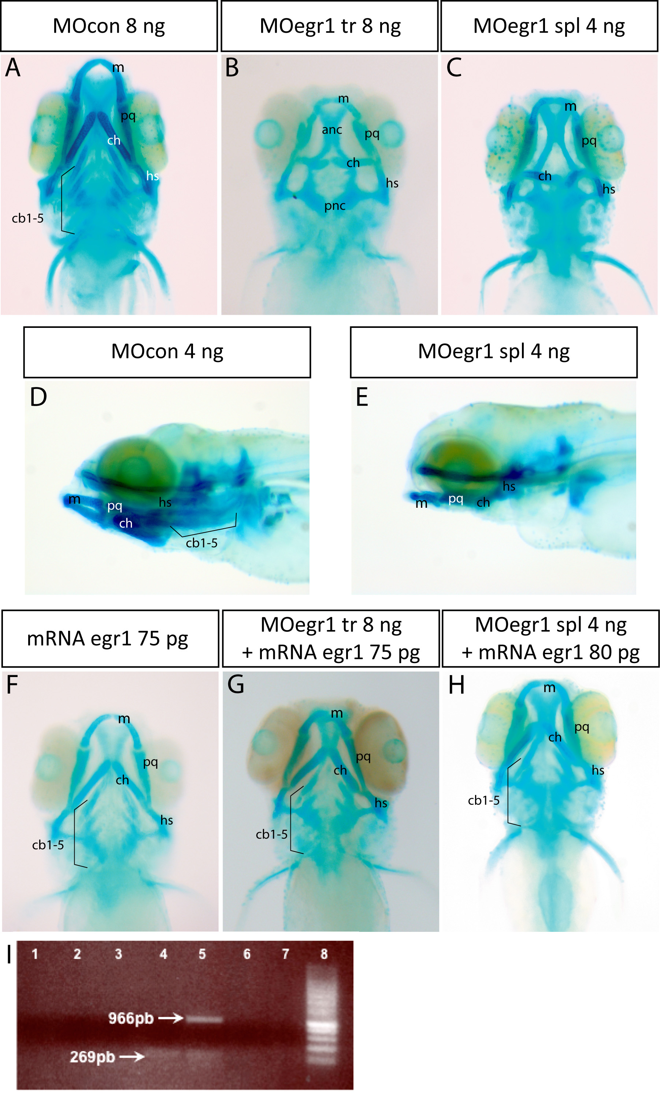

Figure 2. Knock-down of egr1 severely affects head cartilage formation at 4 dpf.
(A-I) Head cartilages were stained with Alcian Blue in morpholino treated larvae at 4 dpf; ventral (A-C) and lateral (D,E) views are shown. (A,D) control 8 ng MOcon treated larvea. (B) 8 ng translation MOegr1 injected larvae display an absence of ceratobranchials and a reduction of size and mis-shaping of pharyngeal cartilage compared to controls (A); (C,E) 4ng splicing MOegr1 injected embryos display similar cartilage defects than 8 ng translation MOegr1 (B). (F) Ectopic expression of Egr1 does not significantly affect cartilage development. (G) Rescue of 8 ng MOegr1 tr treated larvae restores all cartilaginous elements of the viscerocranium. (H) A complete restoration of all cartilage elements is obtained by rescuing 4 ng splicing MOegr1 injected larvae. Meckel’s cartilage (m), palatoquadrate (pq), ceratohyal (ch) and hyosymplectic (hs), ceratobranchials 1 to 5 (cb1-5). (I) Agarose gel electrophoresis analysis of RT-PCR products from mRNA of injected embryos: 1) control mRNA ; 2) mRNA of embryos injected with MOcon 4ng and without reverse transcriptase; 3) mRNA of embryos injected with MOegr1 spl 4 ng and without reverse transcriptase; 4) cDNA of embryos injected with MOcon 4 ng. Presence of a band at 269bp, intron has been spliced properly; 5) cDNA of embryos injected with MOegr1 spl 4 ng. Presence of a band at 966bp indicating that the intron has not been properly spliced. However a residual band at 269bp reveals that the mRNA has been partially spliced; 6) and 7) cDNA of MOcon 4 ng and MOegr1 spl 4 ng injected embryos that have not undergone the PCR step; 8) molecular weight marker.

Egr1 regulates late chondrogenesis in pharyngeal skeleton.
To specify the function of Egr1 during cartilage development, we assayed the expression of neural crest cell and cartilage markers in egr1 morphant embryos by in situ hybridization. Expression of the early neural crest marker ap2a3 was not affected in egr1 morphants at 24 hpf (Fig.3A,F). In addition, expression of dlx2a, in a subset of pre- and post-migratory cNCC that give rise to pharyngeal cartilage (Akimenko, Ekker et al. 1994; Miller, Schilling et al. 2000), was not affected at 24 and 48 hpf in egr1 morphants (Fig.3B,C,G,H). This indicates that Egr1 is not required for formation of cNCC or their migration into pharyngeal arches.
Proper chondrocyte stacking in cartilage requires the expression of Sox9a in these cells (Yan, Miller et al. 2002). In egr1 knock-down embryos, sox9a expression in pharyngeal chondrocytes remained unaffected at 48 hpf compared to control embryos (Fig.3D,I), indicating that the initial steps of chondrocyte differentiation are not affected following egr1 knock-down.
Runx2b is a transcription factor known to play a key role in chondrocyte maturation and is expressed in mesenchymal cartilage condensations in the viscerocranium starting at 40 hpf (Flores, Tsang et al. 2004; Pinto, Conceicao et al. 2005) and, at later stages in endochondral and intramembranous bone elements. In contrast to the earlier marker sox9a, expression of runx2b was abolished in 40 hpf (247/263, 93 %) and 48 hpf (621/647, 95 %) egr1 morphants (Fig.3E,J). At 48 hpf, no expression was detected in the mandible, the hyoid nor in the ceratobranchials, a weaker expression was observed in the ethmoid plate while interestingly the expression remained normal in the cleithrum, an intramembranous bone. The specificity of this effect was confirmed by co-injection of 80pg of egr1 mRNA to 4ng of MO egr1 spl (Fig.3K), revealing that exogenous Egr1 was able to rescue runx2b expression in the head cartilage (265/297, 89 %).
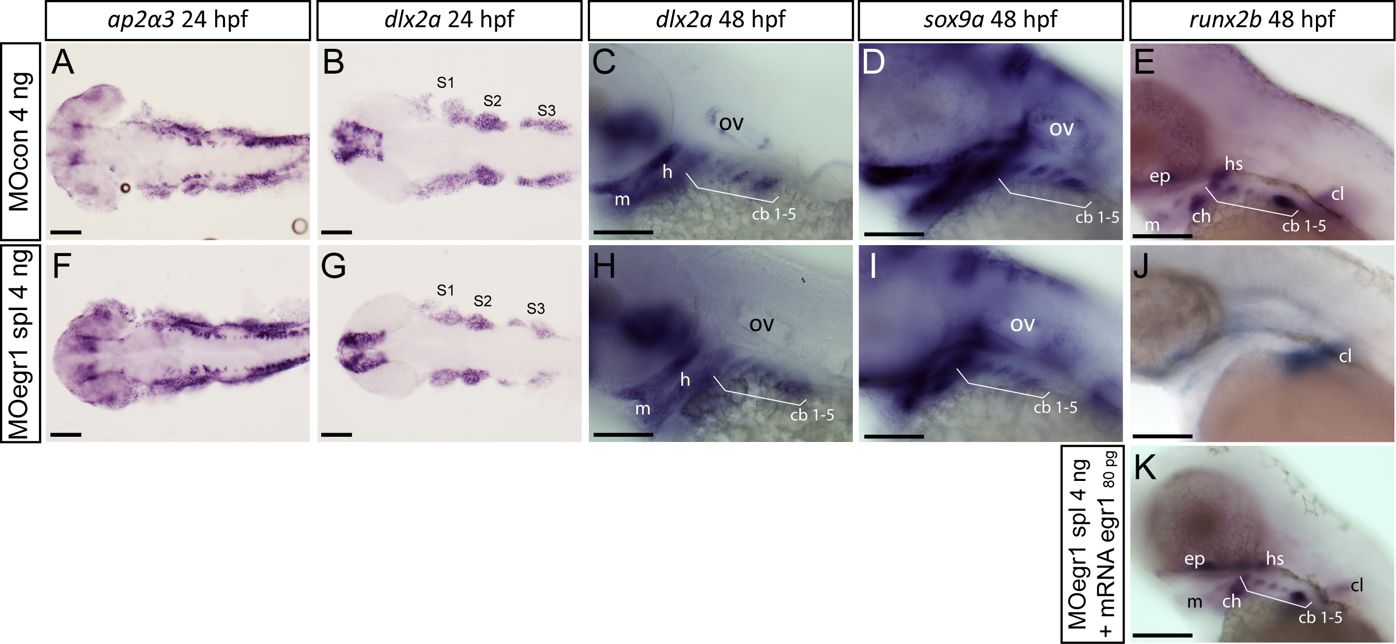
Figure 3. Only late chondrogenic and osteogenic marker genes display decreased expression in egr1 morphants between 24 and 48 hpf.
In situ hybridization was performed at the indicated stages for various cartilage markers, lateral views, anterior to the left. Scale bars 100 μm. (A-E) 4 ng MOcon treated control embryos, (F,G,H,I,J) 4ng splicing MOegr1 injected embryos and (K) rescue. (A,F) At 24 hpf, ap2α3 expression in cranial neural crest cells (cNCC) is not altered in morphants. (B,C,G,H) cNCC marker dlx2a is normally expressed in egr1 morphants (G,H) compared to control embryos (B,C) at 24 and 48 hpf. (D,I) Expression of the essential chondrogenic gene sox9a is not changed at 48 hpf by egr1 knock-down. (E,J,K) At 48 hpf, runx2b transcripts are absent in pharyngeal cartilage precursor cells in 4 ng MOegr1 spl embryos. Expression of runx2b is maintained in the cleithrum (cl) and ethmoid plate (ep). (K) Rescue by injection of 80 pg egr1 mRNA restores all runx2b expression domains at 48hpf. Otic vesicle (ov), mandible (m), ceratohyal (ch), hyosymplectic (hs), ceratobranchial pairs 1 to 5 (cb1-5), cleithrum (cl), ethmoid plate (ep), stream of cNCCs (S1-S3).

We also performed morpholino injections against egr1 into the transgenic line fli1a-GFP, which expresses the green fluorescent protein in pharyngeal cartilage and endothelial cells (Fig.4). Observation of these living embryos did not reveal any difference in expression pattern between controls and morphants between 25 hpf and 47 hpf.

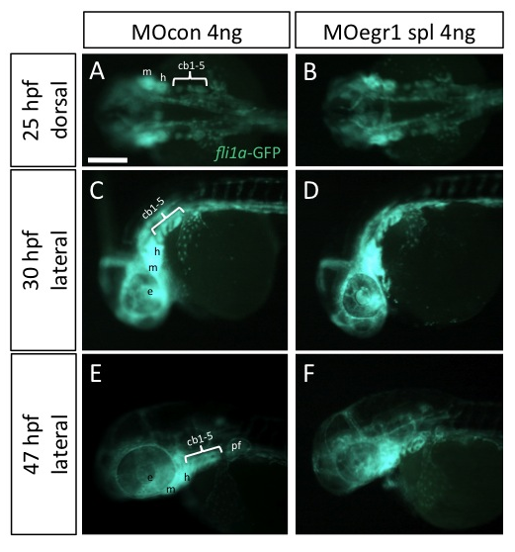

Figure 4. Egr1 knock-down does not alter Fli1a expression during chondrogenesis.

MOegr1 spl 4 ng was injected into fli1a-GFP transgenic embryos and expression of the transgene was followed by fluorescence microscopy. mandible (m), ceratohyal (ch), hyosymplectic (hs), ceratobranchial pairs 1 to 5 (cb1-5), cleithrum (cl), ethmoid plate (ep).

We conclude that egr1 expression is dispensable for early specification and migration of cNCCs, but is required for proper late chondrogenesis in pharyngeal arches.

Egr1 regulates myogenic gene myoD.

To extend our investigations to the entire musculoskeletal development in the head, we focused on the muscular system. We analyzed the expression of myoD, which codes for a key protein regulating muscle differentiation. MyoD is one of the earliest markers of myogenic commitment (Tapscott, Davis et al. 1988; Weinberg, Allende et al. 1996).

We performed in situ hybridization for myoD mRNA at 48 hpf. In wild-type embryos, myoD is expressed in the somites and various muscles of the head. In egr1 morphants, the reduction of Egr1 expression causes an increase of myoD expression in somites (Fig.5A,B), an absence of expression in the transversus ventralis (Fig.5C-F, yellow circle) and a reduction of expression domains in the other head musculature (Fig.5C-F). Transversus ventralis are muscles associated to the pharyngeal arches, they insert on ceratobranchial cartilage and control gill bar movements.

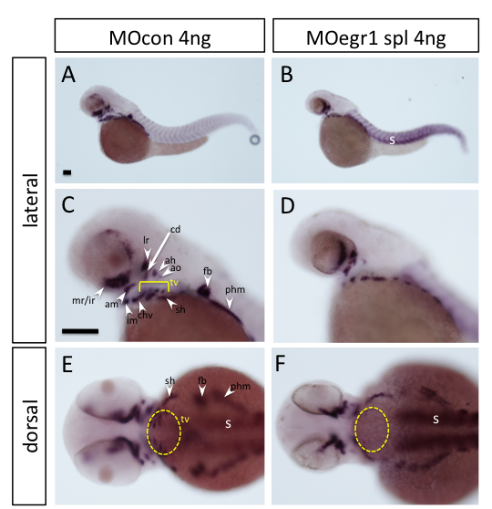

Figure 5. Transcription factor Egr1 regulates expression of myoD.

In situ hybridization was performed at 48 hpf for the myoD marker, lateral (A-D) and dorsal (E,F) views, anterior to the left. Scale bars 100 μm. (A, C, E) 4 ng MOcon injected control embryos express myoD in somites and various muscles of the head. (B, D, F) Embryos injected with 4 ng of MOegr1 spl are lacking expression in the transversus ventralis muscles, display a reduction in the other head muscles and an overexpression of myoD in the somites. adductor hyoideus (ah), adductor mandibulae (am), adductor operculi (ao), constrictor dorsalis (cd), constrictor hyoideus ventralis (chv), fin bud (fb), inferior rectus (ir), lateral rectus (lr), medial rectus (mr), posterior hypoaxial muscle (phm), somites (s), sternohyoideus (sh), transversus ventralis 1-5 (tv1-5).

Egr1 is expressed in pharyngeal endoderm and oral epithelium.
To better understand the cartilage defects observed in the absence of Egr1, we sought to determine the egr1 expression pattern in the developing pharyngeal region. Whole-mount in situ hybridization against egr1 confirmed its expression in the pharyngeal region starting at 30 hpf and persisting until at least 48 hpf (Fig.6A,D and (Close, Toro et al. 2002)). At 48hpf, egr1 mRNA was detected in oral epithelium (Fig.6D) and in the endodermal pouches of the arches. This expression is observed until at least five days of development (Fig.6I,J). Expression in pharyngeal cartilage condensations was never observed.
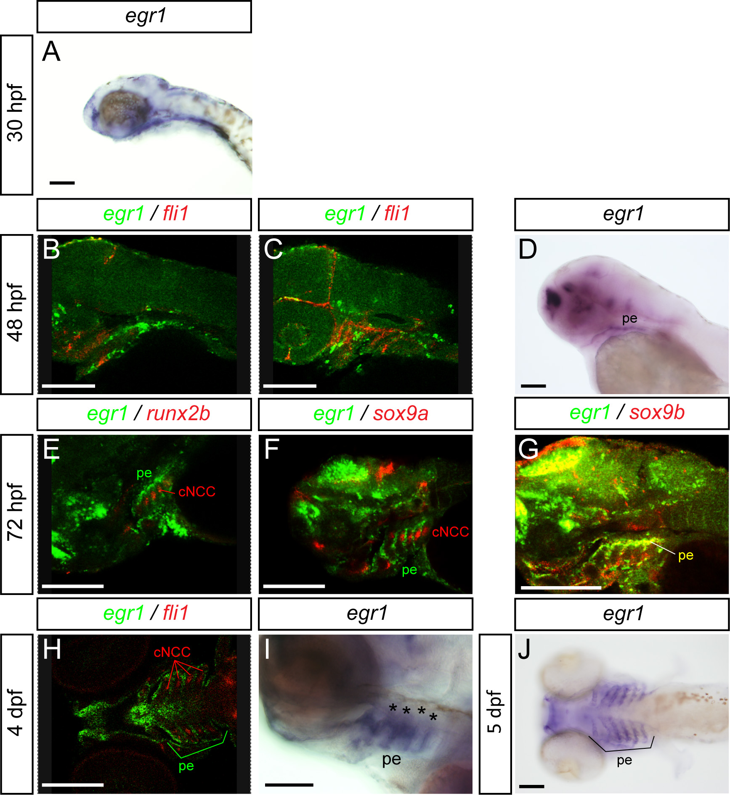
Figure 6. Expression of egr1 in the pharyngeal region between 30 hpf to 5 dpf is restricted to endoderm and epithelium.
Lateral (A-G,I) and ventral (H,J) views, anterior to the left. Scale bars 100 μm. Images of double in situ hybridizations were taken by confocal microscopy and pictures of individual Z-sections are shown. (A) egr1 transcripts are observed in the pharyngeal region starting at 30 hpf in endoderm. (B,C) At 48 hpf, double in situ hybridization for egr1 (green) and fli1 (red); egr1 transcripts are localized in pharyngeal endoderm and do not colocalize with fli1 mRNA in pharyngeal cartilage precursor cells. (D) egr1 is expressed in pharyngeal endoderm. (E-G) At 3 dpf, egr1 (green) does not colocalize with runx2b (red) (E) or sox9a (red) (F) in cartilage, while (G) egr1 (green) mRNAs colocalize with those for the pharyngeal endoderm marker sox9b (red). (H) At 4 dpf, egr1 (green) is never expressed in cells in pharyngeal cartilage precursor cells expressing fli1 (red). (I) Expression of egr1 at 4 dpf in pharyngeal endoderm. (J) At 5 dpf, egr1 is still expressed in pharyngeal endoderm (stars) and not in pharyngeal cartilage. Pharyngeal endoderm (pe), cranial neural crest cells (cNCC).

To determine precisely in which tissue egr1 is expressed, we performed double fluorescent in situ hybridizations at different stages of embryonic development using various markers for specific tissues. At 48hpf, we performed a double hybridization for egr1 (in FITC, green) and fli1 (in Cy3, red), which is expressed in pre-cartilage condensations and endothelium (Knight, Javidan et al. 2005). In confocal microscopy, the most lateral optical (longitudinal) sections reveal expression of fli1 in the cartilage condensations while egr1 expression is located in stripes separating cartilages (Fig.6B). In more central sections, egr1 mRNA is seen in the medial pharyngeal endoderm (Fig.6C). At three days of development, by comparing the expression of runx2b (Fig.6E), dlx2a (not shown) and sox9a (Fig. 6F) in the pharyngeal cartilage condensations with that of egr1, we did not observe any colocalization. We can clearly see that, at this stage, egr1 is expressed in the pharyngeal endoderm and pouches that surround the pharyngeal cartilage. Furthermore, we observed co-expression of egr1 with that of the endodermal marker sox9b at three days in pharyngeal endoderm and pouches (Fig. 6G). At 4dpf, the egr1 expression domain is clearly surrounding the fli1 domain in cartilage (Fig.6H). No colocalization was observed between egr1 and fli1 at any stage. To confirm the expression of egr1 in the pharyngeal endoderm, we also carried out in situ hybridization for egr1 in casanova (cas) mutant embryos, devoid of all molecular endodermal markers (Alexander, Rothenberg et al. 1999). In wild-type siblings (Fig.7A,C), egr1 transcripts were observed at 48 hpf in the pharyngeal region as well as in different brain regions and in the heart. In contrast, in 48 hpf homozygous cas embryos (Fig.7B,D), no egr1 expression was observed in the pharyngeal region (126/126, 100 %), while expression is maintained in the brain, the duplicated hearts and increased in the fin buds.
We conclude that egr1 is expressed in the pharyngeal endoderm of developing zebrafish embryos.
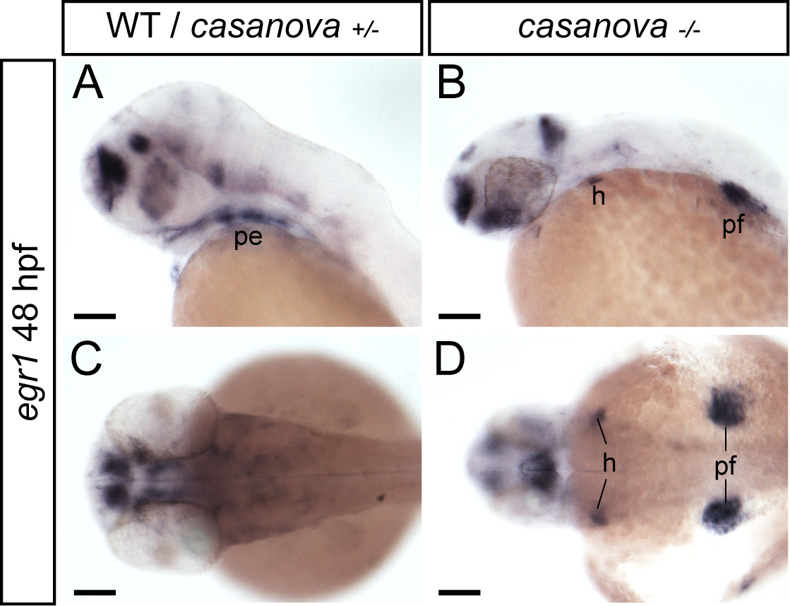 | Figure 7. casanova mutants, lacking endoderm, do not express egr1 at 48 hpf.  Single in situ hybridization for egr1 in casanova mutants. Lateral (A,B) and dorsal (C,D) views, anterior to the left. Scale bars 100 μm. (A,C) Wild-type or heterozygous cas^{+/-} express egr1 in the pharyngeal endoderm (pe). (B,D) Homozygous cas^{-/-} do not express egr1 in the pharyngeal region, but in the pectoral fins and in the two hearts of cas^{-/-} embryos. Pectoral fin (pf), heart (h).

Egr1 is required for pharyngeal endoderm expression of sox9b.
The casanova mutant, devoid of endodermal tissue and known to be deficient in cartilage formation, (Flores, Lam et al. 2006) fails to express runx2b at 48hpf ((Flores, Lam et al. 2006) and data not shown) similar to egr1 morphants. Given the importance of pharyngeal endoderm for craniofacial cartilage development, we wished to test the role of Egr1 in this tissue. But first, we confirmed the results obtained by Piotrowski and Nusslein-Volhard (Piotrowski and Nusslein-Volhard 2000) showing that homozygous casanova mutants do not develop any viscerocranium cartilage elements at 4 dpf by Alcian Blue staining on 4 dpf larvae, while wild-type and heterozygous individuals develop all cartilage elements (Fig.8).
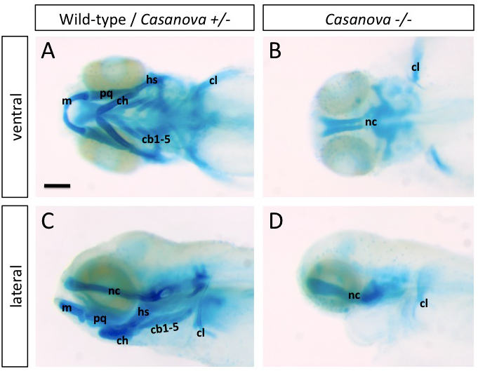
Figure 8. casanova mutants, lacking endoderm, display head cartilage deffects at 4 dpf.
(A-D) Head cartilages were stained with Alcian Blue cas mutant and wt sibling larvae at 4 dpf; ventral (A,B) and lateral (C,D) views are shown. Wild-type or heterozygous casanova have all expected cartilage elements at 4 dpf, while homozygous casanova mutants do not develop viscerocranium elements. ceratobranchial 1-5 (cb1-5), ceratohyal (ch), cleithrum (cl), hyoid (h), Meckel’s cartilage (m), neurocranium (nc), palatoquadrate (pq).

To determine whether Egr1 is required for endoderm formation, we tested whether pharyngeal endoderm is still present in egr1 morphants. By in situ hybridization, expression of the endodermal marker nkx2.3 was still present in egr1 morphants at 48 hpf, although some alterations in the precise shape of the pouches are observed relative to control embryos, probably reflecting the described defects in cNCC cells (Fig.9A,D). Similarly, sox17-GFP transgenic embryos expressing GFP in the entire endoderm, previously injected with MOegr1 spl morpholino display a normal pharyngeal GFP expression until 72hpf (Fig.9B,E). Thus, Egr1 depletion does not prevent formation of the pharyngeal endoderm.
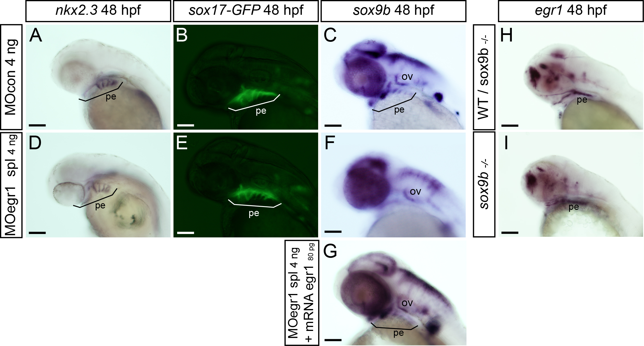

Figure 9. Egr1 is required for expression of sox9b in pharyngeal endoderm.
Endodermal gene expression by in situ hybridization (A,C,D,F,G,H,I) or in living transgenic embryos (B,E) in control embryos (A-C,H), egr1 morphants (D-F), rescued embryos (G) and sox9b mutants (I) at 48 hpf. Lateral views, anterior to the left. Scale bars 100 μm. (A,D) nkx2.3 expression is not altered in 4 ng MOegr1 spl injected embryos. (B,E) In living sox17:GFP transgenic embryos, the transgene is correctly expressed in egr1 morphants. (D,F,G) The endodermal marker sox9b is not expressed in the pharyngeal endoderm in 4 ng MOegr1 spl injected embryos, but its expression is rescued upon co-injection of 80 pg egr1 mRNA and spl 4 ng MOegr1. (H, I) In homozygous sox9b^{-/-} embryos, egr1 transcripts are still observed in the pharyngeal endoderm like in the wild-type or heterozygous sox9b^{+/-} embryos. Pharyngeal endoderm (pe), otic vesicle (ov).

Knowing that egr1 is expressed in pharyngeal endoderm, we investigated potential regulatory connections between the sox9b and egr1 genes. At 42hpf, egr1 morphants do not express sox9b in the pharyngeal pouches and its expression in the brain is altered (156/171, 91 %) (not shown). At 48hpf, sox9b mRNA is still absent in the branchial arches of egr1 morphants, while a decreased expression relative to controls is observed in the two first pharyngeal arches (432/ 462, 93 %) (Fig.9C,F). The observed decreased sox9b expression was rescued by injecting 80pg of egr1 mRNA along with 4ng of egr1 splicing morpholino, showing its specificity for Egr1 knock-down (264/311, 84 %) (Fig.9G). Conversely, in sox9b mutant (sox9b^{b971}) embryos, the egr1 expression pattern remains intact in the pharyngeal endoderm and epithelium as compared to wild type control siblings (Fig.9H,I). Our results demonstrate that Egr1 is required for sox9b expression in pharyngeal endoderm.
At stages beyond 26 hpf, expression of the Sox9b transcription factor is localized in pharyngeal epithelium and endoderm; this factor indirectly regulates runx2b expression in the neighboring perichondrium and chondrocytes and controls chondrocyte proliferation, cell death and patterning (Yan, Willoughby et al. 2005). In homozygous sox9b^{b971} mutants, cranial runx2b expression is only maintained in the cleithrum (Fig.10) (84/88, 95 %), reminiscent of the situation observed in egr1 morphants.
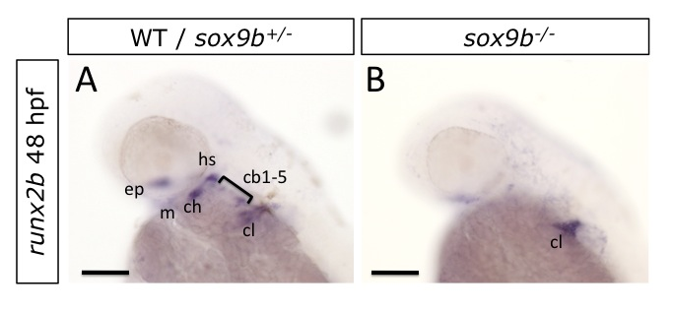

Figure 10. Endodermal Sox9b is essential for runx2b expression pharyngeal arches.

runx2b expression by in situ hybridization in wild-type and sox9b mutants at 48 hpf. Lateral views, anterior to the left. Scale bars 100 μm. In homozygous sox9b^{b971} mutants, runx2b expression only appears in the cleithrum and slightly in the ethmoid plate. cb1-5, ceratobranchials 1 to 5; ceratohyal (ch), cleithrum (cl); ethmoid plate (ep); hyosymplectic (hs); Meckel’s cartilage (m).

Runx3 controls cartilage development by regulating egr1 and sox9b expression in pharyngeal endoderm.
In zebrafish, runx3 is another gene expressed in pharyngeal endoderm and required for runx2b expression in the ventral pharyngeal chondrocytes (Flores, Lam et al. 2006), similar to the egr1 and sox9b genes. Therefore, we decided to investigate the contribution of the runx3 gene to the regulatory cascade in pharyngeal endoderm by performing epistasis experiments.
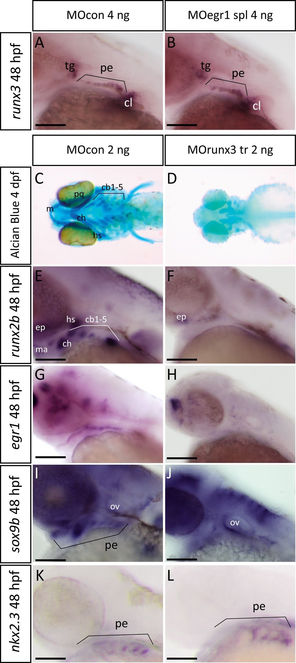 | Figure 11. Runx3 is required for pharyngeal egr1 and sox9b expression at 48 hpf.  Lateral views of in situ hybridizations (A,B,E-L) with indicated markers and ventral views of Alcian Blue stained embryos (C,D), anterior to the left. Scale bars 100 μm. (A,B) Endodermal runx3 expression in the pharyngeal region is not altered in 4 ng MOegr1 spl morphants. (C,D) runx3 knock-down using 2 ng MOrunx3 tr leads to total absence of viscerocranium and the anterior neurocranium (D) compared to control (C) embryos. (E,F) runx3 morphants do not express runx2b in pharyngeal cartilage precursor cells. (G,H) runx3 morphants do not express egr1 transcripts in pharyngeal endoderm. (I,J) The endodermal marker sox9b is absent in pharyngeal endoderm when runx3 expression is blocked. (K,L) runx3 knock-down does not affect expression of pharyngeal endodermal marker nkx2.3 at 48 hpf. Trigeminal ganglia (tg), pharyngeal endoderm (pe), cleithrum (cl), Meckel’s cartilage (m), palatoquadrate (pq), hyosymplectic (hs), ceratohyal (hs), ceratobranchials 1 to 5 (cb1-5), ethmoid plate (ep), otic vesivle (ov).

By in situ hybridization, we showed that runx3 expression at 48hpf was similar in endodermal pouches of egr1 morphants (102/106, 96 %) to that in control embryos (Fig.11A,B). Conversely, to investigate the function of Runx3 in egr1 and consequently also sox9b and runx2b expression, we performed runx3 depletion using well established morpholino-mediated knock-down (Flores, Lam et al. 2006). As expected, injection of 2ng of runx3 morpholino into wild-type eggs resulted in a complete absence of viscerocranium and the anterior part of the neurocranium, as revealed by Alcian Blue cartilage staining at 4dpf (123/137, 92 %) (Fig.11C,D). We also confirmed that runx3 knock-down disrupts runx2b expression in pharyngeal arch mesenchyme and that only a small expression remains in basicranial anlagen at 48 hpf (251/ 273, 91 %) (Fig.11E,F). Importantly, runx3 morpholino injected embryos completely lost egr1 transcripts in the pharyngeal region, while these were maintained in the telencephalon at 48hpf compared to control morpholino-injected siblings (310/347, 89 %) (Fig.11G,H). Consistent with our previous observations, sox9b expression in pharyngeal endoderm was also disrupted at 48hpf in runx3 morphants (172/198, 86 %) (Fig.11I,J). Finally, nkx2.3 expression was maintained (Fig.11K,L) indicating that the endoderm itself was present.
When we tested the specificity of the effects observed in runx3 morphants by alcian blue staining at 4 dpf, we observed that co-injection of runx3 mRNA caused a partial rescue in 89% of the larvae (Fig.12A,B,D), while runx3 mRNA alone had no effect (Fig.12C). As shown before, injection of egr1 mRNA had no effect (Fig.12E), however its co-injection with MO runx3 caused a partial rescue of the anterior part of the viscerocranium in 62% of the larvae (Fig.12F), indicating that Runx3 is indeed acting through activation of egr1 expression.
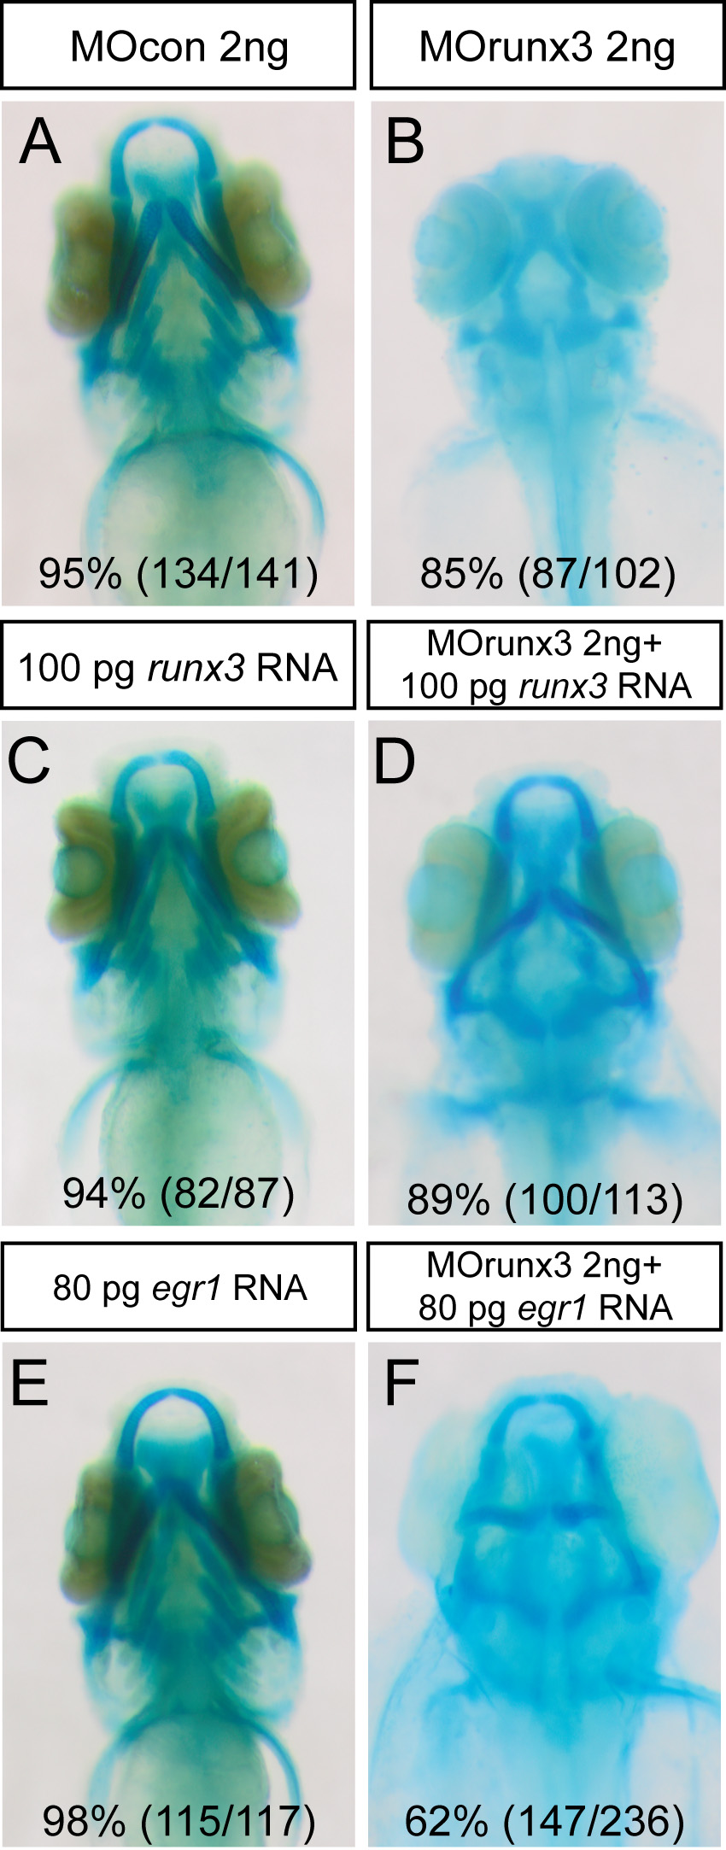 | Figure 12. Runx3 depleted embryos can be rescued by runx3 and egr1 mRNA.  (A-F) Head cartilages were stained with Alcian Blue in morpholino treated larvae at 4 dpf; ventral views are shown. (A) MOcon 2 ng injected larvae. (B) MOrunx3 2 ng injected larvae do not develop viscerocranium. (C) 100 pg of runx3 mRNA do not affect 4 dpf old larvae cartilage morphology. (D) Injection of 100 pg runx3 mRNA rescues 89% of MOrunx3 2ng injected eggs. (E) 80 pg of egr1 mRNA. (F) Injection of 80 pg egr1 mRNA rescues 62% of MOrunx3 2ng injected eggs.

In conclusion, our results show that in pharyngeal endoderm Runx3 is required for egr1 expression, which in turn is required for sox9b expression and, finally Sox9b presumably triggers an extracellular signal leading to runx2b expression in post-migratory cNCC and chondrogenesis.

Down-regulation of egr1 does not regulate Hh or Bmp ligand expression in the pharyngeal region.
To better understand the link between egr1 expression in the pharyngeal endoderm and its action on pharyngeal cartilage development, we decided to study the status of different signaling pathways in pharyngeal endoderm.
One interesting secreted extracellular ligand to study was shh (sonic hedgehog) from the Hh hedgehog family (Schwend and Ahlgren 2009). shh is expressed in pharyngeal endoderm (Piotrowski and Nusslein-Volhard 2000). We show that, until at least two days of development, endodermal and neuroectodermal shh expression did not vary in egr1 morphants compared to MOcon injected embryos (Fig.13).
Figure 13. egr1 expression does not regulate shh expression at 48hpf.
Lateral views of in situ hybridizations (A,B) with shh marker, anterior to the left. Scale bars 100 μm. shh expression pattern is not modified in egr1 morphants compared to control embryos. neuroectoderm (ne), pharyngeal endoderm (pe).

Concerning the other members of the Hh family, we did not test ihha and ihhb (indian hedgehog a/b) because they are expressed later stages (starting at 4 dpf).

Among the BMP factor family, bmp2a, bmp2b, bmp4, and bmp5 are all expressed in pharyngeal endoderm (Holzschuh, Wada et al. 2005). We performed in situ hybridization on egr1 morphants at stages between 35 and 48 hpf for expression of these endodermal Bmp ligands bmp2a, bmp2b, bmp4 and bmp5 (Fig.14). No significant variation of expression was observed between controls and morphants; Egr1 does not influence expression of the endodermal Bmp ligands tested.
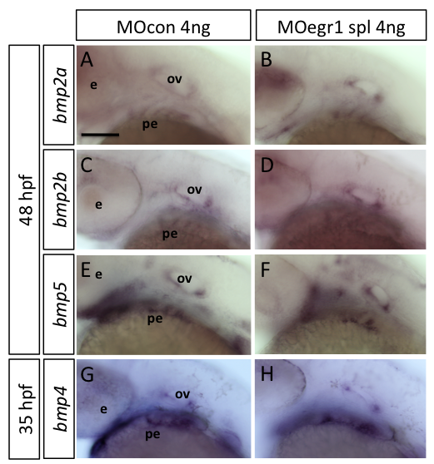 | Figure 14. egr1 morphants do not display a variation in expression of Bmp ligands.  Lateral views of in situ hybridizations (A-H) with the indicated markers, anterior to the left. Scale bars 100 μm. No significant variation of expression is observed between controls (A,C,E,G) and egr1 morphants (B,D,F,H) for bmp2a, bmp2b, bmp4 and bmp5. eye (e), otic vesicle (ov), pharyngeal endoderm (pe).

Egr1 down regulates follistatin a expression in pharyngeal endoderm and cartilage.
Our previous results showed that Egr1 depletion did not affect expression of Bmp or Hh ligands, we thus decided to investigate known inhibitors for these pathways.
The gene coding for the secreted TGFß/BMP antagonist follistatin A (Fsta) is expressed in presumptive cephalic mesendoderm at 8 hpf (Bauer, Meier et al. 1998; Dal-Pra, Furthauer et al. 2006) and at later stages in arch vasculature and skeleton (Thisse, Pfumio et al. 2001; Erickson, French et al. 2010). In homozygous casanova mutants, devoid of endoderm, sox9b mRNA was undetectable (92/96, 95 %) (Fig.15A,B) and fsta expression is abolished (57/61, 93 %) (Fig.15C,D) in the branchial region at 48 hpf, confirming the expression of both genes in pharyngeal endoderm or at least the requirement of this tissue for their expression in this region.
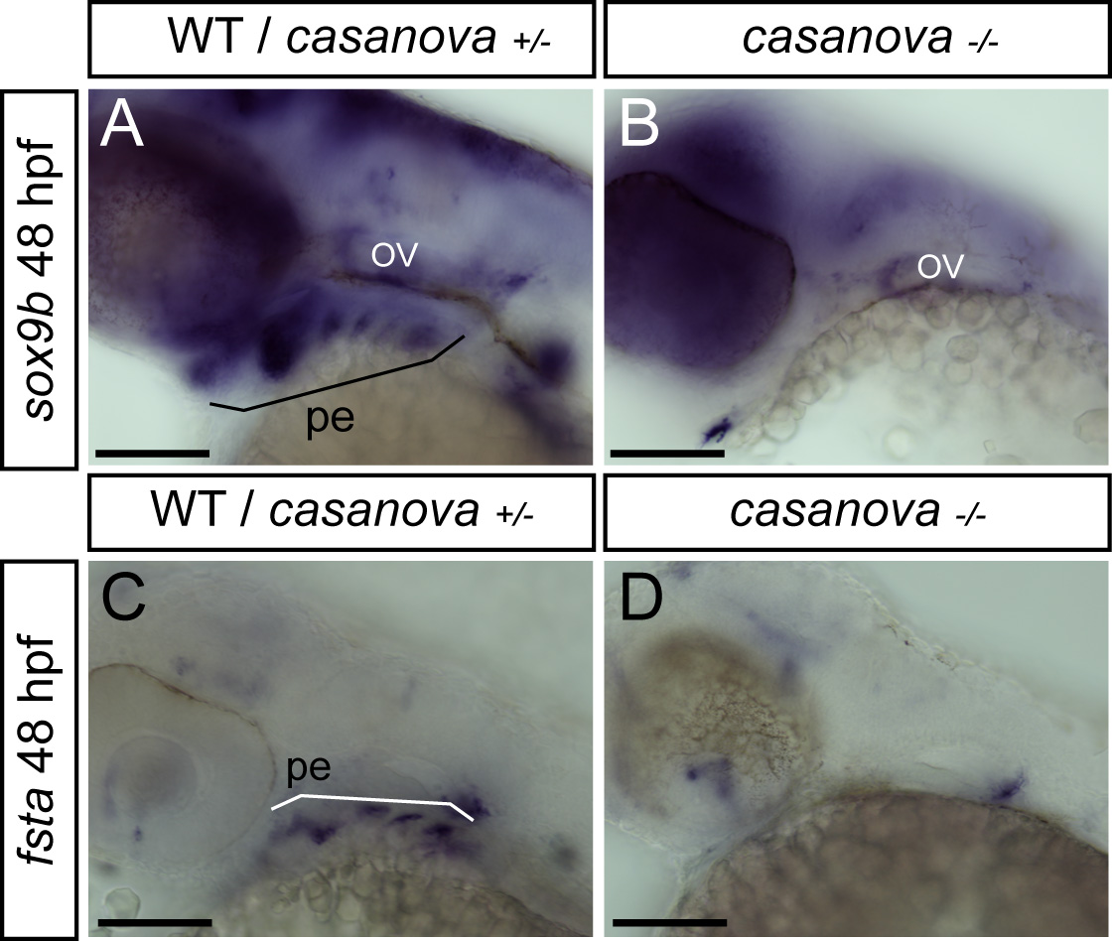 | Figure 15. casanova mutants, lacking endoderm, do not express sox9b or fsta at 48 hpf.  Lateral views of in situ hybridizations (A-D) with indicated markers, anterior to the left. Scale bars 100 μm. Homozygous cas^{-/-} do not express fsta (A,B) nor sox9b (C,D) compared to wild-type or heterozygous cas^{+/-}. Pharyngeal endoderm (pe), otic vesicle (ov).

In egr1 morphants, a clear over-expression of fsta (274/302, 90 %) relative to controls was observed at two days of development (Fig.17A, B). The fsta expression domain is more intense and extended in MOegr1-injected relative to MOcon-injected embryos, indicating that Egr1 is required for inhibition of fsta expression in wild type embryos. Similarly, embryos depleted of Runx3 by microinjection of MOrunx3 (157/170, 92 %) (Fig.16C,D), or of Sox9b in the homozygous sox9b^{b971I} mutant (77/79, 97 %) (Fig.16E,F) displayed a dramatic increase of fsta expression and an extension of its expression domain as compared to wild type embryos. Thus, depletion of any of the endodermal transcription factors leads to increased fsta expression.
To further characterize a putative function of Follistatin A in cartilage development, we decreased its expression by injecting a splicing morpholino against fsta (Dal-Pra, Furthauer et al. 2006). Injection of 6 ng of MOfsta spl resulted in 85% (86/101) of 4 dpf larvae displaying clearly increased cartilage elements compared to the controls (Fig.16G,H), showing that Follistatin A indeed plays an inhibitory role on the formation of head cartilage.
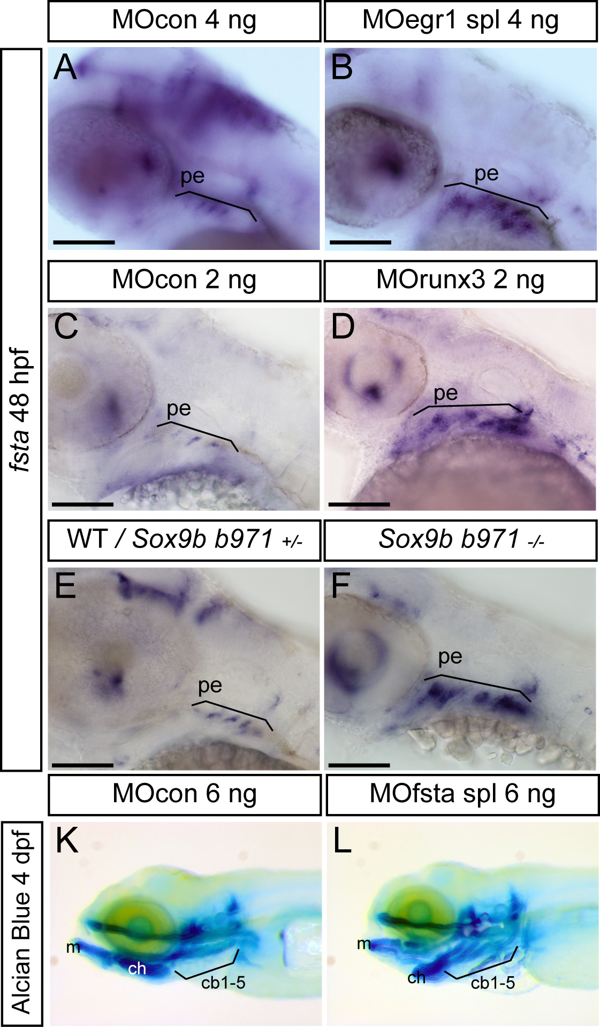 | Figure 16. Expression of fsta is increased in runx3 and egr1 morphants and sox9b mutants.  Lateral views of in situ hybridizations, anterior to the left. Scale bars 100 μm. (A-F) Compared to controls or wild-type embryos, expression of fsta is up-regulated in egr1 morphants (A,B), runx3 morphants (C,D), and homozygous sox9b mutants (E,F) at 48 hpf. pharyngeal endoderm (pe). (G,H) 4 dpf Alcian Blue stained larvae injected with MOcon 6 ng (K) and MOfsta 6ng (L). Knock-down of fsta causes a hyperplasia of the viscerocranium. Meckel’s cartilage (m), ceratohyal (ch), ceratobranchials 1 to 5 (cb1-5).

Taken together, these results indicate that the endodermal cascade of transcription factors Runx3, Egr1 and Sox9b is required to reduce the level of fsta expression in the pharyngeal region.

BMP signaling is required for pharyngeal cartilage formation and runx2b expression in cartilage.
In vertebrates, the BMP pathway is known to play an essential role in skeletogenesis (Nie, Luukko et al. 2006), but also many early developmental processes such as gastrulation or neurulation (Poulain, Furthauer et al. 2006). In particular, BMP signaling directs ventral patterning of the viscerocranium before 24 hpf (Alexander, Zuniga et al. 2011). Most of the factors investigated here are expressed in the pharyngeal region at stages beyond 24 hpf and the defects caused by their depletion are also observed at these later stages. To investigate whether Egr1 or FstA might be required for early ventral patterning of the pharyngeal arches, we tested the expression of the ventral markers hand2 and edn1 at 24 hpf in egr1 and fsta morphants. Expression of both ventral markers was maintained in the microinjected embryos (Fig.17A-F), indicating that dorso-ventral patterning is not affected by depletion of Egr1 or FstA. We also showed that the weak fsta expression at 24 hpf is not affected in egr1 morphants (Fig.17G,H), further supporting the notion that the endodermal regulatory cascade acts beyond 24 hpf. Similar results were obtained at 30 hpf (data not shown).
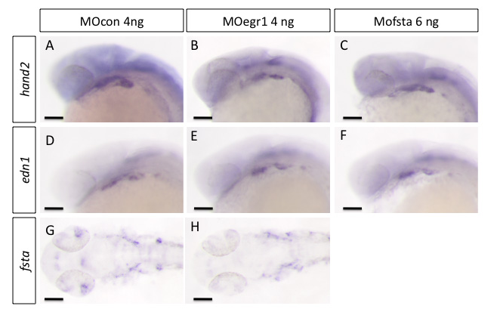
Figure 17. egr1 and fsta knock-down do not affect ventralisation of cranial neural crest cells.
In situ hybridization was performed at 24 hpf, lateral views, anterior to the left. Scale bars 100 μm. (A,D,G) MOcon 4ng, (B,E,H) MOegr1 4 ng and (C,F) MOfsta 6 ng. No modification in the expression of markers hand2, edn1 and fsta was observed in MOegr1 4 ng or MOfsta 6 ng injected embryos compared to control.

To assess the role of BMP signaling in head cartilage formation at later stages of development without affecting earlier processes, we investigated the effects of dorsomorphin, a selective inhibitor of ALK2, BMPR-IA and BMPR-IB signaling and of BMP-induced Smad1/5/8 phosphorylation (Hao, Daleo et al. 2008) at different stages beyond 24 hpf. The effects on cranial cartilage formation were analyzed by Alcian blue staining at 4 dpf and the treated larvae were classified according to the extent of the defects seen in cartilage formation (Fig.18A-C). Type 1 was considered as wild-type cartilage morphology, type 2 larvae displayed a severe reduction or absence of the five pairs of branchial arches and a malformation and reduction of the first two pairs of pharyngeal arches (mandible and hyoid). Finally, type 3 larvae are characterized by a complete absence of pharyngeal arches (viscerocranium) and a severe reduction of the neurocranium.
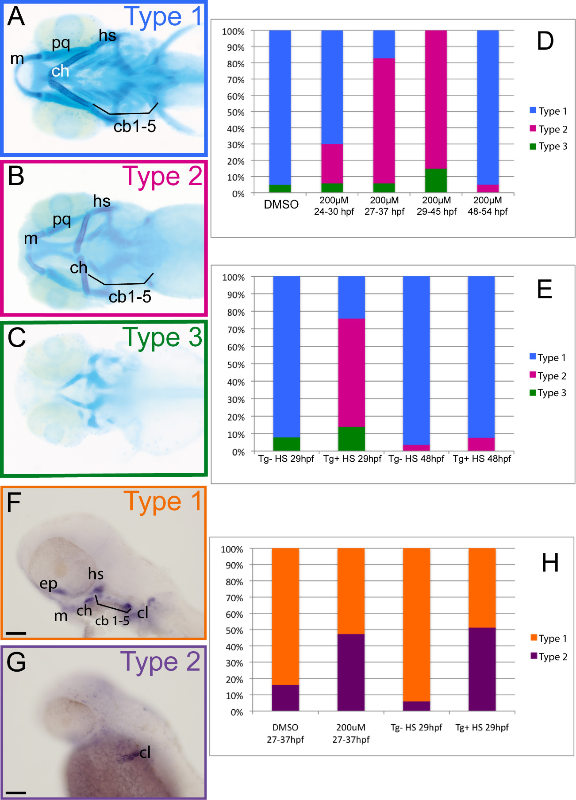
Figure 18. BMP signaling is required between 27 and 37 hpf for runx2b expression and head cartilage development.
(A-E) Cartilage was stained with Alcian Blue in 4 dpf larvae, ventral views are shown, anterior to the left. (A) Type 1 larvae (blue) display a wild-type morphology, all cartilage elements are present and well shaped. (B) Type 2 larvae (pink) lack ceratobranchials and have mis-shaped Meckel’s cartilage, palatoquadrate, ceratohyal and hyosymplectic. (C) Type 3 larvae (green) display a complete absence of viscerocranium and a reduction of the anterior neurocranium. (D,E) Graphs representing the proportions of the three types of larvae after the indicated treatments. (D) Treatment with the BMP inhibitor dorsomorphin (200µM) most severely affects head cartilage between 29 and 45 hpf; (DMSO) dimethylsulfoxide. (E) Heat shock treatment of (hsp70l:dnBmpr-GFP)w30 transgenic embryos between 27 hpf and 37 hpf most severely affects pharyngeal cartilage development. (F-H) In situ hybridization for runx2b expression at 48 hpf, lateral views, anterior to the left, scale bars 100 μm. (F) Type 1 embryos (orange) have a normal runx2b expression pattern in all pharyngeal cartilage precursor cells, cleithrum and ethmoid plate. (G) Type 2 embryos (purple), compared to type 1 embryos, only express runx2b in cleithrum and weakly in the ethmoid plate. (H) Graph representing the proportions of the two types of larvae after the indicated treatments. Dorsomorphin treatment of wt embryos and heat shock treatment of (hsp70l:dnBmpr-GFP)w30 between 27 hpf and 37 hpf decreases runx2b expression in pharyngeal cartilage, but not in the cleithrum. (DMSO) dimethylsulfoxide, (Tg+) Transgene expressing embryo, (Tg-) Transgene non-expressing siblings, (HS) heat shock. Meckel’s cartilage (m), palatoquadrate (pq), ceratohyal (ch) and hyosymplectic (hs), ceratobranchials 1 to 5 (cb1-5).

Treatment of embryos with 200 μM dorsomorphin between 24 and 30 hpf resulted in 70 % (138/197) of type 1 larvae, 23 % (47/197) of type 2 larvae and 6 % (12/197) of larvae with a complete loss of viscerocanium (type 3), while after treatment between 27 hpf and 37 hpf, we observed only 6 % (14/231) of type 1 larvae, 77 % (177/231) of type 2 larvae and finally 17 % (40/231) of type 3 larvae (Fig.18D). Treatment between 29 hpf and 45 hpf resulted in 85 % (218/257) of type 2 larvae and 15% (39/257) of type 3 larvae. In contrast, dorsomorphin treatment performed between 48 hpf and 54 hpf led to 88 % (174/198) of the drug treated larvae displaying a type 1 cartilage morphology and only 12% (24/198) with a type 2 cartilage morphology. These results clearly confirm that the BMP pathway is required for proper cartilage formation in zebrafish at these later stages, comparison of the different experiments reveals that the most crucial period lies between 27 hpf and 37 hpf.
To confirm this requirement for BMP signaling at late stages, we also used an inducible dominant negative BMP receptor-GFP transgenic line (hsp70l:dnBmpr-GFP)w30. We performed a heat shock at 37°C during 30 minutes at 29 hpf and compared the head cartilage at 4 dpf of the transgenic larvae to that of their non-transgenic siblings (Fig.18E). While 92 % (140/152) of control larvae formed a perfectly normal type 1 cartilage, indicating that the heat shock itself had no effect, the transgenic larvae (positive for GFP expression) producing the active dominant negative BMP receptor presented a clear alteration of chondrogenesis, with 62% (106/171) belonging to type 2 cartilage morphology, 24 % (41/171) type 1 cartilage morphology and 14 % (147/171) type 3 cartilage morphology. When heat shock on (hsp70l:dnBmpr-GFP)w30 was performed after 48 hpf, almost all larvae presented normal cartilage (123/129, 95 %) (type 1). These results clearly confirm that BMP signaling is required for pharyngeal cartilage formation between 27 hpf and 37 hpf.
The cartilage defects observed upon BMP inhibition are quite similar to those obtained in egr1 and runx3 morphants or sox9b mutants. Therefore, we also analyzed runx2b expression at 48hpf in embryos treated with 200μM dorsomorphin between 27hpf and 37hpf (Fig.18F-H). Half of the treated embryos did not express runx2b in pharyngeal arches (285/543, 52 %), while it remained expressed in the ethmoid plate and cleithrum. Upon heat shock of (hsp70l:dnBmpr-GF)w30 transgenic animals at 29 hpf, we observed the same percentage (33/66, 50 %) of embryos expressing runx2b only in the cleithrum at 48 hpf.
Taken together, these observations indicate that inhibition of BMP signaling between 29 and 37 hpf causes cartilage defects at 4 dpf and prevents runx2b expression at 2 dpf, similar to the defects observed upon blocking of the Runx3-Egr1-Sox9b cascade in the endoderm.

Egr1 is required for BMP signaling in the pharyngeal region.
Finally, we determined whether the Runx3-Egr1-Sox9b cascade is required to maintain normal BMP signaling in cartilage precursors by reducing Fsta signaling in the pharyngeal arches. To this end, we performed double fluorescent immunohistochemistry using anti-phospho-Smad1/5/8 and anti-GFP antibodies on fli1-GFP embryos. We used fli-GFP expressing embryos in order to visualize the cNCC through the presence of GFP. The embryos were injected with a control morpholino or the egr1 splicing morpholino and fixed at 32 hpf to perform immunohistochemistry (Fig.19A-F).
By confocal analysis, we detected the presence of phospho-Smad1/5/8 in the entire pharyngeal arch region including the fli1-expressing cranial cartilage precursor cells in 32 hpf old MOcon embryos, indicating that BMP signaling is active at 32 hpf in control embryos (Fig.19A-C). When we analyzed egr1 morphants, no phospho-Smad1/5/8 was detected in the pharyngeal region (Fig.19D-F). In addition, we could also confirm that fli1-GFP expressing cNCCs are disorganized in egr1 morphants compared to controls. Altogether, our results demonstrate that Egr1 and the regulatory cascade Runx3/Egr1/Sox9b/Fsta expressed in the pharyngeal endoderm is absolutely required for BMP activation in cartilage around 29 hpf.
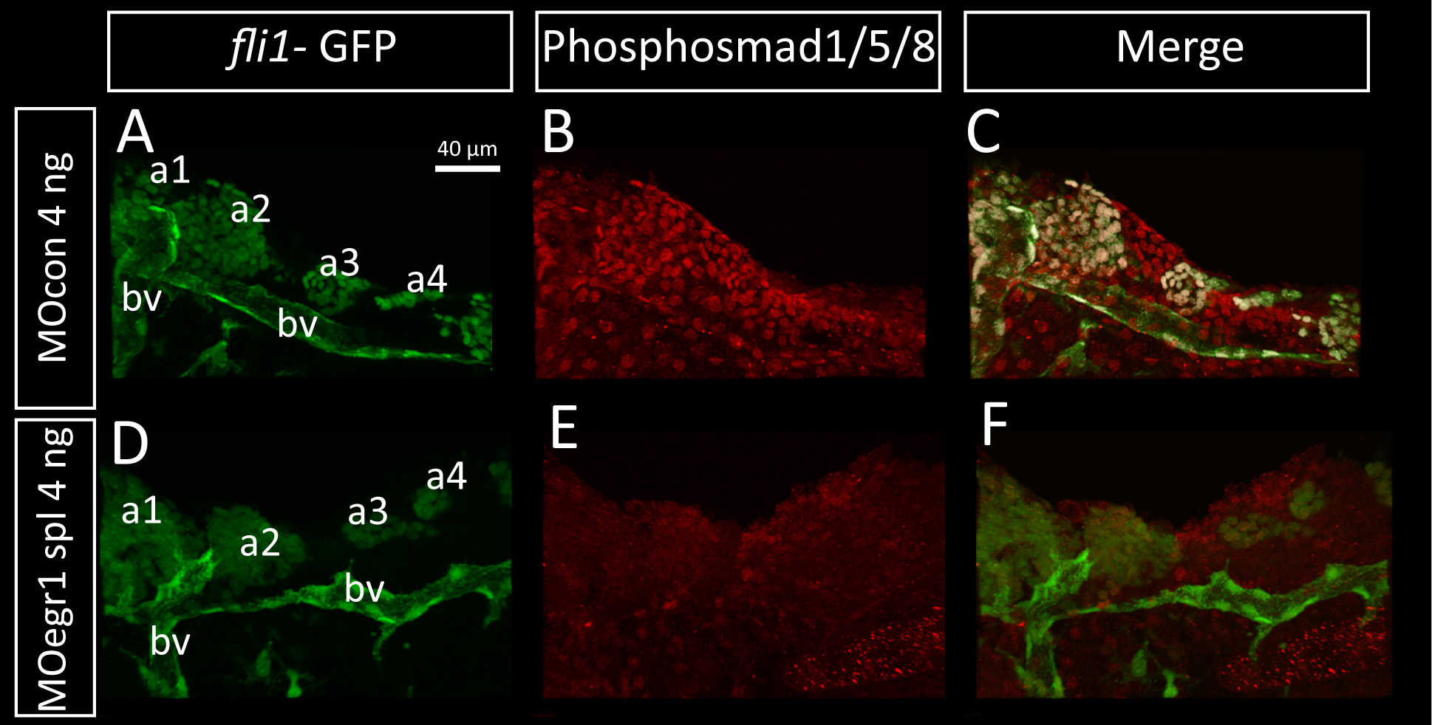
Figure 19. Bmp signaling is down-regulated in egr1 morphants.
Pharyngeal cartilage precursor cells were visualized by immunohistochemistry using anti-GFP antibodies (green) in fli-GFP embryos. Activity of the BMP signaling pathway was assessed using antibodies against phospho-Smad1/5/8 (red) in 32 hpf embryos. Ventral view of pharyngeal arches, scale bar 40 μm. (A-F) Pharyngeal cartilage precursor cells were visualized by immunohistochemistry using anti-GFP antibodies (green) in fli1-GFP embryos. Activity of the BMP signaling pathway was assessed using antibodies against phospho-Smad1/5/8 (red) in 32 hpf embryos. Ventral view of pharyngeal arches, scale bar 40 μm. (A,B,C) 4 ng MOcon injected embryos, (D, E, F) 4 ng MOegr1 spl injected embryos. fli1-GFP embryos express the GFP transgene in cartilage precursors and endothelial cells in control (A) and in egr1 morphants (D). In contrast, phospho-Smad1/5/8 is clearly down regulated in egr1 morphants (E) compared to control embryos (B). (C,F) Overlay images of the two anti-body signals clearly show that phospho-Smad1/5/8 is present in GFP-expressing cartilage precursor cells in control embryos (C), while no colocalization is observed in egr1 morphants (F). first arch (a1), second arch (a2), third arch (a3), fourth arch (a4), blood vessel (bv).

Egr1 is involved in early bone formation.

As shown previously, we have observed that the transcription factor Egr1 regulates expression in cartilage precursor cells of the runx2b gene, which is also a key regulator gene in bone formation. We also described that egr1 transcripts are identified by in situ hybridization in the pharyngeal endoderm until at least 5 dpf. By injecting MO egr1 spl 4 ng, all bones are absent or reduced in the entire embryo at 5 dpf (Fig.20). In egr1 morphants, all endochondral bones are absent, while dermal bones such as opercle and cleithrum are reduced. These results correlate with the observations in sox9b mutants (Yan, Willoughby et al. 2005). Similar to transcription factor Sox9b (see Introduction Fig.10), whose expression in endoderm is regulated by Egr1, Egr1 is necessary for runx2b expression (except in cleithrum) and for endochondral and partially dermal bone formation.

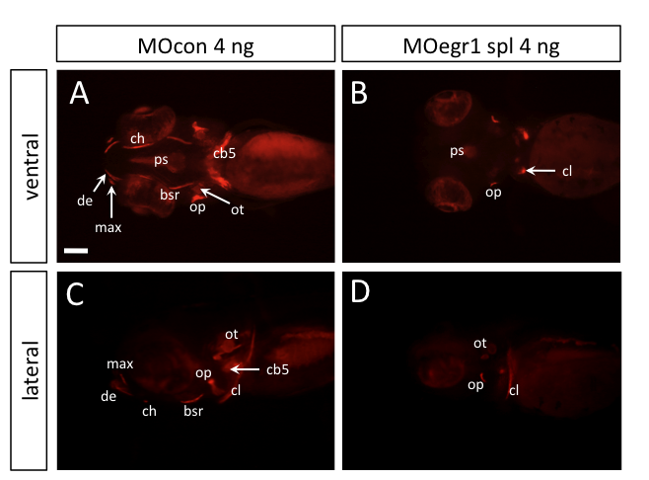

Figure 20. Egr1 regulates bone formation at 5 dpf.

Compared to 5 dpf old control larvae (A, C), larvae’s injected with MO egr1 spl 4 ng (B, D) do not develop endochondral bones and some of the dermal bones are absent or reduced (opercle, cleithrum). branchiostegal (bsr), ceratobranchial (cb), ceratohyal (ch), cleithrum (cl), dentary (de), maxillary (max), opercle (op), otholith (ot), parasphenoid (ps).

Mutation of the egr1 gene causes defects similar to those in egr1 morphants.
Recently, an egr1 mutant was obtained through the TILLING (Targeting Induced Local Lesions in Genomes) initiative (Kettleborough, Bruijn et al. 2011). Heterozygous adults were identified by fin clip; cutting a piece of fin and extracting the DNA to identify whether the individual possesses a wild-type or heterozygous egr1^{+/-} profile. Heterozygous egr1 adults were crossed together to generate one quarter of homozygous egr1^{-/-} individuals in the spawn. One fourth of the embryos of each clutch exhibited defects similar to those observed in egr1 morphants at 4 dpf. These assumed homozygous embryos lacked all ceratobranchials, the mandible (Meckel’s cartilage and palatoquadrate) and hyoid (ceratohyal and hyosymplectic) were severely reduced and misshapen (Fig. 21C,F).
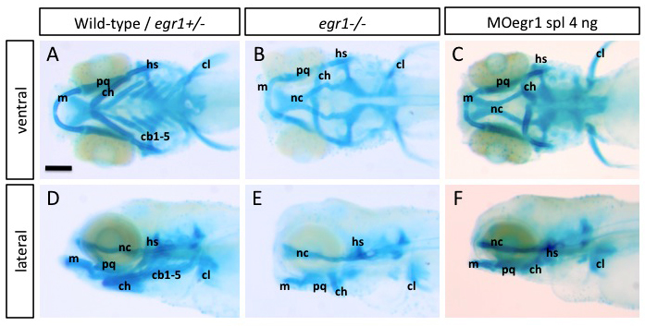
Figure 21. Homozygous egr1 mutant embryos present cartilaginous defects similar to egr1 morphants.
Cartilage in 4 dpf larvae was stained with Alcian Blue; ventral views are shown, anterior to the top. Compared to wild-type or heterozygous egr1^{+/-} larvae (A), homozygous egr1^{-/-} mutant embryos (B) do not develop ceratobranchial (cb1-5) and display a reduction of size and misshaping of the Meckel’s cartilage (m), palatoquadrate (pq), ceratohyal (ch) and hyosymplectic (hs), similar to 4 ng MOegr1 spl injected embryos (C).

To further confirm the function of Egr1 in pharyngeal endoderm, we investigated specific gene expression in homozygous egr1 mutants. In situ hybridization revealed that in one fourth of the embryos derived from heterozygous egr1 mutant parents, a decreased expression was observed for the sox9b and the runx2b gene, while fsta expression was increased (Fig.22).

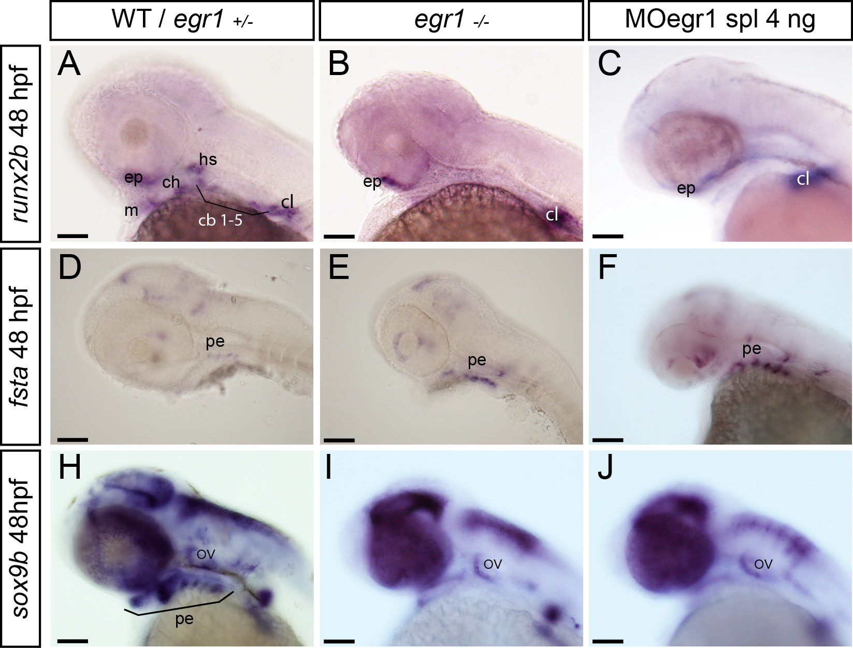
Figure 22. Homozygous egr1 mutant embryos phenocopy egr1 morphants.
Lateral views of in situ hybridizations, anterior to the left. Scale bars 100 μm. In homozygous egr1^{-/-} embryos (B) and 4 ng MOegr1 spl injected embryos (C), runx2b is absent in pharyngeal cartilage precursor cells compared to the wild-type individuals (A), but still expressed in cleithrum and ethmoid plate. Compared to wild-type embryos (D, G), homozygous egr1^{-/-} embryos and 4 ng MOegr1 spl injected embryos display an increase of fsta (E, H) and a decrease of sox9b (F, I) transcripts in pharyngeal endoderm. Meckel’s cartilage (m), palatoquadrate (pq), ceratohyal (ch) and hyosymplectic (hs), ceratobranchials 1 to 5 (cb1-5), ethmoid plate (ep), otic vesicle (ov), pharyngeal endoderm (pe), cleithrum (cl).

Discussion & Conclusions

Endodermal expression of the transcription factor Egr1 is essential for chondrogenesis and ossification.
In this study, we have demonstrated by various in situ hybridization experiments on wild type and casanova mutant (depleted in endodermal tissue) embryos, that the transcription factor Egr1 is expressed during zebrafish embryonic development in pharyngeal endoderm, but also in oral epithelium. Using loss and gain of function experiments, microinjecting morpholinos and mRNA transcripts, we proved that Egr1 plays a crucial role in the maturation and shaping of pharyngeal cartilages of the zebrafish embryos. Moreover, Egr1 is absolutely required for endochondral ossification.
Murine Egr1 is expressed among others in tooth germs, skeletal tissues such as the perichondrium, membranous bones of the head, alveolar bone or the periosteal and endochondral ossification sites in limb bones (McMahon, Champion et al. 1990). It would be interesting to investigate more in detail the involvement of Egr1 in zebrafish bone development and maintenance, but also in joints. As just mentioned, our own analyses of egr1 expression in zebrafish where limited to the first 5 days of development, further investigations would be required to study the egr1 expression pattern later in development and in adults. In situ hybridizations, immunohistochemistry, bone and cartilage stainings and histological sections should be performed to analyze more in detail its expression through later stages of development. Alizarin Red staining at 5 dpf of egr1 morphants revealed that bone (calcification of bones) was possible, except in the cleithrum and partially in parasphenoïd and opercle. Runx2b, a crucial transcription factor for ossification, is only expressed in the cleithrum at two days of development in egr1 morphants. Interestingly, inhibition of BMP signaling (by increased Follistatin A expression) in our experiments led to a decreased expression of runx2b in presumptive head cartilage, but left nearly intact its expression in the developing cleithrum. As a reminder, cleithrum, opercle and parasphenoïd are dermal bones. All these observations in our experiments clearly seem to indicate that Egr1 is essential for endochondral bone formation and partially for dermal bone formation. Similar observations were made in the sox9a mutants (Yan, Miller et al. 2002; Yan, Willoughby et al. 2005). These observations indicate that egr1, sox9a expression and fsta inhibition are mainly required for endochondral bone formation.
After characterizing and validating the egr1 mutant, this mutant line would be a nice tool for cartilage and bone study, instead of using morpholinos, which are diluted and degraded during embryo development. For example, late action of egr1 absence or down-regulation could be studied by injecting a certain amount of egr1 mRNA in the egr1 mutant to rescue the early effects on cartilage formation, revealing later effects on skeletal formation through dilution/inactivation of the injected mRNA.
By studying Egr1^{-/-} KO mice, several research groups have clearly established a role for Egr1 in tissue repair and regeneration, in particular in skeletal tissues (Santiago, Lowe et al. 1999; Wu, Melichian et al. 2009; Bhattacharyya, Sargent et al. 2011; Dussmann, Pagel et al. 2011; Reumann, Strachna et al. 2011). Zebrafish fin ablation is a wonderful model for studying wound healing (Tal, Franzosa et al. 2010; Yoshinari and Kawakami 2011; Sousa, Valerio et al. 2012). We suggest ablating the caudal fin of zebrafish adults and embryos and analyzing whether egr1 is expressed in response to this injury. It would also be interesting to perform the same experiments in egr1 knock-down embryos or in egr1 null-mutants and to see whether regeneration is affected and which factors are immediately under Egr1 control in fin repair.

Pharyngeal endoderm hosts a regulatory cascade of transcription factors required for formation of the viscerocranium.
In this study, we identified a regulatory cascade composed of three transcription factors: Runx3, Egr1 and Sox9b occurring beyond 24 hpf in zebrafish pharyngeal endoderm. This cascade is required for inhibition of fsta expression, coding for a known secreted BMP inhibitor, thereby allowing proper BMP signaling to the developing cNCCs.
We have shown that all three factors are coexpressed in pharyngeal endoderm starting at about 30 hpf and that each of them is absolutely required for pharyngeal cartilage formation. These results are in agreement with previous studies concerning the function of Sox9b and Runx3 in zebrafish. Expression of runx3 was found in pharyngeal pouches at 2 dpf and in endodermally derived oral epithelium at 3 dpf (Flores, Lam et al. 2006). Our own loss of function experiments confirmed that runx3 morphants nearly completely lack head cartilage (Flores, Lam et al. 2006) and lost runx2b expression in pharyngeal cartilage. Similarly, sox9b is expressed (starting at 26 hpf) in pharyngeal endoderm and sox9b mutants or morphants display a dramatic reduction of pharyngeal cartilage at 4 dpf and a lack of runx2b expression at 48 hpf, while exogenously expressed Sox9b partially rescued the mutant phenotype (Yan, Willoughby et al. 2005). Thus, at later stages endodermal Runx3 and Sox9b regulate cartilage and bone development by indirectly controlling runx2b expression in cNCC cells.
Here, we introduce a new player by showing that the endodermal transcription factor Egr1 is required for cartilage formation and expression of sox9b in endoderm and runx2b in cNCCs. Expression of egr1 in endodermal pouches was deduced from single and double fluorescent in situ hybridization experiments, co-expression of egr1 with cNCC markers such as dlx2a or sox9a was never observed. The complete absence of egr1 mRNA in the pharyngeal region of cas mutants, lacking endoderm, further supports this conclusion. The defects were observed following gene knock-down using translation or splicing morpholinos and the specificity of these defects for Egr1 depletion was shown by the rescue experiments.
Additional experiments revealed that Runx3 depletion led to decreased expression of both egr1 and sox9b, while runx3 expression was not affected in egr1 morphants or sox9b mutants. Egr1 depletion decreases sox9b expression only, while conversely egr1 expression is not affected in sox9b mutants. Finally, sox9b mutants display normal expression of egr1 and runx3. We further show that the defects observed in runx3 morphants can be partially rescued by expression of exogenous runx3 or egr1 mRNA, clearly indicating that Runx3 is located upstream of Egr1. Taken together, these results establish a regulatory cascade where Runx3 activates expression of Egr1, which itself then activates sox9b transcription. This cascade is not required for pharyngeal endoderm formation or the survival of pharyngeal endodermal cells, as was previously shown for Runx3 morphants (Flores, Lam et al. 2006). We similarly confirmed that in egr1 or runx3 morphants or sox9b mutants, expression of the endodermal markers nkx2.3 and sox17 is not altered compared to controls. In conclusion, we describe a regulatory cascade that operates mainly in pharyngeal endoderm and controls expression of runx2b in cartilage mesenchyme as well as cartilage differentiation and morphogenesis. This control exerted by endodermal transcription factors is obviously mediated by an extracellular signaling pathway that remains to be described.

Endodermal signaling controls the BMP pathway in cartilage precursor cells.
One of the signaling pathways involved in cartilage and bone formation is the TGFß/BMP pathway (Nie, Luukko et al. 2006). Craniofacial defects were reported in conditional knock-out mice lacking BMP type I receptor Alk2 (Dudas, Sridurongrit et al. 2004) or Smad4 (Ko, Chung et al. 2007) in cNCC, or in transgenic mice expressing the antagonistic Smad7 in cNCC cells (Tang, Snider et al. 2010). In zebrafish, several members of the BMP ligand family, such as Bmp2a, Bmp2b, Bmp4, Bmp5 and Bmp7 were shown to be secreted in the pharyngeal region (Martinez-Barbera, Toresson et al. 1997; Holzschuh, Wada et al. 2005; Nie, Luukko et al. 2006) and their importance for head cartilage development was shown (Wilson and Tucker 2004). More recently, BMPs were shown to promote ventral fates of the craniofacial skeleton in zebrafish (Alexander, Zuniga et al. 2011). Based on our previous experiments, we therefore tested the involvement of the BMP pathway in cartilage formation by inhibiting BMP signaling at stages beyond 24 hpf. Treatment with the specific inhibitor dorsomorphin (Hao, Daleo et al. 2008) revealed that the importance of BMP signaling for visceral cartilage formation and runx2b expression increases after 24 hpf and is most crucial during the period between 27-37 hpf. This result was confirmed by inducing the expression of a dominant-negative Bmp receptor (Pyati, Webb et al. 2005) at 29 hpf. This period coincides with the time of onset of runx3 (Flores, Lam et al. 2006), egr1 and sox9b gene expression in pharyngeal endoderm.
When we tested the expression of various extracellular signaling molecules (Shh and Bmps) in egr1 morphants, we did not detect any decrease of expression for any of these genes. During development, many processes require inhibition of BMP signaling by secreted BMP antagonists (Bauer, Meier et al. 1998; Canalis, Economides et al. 2003; Poulain, Furthauer et al. 2006; Xia and Schneyer 2009). Follistatin was first described as a polypeptide inhibiting the release of follicle stimulating hormone in the pituitary (Esch, Shimasaki et al. 1987). Since then, its involvement in ovarian development and function and its antagonism to members of the TGFß/BMP family has been extensively studied (Bauer, Meier et al. 1998; de Kretser, Hedger et al. 2002). The function of Follistatin as BMP antagonist in skeletal development has also been described (Bauer, Meier et al. 1998; Canalis, Economides et al. 2003; Gajos-Michniewicz, Piastowska et al. 2010). We observed a strongly increased expression of follistatin a (fsta) in the pharyngeal region at 48 hpf in egr1 morphants. Such a strong over-expression of Follistatin A would obviously lead to a perturbation of BMP signaling in the entire pharyngeal region and cause defects similar to the BMP inhibition experiments discussed above. Indeed, when we tested activation of the BMP pathway using antibodies against phospho-Smad1/5/8, we observed that egr1 knock-down dramatically reduces BMP signaling in the pharyngeal region. Pathway activation was abolished not only in the post-migratory cNCC clusters, but also in the neighboring tissues, potentially causing additional perturbations in skeletal morphogenesis.
Clearly, the function of BMP signaling in craniofacial development is conserved in vertebrates, including mouse and human, and the importance of antagonists such as Follistatin is also well documented. Different threshold levels of Bmp4 were shown in mouse to regulate various genes involved in craniofacial skeletal morphogenesis (Liu, Selever et al. 2005). Conservation of the endodermal function of Sox9b is more difficult to assess due to the fact that the diverging functions of zebrafish Sox9a and Sox9b are covered by their single mammalian ortholog Sox9. It is however interesting to note that an increased expression of Follistatin was observed in male gonads of Sox9 knock out mice (Chaboissier, Kobayashi et al. 2004), suggesting a possible repressive function similar to that described here.
Taken together, our results indicate that the Runx3/Egr1/Sox9b regulatory cascade is active in pharyngeal endoderm after 24 hpf to inhibit expression of fsta, which needs to be tightly controlled so that the Bmp ligands can bind to their respective receptors located on cartilage precursors cells (Fig.1A,B). In wild type embryos, BMP signaling also appears to be controlled by the much weaker expression of follistatin A, as illustrated by the presence of increased cartilage elements in fsta morphants. BMP action has to be tightly counterbalanced by inhibitory proteins for correct morphogenesis of the head skeleton. Although other BMP antagonists could also contribute to this control, the increased cartilage observed in fsta morphants attributes an outstanding role to Follistatin A in this function.
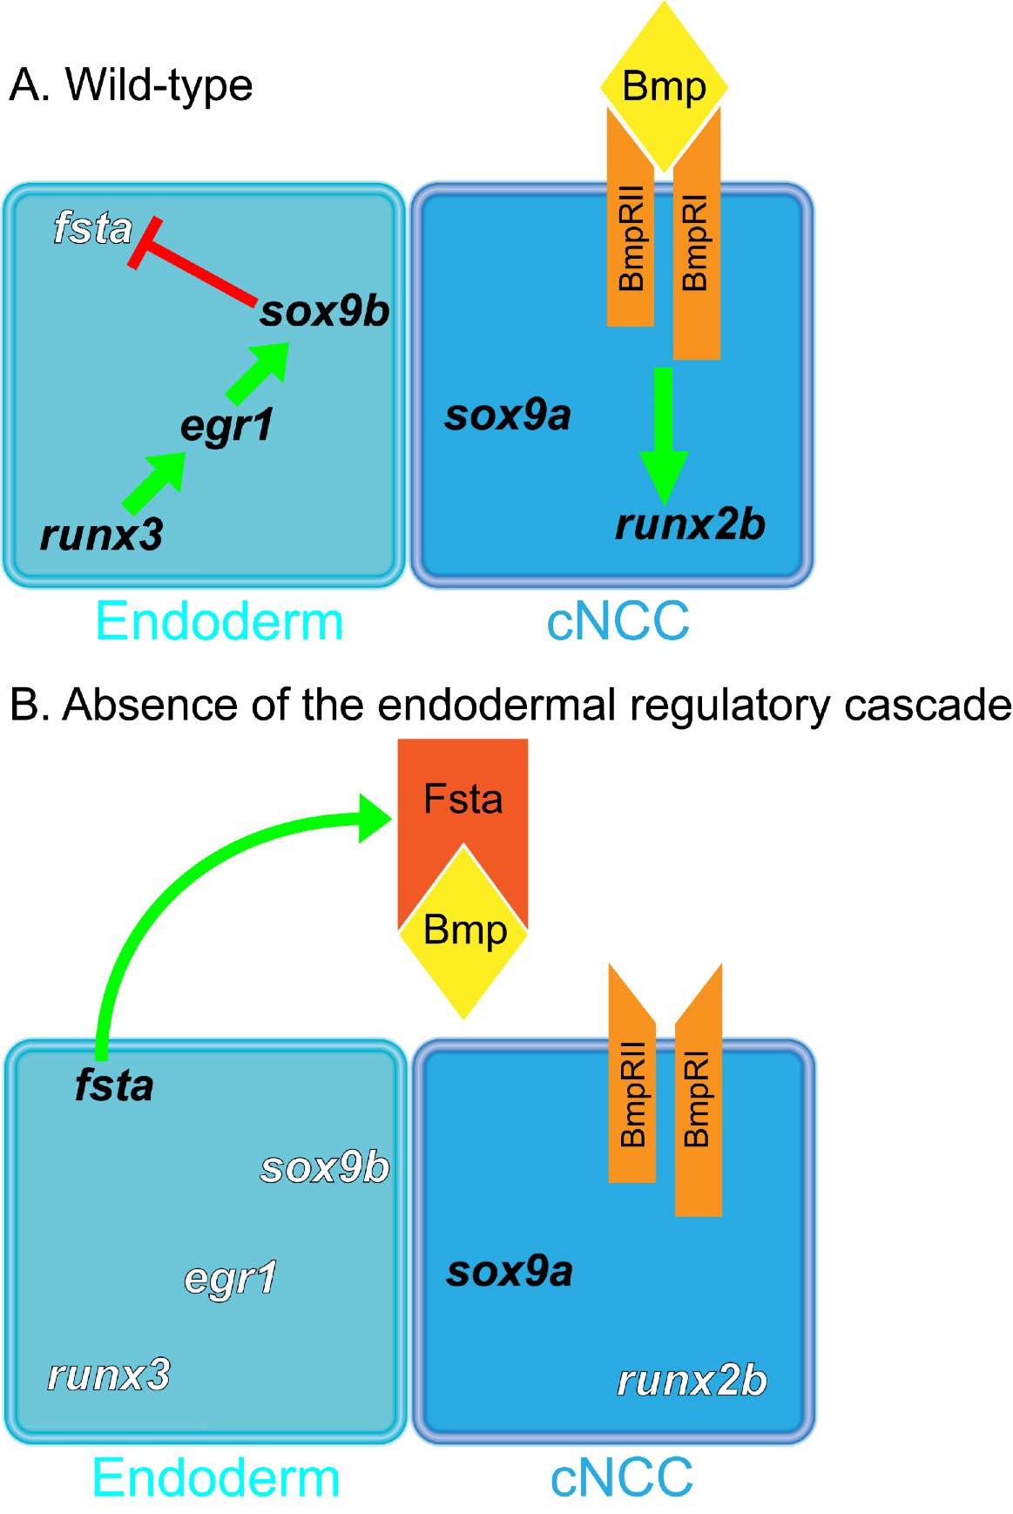
Figure 1. Runx3, Egr1 and Sox9b form a regulatory cascade required to modulate Bmp-signaling during cranial cartilage development in zebrafish.
Signaling model in wild-type embryos (A) and in embryos lacking of endodermal regulatory cascade (B). (A) In wild-type embryos, pharyngeal endoderm expresses a regulatory cascade composed of three transcription factors, Runx3, Egr1 and Sox9b, which down-regulates fsta expression that codes for a Bmp antagonist. This down-regulation of fsta enables Bmp ligands to bind to their heterodimeric receptor (BmpRI and BmpRII) and induce runx2b expression in cranial neural crest cells (cNCC). (B) Embryos lacking of any member of Runx3-Egr1-Sox9b cascade have an over-expression of fsta, which its coding protein is secreted from the endoderm. Antagonist Fsta binds to Bmp ligands and inhibit them to bind to their receptor, having for consequence no Bmp-signaling towards the cNCC and no runx2b expression.

Multiple roles of the pharyngeal endoderm in cranial cartilage formation.
We show that cas mutant embryos lack fsta expression in the pharyngeal region, as would probably be the case for other mutants devoid of endoderm. However, instead of presenting an increase of cartilage as could be expected, cas mutants completely lack a head skeleton and runx2b expression at 48 hpf (Flores, Lam et al. 2006). This observation obviously reflects the fact that chondrogenic and osteogenic signals (Bmp, Hh, Fgf) originate from the endoderm and thus are absent in the mutants, but it also highlights the importance of maintaining a precise balance of agonistic and antagonistic activities. It further suggests that pharyngeal endoderm may be a major source of BMP signaling in the ventral head region, relative to other surrounding tissues that are still present in the cas mutants.
Recently, BMP signaling was shown to be involved at earlier stages (between 17 and 24 hpf) in dorso-ventral patterning by specifying expression of dorso-ventral markers (Alexander, Zuniga et al. 2011). Here we show that inhibition of BMP signaling by dorsomorphin, expression of a dnBMP receptor or by over-expression of Follistatin A leads to a complete absence of runx2b expression, similar to complete absence of endoderm in cas mutants (Flores, Lam et al. 2006). Thus, in addition to early dorso-ventral patterning, BMP signaling is required at later stages for differentiation of all the pharyngeal chondrocytes. Similarly, Shh signaling from pharyngeal endoderm was recently shown to be required before 24 hpf for the selective growth and/or differentiation of anterior cranial cartilage precursor cells, without affecting dorso-ventral patterning, by inducing fgf8a expression in oral ectoderm (Balczerski, Matsutani et al. 2012). Ectopic Shha expression by transgenesis in cas mutant embryos restored fgf8a expression and formation of the mandibular and hyoid arches. Later pharyngeal jaw skeleton was only weakly restored, suggesting the requirement of additional endodermal signals at later stages. According to our results, members of the BMP family coupled to a finely tuned control of Follistatin A levels appear as a good candidate for these signals. The Runx3/Egr1/Sox9b cascade is activated after 24 hpf to reduce fsta expression and allow correct BMP signaling that is required at stages beyond 27 hpf for cartilage formation.
Interestingly, manipulation of the endodermal regulatory cascade leaves intact the early function of BMP signaling in dorso-ventral patterning, as indicated by the maintained expression of the ventral markers hand2 and edn1 at 24 hpf. This is consistent with the onset of expression after 24 hpf of the regulators Runx3, Egr1 and Sox9b in pharyngeal endoderm and with the observed lack of fsta overexpression in egr1 morphants at 24 hpf. An earlier function for control of BMP signaling by Follistatin A was previously shown in dorso-ventral patterning of the retina (Erickson, French et al. 2010). In this case, fsta expression was shown to be increased at 13 hpf upon knock-down of the TALE-class homeodomain transcription factor Meis1, leading to a decrease of BMP signaling in the optic vesicle. At 19 hpf, fsta expression was highly increased in meis1 morphants in all its expression domains (Erickson, French et al. 2010), suggesting a wider role for Meis1 in enabling BMP signaling at this stage. Control of fsta expression specifically in the pharyngeal region at later stages is taken over by the endodermal regulatory cascade described here.

Multiple signaling pathways converge on developing chondrocytes.
Our results indicate that BMP signaling is required in cNCC cells after their migration to their ventral position in the pharyngeal arches to induce their differentiation into hypertrophic chondrocytes, but also to allow their subsequent migration leading to morphogenesis of the different head cartilages. Additional extracellular signals will also play a role, such as Fgfs or Hhs. At 24 hpf, cNCC cells express the early differentiation marker sox9a, whose expression is maintained in pharyngeal cartilage precursor cells and required for their differentiation (Yan, Miller et al. 2002). Depletion of the endodermal regulatory cascade does not affect sox9a expression. In contrast, the key regulatory gene for chondrogenesis and osteogenesis, runx2b is dramatically down-regulated in egr1 morphants. Its expression in pharyngeal cartilage precursor cells normally starts at 34 hpf (Flores, Lam et al. 2006) and was shown to be essential for chondrocyte and osteoblast differentiation (Kimmel, Ballard et al. 1995; Chaboissier, Kobayashi et al. 2004). This timing is consistent with the requirement for fsta down-regulation for efficient activation by BMP signaling as described here. runx2b expression is down-regulated despite the normal expression of sox9a, conversely it is not affected in sox9a mutants (Yan, Willoughby et al. 2005), indicating that at least two different pathways are required in chondrocyte precursor cells for activation of these two genes and, thus for chondrogenesis and that neither of them can compensate the function of the other.
In conclusion, we show here that a regulatory cascade is active in pharyngeal endoderm that represses expression of the fsta gene, thereby allowing the correct activation of BMP signaling in cNCC cells required for their differentiation and morphogenesis of pharyngeal and basicranial cartilage. This cascade starts by increased expression of runx3, followed by activation of egr1 expression and finally sox9b expression in the pharyngeal endoderm.

Preliminary results of the analysis of egr1 mutant are similar to egr1 morphants.
Recently we obtained a mutant line for egr1. The first analyses of the supposed homozygous mutants correlate with the results obtained by knock-down experiments. At 4 dpf, the Alcian Blue staining clearly shows the same defects as in egr1 morphants; an absence of ceratobranchials and misshaping and reduction of the jaws (mandible and hyoïd). We also analysed two days old homozygous embryos with different markers: runx2b, fsta and sox9b. Like in egr1 morphants, we obtained a down-regulation of runx2b in the pharyngeal cartilage mesenchyme, sox9b in the pharyngeal endoderm and an over-expression of fsta in the phrangeal endoderm.
These preliminary results are encouraging for the egr1 mutant characterization. The next experiments to to would be to confirm that the assumed homozygous embryos are really homozygous for egr1, because this mutation was established by the TILLING method and other mutations are present in the genome of these fish. The characterization of this mutant should be completed by analyzing other markers, such as those used for our morphant characterization.

Egr1 in musculoskeletal development.

Our analyses revealed that egr1 down-regulation leads to an absence or/and down regulation of myod expression in the muscles of the head, which contrasts with an increased myoD expression in the trunc (Fig.5 in results). MyoD is a key protein in muscle differentiation (Tapscott, Davis et al. 1988; Weinberg, Allende et al. 1996) and drives myogenesis in head and fins (Hinits, Williams et al. 2011). The Transversus ventralis muscles, which are absent in egr1 morphants at two days of development, are associated to the pharyngeal arches, they insert on ceratobranchial cartilage and control gill bar movements. The decrease of myoD expression in cranial muscles could actually be secondary due to other defects such as the loss of cartilage elements, but also due to the absence or down-regulation of markers in cranial neural crest cells or pharyngeal endoderm. To confirm the potential role of Egr1 in myogenesis it would be interesting to study the expression pattern of other mesoderm and muscle precursor markers, such as myf5 (myogenic factor 5), eng2 (engrailed 2), tbx1 (T-box 1), capsulin and musculin, in egr1 morphants but also in runx3 morphants and sox9b^{b971} mutants. Until now, no publication studied the implication of sox9b. If the function of Egr1 on myogenesis is confirmed, it would be interesting to further investigate the potential role of Sox9b, as the sox9b gene is regulated by Egr1 in the head. The role of Egr1 on muscle development may be independent or dependant of sox9b. Concerning its co-ortholog sox9a, analyses of the sox9a mutant, jef^{tw37} using the muscle marker gene titin (ttn) expression revealed that sox9a has no activity on muscle patterning in the head, but also revealed structural modifications of the muscular system due to the lack of cartilage attachment points and a decrease in ttn expression (Yan, Miller et al. 2002).

During the last two decades, the close relationship and signaling interaction between the various tissues of the pharyngeal arches have clearly been demonstrated. We propose, like in this present work, to study whether the transcription factor Egr1 is involved in pharyngeal myogenesis by analyzing various signaling pathway originating from pharyngeal endoderm and cNCC towards pharyngeal mesoderm.
Regarding the mesoderm of the trunk, our results and those obtained by Close et al. (Close, Toro et al. 2002) revealed that egr1 is expressed in adaxial cells of the presomitic mesoderm (from 12 hpf to 24 hpf) and that its down-regulation leads to an overexpression of myoD later in the development of the somites. Many genes expressed in early somite formation present a cyclic pattern (Gajewski, Sieger et al. 2003; Mara and Holley 2007; Choorapoikayil, Willems et al. 2012). To determine whether Egr1 has a function in the cyclic expression of muscles markers during somitogenesis, the expression of various markers of the somitic mesoderm should be analyzed in egr1 morphants. Further investigation should be carried out to study the potential role of Egr1 in somitogenesis. First, the expression pattern of Egr1 in somites should be described more in detail and finally loss-of-function experiments should be planned to analyze various somitic markers such as delta, notch, hairy-related and hairy-and-enhancer-of-split (Mara and Holley 2007).

It is also important to mention that loss of muscle function was shown to have deleterious effects on bone formation. Indeed, myod (myod^{fh261}) mutation in zebrafish also leads to dysmorphology of the cartilaginous skeleton and failure of maturation of several cranial bones, including the opercle (Hinits, Williams et al. 2011). These mutants have down-turned Meckel’s cartilage and ceratohyals, giving them a permanently open protruding mouth, and the chondrocytes fail to elongate and stack. Lethality of homozygous mutant individuals was observed between 6 and 12 dpf. Skeletal defects observed in myoD^{-/-} larvae arise after failure of muscle development and no cranial skeletal defects were observed before 3 dpf. The absence of myoD expression in egr1 morphants cannot explain the cartilaginous defects that we observe at 4 dpf, but could partially contribute to them. Our results clearly demonstrate Egr1’s implication on skeletogenesis at earlier stages.

Interestingly and confirming the role of muscles on skeletogenesis, a very recent study on zebrafish has demonstrated that muscle contractions are essential for a proper pharyngeal cartilage morphogenesis (Shwartz, Farkas et al. 2012). Shwartz et al. used the nic-1 (b107) mutant, where the function of muscle acetylcholine receptors (AchR) is blocked, giving rise to paralyzed embryos (Westerfield, Liu et al. 1990). Paralyzed fish were also obtained chemically by treating them with tricaïne starting at 8.5 hpf (prior to somitogenesis) until 120 hpf. Alcian Blue staining at 4 dpf of these mutants revealed a reduction and misshaping of the viscerocranium. Like in myod (myod^{fh261}) mutants (Hinits, Williams et al. 2011), skeletal defects arise starting at 3 dpf. Further experiments have demonstrated that these skeletal aberrations are not due to defects in migration or specification of cNCC. Detailed analyses showed that the chondrocytes in the Meckel's to ceratohyal joint are smaller and do not elongate, explaining the morphological alterations of the viscerocranium in paralyzed fish. Paralyzed larvae exhibit an increase of unstacked chondrocytes compared to non-paralyzed controls. Taken together, these observations imply that muscle contractions are required for late development of cartilage, joint and bone morphogenesis of the viscerocranium, but only in late cartilage morphogenesis, after 3 dpf. Similar conclusions were drawn by analyzing the splotch delayed (Sp^{d}) mutant mice, which are characterized by a defect in migration of muscle progenitors in developing limbs (Franz 1993).

In mice, a recent study showed that transcription factor Egr1 is involved in tendon differentiation by regulating type I collagen, the major collagen component (Lejard, Blais et al. 2011). Tendons bind muscles to bones and, like cartilage and endochondral bone, originate from neural crest cells (NCC). cNCC and myogenic cells are intermingled throughout development, leading to close interactions between tendons, skeleton and muscles during embryonic development of the head (Grenier, Teillet et al. 2009). In mice and chicken, is has been shown that tendons initiate their development independently of muscles but require the presence of muscle for further development. In mouse, Egr1 is expressed in the tendons but only in the region close to the muscles and delineating the long tendons. Lejard et al. have proven that Egr1 regulates scleraxis (scx) and collagen1a1 (col1a1). Scx is a basic helix-loop-helix (bHLH) transcription factor and is expressed in progenitor and differentiated cells of tendons, while Col1a1 is the main collagen type in tendons. Egr1 is sufficient for scx and col1a1 expression. Indeed, over-expression egr1 in mesodermal tissue leads to an ectopic expression of scx and col1a1, while Egr1^{-/-} KO mouse display a significant decrease of scx and col1a1 mRNA and a 30 to 40% reduction in the number of collagen fibrils in tendons compared to control mice. However, the absence of Egr1 is not sufficient to completely abolish col1a1 expression.

Final conclusions.
Our studies have led to a better characterization of transcription factor Egr1 and it’s involvement in cellular signaling during skeletogenesis of the zebrafish.
To conclude, we have shown that:
- Transcription factor Egr1 is expressed in the pharyngeal endoderm and oral epithelium.
- The expression of Egr1 is absolutely and specifically required for chondrogenesis of the pharyngeal skeleton.
- Egr1 is involveded in a regulatory cascade in pharyngeal endoderm, composed of runx3, egr1 and sox9b.
- Down-regulation of the Bmp inhibitor Fsta and, consequently activation of Bmp signaling is only possible upon endodermal expression of runx3, egr1 and/or sox9b.
- Up-regulation of the Bmp inhibitor Fsta leads to a down-regulation of Bmp signaling in the entire pharyngeal arch region.
- Runx2b, a marker of early endochondral ossification, is regulated by Bmp signaling.
- Egr1 is essential for endochondral bone and partially for dermal bone formation.
- Preliminary characterization of an egr1 mutant line confirms the results obtained by loss-of-function studies.
- Preliminary results and literature indicate that Egr1 has a function in muscle development.

Materials & Methods

Fish and embryo maintenance.
Zebrafish (Danio rerio) were reared in a recirculating system from Techniplast, Italy at a maximal density of 7 fish/L. The water characteristics were as follows: pH = 7.4, conductivity = 500 µScm-1, temperature = 28°C. The light cycle was controlled (14 h light, 10 h dark). Fish were fed twice daily with dry powder (ZM fish food®) with size adapted to their age, and once daily with fresh Artemia salina nauplii (ZM fish food®). Larvae aged less than 14 days were also fed twice daily with a live paramecia culture. Wild type embryos from the AB strain were used and staged according to Kimmel (Kimmel, Ballard et al. 1995). Transgenic lines Tg(hsp70l:dnBmpr-GFP) (Pyati, Webb et al. 2005), Tg(sox17:GFP)s870/+ (Stainier laboratory) and Tg(fli1a:EGFP)y1/+ (Lawson and Weinstein 2002) were obtained from the ZIRC (Eugene, Oregon, USA) and the mutant egr1 sa0064 was obtained from the Sanger Institute (Welcome Trust Genome Campus, Cambridge, UK).
Breeding: the day before breeding, 2 males and 2 females were placed in breeding tanks out of the recirculating system, with an internal divider to prevent unwanted mating. On the day of breeding, fish were placed in fresh aquarium water and the divider was removed to allow mating. Eggs were collected every 30 minutes and raised in E3 (5 mM Na Cl, 0.17 mM KCl, 0.33 mM CaCl₂, 0.33 mM MgSO₄, 0.00001 % Methylene Blue).

All experiments and the entire study were evaluated by the Ethical Committee of the University of Liege, Belgium and accepted under the file numbers 377, 568 and 1074.

Loss of function and rescue experiments.
Morpholino oligonucleotides (MO) were synthesized by Gene Tools (Philomath, OR, USA) and are complementary to the 5’ sequence near the translation start site or to the splice junctions. Morpholino are small nucleotides (18 to 25 pb) that bind specifically to defined mRNA sequences. MO stock solutions were prepared as suggested by Gene Tools. Tetramethylrhodamine dextran (Invitrogen, Belgium) was added at a concentration of 0.5% to sort correctly injected embryos a few hours after injection. The morpholino sequences are as follow:
MO splicing egr1: GGATTTAGTGCTTACCTCCAGCAAG
MO translation egr1: TGCAGCCATCTCTCTGGAGTGTGCT
MO translation runx3: TGCTCGGGTCTACGGGAATATGCA (Flores, Lam et al. 2006)
MO translation fst1a: CTGACGTTTAGCATCCTTAGCATG (Dal-Pra, Furthauer et al. 2006)
MO standard control: CCTCTTACCTCAGTTACAATTTATA (Gene-Tools®)
An egr1 cDNA fragment starting at the ATG start codon and spanning the entire coding region was obtained by PCR-amplification from the cDNA clone (Close, Toro et al. 2002) and inserted into pCRII-TOPO and a SV40 polyadenylation signal sequence was added at the 3’ end. egr1 mRNA was synthesized using mMessage mMachine Sp6 (Ambion®) and injected alone or co-injected with a morpholino at the one-cell stage with a microinjector (Narishige®).
Efficiency of the splicing morpholino MOegr1 spl was examined by RT-PCR using SuperScript® from Invitrogen (Gent, Belgium). mRNA of 50 injected embryos was extracted for each experiment. The primers used were: Zf-Egr1 forward: 5’-CAGTTTGATCACCTTGCTGG-3’; Zf-Egr1 reverse: 5’-GGAAGACGTGGAAGAGGAAG-3’.

Whole-mount in situ hybridization and immunohistochemisrty.
Injected embryos for in situ hybridization were raised in presence of 0.003% of 1-phenyl-2-thiourea until the desired stage, fixed overnight in 4% of PFA at 4°C and stored in 100% methanol at -20°C until use. Visible in situ hybridizations (ISH) were performed as described (Hauptmann and Gerster 1994). Fluorescent labeling was performed as described (Lopez, Nica et al. 2006; Quiroz, Lopez et al. 2012).
Whole-mount fluorescent immunohistochemistry was described in (Dong, Munson et al. 2007). We used the following antibodies: polyclonal rabbit anti-phospho-Smad (1:200, Cell Signaling®), polyclonal mouse anti-GFP (1:250, Roche®) and fluorescently conjugated Alexa antibodies (Molecular Probes®).

Image acquisition.
Pictures of visible in situ hybridization were taken by Nikon® Eclipse 90i microscope and NIS-Elements microscope imaging software. Fluorescent images were acquired with a Leica® SP2 confocal microscope

Alcian Blue staining.
Cartilage (glycoaminoglycans) was stained with Alcian Blue 8 GX (Sigma-Aldrich®). Four days old embryos were fixed in PFA 4% for 2h at room temperature, rinsed with PBST and finally stained overnight with 10mM Mg Cl2/80% ethanol/ 0.04% Alcian Blue solution. Embryos were rinsed with 80% ethanol/10mM MgCl2. Pigments were bleached in H2O2 3%/KOH 0,5% for 1h. 25% glycérol/0,1% KOH, 50%Glycerol/0,1% KOH.

Alizarin Red staining.
Bone (Calcium) was stained with Alizarin Red S (Sigma-Aldrich®). Living embryos were place overnight in 50 mL of rearing medium with 500 μL of 1 M HEPES and between 200-500 μL of 0.5% of Alizarin Red diluted in water. After incubation, the embryos were rinsed three times with rearing medium and finally observed under fluorescence.

Heat shock conditions.
Transgenic embryos hsp70l:dnBmpr-GFP (Pyati, Webb et al. 2005) were heat shocked at desired stages by placing them into a water bath for 30 minutes at 37°C and afterward placed back at 28°C. Two hours after the heat shock, the embryos were screened for GFP fluorescence. Embryos not expressing GFP were used as non-transgenic controls.

Dorsomorphin treatments.
10 mM stock solution of dorsomorphin (Calbiochem®) was diluted in DMSO (Calbiochem®). Embryos at desired stage were placed into multiwell plates with dorsomorphin diluted in E3 rearing medium at the desired concentration during a specific time period. DMSO alone was used as control. Embryos were then rinsed several times with E3, raised in E3 and finally fixed at the desired stage.

Bibliography

Abdulkadir, S. A., J. M. Carbone, et al. (2001). "Frequent and early loss of the EGR1 corepressor NAB2 in human prostate carcinoma." Hum Pathol 32(9): 935-939.
Aicher, W. K., D. Alexander, et al. (2003). "Transcription factor early growth response 1 activity up-regulates expression of tissue inhibitor of metalloproteinases 1 in human synovial fibroblasts." Arthritis Rheum 48(2): 348-359.
Aicher, W. K., A. Dinkel, et al. (1999). "Serum response elements activate and cAMP responsive elements inhibit expression of transcription factor Egr-1 in synovial fibroblasts of rheumatoid arthritis patients." Int Immunol 11(1): 47-61.
Akimenko, M. A., M. Ekker, et al. (1994). "Combinatorial expression of three zebrafish genes related to distal-less: part of a homeobox gene code for the head." J Neurosci 14(6): 3475-3486.
Alexander, C., E. Zuniga, et al. (2011). "Combinatorial roles for BMPs and Endothelin 1 in patterning the dorsal-ventral axis of the craniofacial skeleton." Development 138(23): 5135-5146.
Alexander, D., M. Judex, et al. (2002). "Transcription factor Egr-1 activates collagen expression in immortalized fibroblasts or fibrosarcoma cells." Biol Chem 383(12): 1845-1853.
Alexander, J., M. Rothenberg, et al. (1999). "casanova plays an early and essential role in endoderm formation in zebrafish." Dev Biol 215(2): 343-357.
Bae, S. C. and J. K. Choi (2004). "Tumor suppressor activity of RUNX3." Oncogene 23(24): 4336-4340.
Balczerski, B., M. Matsutani, et al. (2012). "Analysis of sphingosine-1-phosphate signaling mutants reveals endodermal requirements for the growth but not dorsoventral patterning of jaw skeletal precursors." Dev Biol 362(2): 230-241.
Barrow, L. L., K. Simin, et al. (1994). "Conserved linkage of early growth response 4, annexin 4, and transforming growth factor alpha on mouse chromosome 6." Genomics 19(2): 388-390.
Bauer, H., A. Meier, et al. (1998). "Follistatin and noggin are excluded from the zebrafish organizer." Dev Biol 204(2): 488-507.
Bell, D. M., K. K. Leung, et al. (1997). "SOX9 directly regulates the type-II collagen gene." Nat Genet 16(2): 174-178.
Bhattacharyya, S., J. L. Sargent, et al. (2011). "Egr-1 induces a profibrotic injury/repair gene program associated with systemic sclerosis." PLoS One 6(9): e23082.
Biesiada, E., M. Razandi, et al. (1996). "Egr-1 activates basic fibroblast growth factor transcription. Mechanistic implications for astrocyte proliferation." J Biol Chem 271(31): 18576-18581.
Bradley, L. C., A. Snape, et al. (1993). "The structure and expression of the Xenopus Krox-20 gene: conserved and divergent patterns of expression in rhombomeres and neural crest." Mech Dev 40(1-2): 73-84.
Burke, R., D. Nellen, et al. (1999). "Dispatched, a novel sterol-sensing domain protein dedicated to the release of cholesterol-modified hedgehog from signaling cells." Cell 99(7): 803-815.
Burmeister, S. S. and R. D. Fernald (2005). "Evolutionary conservation of the egr-1 immediate-early gene response in a teleost." J Comp Neurol 481(2): 220-232.
Canalis, E., A. N. Economides, et al. (2003). "Bone morphogenetic proteins, their antagonists, and the skeleton." Endocr Rev 24(2): 218-235.
Cao, X., R. Mahendran, et al. (1993). "Detection and characterization of cellular EGR-1 binding to its recognition site." J Biol Chem 268(23): 16949-16957.
Cao, X. M., R. A. Koski, et al. (1990). "Identification and characterization of the Egr-1 gene product, a DNA-binding zinc finger protein induced by differentiation and growth signals." Mol Cell Biol 10(5): 1931-1939.
Cenci, S., M. N. Weitzmann, et al. (2000). "M-CSF neutralization and egr-1 deficiency prevent ovariectomy-induced bone loss." J Clin Invest 105(9): 1279-1287.
Chaboissier, M. C., A. Kobayashi, et al. (2004). "Functional analysis of Sox8 and Sox9 during sex determination in the mouse." Development 131(9): 1891-1901.
Chavrier, P., P. Lemaire, et al. (1988). "Characterization of a mouse multigene family that encodes zinc finger structures." Mol Cell Biol 8(3): 1319-1326.
Che, J. H., Z. R. Zhang, et al. (2010). "Application of tissue-engineered cartilage with BMP-7 gene to repair knee joint cartilage injury in rabbits." Knee Surg Sports Traumatol Arthrosc 18(4): 496-503.
Chen, W., S. Burgess, et al. (2001). "Analysis of the zebrafish smoothened mutant reveals conserved and divergent functions of hedgehog activity." Development 128(12): 2385-2396.
Chiang, C., Y. Litingtung, et al. (1996). "Cyclopia and defective axial patterning in mice lacking Sonic hedgehog gene function." Nature 383(6599): 407-413.
Choorapoikayil, S., B. Willems, et al. (2012). "Analysis of her1 and her7 mutants reveals a spatio temporal separation of the somite clock module." PLoS One 7(6): e39073.
Christy, B. and D. Nathans (1989). "DNA binding site of the growth factor-inducible protein Zif268." Proc Natl Acad Sci U S A 86(22): 8737-8741.
Christy, B. A., L. F. Lau, et al. (1988). "A gene activated in mouse 3T3 cells by serum growth factors encodes a protein with "zinc finger" sequences." Proc Natl Acad Sci U S A 85(21): 7857-7861.
Chubinskaya, S., M. Hurtig, et al. (2007). "OP-1/BMP-7 in cartilage repair." Int Orthop 31(6): 773-781.
Close, R., S. Toro, et al. (2002). "Expression of the zinc finger Egr1 gene during zebrafish embryonic development." Mech Dev 118(1-2): 269-272.
Corcoran, R. B. and M. P. Scott (2006). "Oxysterols stimulate Sonic hedgehog signal transduction and proliferation of medulloblastoma cells." Proc Natl Acad Sci U S A 103(22): 8408-8413.
Crosby, S. D., J. J. Puetz, et al. (1991). "The early response gene NGFI-C encodes a zinc finger transcriptional activator and is a member of the GCGGGGGCG (GSG) element-binding protein family." Mol Cell Biol 11(8): 3835-3841.
Crosby, S. D., R. A. Veile, et al. (1992). "Neural-specific expression, genomic structure, and chromosomal localization of the gene encoding the zinc-finger transcription factor NGFI-C." Proc Natl Acad Sci U S A 89(10): 4739-4743.
Dal-Pra, S., M. Furthauer, et al. (2006). "Noggin1 and Follistatin-like2 function redundantly to Chordin to antagonize BMP activity." Dev Biol 298(2): 514-526.
David, N. B., L. Saint-Etienne, et al. (2002). "Requirement for endoderm and FGF3 in ventral head skeleton formation." Development 129(19): 4457-4468.
de Kretser, D. M., M. P. Hedger, et al. (2002). "Inhibins, activins and follistatin in reproduction." Hum Reprod Update 8(6): 529-541.
Dong, P. D., C. A. Munson, et al. (2007). "Fgf10 regulates hepatopancreatic ductal system patterning and differentiation." Nat Genet 39(3): 397-402.
Drummond, I. A., P. Rohwer-Nutter, et al. (1994). "The zebrafish egr1 gene encodes a highly conserved, zinc-finger transcriptional regulator." DNA Cell Biol 13(10): 1047-1055.
Dudas, M., S. Sridurongrit, et al. (2004). "Craniofacial defects in mice lacking BMP type I receptor Alk2 in neural crest cells." Mech Dev 121(2): 173-182.
Dussmann, P., J. I. Pagel, et al. (2011). "Live in vivo imaging of Egr-1 promoter activity during neonatal development, liver regeneration and wound healing." BMC Dev Biol 11: 28.
Ehrengruber, M. U., S. G. Muhlebach, et al. (2000). "Modulation of early growth response (EGR) transcription factor-dependent gene expression by using recombinant adenovirus." Gene 258(1-2): 63-69.
Eid, M. A., M. V. Kumar, et al. (1998). "Expression of early growth response genes in human prostate cancer." Cancer Res 58(11): 2461-2468.
Ellies, D. L., D. W. Stock, et al. (1997). "Relationship between the genomic organization and the overlapping embryonic expression patterns of the zebrafish dlx genes." Genomics 45(3): 580-590.
Elrod-Erickson, M. and C. O. Pabo (1999). "Binding studies with mutants of Zif268. Contribution of individual side chains to binding affinity and specificity in the Zif268 zinc finger-DNA complex." J Biol Chem 274(27): 19281-19285.
Erickson, T., C. R. French, et al. (2010). "Meis1 specifies positional information in the retina and tectum to organize the zebrafish visual system." Neural Dev 5: 22.
Esch, F. S., S. Shimasaki, et al. (1987). "Structural characterization of follistatin: a novel follicle-stimulating hormone release-inhibiting polypeptide from the gonad." Mol Endocrinol 1(11): 849-855.
Flores, M. V., E. Y. Lam, et al. (2006). "A hierarchy of Runx transcription factors modulate the onset of chondrogenesis in craniofacial endochondral bones in zebrafish." Dev Dyn 235(11): 3166-3176.
Flores, M. V., V. W. Tsang, et al. (2004). "Duplicate zebrafish runx2 orthologues are expressed in developing skeletal elements." Gene Expr Patterns 4(5): 573-581.
Franz, T. (1993). "The Splotch (Sp1H) and Splotch-delayed (Spd) alleles: differential phenotypic effects on neural crest and limb musculature." Anat Embryol (Berl) 187(4): 371-377.
Fujii, M., K. Takeda, et al. (1999). "Roles of bone morphogenetic protein type I receptors and Smad proteins in osteoblast and chondroblast differentiation." Mol Biol Cell 10(11): 3801-3813.
Gajewski, M., D. Sieger, et al. (2003). "Anterior and posterior waves of cyclic her1 gene expression are differentially regulated in the presomitic mesoderm of zebrafish." Development 130(18): 4269-4278.
Gajos-Michniewicz, A., A. W. Piastowska, et al. (2010). "Follistatin as a potent regulator of bone metabolism." Biomarkers 15(7): 563-574.
Gammill, L. S. and M. Bronner-Fraser (2003). "Neural crest specification: migrating into genomics." Nat Rev Neurosci 4(10): 795-805.
Gibson, T. J., J. P. Postma, et al. (1988). "A model for the tertiary structure of the 28 residue DNA-binding motif ('zinc finger') common to many eukaryotic transcriptional regulatory proteins." Protein Eng 2(3): 209-218.
Gineitis, D. and R. Treisman (2001). "Differential usage of signal transduction pathways defines two types of serum response factor target gene." J Biol Chem 276(27): 24531-24539.
Ginsberg, A. M., B. O. King, et al. (1984). "Xenopus 5S gene transcription factor, TFIIIA: characterization of a cDNA clone and measurement of RNA levels throughout development." Cell 39(3 Pt 2): 479-489.
Granet, C., N. Boutahar, et al. (2001). "MAPK and SRC-kinases control EGR-1 and NF-kappa B inductions by changes in mechanical environment in osteoblasts." Biochem Biophys Res Commun 284(3): 622-631.
Grenier, J., M. A. Teillet, et al. (2009). "Relationship between neural crest cells and cranial mesoderm during head muscle development." PLoS One 4(2): e4381.
Grimbacher, B., W. K. Aicher, et al. (1997). "Measurement of transcription factor c-fos and EGR-1 mRNA transcription levels in synovial tissue by quantitative RT-PCR." Rheumatol Int 17(3): 109-112.
Ham, J., A. Eilers, et al. (2000). "c-Jun and the transcriptional control of neuronal apoptosis." Biochem Pharmacol 60(8): 1015-1021.
Hammond, C. L. and S. Schulte-Merker (2009). "Two populations of endochondral osteoblasts with differential sensitivity to Hedgehog signalling." Development 136(23): 3991-4000.
Hao, J., M. A. Daleo, et al. (2008). "Dorsomorphin, a selective small molecule inhibitor of BMP signaling, promotes cardiomyogenesis in embryonic stem cells." PLoS One 3(8): e2904.
Hauptmann, G. and T. Gerster (1994). "Two-color whole-mount in situ hybridization to vertebrate and Drosophila embryos." Trends Genet 10(8): 266.
Hinits, Y., V. C. Williams, et al. (2011). "Defective cranial skeletal development, larval lethality and haploinsufficiency in Myod mutant zebrafish." Dev Biol 358(1): 102-112.
Hofer, G., C. Grimmer, et al. (1996). "Transcription factor Egr-1 regulates glomerular mesangial cell proliferation." J Biol Chem 271(45): 28306-28310.
Holzschuh, J., N. Wada, et al. (2005). "Requirements for endoderm and BMP signaling in sensory neurogenesis in zebrafish." Development 132(16): 3731-3742.
Hu, C. Y., C. H. Yang, et al. (2006). "Egr1 gene knockdown affects embryonic ocular development in zebrafish." Mol Vis 12: 1250-1258.
Hu, R. M. and E. R. Levin (1994). "Astrocyte growth is regulated by neuropeptides through Tis 8 and basic fibroblast growth factor." J Clin Invest 93(4): 1820-1827.
Huang, R. P., Y. Fan, et al. (1999). "UV irradiation upregulates Egr-1 expression at transcription level." J Cell Biochem 73(2): 227-236.
Huang, R. P., Y. Fan, et al. (1997). "Decreased Egr-1 expression in human, mouse and rat mammary cells and tissues correlates with tumor formation." Int J Cancer 72(1): 102-109.
Huang, R. P., Y. Fan, et al. (1998). "Egr-1 inhibits apoptosis during the UV response: correlation of cell survival with Egr-1 phosphorylation." Cell Death Differ 5(1): 96-106.
Huang, R. P., C. Liu, et al. (1995). "Egr-1 negatively regulates human tumor cell growth via the DNA-binding domain." Cancer Res 55(21): 5054-5062.
Hunter, M. P. and V. E. Prince (2002). "Zebrafish hox paralogue group 2 genes function redundantly as selector genes to pattern the second pharyngeal arch." Dev Biol 247(2): 367-389.
Inoue, K., S. Ozaki, et al. (2002). "Runx3 controls the axonal projection of proprioceptive dorsal root ganglion neurons." Nat Neurosci 5(10): 946-954.
Ito, K., L. S. Chuang, et al. (2011). "Loss of Runx3 is a key event in inducing precancerous state of the stomach." Gastroenterology 140(5): 1536-1546 e1538.
Joseph, L. J., M. M. Le Beau, et al. (1988). "Molecular cloning, sequencing, and mapping of EGR2, a human early growth response gene encoding a protein with "zinc-binding finger" structure." Proc Natl Acad Sci U S A 85(19): 7164-7168.
Kaufmann, K. and G. Thiel (2002). "Epidermal growth factor and thrombin induced proliferation of immortalized human keratinocytes is coupled to the synthesis of Egr-1, a zinc finger transcriptional regulator." J Cell Biochem 85(2): 381-391.
Kawakami, T., T. Kawcak, et al. (2002). "Mouse dispatched mutants fail to distribute hedgehog proteins and are defective in hedgehog signaling." Development 129(24): 5753-5765.
Kettleborough, R. N., E. Bruijn, et al. (2011). "High-throughput target-selected gene inactivation in zebrafish." Methods Cell Biol 104: 121-127.
Kim, M. and S. Choe (2011). "BMPs and their clinical potentials." BMB Rep 44(10): 619-634.
Kimmel, C. B., W. W. Ballard, et al. (1995). "Stages of embryonic development of the zebrafish." Dev Dyn 203(3): 253-310.
Kimmel, C. B., C. T. Miller, et al. (2001). "Specification and morphogenesis of the zebrafish larval head skeleton." Dev Biol 233(2): 239-257.
Klevit, R. E., J. R. Herriott, et al. (1990). "Solution structure of a zinc finger domain of yeast ADR1." Proteins 7(3): 215-226.
Knight, R. D., Y. Javidan, et al. (2004). "Skeletal and pigment cell defects in the lockjaw mutant reveal multiple roles for zebrafish tfap2a in neural crest development." Dev Dyn 229(1): 87-98.
Knight, R. D., Y. Javidan, et al. (2005). "AP2-dependent signals from the ectoderm regulate craniofacial development in the zebrafish embryo." Development 132(13): 3127-3138.
Knight, R. D., S. Nair, et al. (2003). "lockjaw encodes a zebrafish tfap2a required for early neural crest development." Development 130(23): 5755-5768.
Ko, S. O., I. H. Chung, et al. (2007). "Smad4 is required to regulate the fate of cranial neural crest cells." Dev Biol 312(1): 435-447.
Kobayashi, T., D. W. Soegiarto, et al. (2005). "Indian hedgehog stimulates periarticular chondrocyte differentiation to regulate growth plate length independently of PTHrP." J Clin Invest 115(7): 1734-1742.
Kolch, W. (2000). "Meaningful relationships: the regulation of the Ras/Raf/MEK/ERK pathway by protein interactions." Biochem J 351 Pt 2: 289-305.
Kopinke, D., J. Sasine, et al. (2006). "Retinoic acid is required for endodermal pouch morphogenesis and not for pharyngeal endoderm specification." Dev Dyn 235(10): 2695-2709.
Kramer, I., M. Sigrist, et al. (2006). "A role for Runx transcription factor signaling in dorsal root ganglion sensory neuron diversification." Neuron 49(3): 379-393.
Krishnaraju, K., B. Hoffman, et al. (2001). "Early growth response gene 1 stimulates development of hematopoietic progenitor cells along the macrophage lineage at the expense of the granulocyte and erythroid lineages." Blood 97(5): 1298-1305.
Krones-Herzig, A., E. Adamson, et al. (2003). "Early growth response 1 protein, an upstream gatekeeper of the p53 tumor suppressor, controls replicative senescence." Proc Natl Acad Sci U S A 100(6): 3233-3238.
Krones-Herzig, A., S. Mittal, et al. (2005). "Early growth response 1 acts as a tumor suppressor in vivo and in vitro via regulation of p53." Cancer Res 65(12): 5133-5143.
Kukita, T., A. Kukita, et al. (1997). "Regulation of osteoclastogenesis by antisense oligodeoxynucleotides specific to zinc finger nuclear transcription factors Egr-1 and WT1 in rat bone marrow culture system." Endocrinology 138(10): 4384-4389.
Kuo, B. R. and C. A. Erickson (2010). "Regional differences in neural crest morphogenesis." Cell Adh Migr 4(4): 567-585.
Lawson, N. D. and B. M. Weinstein (2002). "In vivo imaging of embryonic vascular development using transgenic zebrafish." Dev Biol 248(2): 307-318.
Lee, B., K. Thirunavukkarasu, et al. (1997). "Missense mutations abolishing DNA binding of the osteoblast-specific transcription factor OSF2/CBFA1 in cleidocranial dysplasia." Nat Genet 16(3): 307-310.
Lee, K. S., S. H. Hong, et al. (2002). "Both the Smad and p38 MAPK pathways play a crucial role in Runx2 expression following induction by transforming growth factor-beta and bone morphogenetic protein." Oncogene 21(47): 7156-7163.
Lee, M. S., G. P. Gippert, et al. (1989). "Three-dimensional solution structure of a single zinc finger DNA-binding domain." Science 245(4918): 635-637.
Lee, S. L., Y. Sadovsky, et al. (1996). "Luteinizing hormone deficiency and female infertility in mice lacking the transcription factor NGFI-A (Egr-1)." Science 273(5279): 1219-1221.
Lee, S. L., Y. Wang, et al. (1996). "Unimpaired macrophage differentiation and activation in mice lacking the zinc finger transplantation factor NGFI-A (EGR1)." Mol Cell Biol 16(8): 4566-4572.
Lejard, V., F. Blais, et al. (2011). "EGR1 and EGR2 involvement in vertebrate tendon differentiation." J Biol Chem 286(7): 5855-5867.
Lemaire, P., O. Revelant, et al. (1988). "Two mouse genes encoding potential transcription factors with identical DNA-binding domains are activated by growth factors in cultured cells." Proc Natl Acad Sci U S A 85(13): 4691-4695.
Liu, W., J. Selever, et al. (2005). "Threshold-specific requirements for Bmp4 in mandibular development." Dev Biol 283(2): 282-293.
Long, F., X. M. Zhang, et al. (2001). "Genetic manipulation of hedgehog signaling in the endochondral skeleton reveals a direct role in the regulation of chondrocyte proliferation." Development 128(24): 5099-5108.
Long, K. D. and J. M. Salbaum (1998). "Evolutionary conservation of the immediate-early gene ZENK." Mol Biol Evol 15(3): 284-292.
Lopez, M., G. Nica, et al. (2006). "Expression of the somatolactin beta gene during zebrafish embryonic development." Gene Expr Patterns 6(2): 156-161.
Lumsden, A. and R. Krumlauf (1996). "Patterning the vertebrate neuraxis." Science 274(5290): 1109-1115.
Maeda, Y., E. Nakamura, et al. (2007). "Indian Hedgehog produced by postnatal chondrocytes is essential for maintaining a growth plate and trabecular bone." Proc Natl Acad Sci U S A 104(15): 6382-6387.
Maity, T., N. Fuse, et al. (2005). "Molecular mechanisms of Sonic hedgehog mutant effects in holoprosencephaly." Proc Natl Acad Sci U S A 102(47): 17026-17031.
Mak, K. K., H. M. Kronenberg, et al. (2008). "Indian hedgehog signals independently of PTHrP to promote chondrocyte hypertrophy." Development 135(11): 1947-1956.
Mara, A. and S. A. Holley (2007). "Oscillators and the emergence of tissue organization during zebrafish somitogenesis." Trends Cell Biol 17(12): 593-599.
Martinez-Barbera, J. P., H. Toresson, et al. (1997). "Cloning and expression of three members of the zebrafish Bmp family: Bmp2a, Bmp2b and Bmp4." Gene 198(1-2): 53-59.
McMahon, A. P., J. E. Champion, et al. (1990). "Developmental expression of the putative transcription factor Egr-1 suggests that Egr-1 and c-fos are coregulated in some tissues." Development 108(2): 281-287.
Milbrandt, J. (1987). "A nerve growth factor-induced gene encodes a possible transcriptional regulatory factor." Science 238(4828): 797-799.
Miller, C. T., L. Maves, et al. (2004). "moz regulates Hox expression and pharyngeal segmental identity in zebrafish." Development 131(10): 2443-2461.
Miller, C. T., T. F. Schilling, et al. (2000). "sucker encodes a zebrafish Endothelin-1 required for ventral pharyngeal arch development." Development 127(17): 3815-3828.
Miller, J., A. D. McLachlan, et al. (1985). "Repetitive zinc-binding domains in the protein transcription factor IIIA from Xenopus oocytes." EMBO J 4(6): 1609-1614.
Muller, H. J., C. Skerka, et al. (1991). "Clone pAT 133 identifies a gene that encodes another human member of a class of growth factor-induced genes with almost identical zinc-finger domains." Proc Natl Acad Sci U S A 88(22): 10079-10083.
Mundlos, S., F. Otto, et al. (1997). "Mutations involving the transcription factor CBFA1 cause cleidocranial dysplasia." Cell 89(5): 773-779.
Nair, P., S. Muthukkumar, et al. (1997). "Early growth response-1-dependent apoptosis is mediated by p53." J Biol Chem 272(32): 20131-20138.
Nguyen, H. Q., B. Hoffman-Liebermann, et al. (1993). "The zinc finger transcription factor Egr-1 is essential for and restricts differentiation along the macrophage lineage." Cell 72(2): 197-209.
Nie, X., K. Luukko, et al. (2006). "BMP signalling in craniofacial development." Int J Dev Biol 50(6): 511-521.
Nieto, M. A., L. C. Bradley, et al. (1991). "Conserved segmental expression of Krox-20 in the vertebrate hindbrain and its relationship to lineage restriction." Development Suppl 2: 59-62.
Nishimura, R., K. Hata, et al. (2008). "Signal transduction and transcriptional regulation during mesenchymal cell differentiation." J Bone Miner Metab 26(3): 203-212.
Noden, D. M. (1983). "The role of the neural crest in patterning of avian cranial skeletal, connective, and muscle tissues." Dev Biol 96(1): 144-165.
Nüsslein-Volhard, C. and R. Dahm (2001). Zebrafish: A Practical Approach, Oxford University Press.
Nüsslein-Volhard C., D. R. (2002). "Zebrafish."
O'Brien, E. K., C. d'Alencon, et al. (2004). "Transcription factor Ap-2alpha is necessary for development of embryonic melanophores, autonomic neurons and pharyngeal skeleton in zebrafish." Dev Biol 265(1): 246-261.
O'Donovan, K. J., W. G. Tourtellotte, et al. (1999). "The EGR family of transcription-regulatory factors: progress at the interface of molecular and systems neuroscience." Trends Neurosci 22(4): 167-173.
Otto, F., A. P. Thornell, et al. (1997). "Cbfa1, a candidate gene for cleidocranial dysplasia syndrome, is essential for osteoblast differentiation and bone development." Cell 89(5): 765-771.
Oxtoby, E. and T. Jowett (1993). "Cloning of the zebrafish krox-20 gene (krx-20) and its expression during hindbrain development." Nucleic Acids Res 21(5): 1087-1095.
Panitz, F., B. Krain, et al. (1998). "The Spemann organizer-expressed zinc finger gene Xegr-1 responds to the MAP kinase/Ets-SRF signal transduction pathway." EMBO J 17(15): 4414-4425.
Pasqualetti, M., M. Ori, et al. (2000). "Ectopic Hoxa2 induction after neural crest migration results in homeosis of jaw elements in Xenopus." Development 127(24): 5367-5378.
Patwardhan, S., A. Gashler, et al. (1991). "EGR3, a novel member of the Egr family of genes encoding immediate-early transcription factors." Oncogene 6(6): 917-928.
Pavletich, N. P. and C. O. Pabo (1991). "Zinc finger-DNA recognition: crystal structure of a Zif268-DNA complex at 2.1 A." Science 252(5007): 809-817.
Payne-Ferreira, T. L. and P. C. Yelick (2003). "Alk8 is required for neural crest cell formation and development of pharyngeal arch cartilages." Dev Dyn 228(4): 683-696.
Pelham, H. R. and D. D. Brown (1980). "A specific transcription factor that can bind either the 5S RNA gene or 5S RNA." Proc Natl Acad Sci U S A 77(7): 4170-4174.
Pellegrino, G. R. and J. M. Berg (1991). "Identification and characterization of "zinc-finger" domains by the polymerase chain reaction." Proc Natl Acad Sci U S A 88(2): 671-675.
Perez-Castillo, A., C. Pipaon, et al. (1993). "NGFI-A gene expression is necessary for T lymphocyte proliferation." J Biol Chem 268(26): 19445-19450.
Pignatelli, M., R. Luna-Medina, et al. (2003). "The transcription factor early growth response factor-1 (EGR-1) promotes apoptosis of neuroblastoma cells." Biochem J 373(Pt 3): 739-746.
Pinto, J. P., N. M. Conceicao, et al. (2005). "Identification of a new pebp2alphaA2 isoform from zebrafish runx2 capable of inducing osteocalcin gene expression in vitro." J Bone Miner Res 20(8): 1440-1453.
Piotrowski, T., D. G. Ahn, et al. (2003). "The zebrafish van gogh mutation disrupts tbx1, which is involved in the DiGeorge deletion syndrome in humans." Development 130(20): 5043-5052.
Piotrowski, T. and C. Nusslein-Volhard (2000). "The endoderm plays an important role in patterning the segmented pharyngeal region in zebrafish (Danio rerio)." Dev Biol 225(2): 339-356.
Piotrowski, T., T. F. Schilling, et al. (1996). "Jaw and branchial arch mutants in zebrafish II: anterior arches and cartilage differentiation." Development 123: 345-356.
Poulain, M., M. Furthauer, et al. (2006). "Zebrafish endoderm formation is regulated by combinatorial Nodal, FGF and BMP signalling." Development 133(11): 2189-2200.
Pyati, U. J., A. E. Webb, et al. (2005). "Transgenic zebrafish reveal stage-specific roles for Bmp signaling in ventral and posterior mesoderm development." Development 132(10): 2333-2343.
Qiu, M., A. Bulfone, et al. (1997). "Role of the Dlx homeobox genes in proximodistal patterning of the branchial arches: mutations of Dlx-1, Dlx-2, and Dlx-1 and -2 alter morphogenesis of proximal skeletal and soft tissue structures derived from the first and second arches." Dev Biol 185(2): 165-184.
Quiroz, Y., M. Lopez, et al. (2012). "The HMG-box transcription factor Sox4b is required for pituitary expression of gata2a and specification of thyrotrope and gonadotrope cells in zebrafish." Mol Endocrinol 26(6): 1014-1027.
Reumann, M. K., O. Strachna, et al. (2011). "Loss of transcription factor early growth response gene 1 results in impaired endochondral bone repair." Bone 49(4): 743-752.
Rockel, J. S., S. M. Bernier, et al. (2009). "Egr-1 inhibits the expression of extracellular matrix genes in chondrocytes by TNFalpha-induced MEK/ERK signalling." Arthritis Res Ther 11(1): R8.
Roessler, E., E. Belloni, et al. (1996). "Mutations in the human Sonic Hedgehog gene cause holoprosencephaly." Nat Genet 14(3): 357-360.
Roessler, E., Y. Ma, et al. (2009). "Truncating loss-of-function mutations of DISP1 contribute to holoprosencephaly-like microform features in humans." Hum Genet 125(4): 393-400.
Russo, M. W., B. R. Sevetson, et al. (1995). "Identification of NAB1, a repressor of NGFI-A- and Krox20-mediated transcription." Proc Natl Acad Sci U S A 92(15): 6873-6877.
Santagati, F. and F. M. Rijli (2003). "Cranial neural crest and the building of the vertebrate head." Nat Rev Neurosci 4(10): 806-818.
Santiago, F. S., H. C. Lowe, et al. (1999). "Early growth response factor-1 induction by injury is triggered by release and paracrine activation by fibroblast growth factor-2." Am J Pathol 154(3): 937-944.
Schilling, T. F. and C. B. Kimmel (1994). "Segment and cell type lineage restrictions during pharyngeal arch development in the zebrafish embryo." Development 120(3): 483-494.
Schilling, T. F., T. Piotrowski, et al. (1996). "Jaw and branchial arch mutants in zebrafish I: branchial arches." Development 123: 329-344.
Schippert, R., E. Burkhardt, et al. (2007). "Relative axial myopia in Egr-1 (ZENK) knockout mice." Invest Ophthalmol Vis Sci 48(1): 11-17.
Schorle, H., P. Meier, et al. (1996). "Transcription factor AP-2 essential for cranial closure and craniofacial development." Nature 381(6579): 235-238.
Schwend, T. and S. C. Ahlgren (2009). "Zebrafish con/disp1 reveals multiple spatiotemporal requirements for Hedgehog-signaling in craniofacial development." BMC Dev Biol 9: 59.
Shu, B., M. Zhang, et al. (2011). "BMP2, but not BMP4, is crucial for chondrocyte proliferation and maturation during endochondral bone development." J Cell Sci 124(Pt 20): 3428-3440.
Shwartz, Y., Z. Farkas, et al. (2012). "Muscle contraction controls skeletal morphogenesis through regulation of chondrocyte convergent extension." Dev Biol 370(1): 154-163.
Slade, J. P. and D. A. Carter (2000). "Cyclical expression of egr-1/NGFI-A in the rat anterior pituitary: a molecular signal for ovulation?" J Neuroendocrinol 12(7): 671-676.
Smith, A., F. Avaron, et al. (2006). "Inhibition of BMP signaling during zebrafish fin regeneration disrupts fin growth and scleroblasts differentiation and function." Dev Biol 299(2): 438-454.
Song, H. D., X. J. Sun, et al. (2004). "Hematopoietic gene expression profile in zebrafish kidney marrow." Proc Natl Acad Sci U S A 101(46): 16240-16245.
Sousa, S., F. Valerio, et al. (2012). "A new zebrafish bone crush injury model." Biol Open 1(9): 915-921.
Speck, N. A. and D. G. Gilliland (2002). "Core-binding factors in haematopoiesis and leukaemia." Nat Rev Cancer 2(7): 502-513.
Sperber, S. M., V. Saxena, et al. (2008). "Zebrafish dlx2a contributes to hindbrain neural crest survival, is necessary for differentiation of sensory ganglia and functions with dlx1a in maturation of the arch cartilage elements." Dev Biol 314(1): 59-70.
Srivastava, S., M. N. Weitzmann, et al. (1998). "Estrogen blocks M-CSF gene expression and osteoclast formation by regulating phosphorylation of Egr-1 and its interaction with Sp-1." J Clin Invest 102(10): 1850-1859.
St-Jacques, B., M. Hammerschmidt, et al. (1999). "Indian hedgehog signaling regulates proliferation and differentiation of chondrocytes and is essential for bone formation." Genes Dev 13(16): 2072-2086.
Stock, D. W., D. L. Ellies, et al. (1996). "The evolution of the vertebrate Dlx gene family." Proc Natl Acad Sci U S A 93(20): 10858-10863.
Strutt, H., C. Thomas, et al. (2001). "Mutations in the sterol-sensing domain of Patched suggest a role for vesicular trafficking in Smoothened regulation." Curr Biol 11(8): 608-613.
Suggs, S. V., J. L. Katzowitz, et al. (1990). "cDNA sequence of the human cellular early growth response gene Egr-1." Nucleic Acids Res 18(14): 4283.
Sukhatme, V. P., X. M. Cao, et al. (1988). "A zinc finger-encoding gene coregulated with c-fos during growth and differentiation, and after cellular depolarization." Cell 53(1): 37-43.
Sukhatme, V. P., S. Kartha, et al. (1987). "A novel early growth response gene rapidly induced by fibroblast, epithelial cell and lymphocyte mitogens." Oncogene Res 1(4): 343-355.
Suva, L. J., M. Ernst, et al. (1991). "Retinoic acid increases zif268 early gene expression in rat preosteoblastic cells." Mol Cell Biol 11(5): 2503-2510.
Svaren, J., B. R. Sevetson, et al. (1996). "NAB2, a corepressor of NGFI-A (Egr-1) and Krox20, is induced by proliferative and differentiative stimuli." Mol Cell Biol 16(7): 3545-3553.
Swirnoff, A. H., E. D. Apel, et al. (1998). "Nab1, a corepressor of NGFI-A (Egr-1), contains an active transcriptional repression domain." Mol Cell Biol 18(1): 512-524.
Swirnoff, A. H. and J. Milbrandt (1995). "DNA-binding specificity of NGFI-A and related zinc finger transcription factors." Mol Cell Biol 15(4): 2275-2287.
Tal, T. L., J. A. Franzosa, et al. (2010). "Molecular signaling networks that choreograph epimorphic fin regeneration in zebrafish - a mini-review." Gerontology 56(2): 231-240.
Tang, S., P. Snider, et al. (2010). "Trigenic neural crest-restricted Smad7 over-expression results in congenital craniofacial and cardiovascular defects." Dev Biol 344(1): 233-247.
Tapscott, S. J., R. L. Davis, et al. (1988). "MyoD1: a nuclear phosphoprotein requiring a Myc homology region to convert fibroblasts to myoblasts." Science 242(4877): 405-411.
Thiel, G. and G. Cibelli (2002). "Regulation of life and death by the zinc finger transcription factor Egr-1." J Cell Physiol 193(3): 287-292.
Thisse, B., S. Pfumio, et al. (2001). "Expression of the zebrafish genome during embryogenesis. ." ZFIN on-line publication.
Topilko, P., S. Schneider-Maunoury, et al. (1998). "Multiple pituitary and ovarian defects in Krox-24 (NGFI-A, Egr-1)-targeted mice." Mol Endocrinol 12(1): 107-122.
Tou, L., N. Quibria, et al. (2003). "Transcriptional regulation of the human Runx2/Cbfa1 gene promoter by bone morphogenetic protein-7." Mol Cell Endocrinol 205(1-2): 121-129.
Towers, M., R. Mahood, et al. (2008). "Integration of growth and specification in chick wing digit-patterning." Nature 452(7189): 882-886.
Trainor, P. A. and R. Krumlauf (2001). "Hox genes, neural crest cells and branchial arch patterning." Curr Opin Cell Biol 13(6): 698-705.
Tsai-Morris, C. H., X. M. Cao, et al. (1988). "5' flanking sequence and genomic structure of Egr-1, a murine mitogen inducible zinc finger encoding gene." Nucleic Acids Res 16(18): 8835-8846.
Vandewalle, P., E. Parmentier, et al. (1998). "Distinctive anatomical features of the branchial basket in four carapidae species (ophidiiformi, paracanthopterygii)." Eur J Morphol 36(3): 153-164.
Virolle, T., E. D. Adamson, et al. (2001). "The Egr-1 transcription factor directly activates PTEN during irradiation-induced signalling." Nat Cell Biol 3(12): 1124-1128.
Wang, F. L., J. R. Connor, et al. (2000). "Differential expression of egr-1 in osteoarthritic compared to normal adult human articular cartilage." Osteoarthritis Cartilage 8(3): 161-169.
Weather, P. R., Young B. (2001). "Histologie fonctionnelle."
Weinberg, E. S., M. L. Allende, et al. (1996). "Developmental regulation of zebrafish MyoD in wild-type, no tail and spadetail embryos." Development 122(1): 271-280.
Westerfield, M., D. W. Liu, et al. (1990). "Pathfinding and synapse formation in a zebrafish mutant lacking functional acetylcholine receptors." Neuron 4(6): 867-874.
Wilson, J. and A. S. Tucker (2004). "Fgf and Bmp signals repress the expression of Bapx1 in the mandibular mesenchyme and control the position of the developing jaw joint." Dev Biol 266(1): 138-150.
Wilson, T. E., M. L. Day, et al. (1992). "In vivo mutational analysis of the NGFI-A zinc fingers." J Biol Chem 267(6): 3718-3724.
Wrana, J. L., L. Attisano, et al. (1992). "TGF beta signals through a heteromeric protein kinase receptor complex." Cell 71(6): 1003-1014.
Wu, M., D. S. Melichian, et al. (2009). "Essential roles for early growth response transcription factor Egr-1 in tissue fibrosis and wound healing." Am J Pathol 175(3): 1041-1055.
Xia, Y. and A. L. Schneyer (2009). "The biology of activin: recent advances in structure, regulation and function." J Endocrinol 202(1): 1-12.
Yamagata, K., W. E. Kaufmann, et al. (1994). "Egr3/Pilot, a zinc finger transcription factor, is rapidly regulated by activity in brain neurons and colocalizes with Egr1/zif268." Learn Mem 1(2): 140-152.
Yamagishi, C., H. Yamagishi, et al. (2006). "Sonic hedgehog is essential for first pharyngeal arch development." Pediatr Res 59(3): 349-354.
Yan, S. F., J. Lu, et al. (1999). "Hypoxia-associated induction of early growth response-1 gene expression." J Biol Chem 274(21): 15030-15040.
Yan, Y. L., C. T. Miller, et al. (2002). "A zebrafish sox9 gene required for cartilage morphogenesis." Development 129(21): 5065-5079.
Yan, Y. L., J. Willoughby, et al. (2005). "A pair of Sox: distinct and overlapping functions of zebrafish sox9 co-orthologs in craniofacial and pectoral fin development." Development 132(5): 1069-1083.
Yanagisawa, H., D. E. Clouthier, et al. (2003). "Targeted deletion of a branchial arch-specific enhancer reveals a role of dHAND in craniofacial development." Development 130(6): 1069-1078.
Yoshinari, N. and A. Kawakami (2011). "Mature and juvenile tissue models of regeneration in small fish species." Biol Bull 221(1): 62-78.
Zhang, L., J. Cho, et al. (2013). "The Role of egr1 in Early Zebrafish Retinogenesis." PLoS One 8(2): e56108.
Zhang, Z., J. M. Verheyden, et al. (2009). "FGF-regulated Etv genes are essential for repressing Shh expression in mouse limb buds." Dev Cell 16(4): 607-613.
Zhao, M., S. E. Harris, et al. (2002). "Bone morphogenetic protein receptor signaling is necessary for normal murine postnatal bone formation." J Cell Biol 157(6): 1049-1060.
Zhao, M., M. Qiao, et al. (2006). "The zinc finger transcription factor Gli2 mediates bone morphogenetic protein 2 expression in osteoblasts in response to hedgehog signaling." Mol Cell Biol 26(16): 6197-6208.
Zuniga, E., M. Rippen, et al. (2011). "Gremlin 2 regulates distinct roles of BMP and Endothelin 1 signaling in dorsoventral patterning of the facial skeleton." Development 138(23): 5147-5156.

