Hemocompatibility assessment of poly(2-dimethylamino ethylmethacrylate) (PDMAEMA)-based polymers

Bernardino Isaac Cerda-Cristerna ^{a,b}, Héctor Flores ^{b}, Amaury Pozos-Guillén ^{b}, Elías Pérez^{c}, Chantai Sevrin ª, Christian Grandfils ª
ª Interfacultary Research Center of Biomaterials, University of Liège, Institute of Chemistry, Building B6C, Sart-Tilman (Liège), Liège (ZIP code 4000), Belgium
^{b} Laboratory of Basic Sciences, University of San Luis Potosí, Faculty of Dentistry, Avenida Dr. Manuel Nava No. 2, San Luis Potosí, (ZIP code 78290), San Luis Potosí, México
^{c} Laboratory of Polymers, University of San Luis Potosí, México, Institute of Physics, Avenida Dr. Manuel Nava No. 6, San Luis Potosí, (ZIP code 78290), San Luis Potosí, México

ABSTRACT
Poly(2-dimethylamino-ethylmethacrylate) (PDMAEMA), a cationic polymer, has been widely reported as a nonviral carrier. Despite the fact that the cytotoxicity of this polymer has been extensively studied, there is a lack of information about its blood compatibility. Hence, this work evaluates the hemocompatibility of free-form PDMAEMA homopolymers differing in molecular weight (Mw) with or without a poly(ethylene glycol) (PEG) sequence in the form of a palm tree-like structure. Poly(ethylenimine) (PEI) was used as a reference in order to compare its hemoreactivity. Hemagglutination, hemolysis, platelet number, blood coagulation, and the complement systems were assessed in normal human whole blood according to the ISO 10993-4. Results showed that Mw, concentration, and incubation time strongly affected the hemocompatibility of the polymers evaluated. Our in vitro observations highlight that PDMAEMA homopolymers interacted strongly with the surface of the red blood cells but not with the inner structure of the membrane, while PEI behaved in the opposite way. No clear correlation has been evidenced between PDMAEMA-induced hemagglutination, PEI-induced hemagglutination, and hemolysis. Interestingly, if these polyelectrolytes strongly affect the platelets and blood coagulation cascades in a dose dependent way, none of them significantly affects the complement system. Our work reveals new knowledge on the toxicology of 2 families of polycations largely explored for gene delivery and on their mechanisms of cellular and humoral interactions.
Keywords : Gene delivery ; Polycations ; Poly(2-dimethylamino-ethylmethacrylate) ; Poly(ethylenimine) ; Hemocompatibility ; Hemoreactivity

1. Introduction
Polycations have been widely explored as nonviral vectors (polyplexes) for gene delivery [1]. Poly(amidoamine) (PAMAM), protamine sulfate, poly(L-lysine) (PLL), chitosan derivates, poly(ethylenimine) (PEI), and poly(2-dimethylamino-ethylmethacrylate) (PDMAEMA) are among the most common cationic polymers employed for such purpose. However, although they have shown suitable properties as gene carriers, at the same time they can cause in vivo or in vitro toxicity [2-4]. Toxicity requires major attention when using cationic carriers for IV administration because polycations can interact electrostatically with various negatively charged domains as found on blood elements such as red blood cells (RBCs) or plasma proteins [5]. It has already been reported that polycation-RBC interactions can provoke in vitro cell aggregation (hemagglutination) [5-7] or hemolysis [4-7], while polycation-plasma protein interactions can promote complement system activation [8,9] or delayed blood coagulation [10].
Evidently the hemoreactivity of polycations is governed not only by their inherent cationic charges but also by other molecular factors such as architecture of the polymer, molecular weight (Mw), or local polymer concentration. For instance, Fischer et al. observed that branched (Br) PEI and linear PLL showed higher hemolytic activity than globular PAMAM [5]. Domurado et al. reported that the Mw of PLL influenced on hemolysis and cell aggregation of RBCs [6]. Planck et al. noticed the same trend in the influence of Mw on the activation of the complement system, that is, longer PLL chains being more reactive than shorter ones [8]. During injection, not only the polymer concentration but also the local concentration reached within the blood was determined, among other things, by the injection flow rate, homogenization speed, and hemoreactivity of the polycations. Moreau et al. observed that a 5-fold increment of partially quaternized poly(thio-1- (N,N-diethyl-aminoethyl)ethylene) (Q-P(TDAE)) significantly enhanced the percentage of released hemoglobin (% rHb) as well as hemagglutination [7]. Clearly, polycations can induce several blood responses, affecting both the cells and the biological cascades regulated by plasma proteins.
Therefore, hemocompatibility studies of these polymers should include sufficient tests to allow evaluating the main families of blood responses. In this respect, ISO 10993-4: Biological evaluation of medical devices-Part 4: Selection of test for interactions with blood has clearly identified 5 categories for the testing implant devices intended to be in contact with blood: (1) thrombosis, (2) coagulation, (3) platelet behavior, (4) hematology, and (5) immunology [11]. We therefore recommended that, even at the prescreening level, hemocompatibility studies for polycationic carriers include these 5 categories of testing. Surprisingly, this has not been the case for 1 of the most common polycations employed as a nonviral vector-PDMAEMA.
PDMAEMA has gained popularity because it has shown similar transfection efficiency but lower cytotoxicity than the gold standard of nonviral vectors-PEI [12-14]. Despite the fact that the cytotoxicity of PDMAEMA has been widely addressed in several works [12-15], most hemocompatibility studies have been restricted to hemolysis and hemagglutination tests. Moreover, these studies have focused on polyplexes [14,16-19]. Consequently, the literature contains little information on the hemocompatibility of noncomplexed PDMAEMA. In blood, free-form (ff) polycations can be released from the polyplexes due to the increase in ionic strength and their encountering various plurianionic sites which can compete and destabilize the preformed polyelectrolyte complexes, thereby potentially increasing their blood reactivity [20]. These ionic complexes ultimately dissociate, thus enabling the pharmacological activity of the carried molecules. It should also be noted that PDMAEMAs are bioexcretable but not biodegradable. Any interaction of these synthetic polymers with blood elements can therefore modify their excretion, among other things, by modifying the Mw of the protein clusters that they could build (in case of association with soluble proteins) or by their interaction with various cell membranes (including the kidney glomeruli).
In an effort to reinforce our knowledge of the hemocompatibility of the ff PDMAEMA, we undertook the present study to evaluate the hemocompatibility of 3 distinct PDMAEMA homopolymers varying in Mw between 10,000 and 40,000. A copolymer with a P(DMAEMA-b-methacrylate) end functionalized polyethylene glycol macromonomer (MAPEG) palm tree-like structure was also evaluated. This type of copolymer has already shown suitable hemocompatibility properties due to steric shielding of PEG moieties [19].
The rationale behind the selection of the range of Mw represents a compromise between body clearance of the polymers, ability to generate polyelectrolyte complexes and hemoreactivity. Taking into account that PDMAEMA are non-degradable polymers, their use for parenteral applications require therefore selecting Mw which could facilitate their elimination, in particular through the kidney route. Keeping in mind this important specification, if higher Mw PDMAEMA have been reported promote gene transfection [14,21,22], (i.e. with Mw 100,000 up to 915,000), with formation of stable polyelectrolyte complexes, a Mw of 40 kDa has been considered as the highest limit to facilitate kidney elimination. Additionally, it has been already highlighted in the literature that high Mw PDMAEMA based polyplexes, when injected in the bloodstream, induce hemolysis and hemagglutination [14]. These adverse responses could be avoided using either low Mw (LMW) PDMAEMA or their pegylated copolymers as we have assessed in our current study. A BrPEI was adopted as also used by others as a reference material [13,14]. The hemocompatibility studies were based on ISO 10993-4. Extensively purified and well-characterized polymers were used in the experiments.
2. Materials and methods
2.1. Materials
Two-(dimethylamino)ethyl methacrylate (DMAEMA) and poly(ethylene glycol) α-methoxy, ω-methacrylate (MAPEG), Drabkin's reagent (cyanmethemoglobin), Brij 35, and bovine hemoglobin were purchased from Sigma-Aldrich (Bornem, Belgium). Branched PEI, Mw 10,000, was purchased from Polysciences Europe (Eppelheim, Germany). Human C3a ELISA Kit for quantification of Human C3a-des-Arg was purchased from Becton Dickinson (Erembodegem, Belgium). Thromborel® S (Human thromboplastin, containing calcium for prothrombin time) was acquired from Dade Behring (Marburg, Germany). STA®-C.K. Prest® 2 (kaolin, for determination of the activated partial thromboplastin time APTT) was purchased from Diagnostica Stago (Asnières sur Seine, France). All other chemicals and reagents used were of analytical grade. Phosphate buffered saline (PBS), pH 7.4, the final composition, was prepared with KH₂PO₄, 1.4 mM; Na₂HPO₄, 10 mM; NaCl, 137 mM; and KCl, 2.7 mM.
2.2. Synthesis and characterization of PDMAEMA
PDMAEMA and P(DMAEMA-b-p(MAPEG) were synthesized by solvent-free, atom-transfer radical polymerization (ATRP) [19]. After polymerization, the polymers were purified in 3 successive steps consisting of chromatography realized on alumina support, precipitation in heptane, and dialysis against MilliQ (1 MΩ.cm) water, employing a cellulose membrane (cut off at 10,000). The purified polymers were dried by lyophilization. Relative average Mw (Mn and Mw) was determined by size exclusion chromatography in THF/triethylamine (TEA) (2.5%) against polystyrene standards. The molar fraction in MAPEG was determined by ¹H NMR spectroscopy in CDCl₃. Absolute molecular weight and polydispersity of the PEI has been analyzed by SEC-MALS according to Jiang et al. considering a dn/dc of 0.210 dL/g [23],
2.3. Blood sample collection
Human blood was obtained from the Red Cross Transfusion, Central Hospital, The University of Liège. Blood was collected from healthy donors in 4.5-mL tubes containing 3.2% sodium citrate. Experiments were done within 2 hours after collection. This study received the approval of the Ethics Committee of the Medical Faculty of Liège.
2.4. RBC aggregation
Briefly, in micro Eppendorf tubes (200 µL), 1 vol of polymer solution was diluted in 9 vol of whole blood. In view to assure a rapid and reproducible homogenization of the polycation solution in whole blood we adopted the following detailed procedure. One volume of the polycation solution was transferred within an Eppendorf tube. Nine volumes of whole blood were injected rapidly (less than 1 s) within the polycation solution with a micropipette. Immediately after, the mixture was homogenized by 3 up-and-down aspirations. Samples were incubated for 15, 60, 120, and 240 minutes at 37 °C under horizontal roller mixing (35 rpm). After each incubation time, 10 µL of each sample was diluted in 990 µL of PBS in 1.5-mL Eppendorf tubes. From this suspension, 40 µL was dropped into a 96-well multiplate. Samples were immediately imaged with an inverted microscope (Inverso-TC, CETI, Kontich-Antwerpen, BE) at x25 magnification. Three images of each sample were acquired with a digital camera (VisiCam 5.0, VWR, Leuven, BE) for scoring according to size of cell aggregates. A cross score was adapted from Straton and Renton [24]. Two independent experiments were performed to support our results. Two distinct polymers batches were used to perform the tests.
2.5. Hemolysis test
The hemolysis test was adapted from Standard Practice for Assessment of Hemolytic Properties of Materials (ASTM designation: F 756-00) [25]. Polymer solutions and blood were prepared and incubated as described in Section 2.4. After incubation, the samples were centrifuged for 5 minutes at 600g at room temperature (RT). Supernatants were collected and mixed with cyanmethemoglobin reagent. The released hemoglobin was measured at 540 nm in a microplate reader (Anthos HT III, type 12600, Anthos, Salzburg, AU). A calibration curve was established using bovine hemoglobin as the standard. Saponine (0.8 mg/mL) and PBS were used as positive and negative controls, respectively. Total hemoglobin released from whole blood diluted in the cyanmethemoglobin reagent was determined as 100% hemoglobin release. Hemolysis was expressed as the percentage of hemoglobin released (% rHb) to total content. Tests were done in triplicate. Three distinct experiments with distinct blood donor samples were performed to support our data. In view to assess the influence of plasma protein on the hemolytic action of the polycations, this test was also realized according to the same procedure but using washed red blood cells (a 45% RBC suspension) instead whole blood. Two independent experiments were performed to support our results. Two distinct polymers batches were used to perform the tests.
2.6. Platelet counting
One volume of polymer solution was diluted in nine volumes of whole blood in 1.5-mL Eppendorf tubes. Samples were incubated at 37 °C for 15 minutes under lateral agitation at 250 rpm. After incubation, 125 µL of blood incubated with the polycation was diluted in 3000 µL of Isoton 11. This suspension was centrifuged at 850 rpm for 90 s at RT to obtain platelet-rich plasma (PRP). The supernatant was diluted in 40 mL Isoton 11 in a 50-mL Falcon tube. Platelet size distribution and counting were determined with a Coulter Multisizer 11, assigning threshold limits between 1.0 and 3.7 µm. Samples incubated with PBS (pH 7.4) were used as negative control. All tests were done in duplicate. Two independent experiments were performed to support our results. Two distinct polymers batches were used to perform the tests. A oneway ANOVA and Tukey-l<ramer HSD were performed to identify possible significant statistical differences between concentrations.
2.7. Evaluation of blood coagulation: extrinsic and intrinsic pathways
Whole blood and polycation solutions were mixed and incubated as described in Section 2.6. Samples were centrifuged for 5 minutes at 2000g at RT. After supernatant collection, prothrombin time (PT) to evaluate extrinsic pathway (EP) and activated partial thromboplastin time (APTT) to evaluate intrinsic pathway (IP) were measured directly with a Behring Coagulation Timer analyzer (BCT) (Dade Behring, Deerfield, IL, USA). In both tests plasma samples are first recalcified to reverse the effect of citrate anticoagulant and then supplied with the specific activators of coagulation. Then, time of clot formation is measured. Clotting ability of the control plasma is normalized to be 100%. The longer it takes plasma to clot, the lower is its clotting ability and the lower is the resulting test value expressed in % to the control plasma. Kaolin reagent was used as a positive control and PBS as negative control. Measurements were done in duplicate. Two independent experiments were performed to support our results. Two distinct polymers batches were used to perform the tests.
A one-way ANOVA and Tukey-Kramer HSD were performed to identify possible significant statistical differences between concentrations.
2.8. Complement activation
Whole blood and polycation solution were mixed and incubated as described in Section 2.6. After incubation, ethylenediaminetetraacetic acid (EDTA) (1 mM final) was added to stop any complement activation. Samples were centrifuged for 5 minutes at 2000g at RT. Supernatants were stored at -80 °C for future analysis. Complement activation was estimated using the Human C3a EL1SA kit for quantification of Human C3a-des-Arg (Becton Dickinson). Absorbance was measured at 450 nm with a microplate reader (Anthos HT III, type 12600). Concentration of C3a was expressed in ng/mL and as a percentage of activation of the blood control incubated and treated in the same manner. Zymosan was included as the positive control. Measurements were done in duplicate. Two independent experiments were performed to support our results. Two distinct polymers batches were used to perform the tests. A one-way ANOVA and Tukey-Kramer HSD were performed to identify possible significant statistical differences between concentrations.
3. Results and discussion
3.1. Synthesis and characterization of PDMAEMA
Table 1 shows the characteristics adopted for the PDMAEMA-based polymers synthesized as for the commercial PEL To simplify their use, the linear PDMAEMA homopolymers were named P1, P2, and P3, while the palm tree PDMAEMA-b-MAPEG copolymer and PEI were coded P4 and P5, respectively. It should be stressed that ATRP was particularly advantageous to assess the toxicological properties of well-defined PDMAEMA-based polymers with well-controlled molecular length and architecture. According to the procedure reported by Pirotton et al. [19], we were able to synthesize the PDMAEMA of a low-Mw polydispersity and a block copolymer such as PDMAEMA-b-MAPEG. Control of the molecular features of these macromolecules is particularly important because their hemoreactivity can be significantly affected by their Mw, according to their polydispersity. To avoid any side reactivity of the blood with monomer, catalyst, or initiator residues, special attention was paid to extensively purify these polymers, having been submitted to 3 successive and complementary extraction steps. After purification, Cu residue, determined by 1CP/MS was founded 158 +/- 17 ppm. Monomer residue, estimated from H NMR analysis, was below 0.1%.

Table 1Codes, Mw, and polydispersity index (PDI) of the polymers used in the experiment
Polymer | Name | Mw | PDI
PDMAEMA | P1 | 10,000 | 1.19
PDMAEMA | P2 | 26,400 | 1.17
PDMAEMA | P3 | 40,000 | 1.43
PDMAEMA-b-MAPEO | P4 | 30,700 | 1.18
PEI | P5 | 12,300 | 1.51
3.2. RBC aggregation
RBC aggregation is a highly undesirable phenomenon that can induce serious circulatory disorders, even lethal toxicity [6]. Thus, absence of hemagglutination should be considered a main criterion for blood compatibility. In our experiment, a particular effort was made to promote a rapid homogenization of the polycation solution with the RBC suspension to prevent their high local concentration. Accordingly, the procedure of mixing the polycation solution with the RBC suspension has been standardized, that is, the order of reagent addition, volume ratio of polycation solution to RBC suspension, concentration of the stock polycation solutions, rate of addition, mixing conditions during and after polycation solution, and mode and geometry of polycation addition. All these factors can affect the total surface of RBCs accessible to the polycations by controlling the initial and local concentration of free polycations.
Fig. 1 includes representative images of RBC aggregates observed in the presence of some of the PDMAEMA. These observations have been quantified according to the score proposed by Straton and Renton [24] (Table 2). These data clearly validate that the Mw, polymer concentration, incubation time, and structure of polycations strongly influenced RBC aggregation. The influence of Mw is clearly shown by the evolution of the P1, P2, and P3 scores. It is worthwhile to stress that whatever the time and concentration, no RBC aggregates were detected in the presence of the lowest molecular P1. By comparison, an aggregation of RBCs was observed at 200 and 500 µg/mL for polycations P3 and P2, respectively. Interestingly, if cell aggregation proceeds relatively quickly, that is, after the first 15 minutes of incubation with the polycation solution, an evolution in the extent of hemagglutination is observed after 4 hours of incubation.

Table 2 Aggregation score for the polymers evaluated. Scores have been assigned as described in Section 2.4.
 | 15 minutes |  |  |  |  | 60 minutes |  |  |  |  | 120 minutes |  |  |  |  | 240 minutes
 | µg/mL |  |  |  |  | µg/mL |  |  |  |  | µg/mL |  |  |  |  | µg/mL
 | 10 | 100 | 200 | 500 | 1000 | 10 | 100 | 200 | 500 | 1000 | 10 | 100 | 200 | 500 | 1000 | 10 | 100 | 200 | 500 | 1000
P1 | - | - | - | - | - | - | - | - | - | - | - | - | - | - | - | - | - | - | - | -
P2 | - | - | - | + + | + + + | - | - | - | + + | + + + | - | - | - | + + | + + + + | - | - | - | + + + + | + + + +
P3 | - | - | + R | + + + | + + + + | - | - | + R | + + + | + + + + | - | - | + R | + + + | + + + + | - | - | + + + | + + + + | + + + + +
P4 | - | - | - | - | - | - | - | - | - | - | - | - | - | - | - | - | - | - | - | -
P5 | - | - | - | - | - | - | - | - | - | - | - | - | - | - | - | - | - | - | - | + R

Fig. 1. Micrographies (25x, scale bar 100 µm) representative of the hemagglutination scores. A. Score (-) Negative control (PBS) ; B. Score (+ R) Few single cells, presence of cell rolls (R) and small aggregation bodies (P3 200 µg/mL-15 minutes); C. Score (++) Few single cells and medium aggregation bodies (P2 500 µg/mL-15 minutes); D. (+++) No cells and medium aggregation bodies (P2 1000 µg/mL-15 minutes); E. (++++) Large aggregation bodies (P3 1000 µg/mL-15 minutes); and F. (+++++) Large aggregation body filling visual field (P3 1000 µg/mL-240 minutes).
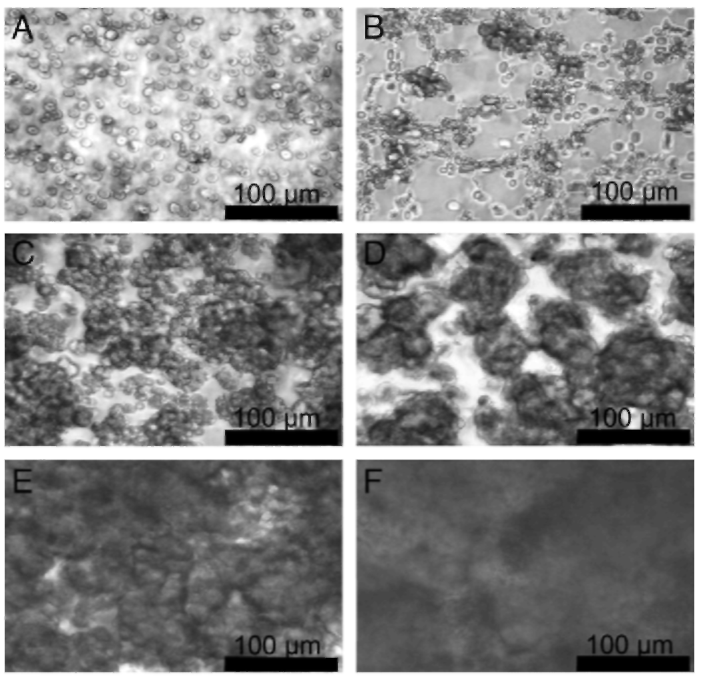
This evolution in aggregability of RBCs having the Mw and concentration of polycation clearly verifies the physico-mechanical mechanism(s) responsible for erythrocyte aggregation. Our observations support the assumption that aggregation of RBCs requires at least the combination of 2 physico-chemical mechanisms. The first relies on a decrease of the Zeta potential of the cells by neutralization of the negative charges present on the glycocalyx from the plasma membrane surface [6,7]. The second, which is facilitated by the first event with a decrease in electrical repulsion forces, depends on a physical bridging of RBCs through macromolecule chains physically attached to adjacent cells [26]. Charge neutralization is well known to increase with an increment in polymer concentration [5-7]. Based on the Mw dependence highlighted in this study, it should be noted that the critical length needed to promote the physical cross-linking between erythrocytes should be within the nanometer size scale, taking into account the relatively small difference in Mw needed to be efficient (10,000 vs 26,400). Although longer molecular lengths are typically reported to promote bridging coagulation in latex coagulation [27], our results can be explained by the fact that these studies are carried out in a physiological saline medium which therefore decreases the Debye length involved in electrostatic repulsion. Additionally, the surface charge neutralization afforded by the polycations reduces the Zeta potential of the RBCs and therefore facilitates this hemagglutination process. The increase in hemagglutination with time of incubation also supports the mechanism of cell bridging since it can be anticipated that the cell networking process is the result of at least 2 events: polycation adsorption on the cell membrane and cell-to-cell cross-linking. It has been reported elsewhere that to proceed within a time scale of some minutes [28], cell bridging after adsorption on the cell membrane could proceed only after the polymer chain is rearranged to favor cell-to-cell interaction.
It is also of interest to point out the relatively high PDMAEMA concentration required to induce hemagglutination. Based on the assumption of a quantitative adsorption of the polycation molecules on the RBC membrane surface and roughly estimating that the surface covered by polycation molecules of Mw 20,000 should be -75 nm², it follows that a theoretical polycation concentration of 75 µg/mL of whole blood should be required to cover all the RBC surfaces. This discrepancy can be explained by a partial neutralization of the polycations through their interaction with plasma proteins. Albumin and other plasma proteins with an acidic isoelectric point may indeed interact with polycations [5-7], leading therefore to a competitive interplay between plasma proteins and RBCs. This protective effect afforded by plasma proteins against RBC aggregation and reported elsewhere for other polycations [6] does not overcome the action of higher Mw PDMAEMA homopolymers above a concentration threshold between 250 and 500 µg/mL.
The difference in the hemoreactivity of P4 is also of interest. Despite its higher Mw (i.e., 30,700), no aggregation was observed, whatever the duration and polycation concentration assessed. This lack of hemoreactivity can be explained by the steric protection afforded by the PEG moieties. It can be anticipated that, if orientated correctly toward the surface, the PEG chains should reduce the cross-linking action mediated by the polycation segments. Our data correspond, therefore, to the results reported by other authors dealing either with other polycations or with polyelectrolyte complexes [17-19],
If charge neutralization and cell bridging can be expected from the interaction of RBCs and polycations, whatever their chemical nature, other mechanisms could also be involved in the interrelationship of these polymers with cells. It was therefore relevant to compare the results of our study with other polycation studies. For this propose, we also included a PEI with an Mw of 10,000 and a branched structure. Except for a weak aggregation observed at the highest concentration assessed (1000 µg/mL 240 minutes after incubation), no other macro-or microscopic changes were detected in the other experimental conditions. Although it has been reported that PEI induces hemagglutination [20, 29, 30], all the studies were done using a higher Mw PEI, that is, 25,000 to 800,000. If PEI behaves in the same way as PDMAEMA, the lack of aggregability of the PEI assessed in our study can be explained by its insufficient length to support cell bridging.

Fig. 2. Evolution of the percentage of released hemoglobin (% rHb) after whole blood incubation vs polycation nature and concentration. Results express the average of 2 independent experiments.
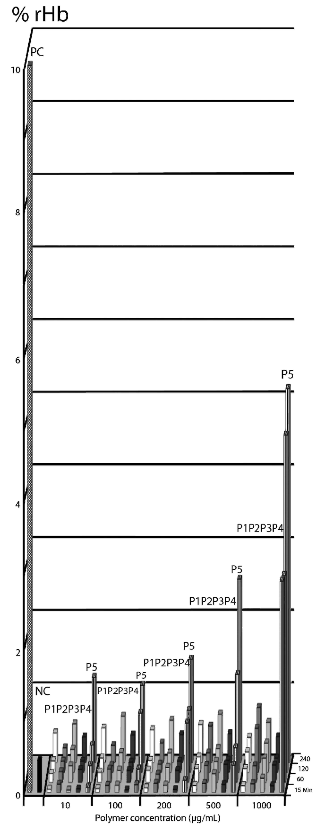

3.3. Hemolytic properties
Having demonstrated the aggregability of RBCs by PDMAEMA homopolymers, we were interested in evaluating the extent of cell damage due to changes in membrane permeability or in membrane fusion. For this purpose, hemolytic properties were evaluated using the ISO Standard Practice for Assessment of Hemolytic Properties of Materials [25]. According to this test, the hemolytic properties of biomaterials were classified as a percentage of hemoglobin (% rHb) after incubating whole blood with a biomaterial. Materials were classed as nonhemolytic, slightly hemolytic, or hemolytic when rHb was 0%-2%, 2%-5, or >5%, respectively. Based on this classification, as highlighted in Fig. 2, all the PDMAEMA-based polymers were nonhemolytic whatever their concentration or Mw and irrespective of the duration of incubation time. These findings differ from the toxicological data reported earlier by Moreau et al. [6] and Dubruel et al. [14], These later authors demonstrated that PDMAEMA could induce a lysis of erythrocytes, depending on the Mw, concentration, and incubation time. However, the experimental conditions employed by these researchers differ from those of our study mainly by the fact that their hemolytic studies were realized in a saline buffer with washed RBCs and not in whole blood [14]. The difference in hemoreactivity might well be explained by the protection afforded by the plasma proteins that bind polycations and form polyelectrolyte complexes with a reduced affinity for the RBCs [6,7]. In order to support this explanation, we performed a hemolysis test incubating RBCs previously washed in PBS with the PDMAEMA solutions. The results from this test (Fig. 3) demonstrated that in saline medium PDMAEMA induced up to 6 times more hemolysis in washed RBCs than in whole blood and this independently of the Mw and composition of this polycation. These data therefore clearly support the protective action afforded by the plasma proteins through their charge neutralization properties.
As we mentioned in the previous section, even in the presence of the strongest aggregation score (P3+++++), no hemolysis was observed. This variation in hemoreactivity could be explained by the fact that cell aggregation involved only the external layer of the RBC membrane, while the induction of hemolysis should disturb the inner part of the membrane structures sufficiently to affect cell permeability [6]. In this respect, comparing the hemolytic properties of PDMAEMAs and PEIs is of major interest. As Fig. 2 illustrates, PEI induced hemolysis in a concentration- and time-dependent way. This hemolytic behavior of PEI has already been reported by Fischer et al. [4]. Based on their experimental findings, these authors suggested that the cytotoxic action of PEI could be related to its binding to proteoglycans present at the surface membrane. According to Moghimi et al., this adsorption process could induce a membrane destabilization with a rapid redistribution of phosphatidylserine from the inner plasma membrane to the outer cell surface [31]. Although this mechanism has not been demonstrated on RBCs per se, it does not by itself explain the difference of hemoreactivity observed between the PDMAEMA and the PEI. We can only guess why the ionic interaction of a polycation with the cell glycocalyx would affect these alterations in the membrane integrity while others do not. This difference in hemoreactivity between PEI and PDMAEMA allows us to suggest that PEI could better penetrate into the RBC membrane with its consequent cell lysis, while in opposite fashion, PDMAEMA could adsorb more weakly on the cell surface, keeping a more open conformation with flexible polymer segments able to bridge adjacent RBCs. This difference in polymer adhesion on the RBCs would be of interest for future assessment by using molecular probe microscopy such as atomic force microscopy. If at this stage we have no direct experimental proof of a mechanism of action between these two polymer families, there are nevertheless some theoretical and experimental observations which also support the actual interpretations of our data. As already discussed for protein opsonization, the difference existing in charge density between PEI and PDMAEMA can also support their difference of ability to penetrate within RBC membrane. Surface charge is well-known to be an important factor regulating the mobility of a charged particle in the polycation-induced transmembrane migration of lipid molecules [32]. Fischer et al. found also that, besides the molar mass, the charge density represents a key parameter for the interaction with biological membranes with consequence a significant effect on cell toxicity [4]. The driving force for this interaction with cell membrane and perturbation results from the electrostatic attraction between the polyelectrolyte and the head groups of the lipids. A charge density threshold to be membrane-disruptive has been evidenced by Kügler et al. [33]. Due to its difference in pKa, but also due to its higher hydrodynamic diameter, PDMAEMA should have therefore less propensity to penetrate within the erythrocyte bilayer and induce cell lysis.
Fig. 3. Evolution of the percentage of released hemoglobin (% rHb) after incubation with washed RBCs vs PDMAEMA nature and concentration. Results express the average of 2 independent experiments.
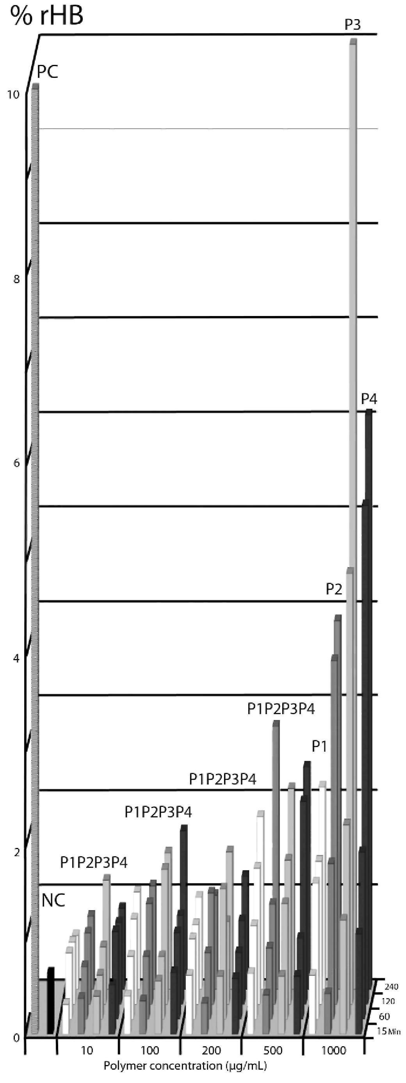
3.4. Platelet counting
Compared with other blood cells, platelets are some of the most sensitive cells to react with foreign body surfaces, giving rise to their activation or aggregation. In particular, their adhesion is well known to be mediated through conformational change of their glycoprotein integrin receptor GPIIb/IIIa responsible for platelet aggregation [34]. In addition, changes in the amount of GPIIb and the translocation of P-selectin from α-granules to the platelet surface membrane underlie platelet-leukocyte aggregation, respectively [35]. The results of our study, seen in Fig. 4, clearly demonstrate that a least a 20% decrease in platelet number was already observed in the presence of such a low PDMAEMA concentration as 10 µg/mL. At 100 µg/mL, platelet counting achieved values up to 20% of control. Surprisingly, and in contrast to observations done with RBCs, the Mw of PDMAEMA has no major influence on platelet aggregation. Comparison with data acquired with PEI is also worthwhile. Only a 20% reduction in platelet number occurred with this polycation at the highest concentration assessed (100 µg/mL). Based on these different observations and by comparison with RBC behavior, it is difficult to anticipate the mechanism underlying this platelet aggregation. If a similar physical-chemical explanation could be suggested other than RBCs, that is, charged neutralization by the polycation combined with the bridging process, we can only guess why these events are so sensitive compared with the RBCs and why they were not affected by the Mw of the polycations and by the presence of a PEG segment (P4) as observed for erythrocyte aggregation. If, at this stage, we cannot rule out this mechanism (as suggested by Yancheva et al. [36]) when comparing the action of quaternized PDMAEMAs with the nonquaternized form of the same polymethacrylate or by Coller when studying polybrene hemocompatibility [37], other mechanisms of action might be involved.
If higher platelet countings have been observed for intermediate polycation concentrations these variations, although statistically significantly different, can be ascribed to the evolution in adhesion ability of platelets using citrate as anticoagulant. It should be indeed stressed that if platelet counting seems a relatively simple biological assay when adopting EDTA as anticoagulant, citrate selected here in order to preserve the activation/aggregation of platelets give rise to more variations in counting especially within the first hour after blood sampling.

Fig. 4. Evolution of platelet after incubation of whole blood with the polycations vs polycation nature and concentration. Platelet counting in blood control was normalized as 100% platelet number. Bars with (*) show statistically significant differences in comparison to the blood control (P<0.05).
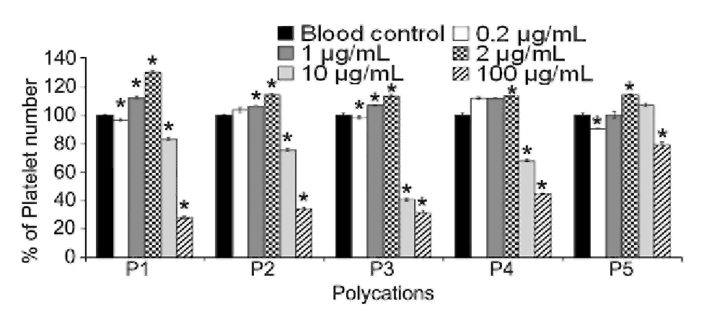

Table 3 Evaluation of intrinsic pathway after whole blood incubation with polycations. Activated partial thromboplastin time (APTT) has been assessed with a Behring Coagulation Timer analyzer (BCT) (Dade Behring). Blood control was automatically normalized as 100% by the BCT. A decrease in APTT % corresponds to an inhibition of the pathway compared with blood control. Data with (*) show statistically significant differences in comparison to the blood control (P<0.05).
APTT(%) | P1 | P2 | P3 | P4 | P5
Blood control | 100 | 100 | 100 | 100 | 100
Positive control | 52* | 49* | 50* | 51* | 54*
0.2 µg/mL | 100 | 100 | 99 | 100 | 99
1 µg/mL | 100 | 96 | 100 | 100 | 100
2 µg/mL | 100 | 71 | 90 | 100 | 100
10 µg/mL | 39* | 40* | 40* | 34* | 30*
100 µg/mL | 0* | 0* | 0* | 15* | 30*
Table 4 Evaluation of extrinsic pathway after whole blood incubation with polycations. Prothrombin time (PT) has been assessed with a Behring Coagulation Timer analyzer (BCT) (Dade Behring). Blood control was automatically normalized as 100% by the BCT. A decrease in PT % corresponds to inhibition of the pathway compared with blood control. Data with (*) show statistically significant differences in comparison to the blood control (P<0.05).
PT (%) | P1 | P2 | P3 | P4 | P5
Blood control | 100 | 100 | 100 | 100 | 100
Positive control | 130 | 130 | 130 | 130 | 126
0.2 µg/mL | 110 | 114 | 102 | 104 | 95
1 µg/mL | 124 | 128 | 124 | 114 | 92
2 µg/mL | 126 | 129 | 127 | 115 | 88
10 µg/mL | 64* | 71* | 92* | 118* | 43*
100 µg/mL | 25* | 25* | 25* | 25* | 25*

3.5. Coagulation
Several proteins are associated with both coagulation cascades, the intrinsic and extrinsic pathways. Hence it could be expected that hemostasis is affected if polycations form the polyelectrolyte complexes with key proteins governing these coagulation pathways. In our study, activated partial thromboplastin time (APTT) and prothrombin time (PT) were measured in order to evaluate the effects of polycations on intrinsic and extrinsic pathways, respectively. From the data summarized in Tables 3 and 4, it can be observed that all the polycations within a concentration range of 10 to 100 µg/mL strongly increased the APTT and PT. For all 3 PDMAEMA homopolymers at a concentration of 100 µg/mL, the intrinsic pathway was no longer measurable under the standard conditions of analysis. By comparison, inhibition of the IP induced by the PEI is even stronger (a reduction already observed at 1 and 2 µg/mL). The extrinsic pathway was also significantly reduced in the presence of the PDMAEMAs, although not totally inhibited at 100 µg/mL in contrast to the action of PEI. Interestingly, the efficiency of EP inhibition decreases when the Mw of the homo PDMAEMAs is raised. Here and in contrast to platelet reactivity, the benefit in the steric shielding of PEG (see P4) is highlighted both for APPT and PT. In agreement with the results obtained by Yancheva et al. [36] with either PDMAEMA (Mw 24,000) or their quaternized forms, the inhibition of intrinsic and extrinsic pathways of coagulation can be readily explained by the acidic pI of several of the key proteins involved in the coagulation cascades allowed to generate polyelectrolytes complexes. Among these proteins, fibrinogen, factor IX, prothrombin, factor X, and antithrombin III deserve particular mention as key factors in the activation of all humoral blood reactions (i.e., Hageman factor XII).

Fig. 5. Evolution of the complement activation after incubation of whole blood vs polycation nature and concentration. Complement activation has been determined based on C3a assay (ELISA). C3a activation in blood control was normalized as 100% platelet number. Bars with (*) show statistically significant differences in comparison to the blood control (P<0.05).
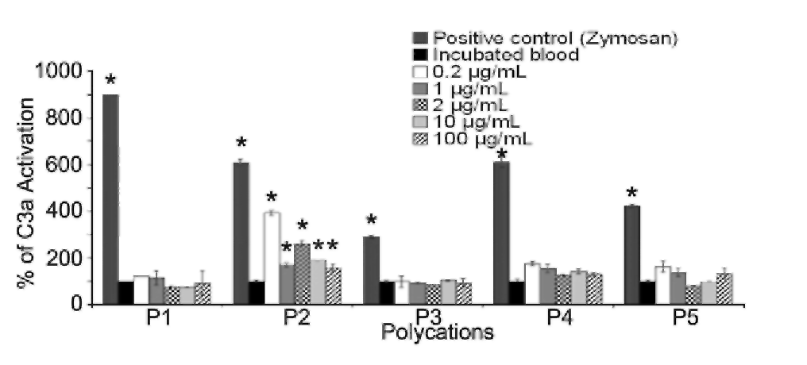

3.6. Complement activation
The complement system is a major mechanism in the immunogenic response to facilitate the elimination of bacteria, viruses, and other foreign bodies. About 30 proteins of the plasma or those linked to the surface of the immune cells may be involved in this complex immunological machinery [38]. Activation of this system can proceed according to 3 possible pathways involving multistep protein cleavages, but which differ both by the nature of the triggering element and by the first steps involved in initiating this activation. These 3 enzymatic cascades have a common enzyme: C3 convertase, which cleaves the C3 protein in the anaphylotoxin called C3a, the biological parameter considered in our in vitro study to assess complement activation. Complement system activation is a major parameter to evaluate since it has been shown than polycations can activate such cascade [8]. Fig. 5 highlights the level of complement activation (expressed in percentage of the normal blood incubated) observed in human blood samples incubated with PDMAEMA-based polymers or PEL Zymosan, a mannanrich, insoluble cell-wall polysaccharide of Saccharomyces cerevisiae, was employed as positive control for all tests. Before analyzing and discussing the data, it should be stressed that the level of activation observed for the zymosan control differs from polymer to polymer because each polymer has been evaluated separately, thus using different blood samples. This variation in positive control can therefore be assigned to an interindividual variation in complement activation as already reported by Bergh et al. [39]. Analysis of the level of C3a detected in blood incubated with the 5 polycations leads to the conclusion that no significant activation was observed, whatever their Mw and composition are. In the case of the homopolymer P2, statistically significant differences in complement activation were however noticed. Taking into account that no dose/response can be derived from these data and they do not fit with the responses observed for the other polymers, we can only anticipate that these variations are linked to subject to subject variations. Compared with coagulation alteration, these observations open the question of the lack of reactivity of C3 protein, which has a pi of 5.7. Considering the high concentration and diversity of proteins present in plasma, the easiest way to support our data relies, of course, on the competition between these proteins for the foreign polymers. Compared with our data, those reported by Ward et al. [9] showed complement activation for PEI 25,000 at a low concentration of 0.01 to 1 µg/mL Although their PEI differs from the polycations evaluated in our study, it opens the question of the purity of the polycations evaluated and of the possible difference in this biological assay in function of the method adopted [8].
4. Conclusions
The hemocompatibility of 4 PDMAEMA-based polymers and 1 PEI was evaluated according to the 5 categories of tests recommended in ISO10993-4. To our knowledge, no other studies have evaluated the hemocompatibility of free PDMAEMA and PEI following such recommendations. In contrast to most of the hemocompatibility studies of PDMAEMA and PEI, our experiments were performed on whole blood to take into account the humoral response. Employing well-defined and extremely purified polymeric materials, our data have allowed us to draw clear relationships between the macromolecular properties of this polycation family and their hemoreactivity. Based on these systematic and extensive observations, we are in a position to propose, or confirm, the mechanisms underlying the different blood reactions. If most of them can be explained on the basis of nonspecific ionic interaction with the various polyanionic domains presented at the surface of various cellular and humoral blood elements, the sensitivity of some the reactions observed, in particular platelet aggregation, leads us to suggest that more complex mechanisms could be altered involving some specific biochemical signals. As outlined at the beginning of our study, it should be reemphasized that the hemoreactivity of PDMAEMA cannot be extrapolated to the same polycation once associated with the polyelectrolyte complexes. In addition, we have shown that PEGylation of the polycation sequence is also a strategy that masks the reactivity of the cationic sequence. Interestingly enough no major differences were observed in the humoral reactions of PEI and the various PDMAEMA evaluated, thus either regarding coagulation and complement activation. Difference in opsonization behavior between PEI and PDMAEMA could be expected due to the existence of several macromolecular differences between these two polycation families. It is indeed well-known that polyelectrolyte complex condensation capacity is not only related to the charge density of the interacting polymers but is also a function of charge distribution, polymer backbone flexibility, and hydrophobicity/hydrophilicity balance [40]. In the particular case of the comparison between branched PEI and PDMAEMA their architecture and accordingly flexibility largely differs. With an extensive branched structure as is typically the case for commercial PEI this polymer has an amino group ratio 1°:2°:3° equal to 1:1:1 [41], Compared to the linear structure of PDMAEMA the PEI architecture promotes therefore the condensation of the macromolecules which explains the exponential factor of the Mark-Houwink parameters of 0.26 as reported by von Harpe et al. [41 ]. This value, similar to the data reported by Park and Choi [42] is noticeably low and mainly affected by the solvent quality and/or different degree of branching can be ascribed to the very compact structure of branched PEI. By comparison the value reported for linear PDMAEMA is significantly higher i.e. 0.5 and 0.6 [43]. The charge density of the polycation is also expected to play a key role for their interaction with proteins. Polymer charge density is usually taken as the ratio between the amount of charged and total monomers. With a pK value ranging between 8.2 and 9.9 in function of the Mw and branching level [41], branched PEI has a high density of amine groups, despite that it has been measured that two thirds of them could remain unprotonated in physiological environment [44]. By comparison PDMAEMA has a mean pKa surrounding physiological pH, i.e., 7.4 [45]. This discussion should not been limited to thermodynamical parameters but should also take into consideration the kinetics aspects related to the dynamics of the macromolecule association-dissociation in aqueous mixtures. Although this topic remains mainly under-investigated in literature these exchange, addition reactions, and structural reorganization of either primary complexes or supramolecular organization can largely contribute to modify the opsonization behavior of polycation in blood. Function of the final outcome of this interplay between plasma proteins, the preferential adsorption of key opsonins in the activation of the classical biological cascades of the blood (such as Hageman Factor or Factors C3, B and D) should be definitely taken into consideration.
Definitively, if some of our observations have allowed us to support some mechanisms in hemoreactivity, they have also raised additional questions for which answers can be provided only by using additional biochemical and biophysical methodologies required to highlight the intimate molecular and cellular events involved.
Acknowledgment
Financial support from the EU FP6 IP NanoBioPharmaceutics, Doctorado Institucional en Ingeniería y Ciencia de Materiales-PNPc-CONACYT México (grant no. 213606) as well as PIFI 2009 grant, is gratefully acknowledged.
References
[1] S. Zhang, Y. Xu, B. Wang, W. Qiao, D. Liu, Z. Li, Cationic compounds used in lipoplexes and polyplexes for gene delivery, J. Control. Release 100 (2004) 165-180.
[2] H. Lv, S. Zhang, B. Wang, S. Cui, J. Yan, Toxicity of cationic lipids and cationic polymers in gene delivery, J. Control. Release 114 (2006) 100-109.
[3] A.C. Hunter, Molecular hurdles in polyfectin design and mechanistic background to polycation induced cytotoxicity, Adv. Drug Deliv. Rev. 58 (2006) 1523-1531.
[4] D. Fischer, Y. Li, B. Ahlemeyer, J. Krieglstein, T. Kiseel, In vitro cytotoxicity of polycations: influence of polymer structure on cell viability and hemolysis, Biomaterials 24 (2003) 1121-1131.
[5] D. Domurado, E. Moreau, R Chotard-Ghodsnia, I. Ferrari, P. Chapon, M. Vert, Relative polycation interactions with whole blood and model median, in: E. Chiellini, J. Sunamoto, C. Migliaresi, R.M. Ottenbrite, D. Cohn (Eds.), Biomedical Polymers and Polymer Therapeutics, Kluwer Academic/Plenum Publishers, New York, 2001, pp. 159-176.
[6] E. Moreau, M. Domurado, P. Chapon, M. Vert, D. Domurado, Biocompatibility of polycations: in vitro agglutination and lysis of red blood cells and In vivo toxicity, J. Drug Target. 10 (2002) 161-173.
[7] E. Moreau, I. Ferrari, A Drochon, P. Chapon, M. Vert, D. Domurado, Interactions between red blood cells and a lethal, partly quaternized tertiary polyamine, J. Control. Release 64 (2000) 115-128.
[8] C. Plank, K. Mechtler K., FC. Jr. Szoka, E. Wagner, Activation of the complement system by synthetic DNA complexes: a potential barrier for intravenous gene delivery, Hum. Gene. Ther. 7 (1996) 1437-1446.
[9] C. Ward, M.L. Read, L.W. Seymour, Systemic circulation of poly(L-lysine)DNA vectors is influenced by polycation molecular weight and type of DNA: differential circulation in mice and rats and the implication for human gene therapy, Blood 97 (2001)2221-2229.
[10] J.A. Chu, S. Beydoun, S.T. Mathews, J. Hoang, Novel anticoagulant polyethyleneimine: inhibition of thrombin-catalyzed fibrin formation, Arch. Biochem. Biophys. 415 (2003) 101-108.
[11] International Standard ISO 10993-4., Biological evaluation of medical devices-part 4: selection of test for interactions with blood, 2002.
[12] A. Schallon, V. Jérôme, A. Walther, C.V. Synatschke, AH.E. Millier, R Freitag, Performance of three PDMAEMA-based polycation architectures as gene delivery agents in comparison to linear and branched PEI, React Funct. Polym. 70 (2010) 1-10.
[13] J. Robbens, C. Vanparys, N. Nobels, R. Blust, K.V. Hoecke, C. Janssen, K. de Schamphelaere, K. Roland, G. Blanchard, F. Silvestre, V. Gillardin, P. Kestemont, R Anthonissen, O. Toussaint, S. Vankoningsloo, C. Saout, E. Alfaro-Moreno, P. Hoet, L Gonzalez, P. Dubruel, P. Troisfontaines, Eco-, geno- and human toxicology of bioactive nanoparticles for biomedical applications, Toxicology 269 (2010) 170-181.
[14] P. Dubruel, B. Christiaens, B. Vanloo, K. Bracke, M. Rosseneu, J. Vandekerchove, E. Schacht, Physicochemical and biological evaluation of cationic polymethacrylates as vectors for gene delivery, Eur. J. Pharm. Sci. 18 (2003) 211-220.
[15] RA Jones, M.H. Poniris, M.R Wilson, pDMAEMA is internalised by endocytosis but does not physically disrupt endosomes, J. Control. Release 96 (2004) 379-391.
[16] F. Verbaan, I. van Dam, Y. Takakura, M. Hashida, W. Hennink, G. Storm, Ch. Oussoren, Intravenous fate of poly(2-(dimethylamino) ethyl methacrylate)-based polyplexes, Eur. J. Pharm. Sci. 20 (2003) 419-427.
[17] S. Lin, F. Du, Y. Wang, S. Li, D. Liang, L. Yu, Z. Li, An acid-labile block copolymer of PDMAEMA and PEG as potential carrier for intelligent gene delivery systems, Biomacromolecules 9 (2008) 109-115.
[18] R Sharma, J.-S. Lee, R.C. Bettencourt, Ch. Xiao, S.F. Konieczny, Y.-Y. Won, Effects of the incorporation of a hydrophobic middle block into a PEG-polycation diblock copolymer on the physicochemical and cell interaction properties of the polymer-DNA complexes, Biomacromolecules 9 (2008) 3294-3307.
[19] S. Pirotton, C. Muller, N. Pantoustier, F. Botteman, S. Collinet, C. Grandfils, G. Dandrifosse, P. Degée, P. Dubois, M. Raes, Enhancement of transfection efficiency through rapid and noncovalent post-PEGylation of poly(dimethylaminehtyl methacrlyate)/DNA complexes, Pharm. Res. 21 (2004) 1471-1479.
[20] R Kircheis, L. Wightman, A. Schreiber, B. Robitza, V. Rδssler, M. Kursa, E. Wagner, Polyethylenimine/DNA complexes shielded by transferrin target gene expression to tumors after systemic application, Gene Ther. 8 (2001) 28-40.
[21] P. van de Wetering, J.-Y. Cherng, H. Talsma, D.J.A Crommelin, W.E. Hennink, 2-(dimethylamino) ethyl methacrylate based (co) polymers as gene transfer agents, J. Control. Release 53 (1998) 145-153.
[22] F.J. Verbaan, P.K. Klouwenberg, J.H. van Steenis, C.J. Snel, O. Boerman, W.E. Hennink G. Storm, Application of poly(2-(dimethylamino)ethyl methacrylate)-based polyplexes for gene transfer into human ovarian carcinoma cells, Int. J. Pharm. 304 (2005) 185-192.
[23] X. Jiang, A. van der Horst, M.J. van Steenbergen, C.F. van Nostrum, P.J. Schoenmakers, W.E. Hennink, Molar-mass characterization of cationic polymers for gene delivery by aqueous sizeexclusion chromatography, Pharm. Res. 23 (2006) 595-603.
[24] F. Straton, P.H. Renton, Practical Blood Grouping, Blackwell Scientific Publications, Oxford, 1958.
[25] Standard Practice for Assessment of Hemolytic Properties of Materials (ASTM designation F 756-00), 2000.
[26] A. Pribush, D. Zilberman-Kravits, N. Meyerstein, The mechanism of the dextran- induced red blood cell aggregation, Eur. Biophys. J. 36 (2007) 85-94.
[27] S.S. Shenoy, R. Sadowsky, J.L Mangum, LH. Hanus, N.J. Wagner, Heterofloccula- tion of binary latex dispersions of similar chemistry but varying size, J. Colloid Interface Sci. 268 (2003) 380-393.
[28] C. Grandfils, P. Foresto, N. Valverde, D. Sondag-Tull, Optimization and application of electrophoretic mobility analyses of human red blood cells to study their in vitro stability, interaction with polycations and proteolytic enzymes, J. Biomed. Mater. Res. A 84 (2008) 535-544.
[29] H. Petersen, P.M. Fechner, AL. Martin, K. Kunath, S. Stolmik, C.J. Roberts, G. Fischer, M.C. Davies, T. Kissel, Polyethylenimine-graft-poly(ethylene glycol) copolymers: influence of copolymer block structure on DNA complexation and biological activities as gene delivery system, Bioconjug. Chem. 13 (2002) 845-854.
[30] M. Ogris, S. Brunner, S. Schüller, R Kircheis, E. Wagner, PEGylated DNA/ transferrin-PEI complexes: reduced interaction with blood components, extended circulation in blood and potential for systemic gene delivery, Gene Ther. 6 (1999) 595-605.
[31] S.M. Moghimi, P. Symonds, J.C. Murray, AC. Hunter, G. Debska, A Szewczyk, A two-stage poly (ethylenimine)-mediated cytotoxicity: implications for gene transfer/therapy, Mol. Ther. 11 (2005) 990-995.
[32] F. Quemeneur, M. Rinaudo, B. Pépin-Donat, Influence of polyelectrolyte chemical structure on their interaction with lipid membrane of zwitterionic liposomes, Biomacromol. 9 (2008) 2237-2243.
[33] R. Kügler, O. Bouloussa, F. Rondelez, Evidence of a charge-density threshold for optimum efficiency of biocidal cationic surfaces, Microbiol. 151 (2005) 1341-1348.
[34] B.S. Coller, Blockade of platelet GPIIb/IIIa receptors as an antithrombotic strategy, Circulation 92 (1995) 2373-2380.
[35] M.W. Radomski, A.S. Radomski, Ed.P. Vallance, Regulation of blood cell function by the endothelial cells, in: P.J.T. Vallance, D.J. Webb (Eds.), Vascular Endothelium in Human Physiology and Pathophysiology, Harwood Academic Publishers, London, 2000, pp. 95-106.
[36] E. Yancheva, D. Paneva, D. Danchev, L. Mespouille, P. Dubois, N. Manolova, I. Rashkov, Polyelectrolyte complexes based on (quaternized) poly((2- dimethylamino) ethylmethacrylate): behaviour in contact with blood, Macromol. Biosci. 7 (2007) 940-954.
[37] B.S. Coller, Polybrene-induced platelet agglutination and reduction in electrophoretic mobility: enhancement by von Willebrand factor and inhibition by vancomycin, Blood 55 (1980) 276-281.
[38] B. Nilsson, K. Nilsson Ekdahal, T.E. Mollnes, J.D. Lambris, The role of complement in biomaterial-induced inflammation, Mol. Immunol. 44 (2007) 82-94.
[39] K. Bergh, A Hjelde, O.J. Iversen, A.O. Brubakk, Variability over time of complement activation induced by air bubbles in human and rabbit sera, J. Appl. Physiol. 74 (1993)1811-1815.
[40] M. Piest, J.F.J. Engbersen, Effects of charge density and hydrophobicity of poly(amido amine)s for non-viral gene delivery, J. Control. Release 148 (2010) 83-90.
[41] A von Harpe, H. Petersen, Y. Li, T. Kissel, Characterization of commercially available and synthesized polyethylenimines for gene delivery, J. Control. Release 69 (2000) 309-322.
[42] I.H. Park, E.-J. Choi, Characterization of branched polyethyleneimine by laser light scattering and viscometry and Van den Berg, Polymer. 37 (1996) 313-319.
[43] R.V. Egoyan, V.V. Gregoryan, G.E. Safaryan, Determination of Mark Houwink Equation Constant for dimethyl(aminoethyl)methacrylate in different solvents, Arm. Chem. J. 38 (1985) 611-614.
[44] J. Suh, J.J. Pak, B.K. Hwang, Ionization of polyethylenimine and polyallylamine at various pHs, Bioorg. Chem. 22 (1994) 318-327.
[45] V. Bütün, S.P. Armes, N.C. Billingham, Selective Quaternization of 2- (Dimethylamino)ethyl Methacrylate Residues in Tertiary Amine Methacrylate Diblock Copolymers, Biomacromol. 34 (2001) 1148-1159.

